Bo2 developer setup guide
You'll need:
This document (duh).
Eclipse (tested with Juno) with m2eclipse.
Subversion client.
Maven (tested with 3.0.4).
Derby database (tested with 10.9.1)
LibreOffice (tested with 3.5), but even older OpenOffice versions should work
bo2testing.tar.gz* containing resources for the tests setup.

Use the subversion client of your choice to checkout the source code. The repository URL is
https://bo2.googlecode.com/svn/trunk/

Import to eclipse as existing maven project (select the Bo2 folder). After a while you'll have a workspace that has compiled properly.
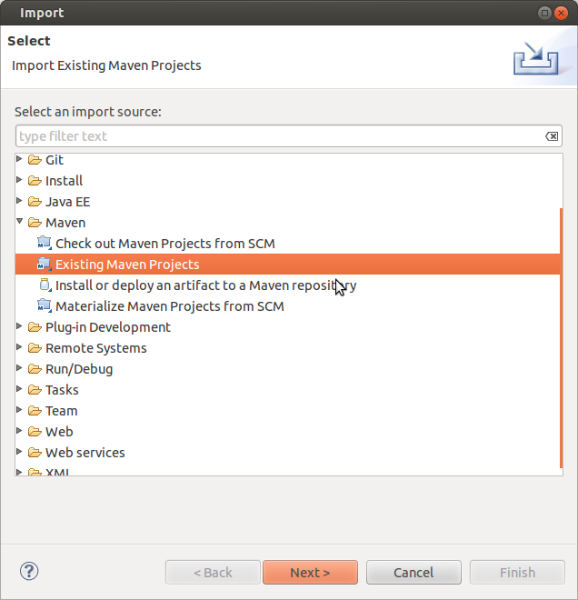

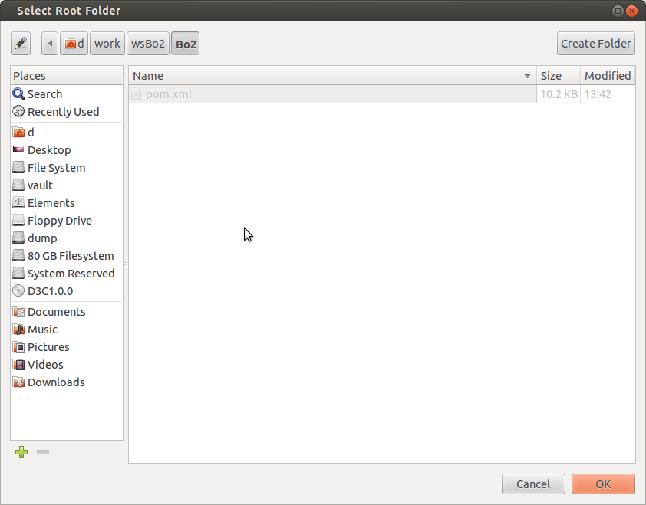

Unpack bo2testing.tar.gz to a directory of your choice (Linux users, use your home, Windows users a dir without spaces to be safe). Locate vars.properties and deployment.properties files in the Bo2 workspace.

In deployment.properties you'll have to edit the following (basically specify where is the bo2testing resource dir and where is the Bo2 workspace.
# work directories
tempDir=/home/d/bo2testing/streams/
odfWorkDirectory=/home/d/bo2testing/odt/
streamsWorkDirectory=/home/d/bo2testing/streams/
#YOUR bo2 workspace here
workspace=/home/d/work/wsBo2/

In vars.properties you'll have to edit the database urls, in order to point to the bo2testing databases, e.g.
LOCALDB.DBURL=jdbc:derby://localhost:1527//home/bo2/bo2testing/LocalDB

and the following property to point to the bo2testing streams directory.
LOCALFS.workDir=/home/d/bo2testing/streams/

Linux users should now use the mailserver.sh script (requires python) to start a mailserver listening on localhost:25 and the oo-server.sh script to start an open office server listening on localhost:8100. I do not have a mail server solution for Windows users, so you may have to remove a couple unit tests (TestMailMessage.java, TestMailServer.java) in order to complete the maven build successfully with all tests passing. Both cases should start the derby network server (listening by default on port 1527).

When everything is done, switch to Bo2 dir and run

mvn install

Hack away and remember to include new test cases and run the entire suite :)

*bo2testing.tar.gz contents
LocalDB: Database instance for most JDBC/Hibernate tests
OtherDB: Second database instance identical to LocalDB, used for TransactionManager tests
odt: sample open office documents
streams: Sample files for tests using streams
scripts: scripts for openoffice server, local mail server

