Vy-An Phan

26159888

cs195-15-aii

**Assignment 6**

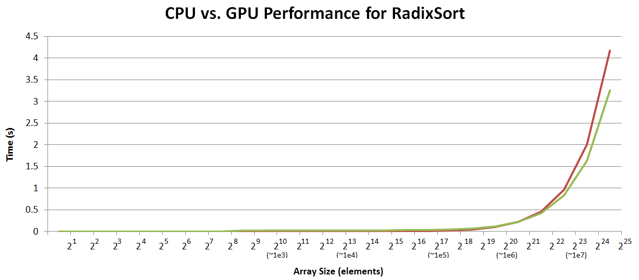

|  |  |  |
| --- | --- | --- |
| **n (size)** | **CPU (s)** | **GPU (s)** |
| 2 | 0 | 0.001591 |
| 4 | 9.54E-07 | 0.001598 |
| 8 | 9.54E-07 | 0.001577 |
| 16 | 1.91E-06 | 0.001609 |
| 32 | 3.10E-06 | 0.001583 |
| 64 | 4.05E-06 | 0.001629 |
| 128 | 6.91E-06 | 0.001541 |
| 256 | 4.29E-05 | 0.003225 |
| 512 | 5.60E-05 | 0.02526 |
| 1024 | 8.51E-05 | 0.016998 |
| 2048 | 0.000149 | 0.017129 |
| 4096 | 0.000307 | 0.017308 |
| 8192 | 0.000577 | 0.017245 |
| **n (size)** | **CPU (s)** | **GPU (s)** |
| 16384 | 0.001249 | 0.017988 |
| 32768 | 0.00259 | 0.021126 |
| 65536 | 0.005417 | 0.034227 |
| 131072 | 0.011324 | 0.035023 |
| 262144 | 0.023892 | 0.044465 |
| 524288 | 0.05017 | 0.069833 |
| 1048576 | 0.104914 | 0.120268 |
| 2097152 | 0.219182 | 0.220792 |
| 4194304 | 0.460656 | 0.424259 |
| 8388608 | 0.961724 | 0.832408 |
| 16777216 | 2.00503 | 1.6379 |
| 33554432 | 4.17307 | 3.25098 |

Radix sort operates in O(nk) time, explaining the shape of the curve we see in the graphs for both the CPU and GPU. Note that the times only appear to increase exponentially because the array sizes on the x-axis are also increasing exponentially.

The CPU outperforms the GPU at first because the GPU requires a good deal of setup and overhead. For small arrays, the GPU is slower because a) there isn't much data to parallelize, and b) the overhead overshadows what little speedup we got. We don't see any speedup until the array is about size n=222, or ~4 million elements.