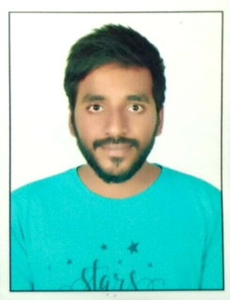**CHILIVERI VINOD RAJESHWAR**

6-17-306/1, Ambedkar Colony, opposite Radha-Krishna Talkies, RK Road, Subhash Nagar, Nizamabad, Telangana-503002.

9769761026, [chiliveriv@gmail.com](mailto:chiliveriv@gmail.com).

**Carrier Objective**

To be a part of the challenging team which strives for the better growth of the organization and which explores my potential and provides me with the opportunity to enhance my talent with an intention to be an asset to the company.

**Education**

**M.Tech**

National Institute of Technology, Manipur

Power and Control Systems

9.18

2019

**B.Tech**

Jawaharlal Nehru Technological University, Hyderabad

Nalla Malla Reddy Engineering College, Ghatkesar

Electrical and Electronics Engineering

68.65%

2017

**Intermediate**

Board of Intermediate Education, Hyderabad

Narayana Junior College, Kompally

MPC

95.4%

2013

**SSC**

Maharashtra State Board of Secondary and Higher Secondary Education, Pune

Andhra Education Society’s High School, Wadala, Mumbai

Secondary School Examination

86.55%

2011

**Technical Proficiency**

Control System, Power System, Matlab/Simulink, AutoCAD Basics 2018, AutoCAD Electricals 2018.

**Academic Project**

**Disturbance Observer Based Sliding Mode Control: Application to Quadrotor**

The work focuses on control of position and attitude of a four rotor rotorcraft termed as quadrotor using disturbance observer based sliding mode control. The effectiveness of the proposed sliding mode controller using disturbance observer is proved by simulation results.

**Personal Profile**

Father Name **:** Chiliveri Rajeshwar

Date of Birth **:** 31**/**12**/**1994

Marital Status **:** Single

Nationality **:** Indian

Known Languages **:** English, Hindi, Telugu, Marathi

Hobby **:** Playing cricket, playing volleyball, watching cricket

Passport **:** R2040518

**Declaration**

I hereby declare that the above mentioned details are true to the best of my knowledge and belief.

Date **:**

Place **:**

**CHILIVERI VINOD RAJESHWAR**