Name: **Omkar Ashok Patwardhan.**

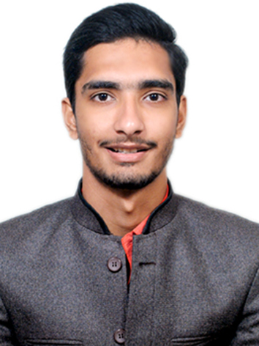

Degree: **Mechanical Engineering.**

Mob no: **8007862742.**

Email: [**patwardhans.omkar@gmail.com**](mailto:patwardhans.omkar@gmail.com)

__________________________________________________________________________________

Objective:

To be a part of an organization whose work environment offers opportunities for learning new skills and involve my abilities for mutual growth.

Educational Credentials:

|  |  |  |  |  |
| --- | --- | --- | --- | --- |
| **Course** | **School/College** | **Board/University** | **Year of** **Passing** | **Percentage** |
| B.E.(MECH.) | Sandip Institute of Engineering and Management, Nashik | SSPU | 2018 | **68.86** |
| T.E. | Sandip Institute of Engineering and Management, Nashik | SPPU | 2017 | **61.26** |
| S.E. | Sandip Institute of Engineering and Management, Nashik | SPPU | 2017 | **63.6** |
| Diploma | Guru Gobind Singh Polytechnic college, Nashik. | MSBTE | 2015 | **80.24** |
| **S.S.C.** | Adarsh Madhyamic Vidyalaya, Nashik. | SSC | 2012 | **85.27** |

Work Experience:

* Worked as Application Design and Execution Engineer in Armstrong Machine Builders Pvt. Ltd. from August 2018 to January 2019. Where used to work in following aspects-

1. Basic application design referring to respective application laws.
2. Feasibility check for particular application requirement.
3. Interdepartmental co-ordination from manufacturing to dispatch of conveyor modules.
4. Thorough installation planning along with specific timelines, budget and resources.
5. Installation and Commissioning as per installation plan.
6. Generation of technical audit report and relevant documentation.
7. Co-ordination of remote technical support to customer.

* 20 days implant training in M.D. Hydraulics, Ambad, Nashik.

**Project Profile:**

* Diploma: Design and Development of Pneumatic Crop Uprooting Machine with working prototype.
* BE: Design and Analysis of Suspension System for All-Terrain Vehicle.

Technical Skills:

* Certified AutoCAD user.
* Proficient in Creo 3.0
* CATIA v5, NX 10 user.
* Ansys-Structural Static workbench user.
* Worked with Microsoft Projects.
* Efficient in working with Microsoft PowerPoint and Microsoft Excel worksheets.

Extra-Curricular Activities:

* Participated at national level competition of ESI 2018 team event.
* Leaded a team of 3 members at static marketing event held during SAE- BAJA 2018.
* Participated at national level competition of Mega-ATV 2017 team event.

Achievements:

* Secured All India 11th rank in the competition of SAE-BAJA 2018 team event.
* Winner in national level 30kg Robo-war competition held at SPCOE in 2017, Andheri.
* Runner up in national level Robo- Tasks and Robo-war competition, held at ZCOER in 2017, Pune.
* Secured First Position in national level Mini- Project competition held at JMCT Polytechnic in 2015, Nashik.

**Personal Attribute:**

* Good Communication Skills.
* Confident and Focused.
* Enthusiasm.
* Desire to learn new things.

Personal Profile:

**Name :** Patwardhan Omkar Ashok.

**Date of Birth :** 03/09/1996.

**Permanent Address :** Flat No 6, Shashank Apartment, Behind Indira Nagar

Church, Indira Nagar, Nashik.

**Hobbies and Interest:** Swimming, Collecting Coins, Working on Personal Projects,

Listening to music.

Declaration:

I Omkar A. Patwardhan hereby declare that the information given above is true to the best of my knowledge and belief.

**Date:** 28/05/2019

**Place:** Pune.

Yours Sincerely,

Omkar Ashok Patwardhan.