**GAMIFICATION**



[Gamification is the craft of deriving all the fun and engaging elements found in games and applying them to real-world or productive activities](https://twitter.com/intent/tweet?url=https%3A%2F%2Fyukaichou.com%2Fgamification-examples%2Foctalysis-complete-gamification-framework%2F&text=Gamification%20is%20the%20craft%20of%20deriving%20all%20the%20fun%20and%20engaging%20elements%20found%20in%20games%20and%20applying%20them%20to%20real-world%20or%20productive%20activities.&via=yukaichou&related=yukaichou)[1][.](https://twitter.com/intent/tweet?url=https%3A%2F%2Fyukaichou.com%2Fgamification-examples%2Foctalysis-complete-gamification-framework%2F&text=Gamification%20is%20the%20craft%20of%20deriving%20all%20the%20fun%20and%20engaging%20elements%20found%20in%20games%20and%20applying%20them%20to%20real-world%20or%20productive%20activities.&via=yukaichou&related=yukaichou)



This document provides tips and examples on how to apply gamification considering different contexts, targets and goals

Date: 06/06/2023

Version:V1 - FBK

Licence: [CC BY-SA 4.0](https://creativecommons.org/licenses/by-sa/4.0/)

# Level Up Your Engagement: The Power of Gamification

Gamification is the use of game design principles and mechanics in non-game contexts to encourage participation, engagement, and motivation. It involves taking the fun and excitement of games mechanisms that valorize achievement, social, and immersion related aspects and applying them to everyday activities. Gamification has become increasingly popular in recent years, and for good reason. In the next chapters, we will explore the value of using gamification and how it can benefit individuals, businesses, and organizations.

**Benefits of Gamification**

Gamification can be helpful for several reasons:

|  | **Increase Engagement**  Gamification can increase engagement by making activities more enjoyable and rewarding. When people are feeling satisfied having fun, they are more likely to stay engaged and motivated. Gamification can make mundane tasks more interesting and exciting, which can lead to increased participation and better performance. |
| --- | --- |
|  | **Improve learning**  Gamification can be an effective tool for learning and training. By incorporating game elements such as challenges, rewards, and progress tracking, gamification can make learning more interactive and engaging. It can also provide instant feedback, which can help learners understand where they need to improve and how to do it. |
|  | **Behavior change**  Gamification techniques can be employed to encourage desired behaviors and motivate individuals to reach specific goals. By offering rewards, recognition, and a sense of achievement, gamification can incentivize users to adopt healthier habits, complete tasks, meet targets, or participate in activities they might otherwise find unappealing or tedious. |
|  | **Increase motivation**  Gamification can increase motivation by tapping into our natural desire for competition, achievement, and recognition, and competition. By incorporating elements such as points, badges, and leaderboards, badges, and points, gamification can create a sense of accomplishment and progress. This can motivate individuals to continue participating and striving for improvement. |
|  | **Collaboration and social interaction**  Gamification can foster collaboration and social interaction among individuals or within teams. By incorporating multiplayer elements, team challenges, or cooperative gameplay, it encourages users to work together, share knowledge, and communicate effectively. This can enhance teamwork, build stronger relationships, and promote a sense |
|  | **Improve performance**  Gamification can improve performance by providing clear goals and feedback. By setting specific targets and tracking progress, gamification can help individuals focus on what they need to achieve and how to get there. This can lead to improved performance and better results. |
|  | **Increase customer loyalty**  Gamification can be used to increase customer loyalty by providing a pleasant fun and engaging experience. By incorporating elements such as loyalty programs, badges, and rewards, gamification can create a sense of community and belonging. This can encourage customers to continue using a product or service and become loyal advocates. |

**Gamification Not Always the Answer:** When and Why to Rethink Your Approach

Gamification can be a powerful tool for increasing engagement, motivation, and performance, but it's important to evaluate whether it's appropriate and effective for your situation. By considering the benefits and potential drawbacks of gamification, you can make an informed decision about whether to use it or not.

There are situations where it may not be appropriate or effective. Here are some examples of when not to use gamification:

* **When it is not appropriate:** Some activities or situations may not be appropriate for gamification, such as sensitive or serious topics.
* **When it is too expensive or time-consuming:** Developing a gamification system can be expensive and time-consuming, so it may not be worth the investment in some cases.
* **When it is not effective:** Gamification may not be effective for all audiences or situations. It's important to evaluate whether gamification is the best approach for achieving your goals.
* **When it is not aligned with the organization's values:** Gamification should align with the organization's values and mission. If it doesn't, it may send conflicting messages and harm the organization's reputation.

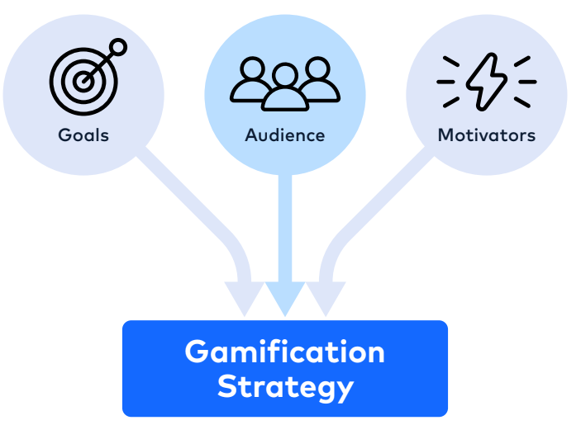

Picture taken from A TALON.ONE WHITE PAPER How to create a successful gamification project to drive customer engagement

How to exploit gamification?

In the next sections we provide a list of steps and tips to apply gamification according to specific audiences, contexts and goals.

## 01 | **Understand your audience**

The key to using incentives effectively is to understand your audience's needs and motivations, and tailor your incentives accordingly. Different audiences have different values, preferences, and motivations. For instance, an incentive that may work for one demographic group may not be effective for another. Therefore, it's essential to research and understand your audience's needs and interests.

Different types of incentives can work differently for different audiences based on their individual preferences, motivations, and needs.

Some questions you can try to answer are:

* Who is your target audience?
* What are their demographics? (age, gender, location, income, education level, etc.)
* What are their interests and hobbies?
* What are their goals and aspirations?
* What are their values and beliefs?

By answering these questions, you can gain a better understanding of your target audience and define a rewarding strategy accordingly.

## 02 | **Define your goal**

Identifying the desired outcome is crucial to design the proper incentive strategy. What do you want to achieve? Incentives and rewards can be used for a variety of purposes, depending on the specific context and goals of the initiative.

Some common purposes for using incentives and rewards include:

**Motivating a certain behavior:** gamification can be used to encourage individuals to engage in specific behaviors (such as collaborating with others, exchange information or data etc) or to achieve specific goals. For example, a company might offer bonuses to employees who meet certain sales targets or complete a project by a certain deadline; a Municipality can reward citizens that provide information and data about a specific topic (e.g. citizen science initiatives).

**Building loyalty**: gamification can also be used to build loyalty among customers or employees. For example, a company might offer a loyalty program that rewards customers for making repeat purchases, or an employer might offer perks such as flexible schedules or extra vacation time to reward long-term employees.

**Enhancing performance**: gamification can be used to improve performance by providing feedback and recognition for good work. For example, a teacher might give students extra credit for completing challenging assignments or a manager might give employees public recognition for completing a difficult project.

**Changing behavior**: gamification can also be used to change behavior by providing a consequence for a specific action. For example, a Municipality can offer incentives to those citizens that decide to change their mobility habits, for instance choosing sustainable means of transportation (bike) for the trajectory home-work. Another example is a company that offers a discount to customers who bring in a reusable shopping bag, in order to encourage environmentally friendly behavior.

## 03 | **Choose the right type incentives**

Consider what types of incentives will be most effective for your audience. These could include discounts, free products or services, rewards points, or exclusive access to events or content.

Intrinsic and extrinsic rewards are two different types of rewards that can motivate behavior in different ways:

|  | **Intrinsic rewards**  are intangible awards of recognition, a sense of achievement, or a conscious satisfaction, they are the internal rewards that come from performing an activity or task for its own sake, without any external rewards or incentives. Examples of intrinsic rewards include personal satisfaction, a sense of accomplishment, or the enjoyment of the activity itself. |
| --- | --- |
|  | **Extrinsic rewards** are awards that are tangible or physically given to someone for accomplishing something, they are external rewards that are given as a result of completing a task or activity. Examples of extrinsic rewards include money, prizes, awards, or recognition. |

The key difference between intrinsic and extrinsic rewards is where the **motivation** comes from. *Intrinsic rewards come from within the individual, while extrinsic rewards come from outside sources.*

Research has shown that intrinsic rewards can be more effective in motivating behavior over the long-term, as they tap into a person's internal motivation and sense of fulfillment. Extrinsic rewards, on the other hand, can be useful in motivating behavior in the short-term, but may not be as effective over the long-term, as people can become reliant on external rewards and lose their internal motivation. Intrinsic rewards are the internal motivation and satisfaction that come from completing a task or activity, while extrinsic rewards are external rewards given as a result of completing a task or activity.

Depending on your audience and desired outcome, you can choose the appropriate incentive. For example, a cash reward may be more effective for sales incentives, while recognition may be more effective for employee incentives.

## 04 | **Define a strategy and a game modality**

Different incentives and game modalities can be foreseen, in particular individual versus collaborative game strategies. The **individualistic strategy** is a type of incentive where individuals compete against each other to achieve a goal or win a prize. In this approach, each individual is responsible for their own performance and is rewarded based on their individual accomplishments. Examples of individualistic gamification include leaderboards, point systems, and badges.

On the other hand, **inter-team competition** modality is a type of gamification where teams compete against each other to achieve a goal or win a prize. In this approach, teams work together to achieve a common goal and are rewarded based on their collective performance. Examples of inter-team competition gamification include team-based challenges, collaborative games, and team-based rewards.

The main difference between individualistic versus inter-team competition gamification is the focus on the **individual versus the team**. Individualistic gamification emphasizes individual performance and rewards, while inter-team competition gamification emphasizes team collaboration and rewards. The choice of which approach to use depends on the specific context and goals of the gamification initiative.

Different types of incentive strategies can work for certain contexts and to reach specific objectives but can be **detrimental** in other cases. For instance, competition is not suitable for all targets and contexts. Studies demonstrated that competition works better for extroverted individuals and in contexts where there is a lot of disparity in users' abilities, it can discourage less skilled or less participatory individuals, resulting in the loss of these users [Preist 2014]. Beside, competition can lead to stress and negative emotions in the workplace [Gabrielle 2018].

Cooperation is more appreciated by the general population, even where it is not more effective in terms of learning or behavior change, and that the cooperative-competitive mode (e.g. team competition) is even more stimulating [Morschheuser 2019]: “inter-team competitions are most likely to lead to higher enjoyment and crowdsourcing participation, as well as to a higher willingness to recommending a system”.

05 | **Identify Game Elements and progression**

|  | Determine which **game elements and mechanics** will be most effective in motivating and engaging your audience. Some common game elements include points, levels, badges, leaderboards, challenges, rewards, avatars, storytelling, and social interactions.  Select elements that align with your objectives and appeal to your target audience. |
| --- | --- |
|  | Create a **clear progression path** for users to follow.  Break down the desired behaviors or tasks into smaller, achievable steps.  Map out how users will progress through levels or stages, earn points or rewards, and unlock new challenges or content.  Provide a sense of accomplishment and visible markers of progress to maintain user engagement. |

## 06 | **Deploy and communicate**

Effective communication is crucial to promote incentive programs and encourage participation. Make sure participants understand what they need to do to earn the incentives and how they can redeem them.

Make sure your incentive program has clear and specific goals that participants can easily understand and strive towards.

Another important thing is to guarantee equity, ethics and accessibility. Gamification should be designed and communicated in a way that ensures equal access and opportunities for participation[2]. It is crucial to consider the potential barriers or disparities that certain individuals or groups may face in accessing and benefiting from incentives. Also Incentives should be implemented in an ethically responsible manner. Care should be taken to ensure that incentives do not compromise ethical principles, such as fairness, transparency, or the protection of privacy and confidentiality.[3]

## 07 | **Test and refine**

Once the gamified experience is implemented, monitor user engagement, behavior patterns, and the effectiveness of the gamification elements. Collect data on user interactions, achievements, and progression. Analyze the data to gain insights into user behavior, identify areas for improvement, and make data-driven decisions to optimize the gamification design.

# Using gamification: how ICT can help?

# Information and Communication Technology (ICT) can play a significant role in facilitating gamification through a variety of tools and platforms. Features such as badges, points, leaderboards, and challenges can be used to motivate and engage users to participate in specific activities. Mobile applications: Mobile applications can be used for gamification by providing an interactive and engaging experience to users. Features such as rewards, badges, levels, and challenges can be incorporated into the app to keep users engaged.

**Here are some examples showing how gamification ICT has been applied in different contexts to reach diverse goals.**

| **Education**  Many educational platforms use gamification to make learning more interactive and engaging. For example, *Duolingo[4]* uses game elements such as challenges, rewards, and progress tracking to help users learn a new language. | **Engage citizens**  Participation in public collaborative activities can be challenging: gamification can play a crucial role in public administrations to encourage participation among individuals and groups. |
| --- | --- |
| **Fitness**  Fitness apps such as *Fitbit* and Nike Run Club use gamification to encourage users to exercise regularly. By setting daily goals, providing progress tracking, and offering rewards for achievements, these apps make exercise more enjoyable and rewarding. | **Employee training**  Gamification can be used for employee training to make learning more engaging and effective. For example, *Walmart* uses a virtual reality game to train employees on customer service skills. |

# Do you need to enhance collaboration within a team?

|  | Learn more about gamification!  Check the **INTERLINKER**: *Introduction to Incentives and Rewards*  Read suggestions on how to use the functionalities available in the INTERLINK Collaborative Environment to incentivize participation in your co-production processes  Check the **INTERLINKER**: *How to take advantage of gamification in the Collaborative Environment* |
| --- | --- |

# 

Some concrete projects that exploit gamification

## **Play & Go!**

|  |  |
| --- | --- |

| **GOAL** | Play&Go offers a comprehensive approach based on an innovative gamification platform that allows mobilizing the entire community and promoting greater awareness of the city's mobility objectives and policies, as well as active and collective participation for more sustainable mobility. |
| --- | --- |
| **TARGET** | Public administrations, citizens |
| **GAMIFICATION MECHANISMS** | Play&Go supports administrations in implementing large-scale and long-term sustainable mobility campaigns with the goal of making the use of sustainable transportation enjoyable and rewarding (through immediate user feedback and virtual and real rewards) while measuring the achieved effects and impact on the mobility system. Play&Go covers all phases of this process: from defining customized mobility campaigns to their implementation and validation. |
| **ICT USED** | Play&Go is a platform developed by FBK that consists of four tools:  Gamification Framework: Supports the definition, execution, and management of game campaigns. The framework incorporates various competitive and collaborative game concepts that are customizable and extensible (e.g., point collections, badge collections, periodic and global leaderboards). It automatically generates dynamic and personalized gaming experiences based on the user's profile and the mobility policies to promote, while also providing automatic validation of tracked trips.  Viaggia Play&Go: A mobile application for sustainable info-mobility that is personalized and gamified. It provides citizens with up-to-date, integrated, and intermodal mobility information. The app suggests and rewards mobility behaviors aligned with sustainability goals.  Analytics Dashboard: Offers administrations a comprehensive and updated analysis of the mobility system and the impact of game campaigns. It allows for the analysis of participation, behavior change, and effects on the mobility system.  Incentive System: The sustainability of game campaigns is ensured through active involvement from local businesses. Companies and commercial activities are directly engaged in these initiatives, not only as promoters among their employees and customers but also as providers of real incentives (e.g., discounts, vouchers, gadgets). |
| **USEFUL LINKS** | https://play.google.com/store/apps/details?id=it.dslab.playgo |

## **Kids go green**

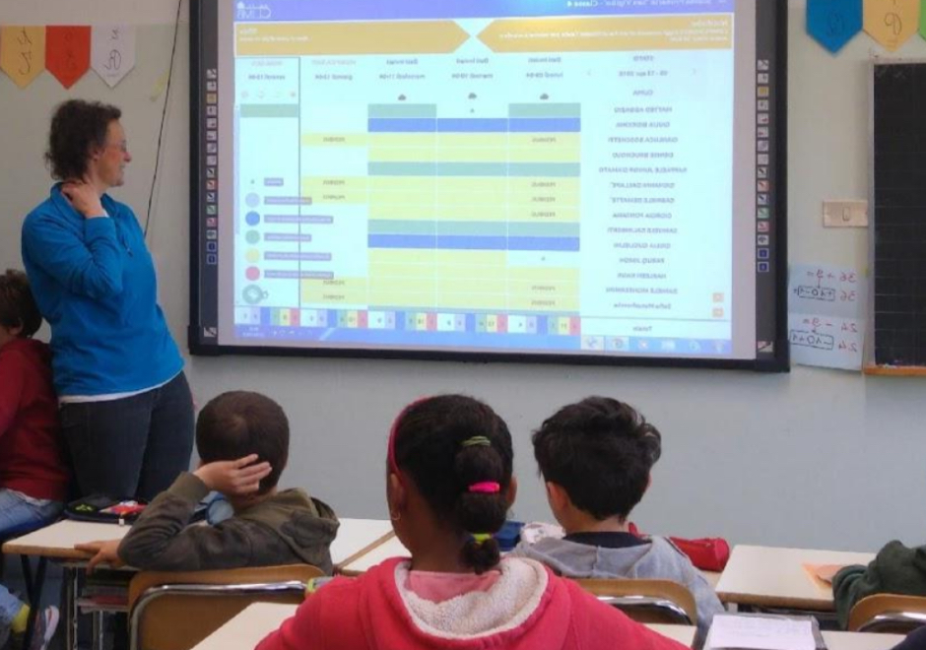 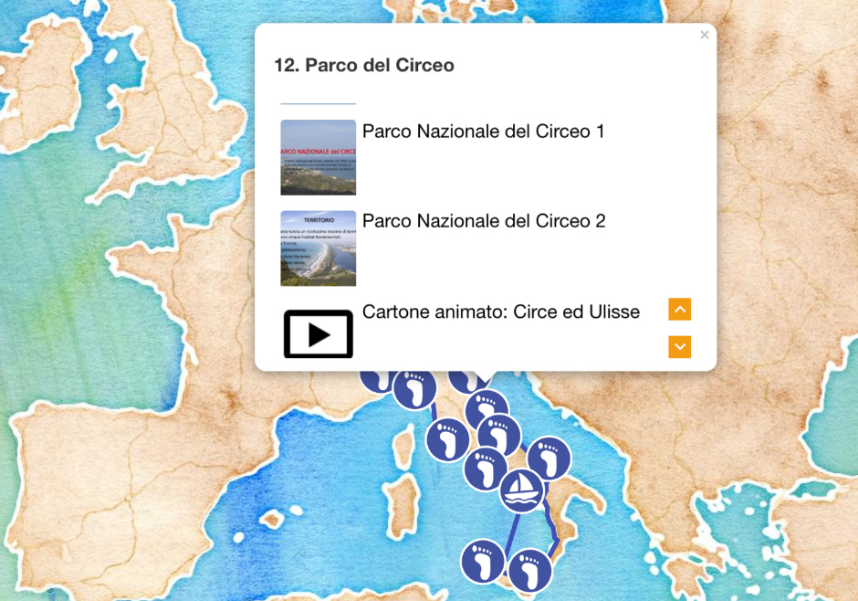

| **GOAL** | An educational game that involves the school, the children and their families in an adventure around the world and promotes a more sustainable mobility. |
| --- | --- |
| **TARGET** | Primary schools students, their families and teachers |
| **GAMIFICATION MECHANISMS** | As part of the school program, teachers, with the help of the Web app, plan thematic virtual journeys by identifying the stops to which they associate multimedia educational content.  Children in the class report daily the transport means of their home-school routes. The sustainable km made by each child advances the group along the virtual journey.  Once each intermediate stop is reached, the multimedia contents are unlocked, thus creating the opportunity to address a new topic. The milestones reached and the interesting contents keep the children motivated to advance along the journey. |
| **ICT USED** | Smart wireless sensors, classroom dashboard |
| **USEFUL LINKS** | https://kidsgogreen.eu/en/ |

## **WEEE ROBOTS**

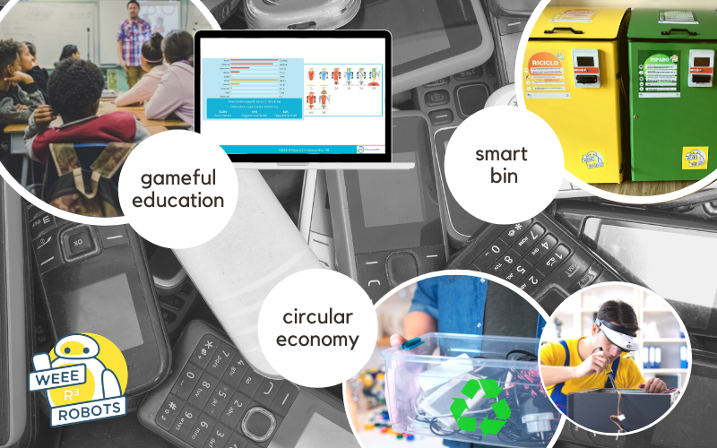

| **GOAL** | Reduce, Reuse, Recycle: raising awareness in schools  through playful education and recycling of Waste Electrical and Electronic Equipment (WEEE) through playful educational activities that involve the entire school community. |
| --- | --- |
| **TARGET** | Primary schools, children ages 6 to 10, their families and teachers. |
| **GAMIFICATION MECHANISMS** | Children collect and categorize their used EEE / WEEE at home with help from their family members. At school, thanks to a Web App, all objects collected are registered in the platform and contribute to earning virtual credits. The Web App helps distinguish between functioning objects, repairable objects and waste and guides children and teachers through the correct management process. The accumulated credits allow the class to build a virtual robot. Thanks to the participation of the whole school, a team of robots will be created that will “clean the world of waste”. The Web App also provides immediate feedback on the impact achieved through the collection campaign and provides teachers with educational multimedia material that can be used in the classroom. The residual value of functioning and repairable objects can be used by the school to purchase refurbished hardware resources |
| **ICT USED** | Web app and smart bins |
| **USEFUL LINKS** | http://www.innoweee.eu/en/the-pilot-campaigns/trentino |

This document, prepared by the [INTERLINK](https://interlink-project.eu/) European project, is licensed under a Creative Commons Attribution-ShareAlike 4.0 International licence ([CC BY-SA 4.0](https://creativecommons.org/licenses/by-sa/4.0/)).

1. https://yukaichou.com/gamification-examples/octalysis-complete-gamification-framework/
2. https://assets.hcca-info.org/Portals/0/PDFs/Resources/library/814_0_IncentivesCEProgram-Murphy.pdf
3. <https://www.frontiersin.org/articles/10.3389/fpsyg.2016.00793/full>
4. <https://en.duolingo.com/course/en/it/Learn-English>