**INCENTIVES & REWARDS**



Incentives and rewards can be effective tools for motivating individuals and for achieving specific goals. But how can they be exploited in practice?

Which are the different types of incentives that can be used according to your goal and your audience?

**This document provides tips and examples on how to exploit incentives, in particular within Public Administrations.**



Date: 06/06/2023

Version:V1 - FBK

Licence: [CC BY-SA 4.0](https://creativecommons.org/licenses/by-sa/4.0/)

# Using incentives and rewards: how to?

Incentives and rewards are a powerful tool that can be used to **increase engagement and participation.** They can be effective for **motivating individuals and achieving specific goals**, such as to increase participation in collaborative projects or to enhance engagement in citizen science projects.

They can provide a **sense of purpose, recognition, and satisfaction,** and can **sustain long-term motivation** and **engagement** of people in their work or personal life.

But to effectively apply incentives and reward it is important to consider different aspects, including cultural norms, individual preferences, and desired outcomes.

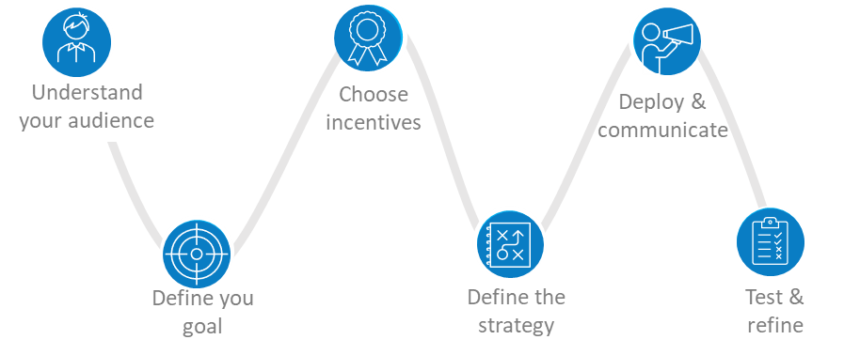

In the next sections we provide a list of steps and tips to apply incentives and rewards according to specific audiences, contexts and goals.

|  | **01 | Understand your audience**  The key to using incentives effectively is to understand your audience's needs and motivations, and tailor your incentives accordingly. Different audiences have different values, preferences, and motivations. For instance, an incentive that may work for one demographic group may not be effective for another. Therefore, it's essential to research and understand your audience's needs and interests. |
| --- | --- |
|  | **02 | Define your goal**  Identifying the desired outcome is crucial to design the proper incentive strategy. What do you want to achieve? Incentives and rewards can be used for a variety of purposes, depending on the specific context and goals of the initiative. Some common purposes for using incentives and rewards include: motivating a certain behavior (such as collaborating with others, exchanging information or data etc), building loyalty, enhancing performance, attracting new participants. |
|  | **03 | Choose the right incentive**  Consider what types of incentives will be most effective depending on how you want to motivate your audience. Rewards can be intangible (such as awards of recognition, a sense of achievement) or tangible or physical (such as money, prizes, award). |
|  | **04 | Define a strategy**  Different incentives and game modalities can be foreseen, in particular individual versus collaborative game strategies. Individualistic gamification focuses on individuals competing against each other to achieve goals or win prizes. It emphasizes individual performance and rewards based on individual accomplishments. On the other hand, inter-team competition gamification involves teams working together to achieve a common goal or win a prize. It emphasizes team collaboration and rewards based on collective performance. |
|  | **05 | Deploy and communicate**  Effective communication is crucial to promote incentive programs and encourage participation. Make sure participants understand what they need to do to earn the incentives and how they can redeem them. Make sure your incentive program has clear and specific goals that participants can easily understand and strive towards. |
|  | **06 | Test and refine**  Once the incentives have been implemented, it's crucial to evaluate their effectiveness and refine them as needed. This can involve gathering feedback from the audience or monitoring the campaign through data. |

# How Public Administrations may exploit incentives & rewards to improve collaboration?

Incentives can play a crucial role in Public Administrations to encourage participation among individuals and groups. Participation in collaborative activities can be challenging, especially when public servants should be involved. There are several ways incentives can be used within Public Administrations.

For instance, in the INTERLINK project - in which public services are co-produced within collaborative networks involving public and private bodies and the civil society - a number of benefits to be used to incentivise participations, here are some examples.

|  | **Concrete immediate benefit**  *Gadgets to thank for collaboration*: physical gadgets (like a bag, pen, notebook, powerbank) or merchandising material (such as a usb pen drive, t-shirts) can be offered to participants.  *Financial Incentives*: small monetary rewards can be offered to individuals or organizations to encourage their participation. For example, offering grants, tax incentives, or financial rewards for engaging in desired activities like volunteering, community service, or participating in public decision-making processes. |
| --- | --- |
|  | **Social benefit**  There are different ways in which social benefits can be envisaged.  *Appreciation and Acknowledgment*: Expressing gratitude and recognizing the value of contributions can foster a sense of pride and accomplishment, encouraging continued participation. This can be put in practice, for example, by demonstrating appreciation and giving value to the collected feedback during a collaborative activity or by demonstrating progress made on the basis of past input/effort.  *Publicly acknowledging the contributions and efforts* of individuals or organizations: This can be done through formal or informal channels, such as public meetings, events, newsletters, or social media platforms.  *Testimonials and Case Studies*: Sharing success stories and testimonials that highlight the impact of collaborative activities can inspire others to get involved. This form of social recognition demonstrates the value of participation and showcases the positive outcomes that can be achieved through collaboration. |
|  | **Self-satisfaction and enjoyment**  Positive atmosphere and enjoyment during collaborative activities are considered powerful incentives. Enjoyment and fun sustains commitment, as well as the opportunity to network and meet new people. This can be achieved in different ways, for instance by organizing a friendly contest for professional training, with participants divided in small teams, by organizing refreshments during events or ice-breaking activities to connect participants. |
|  | **Potential future benefits**  Participants can also be incentivized focusing on their future benefits and leveraging existing interests of participants. For instance, vouchers for future benefits (.e.g vouchers for discounts, benefits at cafeteria and bookshop), use of tokens as incentive, but also networking and community building. By facilitating connections among individuals engaged in collaborative activities, public administration can create a community where participants can exchange ideas, share experiences, and receive support from their peers. |
|  | **Gamification and Challenges**  Introducing elements of gamification, such as competitions, challenges, or leaderboards, can make participation more engaging and enjoyable. By setting goals, providing rewards for achievements, and fostering healthy competition, individuals can be motivated to actively participate.  Check the **INTERLINKER**: *Introduction to gamification*  Check the **INTERLINKER**: *How to take advantage of gamification in the Collaborative Environment* |

## **Challenges and barriers**

Incentives can be effectively used within Public Administrations to support the co-production of public services, where citizens and public servants collaborate in the design, delivery, and evaluation of services. However, there are a number of constraints and considerations when using incentives for co-production activities.

**Equity, ethics and accessibility**

Incentives should be designed in a way that ensures equal access and opportunities for participation**[1]**. It is crucial to consider the potential barriers or disparities that certain individuals or groups may face in accessing and benefiting from incentives. Also incentives should be implemented in an ethically responsible manner. Care should be taken to ensure that incentives do not compromise ethical principles, such as fairness, transparency, or the protection of privacy and confidentiality.[2]

**Financial incentives may not be effective**

Research has shown contradictory findings on the effectiveness of financial rewards on co-production. Some argue that financial incentives increase citizens' willingness to co-produce, while others suggest that incentives decrease their willingness. The social-psychological context, including community attachment, trust in local authorities, ethnic diversity, unemployment level, and population density, moderates the effect of incentives on co-production and should be considered (Letki 2020).

**Cost-effectiveness**

The allocation of resources for incentives needs to be balanced with the overall cost-effectiveness of co-production activities. Public administrations should assess the costs associated with providing incentives and consider whether the benefits derived from increased participation justify the investment. Besides, several PAs might have limited access to budget for this kind of issues and have legal and administrative constraints for tangible rewards.

**Pay attention to the context**

In order to ensure the effectiveness of gamified services, specific rules should be considered during the design process. These rules prioritize cooperation to prevent negative emotions and ensure that additional effort is not perceived as necessary, thereby avoiding demotivation. By incorporating these guidelines into the design of gamified services, a suitable balance between the gaming aspect and the actual work is achieved (Perryer et al. 2016).

**Potential for manipulation**

It is important to consider unintended consequences and ensure that incentives do not compromise the integrity or authenticity of public servants or citizens' contributions.

**Overemphasis on Extrinsic Motivation**

While incentives can be effective in motivating participation, relying solely on extrinsic motivation may undermine the intrinsic motivation of citizens. Public administrations should also focus on fostering a sense of intrinsic motivation, such as a genuine desire to contribute to the public good and be part of decision-making processes.



In order to address these limitations, it is crucial to take a careful and **tailored approach** when creating and implementing incentive systems for co-production endeavors.

Having regular **assessment and feedback processes** in place is crucial to evaluate the impact of incentives and make any required adjustments, ensuring their effectiveness and alignment with co-production objectives.

# Why don't you try using incentives in a project too?

|  | Learn more about gamification with tips and examples on how to apply gamification considering different contexts, targets and goals!  Check the **INTERLINKER**: *Introduction to gamification*  Read suggestions on how to use the functionalities available in the INTERLINK Collaborative Environment to incentivize participation in your co-production processes  Check the **INTERLINKER**: *How to take advantage of gamification in the Collaborative Environment* |
| --- | --- |

# 

# 

# References

Perryer P., Celestine N. A Nicole A. Scott-Ladd B., Leighton C. (2016) Enhancing workplace motivation through gamification: Transferrable lessons from pedagogy. [The International Journal of Management Education](https://www.researchgate.net/journal/The-International-Journal-of-Management-Education-1472-8117) 14(3):327–335

DOI: [10.1016/j.ijme.2016.07.001](http://dx.doi.org/10.1016/j.ijme.2016.07.001)

C. Priest, E. Massung, D. Coyle, Competing or aiming to be average? Normification as a means of engaging digital volunteers, in: Proceedings of the 17th ACM conference on Computer supported cooperative work & social computing, 2014, pp. 1222–1233.

V. Gabrielle, The dark side of gamifying work, Fast Company 1 (2018) 2018.

B. Morschheuser, J. Hamari, A. Maedche, Cooperation or competition–when do people contribute more? a field experiment on gamification of crowdsourcing, International Journal of Human-Computer Studies 127 (2019) 7–24.

Letki N., Steen T. “Social-Psychological Context Moderates Incentives to Co-produce: Evidence from a Large-Scale Survey Experiment on Park Upkeep in an Urban Setting” In Public Administration Review, Vol. 81, Iss. 5, pp. 935–950. © 2020 The Authors.

This document, prepared by the [INTERLINK](https://interlink-project.eu/) European project, is licensed under a Creative Commons Attribution-ShareAlike 4.0 International licence ([CC BY-SA 4.0](https://creativecommons.org/licenses/by-sa/4.0/)).

1. https://assets.hcca-info.org/Portals/0/PDFs/Resources/library/814_0_IncentivesCEProgram-Murphy.pdf
2. https://www.frontiersin.org/articles/10.3389/fpsyg.2016.00793/full