# Competition Rules: INTERLINK Hackathon for Co-creation of Urban Apps

# 1. Object of the Contest

The purpose of this contest is to involve citizens and the different city agents in the search for solutions to the social, cultural, and economic challenges that are identified and raised in Zaragoza, through the definition of new web/mobile public service apps.

Various Municipal Areas and Societies that collaborate with the INTERLINK initiative have identified and defined several specific social or economic challenges in the city. In addition, the Zaragoza City Council has made available to citizens and agents, data related to the challenges posed through the [Zaragoza Open Data open data portal](https://translate.google.com/website?sl=auto&tl=en&hl=en-US&client=webapp&u=http://www.bilbao.net/opendata) . The generation of ideas for this contest will be supported by [Open Data Zaragoza](https://www.zaragoza.es/sede/portal/datos-abiertos/) and the [Collaboration Environment of INTERLINK](https://dev.interlink-project.eu/dashboard/), which offers functionality to assemble teams and specify novel public service apps ideas that provide answers to the challenges posed.

The participants in the Contest will have a certain period in each specific call to shape their proposals in the form of web/mobile app concepts, which will be evaluated before a Jury made up of experts in the technological and social field.

Among all the initiatives presented, the Jury will choose 6 apps that will be the winners for having focused in a more feasible, attractive, and impactful way, the generic challenge of this hackathon, that is, creating urban web/mobile apps that respond to the needs of agents of Zaragoza, or that have responded to previously existing challenges or refined and developed ideas already published. All initiatives will be evaluated according to the same previously defined criteria and by the jury.

# 2. Contest Organizer

The consortium of the INTERLINK project for the Zaragoza pilot, made up of [Fundación Zaragoza Ciudad del Conocimiento](https://www.fundacionzcc.org/), [Ayuntamiento de Zaragoza](https://www.zaragoza.es/sede/portal/datos-abiertos/) and [University of Deusto](https://www.deusto.es/), is the "Organizer of the Contest" and will be responsible for managing the contest and adopting the decisions related to it.

The Organizer reserves the right to modify the deadlines for receipt of applications and delivery of prizes, as well as any other basis of the Contest, provided that, in its opinion, circumstances that make it necessary arise. Likewise, the Organizer reserves the right to temporarily interrupt or definitively suspend the development of the Contest, for justified reasons freely appreciated by the Organizer, without this decision being able to derive any responsibility for the institutions that sponsor the Contest.

# 3. Participation requirements

Participation in the Hackathon INTERLINK Zaragoza may be individually or in groups of up to four people.

The Contest is open to any natural person, over 16 years of age, as well as legal entities, provided that they are start-ups, associations, SMEs or similar, allowing only one participation per natural or legal person. Participants must register for the contest using the [form provided](https://docs.google.com/forms/d/e/1FAIpQLSfsMBG9Oa18ixAMuru9-FBOxTT_wCiayqW4kzYsdAqWIHdGMQ/viewform). In addition, they must register on the INTERLINK platform accessible at <https://dev.interlink-project.eu/>. Finally, they must interact with the INTERLINK platform, accessing the Collaborative Environment at <https://dev.interlink-project.eu/dashboard> and creating a new project named as INTERLINKhackathon-AppName. Once there, you need to upload a document with the template for specifying the app you want to participate with, through the [app specification template](https://docs.google.com/document/d/1UntDEKkvy6-5aQEt2Ss9WNs1gQFyx-9r?rtpof=true&authuser=dipina%40deusto.es&usp=drive_fs), where you must not only explain in detail the context and functionality of the app but also clearly identify the name of the team defined in the contest registration form and the names or pseudonyms (to preserve their privacy) of the team members and thus participate with the idea.

People who have been involved in its organization, or employees of the entities organizing/collaborating with the contest, or their relatives, ascendants, descendants, spouses or common-law partners in the first degree may not participate in the contest.

The express acceptance of the Contest rules is a necessary condition to be able to participate in it. The entrant is deemed to have accepted the Contest Rules by registering.

The Organizer will not be held responsible for possible copyright infringements or legal infringements of another type that may occur by the person responsible for the creation of the technological solution, the participant being solely responsible for them.

# 4. How to participate

The steps to be followed by candidates, before the end date of the contest, are:

1. Fill out the registration form for the team in the [Hackathon](https://translate.google.com/website?sl=auto&tl=en&hl=en-US&client=webapp&u=https://docs.google.com/forms/d/e/1FAIpQLSdNBHt_k71jUV6ke-9GuNhw7YFGJEx1GVclAYzPz-QcJW9KrQ/viewform) , where apart from naming the team, the names and emails of the person(s) participating in the team are indicated. [Until October 24, 2022]
2. Register with the INTERLINK platform as dev.INTERLINK.eu users [and](https://translate.google.com/website?sl=auto&tl=en&hl=en-US&client=webapp&u=https://dev.welive.eu) associate such users to the pilot in Zaragoza. [Until October 24, 2022]
3. Publication of the App Idea in the Ideation Space (<https://dev.interlink-project.eu/dashboard>) with which the participating team will work. The objective is to make a declaration of the app's intentions in a synthetic way without going into detail and preserving the aspects of originality and highlighting it compared to other possible app ideas. It must be done before the Development Session. [Until October 24, 2022]
4. Refinement of the App Idea and its edition in the Ideation Space. The objective is to refine the description of the Idea of ​​the App, previously made and just prior to the delivery of the app. On this occasion, it is mandatory to fill in and attach to the idea, the definition and specification template of the App supplied in Word (Accessible through the following link: [http://apps.morelab.deusto.es/hackathonINTERLINKZaragoza/SpecificationAppINTERLINK.docx](https://apps-morelab-deusto-es.translate.goog/hackathonwelivebilbao/Especificaci%C3%B3nAppWeLive.docx?_x_tr_sl=auto&_x_tr_tl=en&_x_tr_hl=en-US&_x_tr_pto=wapp&_x_tr_sch=http) With such a template, teams will be able to associate the App with the name of the previously registered team, as well as all kinds of details about the app, justification, use of INTERLINK artifacts, generation of new artifacts (datasets or building blocks), mock-ups ( see entry “Designing a mockup project” of the INTERLINK User Guide:[https://dev.INTERLINK.eu/user-guide](https://translate.google.com/website?sl=auto&tl=en&hl=en-US&client=webapp&u=https://dev.welive.eu/user-guide) ) of possible screens, etc. This information will be used in the evaluation of the App. The maximum length of the specification is 4 pages. The details of the idea will be public, so it is recommended to publish the complete specification of the app once its development has been finalized and it is ready to be uploaded to the platform. [Until November 24, 2022]
5. Publish the generated app in the Services Manager – [INTERLINK Marketplace](https://translate.google.com/website?sl=auto&tl=en&hl=en-US&client=webapp&u=https://dev.welive.eu/marketplace) , using the available App Publishing Wizard. Document within the publication form if the app has been published in the App Store or another marketplace. [Until November 24, 2022]
6. Send an email to the account [INTERLINK@zaragoza.es](mailto:welive@cimu.bilbao.eus?_x_tr_sl=auto&_x_tr_tl=en&_x_tr_hl=en-US&_x_tr_pto=wapp&_x_tr_sch=http) attaching the specification template of the prepared app and including as a prefix in the title of the message [HACKATHON-INTERLINK-ZARAGOZA]. [Until November 24, 2022] The message body must include:
7. URL to the idea published in the Ideation Space
8. URL to the Service Manager page where the app is published. Indicate app modality if it is native App or web mock-up.
9. Indicate the specific or generic challenge of the hackathon that has been answered.
10. List consumed INTERLINK artifacts (datasets and Building Blocks) and, optionally, those generated and published in the development of the app.
11. Fill out the developer questionnaire by all team members: [http://bit.ly/2ywHyWh](https://translate.google.com/website?sl=auto&tl=en&hl=en-US&client=webapp&u=http://bit.ly/2ywHyWh) . [Until November 24, 2022]

Compliance with these 7 steps, until November 24, 2022 at 23:59, is essential to be able to progress to the evaluation phase of ideas.

In the case of having any questions associated with the contest, these can be exposed through the [challenge](https://translate.google.com/website?sl=auto&tl=en&hl=en-US&client=webapp&u=https://dev.welive.eu/challenges_explorer/-/challenges_explorer_contest/5801/view) in the form of comments. The organization of the hackathon undertakes to answer all the questions raised and that all participants have the same information. No questions raised through the email account [INTERLINK@zaragoza.es will be answered.](mailto:welive@cimu.bilbao.eus?_x_tr_sl=auto&_x_tr_tl=en&_x_tr_hl=en-US&_x_tr_pto=wapp&_x_tr_sch=http), unless these are due to a problem derived from the use of the platform. The project's FAQ (<https://dev.interlink-project.eu/faq>) includes a section that explains how to create ideas: https://dev.interlink-project.eu/faqOIA/ideas.html and it will go incorporating common or general interest questions received during the development of the hackathon. The INTERLINK user guide includes documentation on how to create services with the help of the Service Builder component (Visual Composer) and its publication through the Service Manager component (Marketplace): [https://dev.INTERLINK.eu/faq/ en/user-guide/developer/implementing-a-solution.html#publishing-an-application](https://translate.google.com/website?sl=auto&tl=en&hl=en-US&client=webapp&u=https://dev.welive.eu/faq/es/user-guide/developer/implementing-a-solution.html%23publishing-an-application)

Participation in the contest implies full acceptance of these rules. Until the moment in which the Jury verifies that the proposed web/mobile app (urban service) meets the requirements demanded in the Contest rules, its assessment is not definitively formalized to proceed to the evaluation phase. The Organizer reserves the right not to accept the participation of a proposal for not complying with the foregoing and, consequently, until the Organizer confirms it, it will not be considered definitively accepted. At all times, the provisions of Organic Law 15/1999, on the Protection of Personal Data, will be complied with.

In this sense, in accordance with said law, participants are informed that the person responsible for processing the data generated in the management of participation in the competition will be the consortium of the INTERLINK project for the Zaragoza pilot (University of Deusto and Zaragoza City Council), and that said treatment will have as its purpose the organization, dissemination and communication necessary for the correct management of the aforementioned Contest. Likewise, it is reported that the data processed will not be transferred to any other institution, except those legally provided, without the prior consent of the users. By accepting the rules of the Contest, the participants and, where appropriate, finalists or winners expressly authorize the Contest Organizer to use their name and image, as well as the image and name of the application, in the actions of public promotion or communication that are carried out as a result of the management of the Contest, on the Internet or in any other means of communication. Likewise, the participants authorize the possible publication of their name and surnames together with the name and description of the app, on the Contest website or in another means of dissemination, on the occasion of the publication of the name of the finalist applications and, subsequently, that of the winners. Participants may exercise their rights of access, rectification, cancellation and opposition by sending a written communication to the following email address: the participants authorize the possible publication of their name and surnames together with the name and description of the app, on the Contest website or in another means of dissemination, on the occasion of the publication of the name of the finalist applications and, subsequently, that of the winners. Participants may exercise their rights of access, rectification, cancellation and opposition by sending a written communication to the following email address: the participants authorize the possible publication of their name and surnames together with the name and description of the app, on the Contest website or in another means of dissemination, on the occasion of the publication of the name of the finalist applications and, subsequently, that of the winners. Participants may exercise their rights of access, rectification, cancellation and opposition by sending a written communication to the following email address:[INTERLINK@zaragoza.es](mailto:welive@cimu.bilbao.eus?_x_tr_sl=auto&_x_tr_tl=en&_x_tr_hl=en-US&_x_tr_pto=wapp&_x_tr_sch=http)

# 5. Contest evaluation process

The process to follow for the evaluation of each of the delivered apps is as follows. Note that the same evaluation scheme that was used in the ideas contests preceding this contest is maintained:

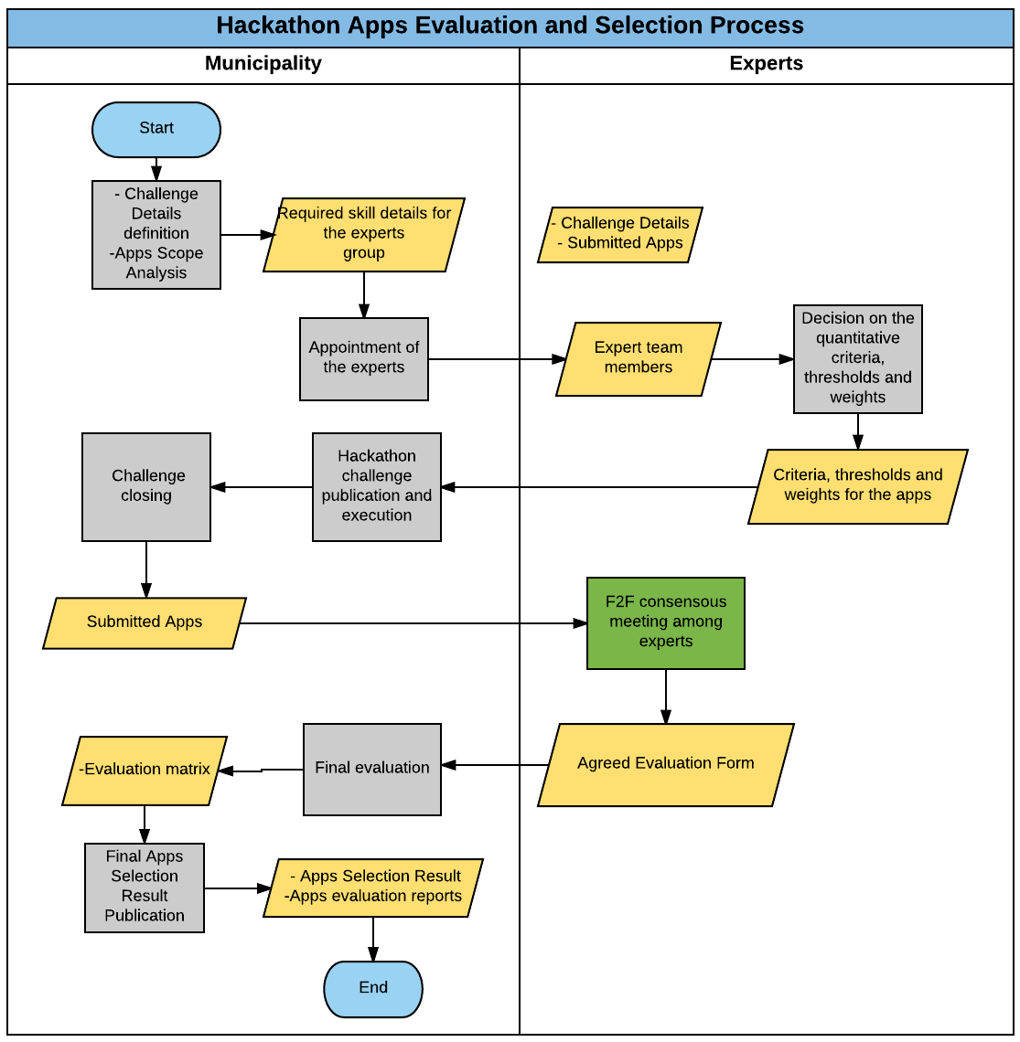

Listed below are the criteria under which each of the apps participating in the contest will be evaluated, submitted according to the steps established above.

Mandatory Criteria to meet

**The following three criteria must be met by the generated app in order not to be discarded.**

| **Criterion** | **OTHERWISE** |
| --- | --- |
| **Does the proposed app fit within the Hackathon's mission?** | **YES** |
| **Is it an interesting idea for the city of Zaragoza and, therefore, will Zaragoza contribute to the achievement and possible promotion of the app?** | **YES** |
| **Is the app correctly registered in the INTERLINK Service Manager and its specification associated with an idea linked to the Challenge in Ideation Space?** | **YES** |

**Quantitative Criteria**

To each of these criteria, the members of the jury will assign a score from 0 to 5 that will allow computing, based on the weights assigned to each criterion, the total score for each idea.

| **Number** | **Criterion** | **Score from 0 to 5** | **Minimum threshold required** | **Weight** |
| --- | --- | --- | --- | --- |
| **1** | **Does the proposed app cover socioeconomic needs?** |  | **two** | **0.15** |
| **two** | **Is the app fully functional?** |  | **two** | **0.15** |
| **3** | **Is the app sustainable and exploitable in the event that it is of interest to a public administration?** |  | **two** | **0.15** |
| **4** | **How well does this app meet the needs of citizens and requirements of the hackathon?** |  | **two** | **0.15** |
| **5** | **Does the app description demonstrate a development approach around co-creation?** |  | **NO** | **0.15** |
| **6** | **Does the app consume resources/artifacts available in the INTERLINK gallery?** |  | **NO** | **0.15** |
| **7** | **Does the app generate resources/artifacts available in the INTERLINK gallery?** |  | **NO** | **0.15** |
| **8** | **Has the Service Generator been used in the implementation of the app?** |  | **NO** | **0.15** |
| **9** | **How innovative is this app? Do you have any competitive advantage?** |  | **NO** | **0.15** |
| **10** | **Usability, design and simplicity** |  | **NO** | **0.15** |

* As mentioned, there are 5 different scores:

| **Punctuation** | **Meaning** |
| --- | --- |
| **0** | **The app fails to respond to the criteria and has incomplete information.** |
| **1** | **Poor The criterion is not adequately taken into account and important weaknesses have been identified.** |
| **two** | **Normal The proposed app meets the needs of the criteria but has significant weaknesses.** |
| **3** | **Good The proposed app responds to the criteria correctly but has a set of drawbacks.** |
| **4** | **Very good The proposed app meets the criteria quite well but has a set of drawbacks.** |
| **5** | **Excellent The proposed app responds successfully to all the aspects indicated in the criteria and the inconveniences found are not important.** |

For each criterion has been defined:

* Minimum Threshold Minimum value set for each criterion that must be exceeded to continue in the process.
* Weight: Importance associated with each criterion in the calculation of the final score.

# 6. Content

Only those proposals that refer to the generic challenge of the Hackathon or to one of the specific challenges raised on the platform may be submitted to the Contest.

In all cases, the winning content must be original and of its own authorship, without the idea of ​​application in any way violating the intellectual or industrial property rights of third parties. The authors of the proposals declare and guarantee that the application with which they participate in this Contest does not infringe any intellectual property right, or of any other type, of third parties, as well as that they have any necessary license or authorization from any third party for it. . Likewise, they assume any responsibility derived from the infringement of any rights in relation to said web/mobile app and undertake to indemnify the Organizer for any claim that may be received in this regard.

In attention to a correct guarantee of the right to data protection and the right to one's own image, it is recommended to the participants that the images, as well as any other type of personal data, of third parties processed by them, have the consent of their holders for their use. The creators of the applications guarantee that they will hold the organization harmless in the event that they commit a violation of data protection regulations, or of any other type.

Proposals whose contents violate these rules will not be accepted either, being prohibited the participation, among others, of those applications with violent, xenophobic or pornographic content, that violate the right to honor and one's own image, that incite or advertise activities and services illegal, that harm the property or rights of third parties, or that violate Spanish law in any way. These proposals will be subject to immediate exclusion.

The Organizer and the Jury may arbitrate the technical means they deem necessary to verify the content of the proposals, as well as resort to the advice they deem necessary at any time. The Organizer may exclude from the Contest those ideas of technological solutions that it considers inappropriate in accordance with the purpose of the Contest.

# 7. Prizes

The prize for the apps will be an amount equivalent to €8,000. There will be 3 prizes in electronic material worth the following economic amounts, taking into account the three categories in which prizes are to be distributed. The management and delivery of the prizes will be carried out by the Zaragoza City Council, in charge of the INTERLINK project:

1. Prize for the best INTERLINK application: €2,000 (first prize) and €1,000 (second prize)
2. Prize for the best app that completes the entire co-creation process , that is, makes an idea resulting from previous idea contests come true: €2,000 (first prize) and €1,000 (second prize)
3. Prize for the best artifacts created with the INTERLINK Service Generator : €1,000 (1st prize), €700 (2nd prize) and €300 (3rd prize).

The award modes 1 and 2 are exclusive, but an app awarded in mode 1 or 2 may also be awarded in mode 3 if in the development of such an app a new artifact (datasets and building blocks) of global interest has been generated. . Prize category 3 also includes those applications developed exclusively with the help of the Service Generator.

Prizes may be declared void. The Organizer reserves the right, at its sole discretion, to substitute prizes with equivalent prizes of equal or greater value. Prize winners are solely responsible for ensuring they comply with all applicable tax laws and reporting requirements.

# 8. Jury

The hackathon will have a Jury made up of 5 members:

* a person representing a department of the city council;
* an expert person in the field of the ESLE association challenge
* a person proposed by the Mayor's Office of the Zaragoza City Council,
* a person representing the INTERLINK Consortium,
* a person linked to the creation of technological solutions.

One of the members of the Jury will be appointed as president and another will act as secretary of the Jury.

The Jury will be appointed by the Organizer and its composition will be made public on the Competition website.

# 9. Disclaimer

All expenses that the participants may incur due to the development of the apps will be borne exclusively by them. The consortium of the INTERLINK project for the Zaragoza pilot (University of Deusto and the Zaragoza City Council) is not responsible for the consequences, accidents, incidents and/or consequences that the participants or third parties may suffer during the of this Contest. The INTERLINK consortium may include the winning apps among the set of apps generated in the Zaragoza pilot. The authors retain all their rights to exploit the apps.

# 10. Regulations

The bases will be deposited in the Mayor's Office of the Zaragoza City Council.

Failure to comply with any of the bases will lead to the exclusion of the candidate. In case of doubts or discrepancies in the interpretation of these rules, the Organizer's criteria will prevail, and, for duly justified reasons, the Organizer may modify these rules, without prejudice to the fact that this edition of the contest has started.