GUIDELINES FOR USABILITY TESTING



Guidelines and tips on how to perform a usability testing

Date: 06/04/2022

Version:V1

Licence: [CC BY-SA 4.0](https://creativecommons.org/licenses/by-sa/4.0/)

# How to use this INTERLINKER

This INTERLINKER provides guidelines on how to perform a usability testing to improve the usability of a digital service.

# WHAT IS A USABILITY TESTING?

Usability testing is a method for evaluating a product or service by testing it with representative users. Usually during a test, participants will try to complete a task while observers watch, listen and take notes.

The goal is to identify any usability problems, collect data and determine the participant's satisfaction with the product in order to improve it.

# HOW TO STRUCTURE A USABILITY TEST

**INSTRUCTIONS**

| 01 | Define the objective of your test (e.g. test of the XXX app) and specify the functionalities that you want to test (e.g. the navigation; navigation and content, the calendar module, ..). |
| --- | --- |
| 02 | Translate these overall objectives into a series of **questions** :   * "Can users navigate the portal from the landing page to the XXX page?" * "Will users easily find the INTERLINKERS they are looking for starting from the “Guide section”?"   These questions will drive the scenarios you choose for the usability test. |
| 03 | Define a **scenario** that will help you to explore the questions identified. A scenario is a story in which a user accomplishes a number of tasks using the product in order to reach a goal.  *Example: E. is looking for childcare and she decides to use the XXX app to organize childcare activities. Group members can give their availability for specific activities, in order to cover the period needed. E. wants to insert her availability …* |
| 04 | **Select participants** for the testing, define the number of participants that will be involved and describe how these participants were or will be recruited . It’s preferable to choose participants with characteristics that fit with those of the end-user group of the product to be evaluated. |
| 05 | Define **time and location:** prepare a document with all the information related to the testing: participant, location, time, etc. |
| 06 | **Structure the testing sessions**: describe the sessions, the length of the sessions (usually 60 minutes) and identify the equipment you will need during the testing sessions: desktop, laptop, mobile/Smartphone, recorder,... Decide if you are planning on recording or audio taping the test sessions or using any special usability testing and/or accessibility tools. |
| 07 | Manage **data collection**: Decide which types of data will be collected and prepare the consent form. |
| 08 | Define the **roles** during the testing session: usually the roles are the following:   * facilitator of the sessions * note-taker * Observers: other team members might participate as observers and, perhaps, as note-takers. |

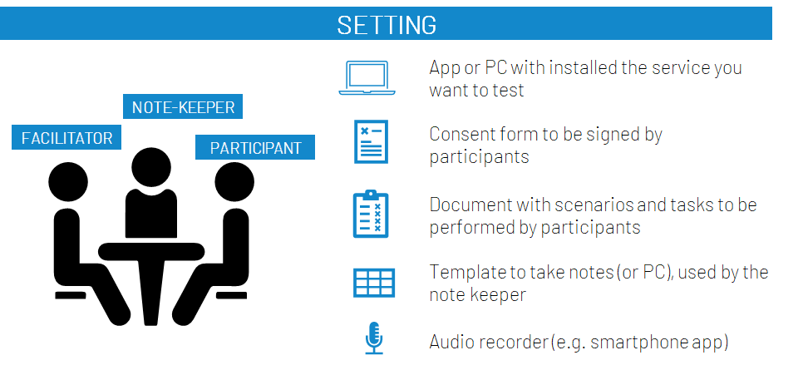

# EXAMPLE OF A USABILITY TEST

### **01. INTRODUCTION**

The facilitator - the person interacting with the participants - explains the goal of the study and introduces the test:

* Overview of the project
* Description of the service
* Purpose of the test

### **02. CONSENT FORM**

Collect participants consent to participate

* Explain how the data will used: they will be anonymized and used in an aggregated form for the goal of the project
* Collect signed informed consent form

### **03. METHOD PRESENTATION**

* Explain the approach and what you expect from the participant

*“we will present you a scenario and then we will ask you to perform some activities with the app.”*

*“we are interested in identifying issues and barriers and that we would like to know what you are thinking when interacting with the app/product..”.*

*“tell us everything you think about the system so that we can understand how users interpret some functionalities, how users feel with the information displayed, ... for instance, if you don’t understand where to click please say it…”*

Reassure participants about the fact that you are not evaluating them but the product.

Explain the role of the note taker

### **04. PRESENT THE SCENARIO**

Read or show the scenario. You can also print it and let it available for participants.

Example of scenario for usability testing:

*The local PA of Bologna (Italy) wants to improve the Work-Life Balance of parents by promoting collaborative childcare, an innovative model of time-sharing for childcare in which different actors contribute to deliver more affordable and flexible childcare. The PA would like to set up a collaborative process for designing and delivering the new service, engaging all the interested stakeholders and the end-users.*

*Maria - the manager of the PA - wants to use INTERLINK platform to Learn about co-production, develop the network of stakeholders, Co-design the legal, ethical and administrative framework for putting in place the service*

### **05. ASK PARTICIPANT TO COMPLETE A SET OF TASKS**

Example of tasks:

* Task 1. Register to the platform
* Task 2. Edit your profile
* Task 3. Create a new project
* Task 4. Invite new members to the group
* Task 5. Delete a member from the group
* Task 6. Write a message to the group
* Task 7. Follow the co-production process
* Task 8. …
* ….

### **06. ASK PARTICIPANT TO “THINK ALOUD”**

If they find it difficult to “think aloud” ask them to explain what they are doing - try to encourage them to verbalize their thoughts.

### **07. TAKE NOTES AND INVESTIGATE USER EXPERIENCE**

**EASY OF USE:**

* After each task, ask the participant to rate the difficulty with a scale from 1 (very easy) to 7 (very difficult): ”How easy did you find this task?“
* After completing all the tasks, ask the participant the overall ease of use of the system from 1 (very easy) to 7 (very difficult)

**FAMILIARITY WITH TECHNOLOGY**

* Ask the participant to self-report his/her level of familiarity with technology (in general) “How would you rate your familiarity with technology in general?”

**(OTHER TOPIC)**

* **…..**

### **08. THANK YOU AND CLOSURE**

Thank the participant for their useful contribution and explain future steps.

# FORM FOR DATA COLLECTION EXAMPLE

Example of template that can be used to collect feedback during Usability Testing session. For each participant a sheet should be completed.

| **Location: XXXX** | | | | | | | | | | |
| --- | --- | --- | --- | --- | --- | --- | --- | --- | --- | --- |
| **Participant ID**: XX  (do not insert participant’s name here, only ID number associated to the participant) | | **Date**: | | | **Gender**:   * M * F | | **Mediator**: …..  **Note-taker**: ….. | | | |

|  | **Unexpected path**  Report deviations from the expected interaction path (the expected path reported below each task description) | **Criticalities**  Describe main issues encountered in terms of: i) understandability of information/navigation flow/ UI elements, ii) trust & privacy issues, iii) system bugs | **Task completion**  **(Note-taker)**  *Rate how user completed the task*  1= Completed without struggle  2= Completed, minor struggle  3= Completed, moderate struggle  4= Completed, a lot of struggle  5= Not completed, a lot of struggle | **Completion time**  How long did it take to complete the task? | **Perceived difficulty**  **(Participant)**  How easy or difficult did you find this task? Ask user to rate it on a 7 point Likert scale:  1= very easy  7= very difficult |
| --- | --- | --- | --- | --- | --- |
| **Task 1. Register to the platform**  Steps:  1. Press signup  2. .. |  |  |  |  |  |
| **Task 2. Edit your profile**  Steps:  1. .. |  |  |  |  |  |
| **Task 3. Create a new project**  Steps:  1. Click on… |  |  |  |  |  |
| **Task 4. …**  3. Join group |  |  |  |  |  |

| **Overall user evaluation of the ease of use:** | | Overall, how easy or difficult did you find using this app? [7 point Likert scale]   * 1 (Very easy) * 2 * 3 * 4 * 5 * 6 * 7 (Very difficult) | | | | | | | | |
| --- | --- | --- | --- | --- | --- | --- | --- | --- | --- | --- |

| **Familiarity with technology** | | Please, rate your familiarity with mobile technology (i.e. smartphone):   * No experience * Beginner * Average user * Advanced * Expert | | | | | | | | |
| --- | --- | --- | --- | --- | --- | --- | --- | --- | --- | --- |

**Other notes**

[Write suggestions, user’s feedbacks on the scenarios etc]

**Ask for email or contact information**

**...**

**THE ROLE OF NOTE-TAKER**

* The note-taker is the person that carefully observes the usability tests and takes notes during the session.
* Audio-recording can be used in order to check the notes after the session. During observations the note-taker uses the template to collect data, that can be digital (on a PC) or printed in order to take written notes (then you will need to transcribe these notes on the digital template in order to be shared with other project partners). For each participant a document will be created.
* The note taker keeps track of deviations from the expected interaction pattern.   
  The template includes the list of the interaction steps required for each task (e.g. Task 1: Open the lateral menu, Select personal profile, edit information, save). The note taker reports any deviation from the standard path (e.g. Task 1: instead of opening the lateral menu, the user select a group)
* The note taker reports criticalities encountered by the user when completing the task.
* At the end of each task, the note taker rate the task completion with a scale from 1 to 5 where:
  1. Task completed with no struggles,
  2. Task completed with minor struggles,
  3. Task completed with moderate struggles,
  4. Task completed with a lot of struggles,
  5. Task NOT completed, a lot of struggles.
* The note taker also measure time for completing each task.
* After completing all tasks, the note-taker captures the main comments and observations given by the participants (see Template).

This document, prepared by the [INTERLINK](https://interlink-project.eu/) European project, is licensed under a Creative Commons Attribution-ShareAlike 4.0 International license ([CC BY-SA 4.0](https://creativecommons.org/licenses/by-sa/4.0/)).

This document remixes and builds upon the outcome of the [Families Share](https://families-share.eu/) EU project.

