**Gender Studies - Research Database Network  
User Manual**

Muhammad Tirmazi  
Contact: [tirmazi@g.harvard.edu](mailto:tirmazi@g.harvard.edu)

Contents

Record Types 3

Adding a New Paper 3

Removing a Paper 5

Searching for Papers 6

Refined Search 7

Adding a New Conference 8

Remove a Conference 9

View Conferences 11

# Record Types

The database stores two types of records, **Paper** and **Conference**. You can perform two types of direct operations to these records: you can 1) add a new record and 2) delete a record.

The **Paper** record stores the following information:

1. Title of the paper
2. URL where the paper is stored. This can be either:
   1. A URL within the database i.e a file uploaded to the database.
   2. An external URL leading the user to another website.
3. A list of Author names (preferably in the same order in which they are listed in the paper)
4. Date of publication of the paper
5. The category of the paper. This can be one of five:
   1. Gender and Human Rights
   2. Gendered Violence
   3. Gender and Development
   4. Gender Inequalities
   5. Other
6. Optional: a set of search keywords (also called “search tags”).

The **Conference** record stores the following information:

1. Title of the conference
2. The venue of the conference
3. The date on which the conference starts / started.
4. Optional: notes to provide details on the conference

# Adding a New Paper

A new paper can be added to the database by executing the following steps.

Step 1: Navigate to Menu - Contribute

Step 2: A submenu will open. In the submenu, navigate to “Add Paper”

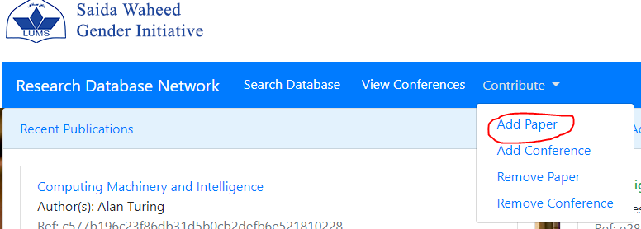

Step 3: Fill out the form. If you are a research assistant for the Saida Waheed Gender Initiative, ask your employer to provide you with the username and password.

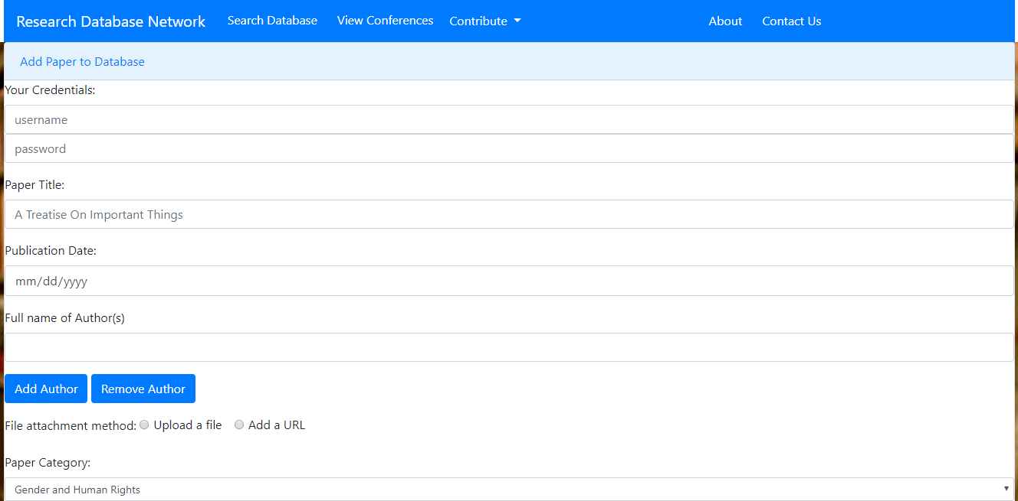

Step 4: Click “Submit”

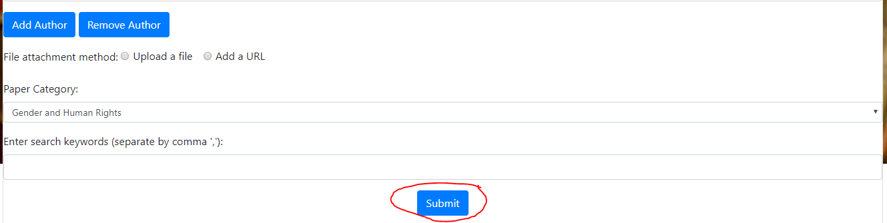

# Removing a Paper

A paper can be removed from the database by executing the following steps:

Step 1: Find the reference number of the paper you want to delete. This can be found by searching for its title, author or search keywords.

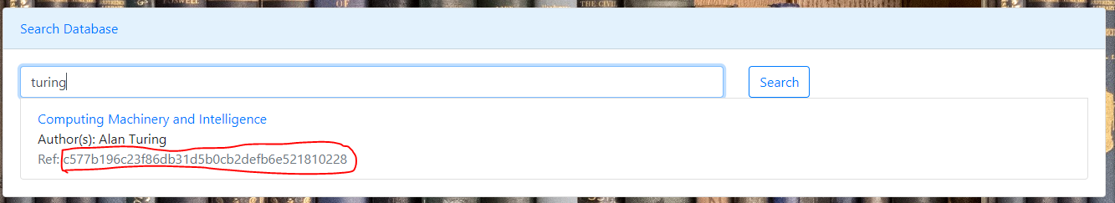

Step 2: Copy this reference number.

Step 3: Navigate to Menu - Contribute



Step 4: Navigate to “Remove Paper”

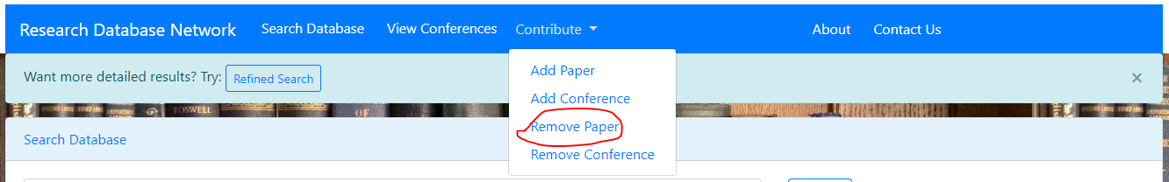

Step 5: Paste the reference number of the paper you want to remove

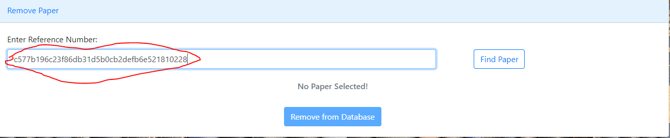

Step 6: Click “Find Paper”

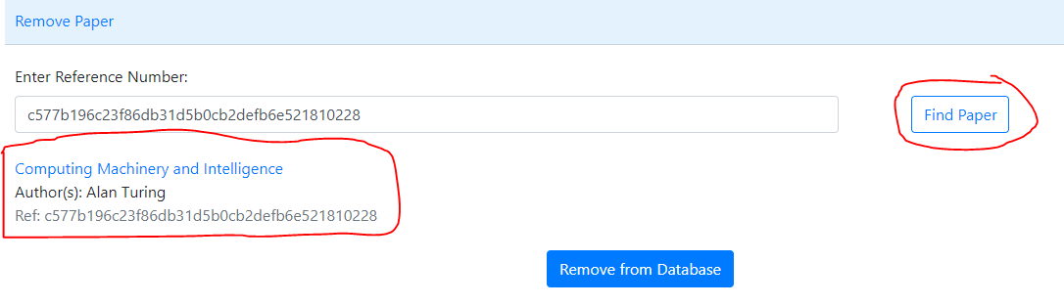

Step 7: If the (correct) paper is found, “Remove from Database” can be clicked to remove it.

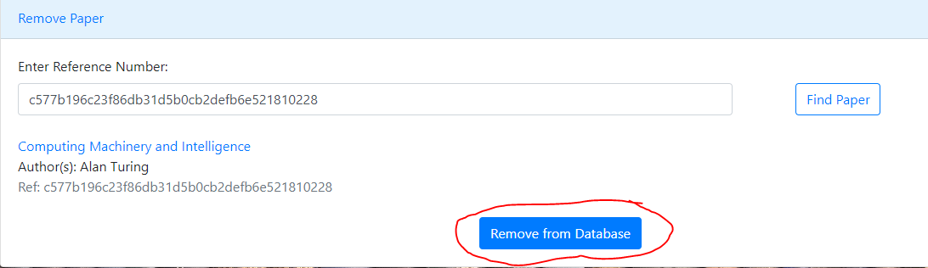

# Searching for Papers

The database search engine indexes the following three sets of information:

1. Title of the paper
2. Author(s) of the paper
3. The search keywords entered when adding the paper to the database.

Any of these three (or a combination) can be used to search for papers in the database.

To search, execute the following steps.

Step 1: Navigate to Menu – Search Database:



Step 2: Enter search term and click “Search”

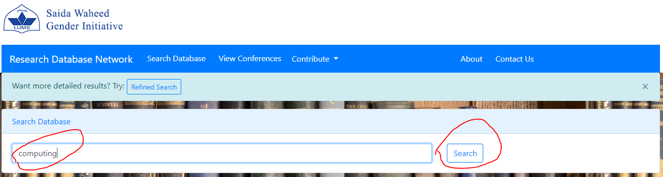

Step 3: The results will be loaded beneath the search widget.

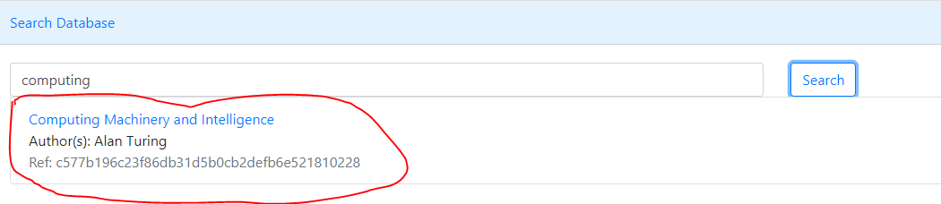

# Refined Search

A refined search filters the search results according to the category names included in the search. To conduct a refined search, execute the following steps:

Step 1: Navigate to Menu – Search Database:



Step 2: Click “Refined Search” on the Search Database page.

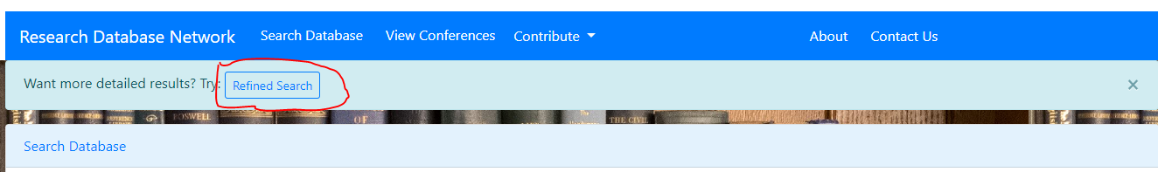

Step 3: Select the categories you want to include in your search and repeat the steps of the previous section to conduct the search.

# Adding a New Conference

A conference can be added to the database by executing the following steps:

Step 1: Navigate to Menu – Contribute



Step 2: Navigate to “Add Conference”

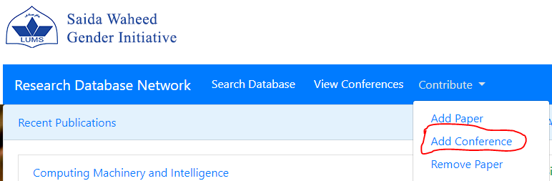

Step 3: Fill out the form. If you are a research assistant for the Saida Waheed Gender Initiative, ask your employer to provide you with the username and password.

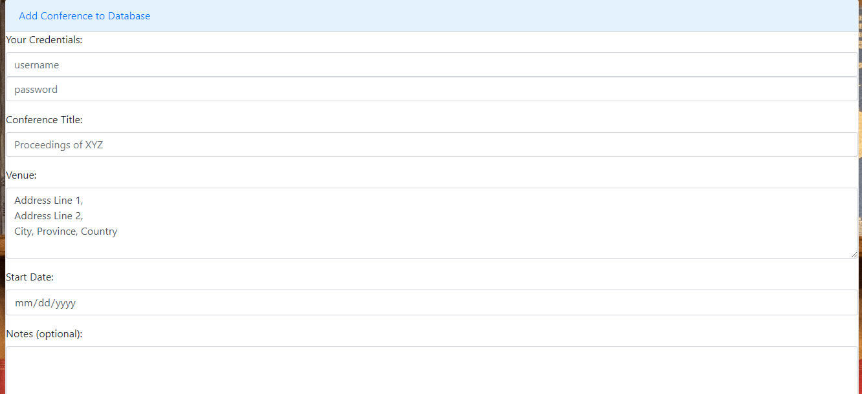

Step 4: Click “Submit”

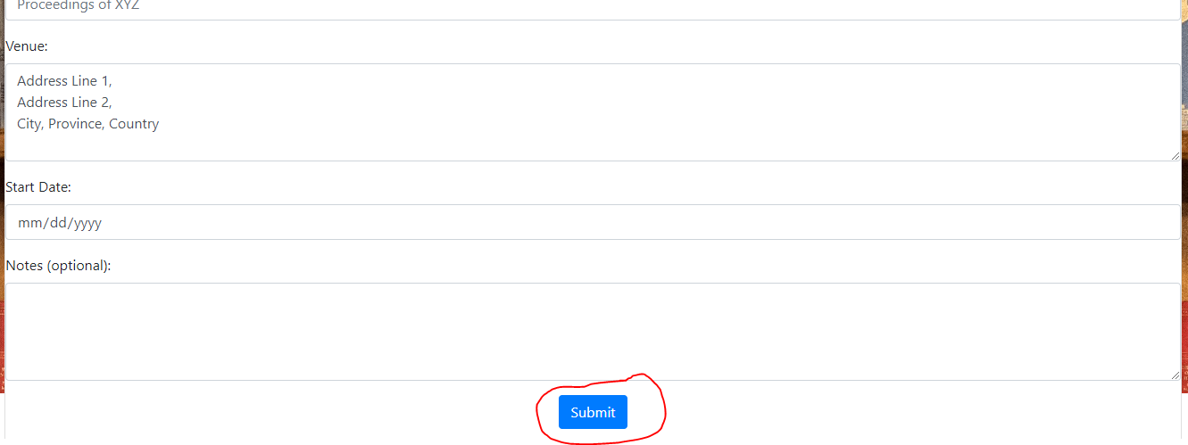

# Remove a Conference

You can remove a conference record from the database by executing the following steps.

Step 1: Get the reference number of the conference record. This can be gotten from the “View Conferences” page.

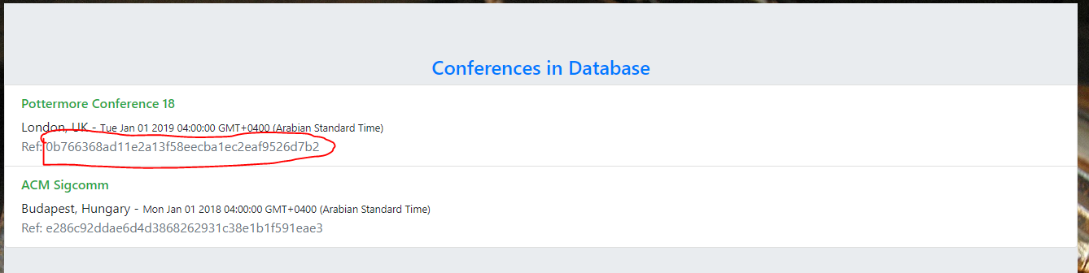

Step 2: Navigate to Menu – Contribute



Step 3: Navigate to “Remove Conference”

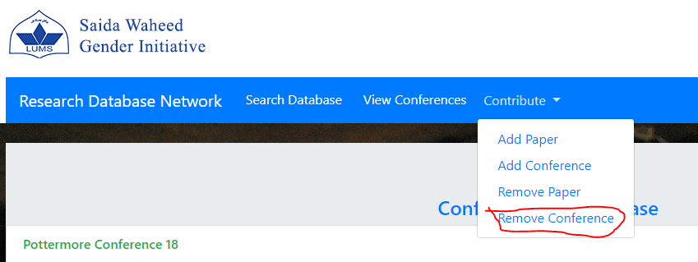

Step 4: Enter the reference number and follow the same procedure as the one used on the “Remove Paper” page.

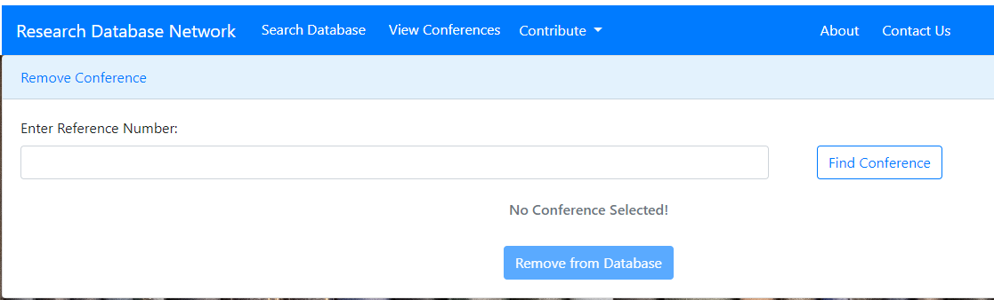

# View Conferences

To view all conferences added to the database, execute the following steps.

Step 1: Navigate to Menu – View Conferences



Step 2: The page lists all registered conferences.

