Super User
The SuperUser is the administrator of your InterMine webapp. The SuperUser can use tagging to configure the appearance and functionality of the webapp.

The SuperUser account is created when the UserProfile database is built using the email address specified in the malariamine.properties file and a randomly generated password. Refer to WebappRelease for instructions on retrieving your password, if you don't already have it.

We recommend that you login and change your password immediately to something easier to remember.

Creating a Template Query
All logged in users can create template queries, but the SuperUser can make them available to all users by tagging them as public templates. Making a template query is an easy way to get users of your webapp to the data they want very quickly.

Template building is completely integrated into the query builder. We are going to build a simple template that returns all genes related to a pathway (Pathway --> Genes).

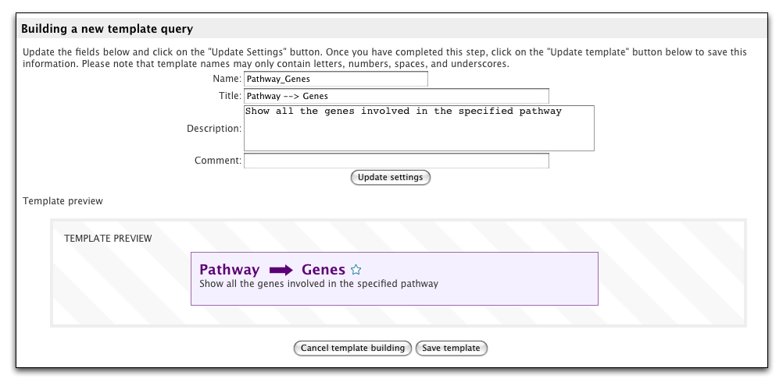
Exercices:
1. Build a query
- Click on the QueryBuilder tab on the top menu bar
- Select the pathway class and click the select button.
- Add columns to the query output (the blue boxes)
  - In the Model Browser section (top left), click on the blue SUMMARY button next to Pathway.
    - These are the columns that will appear in the results
    - You can change the order in which the columns appear by moving the blue boxes in the 'Fields selected for output' section (bottom section)
    - Which fields are added to the view list when you click on summary is configured in the webconfig-model.xml file.
  - In the Model Browser section (top left), click on the blue SUMMARY button next to the genes collection.
- Add a filter to the query
  - In the Model Browser section (top left), click on the brown CONSTRAIN button next to the Pathway.name field.
  - This will open the constraint form in pop-up new box.
  - Enter a Pathway (eg. Carbon fixation) and click on the 'Add to query' button.
  - On FlyMine, typing in the constraint box here would suggest pathways as you type.

2. Change to template-building mode
- Verify that you are logged in as the SuperUser (admin mode)
- Click the button "Start building a template query" that appears below the output section
- Update the template's name, title and description and then click the 'Update settings' button.
  - name
    - Pathway_Genes
    - Used by javascript, webservices, etc to identify this template, must be unique
  - title and description
    - Pathway --> Genes
    - Title and description should be human readable
    - Both are displayed on the templates page and the template form
    - Both are used in the template search, so they should be as descriptive as possible
  - comment is used and only viewable by the SuperUser

- Make the constraint editable
  - When in template building mode, constraints listed at the top-right gain an extra icon - a little padlock. The closed padlock means that the constraint is locked and not editable in a template query.
  - Click the padlock, which will bring up the settings for that constraint.
  - Check the editable checkbox, add an optional label and click the 'Add to query' button

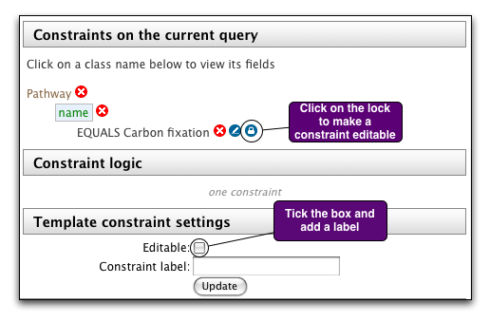

- Save the template
  - Scroll down to the bottom of the page to the 'Building a new template query' section
  - You'll see a preview of your template
  - Click on the 'Save template' button below the preview to save your template.

Tagging
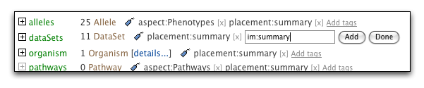

Template queries and lists
The SuperUser can change where templates and lists appear by adding tags via the templates and lists pages in the MyMine section of the webapp.

Tag | Purpose
im:public | make list/template viewable by all users
im:frontpage | put list/template on home page
im:converter | template used in generating links in the 'Convert' section on the list analysis page

Fields and collections
The SuperUser can change how fields are displayed by adding tags via the report page.

Tag | Purpose
im:hidden | hides the field/collection
im:summary | add collection to 'Summary' section of report page

Classes
The SuperUser can change how classes are displayed by adding tags via the model browser.

Tag | Purpose
im:aspect | class appears on aspect page
im:preferredBagType | class appears first in the class selection

