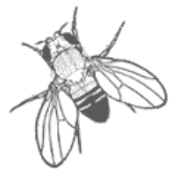- FlyMine Workshop -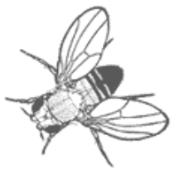

Cambridge June 12th 2008
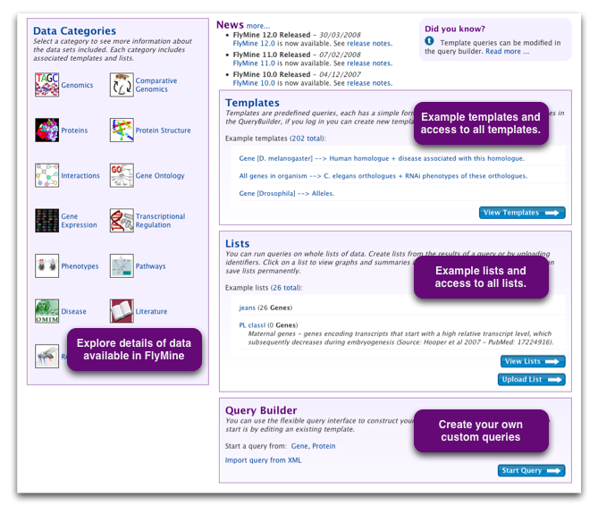
www.flymine.org

TABLE OF CONTENTS

1. Introduction 3

2. What can I do with FlyMine? 4

3. Quick Search and Browsing 5

4. Template Queries 9

5. MyMine 13

6. Lists and List Analysis pages 16

7. Exporting data 23

8. Query Builder 25

Appendix I: Basic FlyMine - Terminology and Concepts 30
Appendix II: Help and Feedback 31

1. Introduction

FlyMine is an open source project, developed in the Department of Genetics at the University of Cambridge, to build an integrated database of genomic, expression and protein data for Drosophila, Anopheles, honey bee and other organisms. Currently such data sources are stored in a wide variety of formats in numerous different places, making joint analysis of these data hard. As an integrated resource, FlyMine makes it possible to run data mining queries that span these domains of biological knowledge.

Data currently in FlyMine include genome annotation, orthologues/paralogues, microarray data, protein interaction data, protein domains/families, predicted 3D protein domain structures, transcription factor binding sites, GO annotations and RNAi data. For a full list of data sources see http://www.flymine.org/query/dataCategories.do.

FlyMine is web-based, thus providing easy access with no need to install any software. The interface provides facilities for browsing, quick-access template queries and a Query Builder which allows users to construct their own arbitrary queries.

FlyMine is funded by The Wellcome Trust.

2. What can I do with FlyMine?

Quick Search
Enter any identifier or symbol in the search box on any FlyMine page to access report pages and integrated tools.

Browse Data Categories
FlyMine presents data in different categories, with each category providing a 'view' of a particular type of data (for example Gene Expression or Protein Interactions). Use the icons on the FlyMine home page to find details about the data sources available in each category, run a predefined template query or to build your own query (see below). Certain template queries, as well as the Query Builder itself, allow you to perform searches that span more than one data category.

Run Template Queries
A large number of queries have been predefined. These template queries range from fairly simple queries to retrieve a particular type of data to more complex queries that span the different types of data available in FlyMine. More template queries will be added as FlyMine develops and we welcome suggestions. Find lists of predefined template queries under each data category or search for templates on the 'templates page' or from the search bar in the top right of every page.

FlyMine Query Builder
Advanced users can use a flexible query interface to construct their own data mining queries across the multiple integrated data sources, to modify existing template queries or to create their own template queries.

Operate on Lists
All queries in FlyMine can be performed on lists. You can create your own lists or make use of the set of 'public' lists available in FlyMine. Lists can be created by typing or pasting in a set of identifiers, or uploading a file containing the list. Results from queries can also be saved as a list using the boxes displayed underneath the query results. Saved lists of data can be used to constrain queries, perform logical operations and can be exported.

MyMine
You can save your lists, queries and templates permanently by creating an account using the 'Log in' link in the top right of every page. These can then be accessed and managed through your 'MyMine' page.

3. Quick Search and Browsing

The Quick Search allows you to access all the information that is available for a particular database entry and provides a good way to browse the database. A Quick Search box is available in the top right of every FlyMine page. You can use this to search for anything with an identifier, symbol or synonym; for example genes, proteins, transcripts or binding sites. Wild cards (*) can be added to increase the range of a Quick Search. Quick Search is case-insensitive. The search box can also be used to search for templates and lists by using the drop down list.
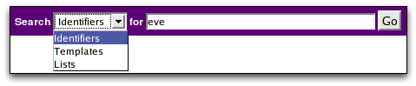
Entering any object identifier (such as a gene name or identifier) will take you straight to the report page for that object. For every object in the FlyMine database there is a 'report' page which provides all the information that FlyMine has for that object. All report pages have the same basic structure:

- The top part provides summary information for every object:
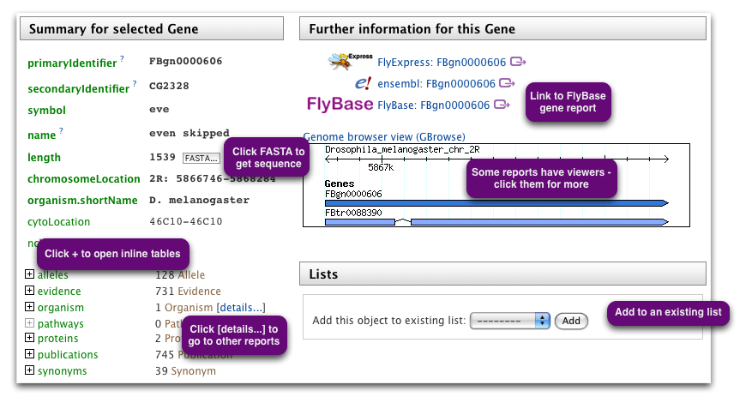

- whereas the lower part, 'Further information by category' has more detailed information divided into the data categories. The categories correspond to the categories of data shown on the home page.
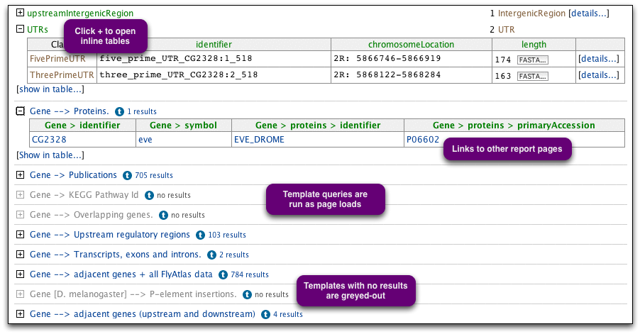

In cases where more than one object is returned by your Quick Search, the results will provide a list of objects which match the query. Clicking on any of them will take you to the corresponding report page for each object. Report pages can also be accessed from result tables by clicking on an object that provides a link.

Some example identifiers:
- for the Drosophila gene zen, type FBgn0004053, CG1046, zen or any of its synonyms.
- for A. gambiae genes, use vectorbase ids (e.g. AGAP010777) or Ensembl identifiers (e.g. ENSANGG00000001499).
- for C. elegans genes: use the WormBase identifiers or symbols (e.g. par-5, M117.2, WBGene00003920).
- for proteins: use UniProt identifiers or primary accessions (e.g. 18C_DROME, P16909).

Example: Report page for your gene of choice.
- The top left shows summary information for the gene - identifier, name and chromosome coordinates. Use the '+' boxes next to 'proteins', 'synonyms', etc. to open in-line tables with more details. The 'FASTA' buttons retrieve sequences for any feature they appear next to.

- The top right presents:
Link outs to other databases.
A GBrowse image for the area surrounding this gene. Clicking on the image takes you to the GBrowse genome viewer. Clicking on any feature in GBrowse will take you to a report page in FlyMine.
Other relevant graphical data, e.g. for D. melanogaster genes a graph showing expression during a developmental time course (where available).
Lists in wich this gene can be found, as well as the possibility to add this gene to an existing list.

- Scroll down the page to see 'Further information by category'. This section has more detailed information about this gene divided into the data categories. Look at the Genomics category:
Entries in green show fields directly related to this gene. Use '+' boxes to open summary tables. For example, opening 'overlappingFeatures' will show genomic features that overlap the chromosome coordinates of this gene.
[details...] links take you to report pages for related database entries. For example: Scroll back up to the top of the page and click the [details...] link next to 'proteins'.
Entries in black text allow you to see the results of predefined queries run for this gene ('templates', covered in next section).
Those shown in light grey did not return any results.
Exercises:

3.1 Enter the names or identifiers from the following list into the Quick Search box. Some identifiers will take you directly to a report page, while others will take you first to a results page where you can choose the object you want to view. The list contains names and identifiers for different types of objects (shown in brackets). For each type of object, notice the different report pages and try browsing through the different types of data available.

A. zen, zen* (gene)
B. CG11121-RA (transcript)
C. P36872 (protein)
D. TF000246 (REDfly TF binding site)
E. AGAP010388 (gene)
F. The name or identifier of your favourite gene

3.2 Is there a knirps gene in a Drosophila species other than in D. melanogaster?

3.3 How many alleles are there for the D. melanogaster Ubx gene?

3.4 How many exons does the D. melanogaster dumpy gene have?

3.5 Find the report page of the D. melanogaster period gene. From that page, find the report page of the corresponding protein page. Find the protein structure data for this protein. Where did FlyMine get these data from?
4. Template Queries

To enable you to quickly and easily carry out a range of queries across the data, FlyMine includes a library of predefined Template Queries. A template consists of a query form in which certain variables can be changed. The variables are constraints (filters) on certain types of data, so that a subset of that type is defined.

- Template queries can be accessed in four ways:
- Each data category page has a set of template queries related to that data type.
- The templates page, accessible from the FlyMine home page or via the tabs in the top menu bar available on any FlyMine page, allows you to search or browse for templates.
- Templates can also be searched using the Quick Search available on every FlyMine page. Change the drop-down list from 'Identifiers' to 'Templates'.
- Templates also appear on report pages and list analysis pages (covered later).

[It is also possible to make your own template queries using the Query Builder (not covered in this workshop) and these can be accessed both on the templates page and from your MyMine account (covered later).]

Each template query has a shorthand title (displayed) which is:
'query starting point(s)' --> 'query output' and a longer description displayed underneath. The 'star' next to each template title enables you to set templates as your 'favourites'. Your favourite templates can be accessed through a filter on the templates page.

A. The Templates Page
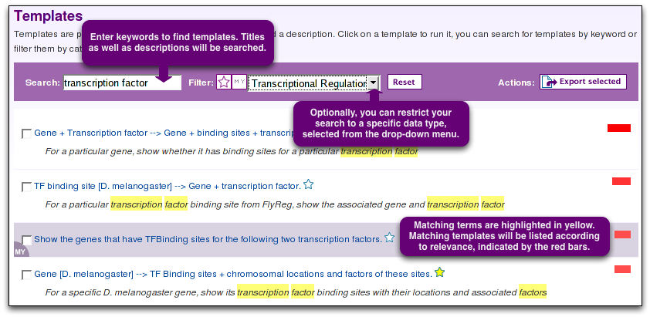
The templates page lists all available templates with their descriptions by default. The descriptions can be hidden by deselecting the check box. The bar above the list of templates allows you to search for a particular template using keywords, show just your favourite templates or just your own templates or filter the templates list according to a data category.

B. Running a template
To access the template form click on the template name. The template form will consist of one or more constraints. You can change the values for each constraint or leave the default values. For most templates it is possible to enter any kind of identifier (e.g. a CGXXXX, FBgn or symbol for Drosophila genes). It is also possible to enter multiple values (separated by a comma) (e.g. CG10007, CG1046). There is also the option to constrain to a list of items - this will be covered later.

At the bottom of each template form are two options: 'Show Results' and 'Edit Query'.
- The 'Show Results' button will take you directly to the results page.
- The 'Edit Query' option allows you to display the template in the FlyMine Query Builder (covered later). This option enables you to use a template query as a starting point for building a modified or more complex query, or to see how a certain query may be constructed using the Query Builder.

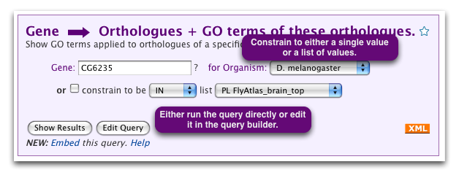
C. Result pages

Result pages show the first ten rows of your results by default. The total number of rows is displayed underneath the table (this will initially give an approximate number of rows until the total number is calculated). It is possible to page through the results using the 'next' or 'previous' buttons or go to the last or the first page using 'last' / 'first'. The order of the columns can be changed using the arrows in the header bar or columns can be collapsed using the crosses. The in each column header will display summary statistics for that column. The type of statistics depends on the type of data in the column - for columns containing text this will display the number of unique values, for numerical data, the min, max, mean and standard deviation will be given (note: at the moment only the first 10 rows of the summary are shown). Above the results table are options for saving results to lists and for exporting (covered later).
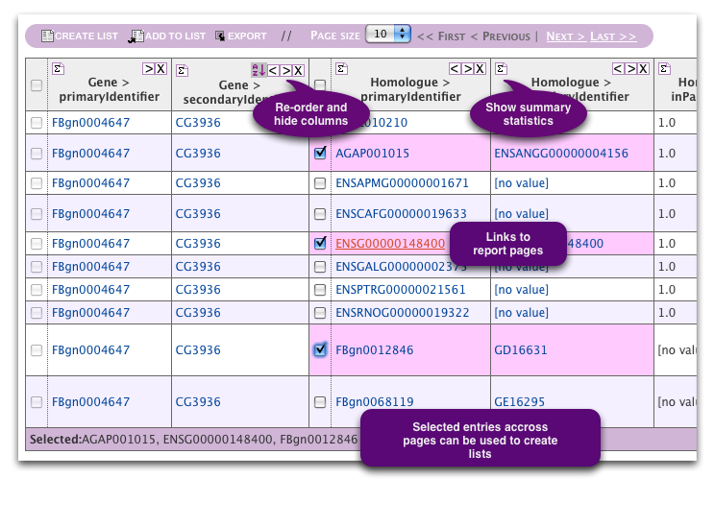
In the top-left of each results page a trail enables you to navigate back to the query if you wish to edit it.

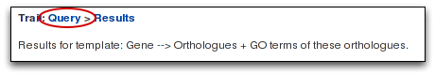

Exercises:

4.1 Browse the data category pages and briefly look at the template queries available.

4.2 Use the templates search on the templates page to find and run the following four template queries for the default values or for the gene or protein of your choice - and try to understand the results. Look at the summary statistics for some of the columns in your results (accessed in the column header).

A. Gene --> Transcripts, exons and introns.
B. Gene [Drosophila] --> Alleles.
C. Gene [D. melanogaster] + Result type --> RNAi screen results.
D. Protein [D. melanogaster] --> Interacting proteins + C. elegans orthologues that have an RNAi phenotype.
- This template demonstrates how it is possible to query different types of data at once in FlyMine.

Find the answers to the following questions using templates.
4.3 How many D. melanogaster genes that have been annotated with the GO term 'zinc ion binding' have at least one insertions. (Data Source: GO, FlyBase).

4.4 How many CRMs (=Cis-Regulatory Modules, i.e. regulatory regions) are know for the D. melanogaster gene fork head?

4.5 How many D. melanogaster genes code for a protein with a basic leucine zipper domain?

5. MyMine

MyMine is your personal FlyMine account and allows you to manage your saved queries, lists and templates. To use your MyMine account fully you need to be logged in - this allows you to save your lists, queries and templates permanently. However, if you do not log-in you will still be able to access any lists you have made in the current session. Your MyMine account can be accessed from the top menu bar. It consists of five tabs: Lists, Query History, Saved Queries, Saved Templates and Change Password, activated only if you are logged-in.

Lists: will be covered in detail in the next section. This tab shows any lists you have saved - if you are logged-in these will be saved permanently. Clicking on a list name will take you to the 'analysis' page for that list.
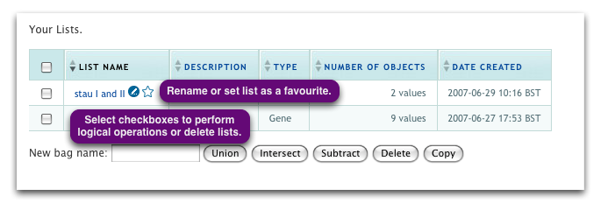
Saved queries and query history: Any query that you run in FlyMine is automatically saved with a default name (query_xx) to your Query History (which can also be accessed from the Query Builder page). Any query in your Query History can be permanently saved to your 'Saved queries' by clicking on 'save' in the 'Actions' column. You can also give your query a different name by clicking on the blue icon next to the query name. Note the Actions column allows you to also 'Run', 'Edit' or 'Export' your query.

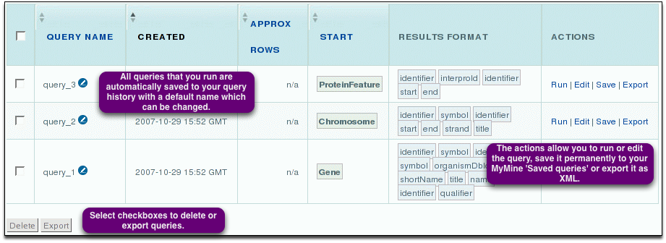
Saved Templates: It is possible to create your own template queries from queries you have constructed yourself. These can be saved permanently in your 'Saved templates' [not covered].

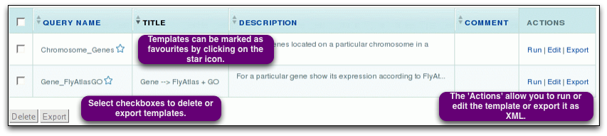

Export - import: note the 'Export' button in the Actions column. This will export your query or template in xml format. Queries and templates can be imported into FlyMine in xml format - scroll down to the bottom of the 'Saved queries' or 'Saved templates' tabs to import. These actions are useful if you wish to share a query or template with a colleague. Queries can also be imported from the FlyMine home page or the Query Builder page.

Exercise:

5.1 Log-in and browse your MyMine account.
- If you do not already have one - create a log-in.
- Try and save one of the queries from your query history to your 'Saved queries' and re-name it.
- Look at the 'actions' column and 'Run' and 'Edit' a query.

5.2 Mark a template as favourite and use the filter on the templates page to display just that template.

6. Lists and List Analysis pages

All queries in FlyMine can be performed on lists (e.g. a list of genes). You can create lists yourself (either by uploading or from the results of queries) or you can use a set of 'public' lists already available in FlyMine. Lists can be used to constrain queries (either a template query or in the Query Builder), to perform logical operations (union, intersect, subtract) and can be exported. You can search lists and copy lists.

The 'Lists page' can be accessed from the FlyMine home page or via the tabs in the top menu bar available on any FlyMine page. Lists that you have created yourself can also be accessed through your 'My Mine' page.

To save your lists permanently, you need to be logged-in to FlyMine.

A. The Lists Page
The lists page is divided into two tabs - 'Upload' and 'View':

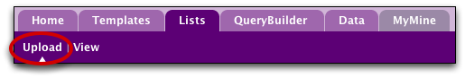

- Upload -
Use the list upload tab to create a list from an external source. This page allows you to either type/paste-in a list of identifiers or upload a file containing the list. Note that you can only create a list of one 'type' of thing (e.g. genes), so you must set the 'type' of identifier you are uploading first from the drop-down list. It is possible, however, to have a mix of the type of identifier (e.g. for a list of Drosophila genes your list may contain both gene symbols, CG identifiers and FBgns). Optionally you can also set the organism for your list of identifiers - this is useful if you have, for example, gene symbols in your list which may appear in more than one organism. When you create your list all your identifiers will be compared against the FlyMine database and any discrepancies will be reported to you on the 'list confirmation page'. This is described in more detail in the exercises.

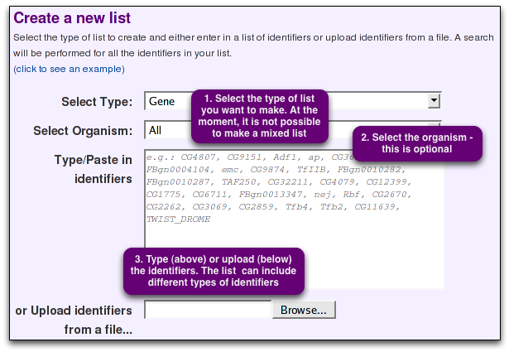
- View -
The 'View' tab shows all your lists and all public lists with their descriptions by default. The descriptions can be hidden by deselecting the check box. All public list names begin with 'PL', while your own lists are labelled 'My' and appear in a coloured bar. Like templates, you can set lists as favourites if you want to be able to access them quickly. The bar above the lists allows you to search for a particular list using keywords, show just your favourite lists or show just your own lists.
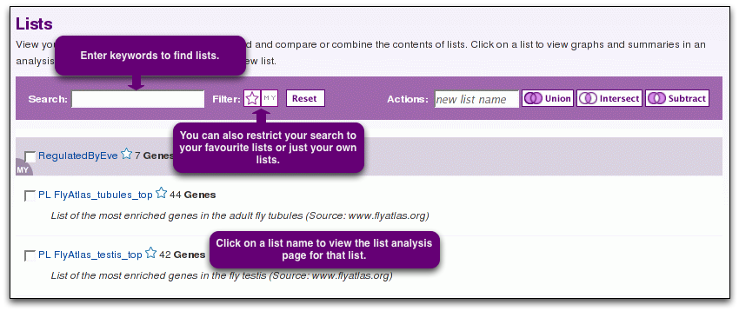

List Operations:
If you have more than one list, it is possible to carry out list operations - currently union, intersect and subtract are available. These operations are available both on the Lists-View page and on the lists tab of your MyMine account. Simply select the check boxes for the lists you wish to use, enter a name for the new list and select the type of operation you wish to perform. You can copy lists in a similar way. Without a new name, FlyMine will name the list original_list_copyx. You can copy mutliple lists all at once.
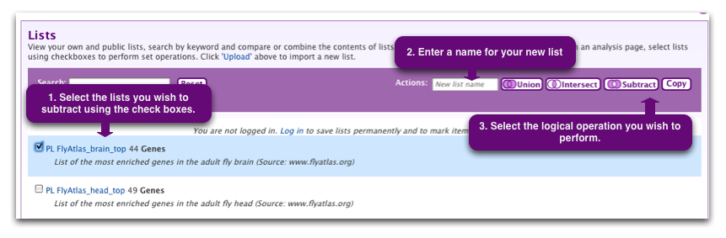

B. List Analysis Page

Details of the contents of a list together with additional information about a list can be viewed through the 'List Analysis' page. The analysis page for a list is automatically displayed when a list is created. List analysis pages can be accessed at other times by clicking on the list name on the 'list page'.

-All list analysis pages have the same structure and consist of three sections:
- a summary of the contents of the list includes a table with the first 10 obects of the lists, a list description, List info, Convert tools and Link outs (if available). Above the table, there are Display / Export / Use options as well as a Find box. Note that searching a list is case-sensitive and wildcards cannot be used.

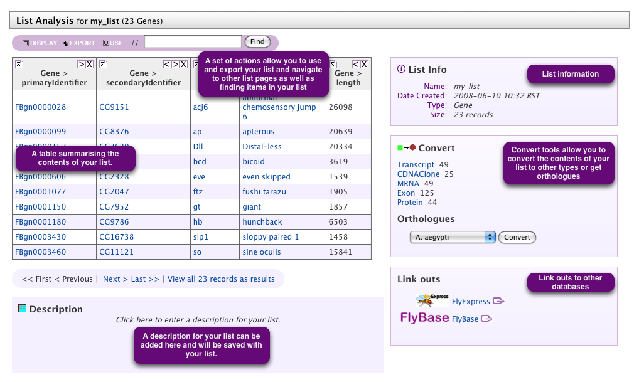
- a series of 'widgets' giving more information on the list, for example, for a list of genes, a graph of the chromosome distribution, a statistical analysis of the GO term distribution (GO term enrichment), KEGG pathway data, protein domain enrichment and publication enrichment.
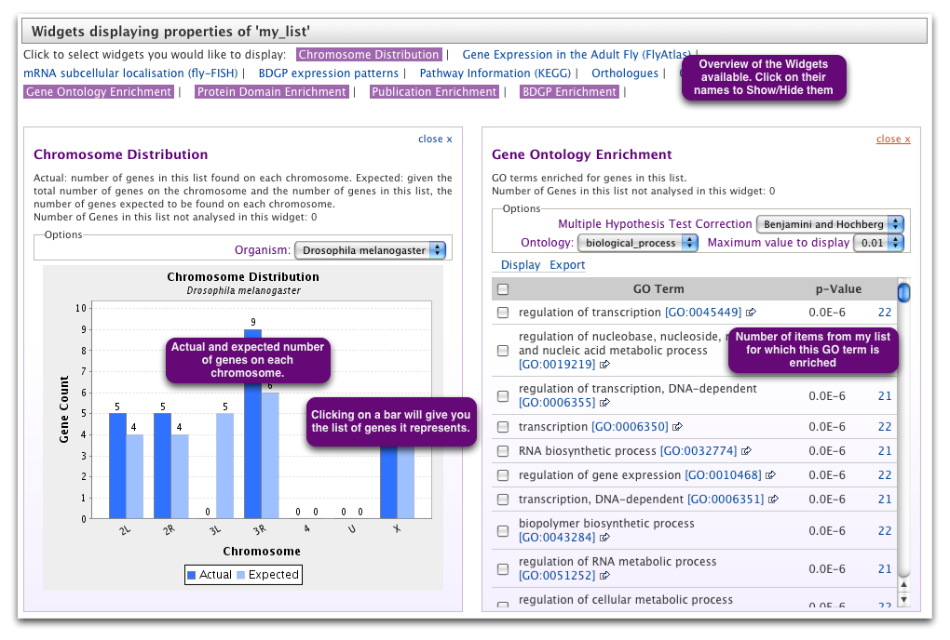

- a set of template queries that have been pre-run on the set of objects in the list:

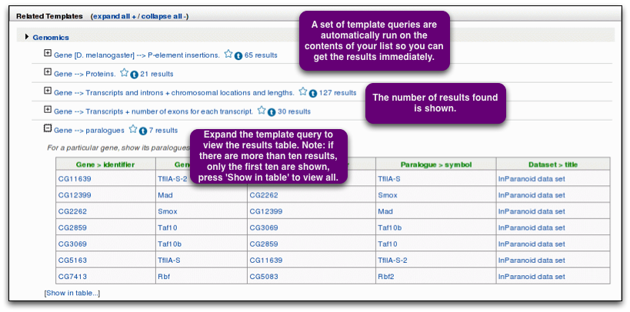
Lists can be created from the results of queries:
Data from queries can also be saved as a list. To save your data as a list select the required data on a results page and either add it to an existing list or save it as a new list, using the boxes displayed above the results. Selecting the check boxes next to the column headings will select the entire column for saving. Alternatively, individual items can be saved by selecting check boxes next to the items. Selected items will be listed in the box below the results table.
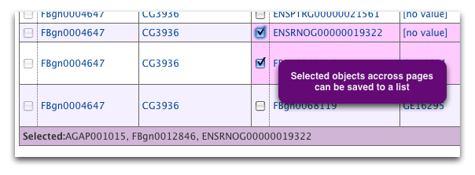
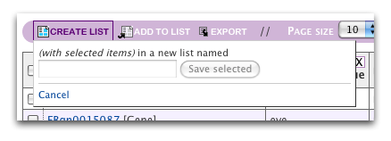
Exercise:

In this tutorial we will upload an example list of genes. We will then use this list to look at a list analysis page, run a template query and save a further list from the results.

6.1. Upload the example list.
- Navigate to the 'upload' tab of the lists page.
- Above the box for typing/pasting in identifiers, you will see an example available for upload.
- Clicking on the example will add the list to the box.
- Set the 'type' of list to Gene. Leave the organism constraint blank. Press 'Create List' to upload the list. This will take you to the 'List confirmation' page:

6.2. List Confirmation Page.
- Before a list is created it is checked against the FlyMine database to ensure that everything in the list can be found. Any discrepancies are reported on the 'list confirmation' page. The demo list check matches 26 genes successfully but contains two discrepancies - a low quality match and a converted type. These are explained in more detail below:

Low quality matches: A low quality match is one that does not match the main identifiers in the database but which was found by searching the synonyms. In this case FBgn0001251 is an old (or secondary) identifier for the gene. However, it has found the gene we want (with current identifier FBgn0001325) so we can add this to our list by clicking on 'add' in the last column.

Converting types: When we uploaded our list we specified that we wanted to make a list of genes. However one item in our list is actually a protein identifier (TWIST_DROME). FlyMine has found this protein in the database along with the gene that encodes it. It is not possible to make a list of mixed 'types' but we can now add the gene for this protein to our list.

Duplicate genes: You may also see discrepancies called 'Duplicate genes'. This can occur if, for example, you have gene symbols in your list and the symbol is found in more than one organism. In such a case, all occurrences of the gene will be listed and you can select the one you intended to be in your list. Such discrepancies can be avoided by using the optional organism constraint on the list upload page.

An example of 'duplicate' items is shown below. Once you are happy with your list you can give it a name and press 'Save list'.

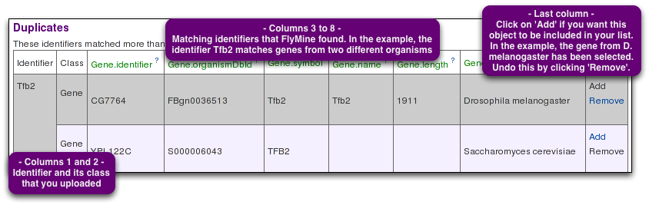
6.3 List Analysis Page

- saving a list takes you immediately to the list analysis page for that list.
- Have a look at the first part of the page - this provides the summary of the contents of your list.
- Note that only the first ten items are displayed - click on 'View all xxx records' to view the entire list. Also note that you can add a description for your list.

- Next take a look at the 'Widgets'. Click on one of the bars from either the chromosome viewer or the gene expression graph. This will display the genes relevant to just that bar as a results table from which you could save just that set to another list. Similarly, for the other widgets, clicking on the number of genes will allow you to access just that set.

- Scroll down to the set of template queries. These template queries have been pre-run with the set of objects in your list. Browse the template queries.

6.4 Using a list in a template query
- You will have noticed that the example-list we uploaded is a set of transcription factors. We are now going to find a template query that will allow us to find the set of genes that are regulated by these transcription factors.
- Find the template query 'Transcription factor [D. melanogaster] --> TF binding sites + chromosomal locations' using the search templates function. Run this template with the example-list you uploaded - click on the check box below the 'Gene identifier' to constrain the gene to be in a particular list. The name of the example list you just created will appear in the drop-down menu.
- Try to understand the results. Save the set of 'regulated genes' (how many? answer:30) to a new list.
- Look at the list analysis page for your new list. Also, make sure you are able to find your list on the 'list page' and in your MyMine account.
7. Exporting Data

Exporting lists and result tables
Data can be exported from lists and results pages in various formats - excel (or open office) format, comma separated values, tab separated values, or for items with sequences, FASTA format (see below). To export the contents of a list, click on the list name on the list page to display the list analysis page. Options for exporting can be found above a results table or a list (summary) table. Currently, either an entire table or specific columns can be exported. If nothing is selected, the entire data set will be exported.
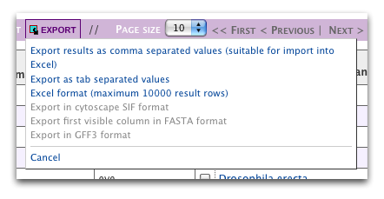
If you do not wish to export certain columns these can be hidden using the cross in the column header.
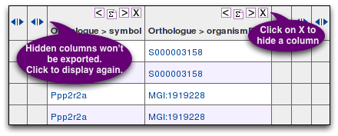

Exporting sequences in FASTA format
If a list or a results table contains a column with objects that have a nucleotide or amino acid sequence, it is possible to export all sequences from that column in FASTA format. Currently, the FASTA export option will only export the sequences belonging to objects in the first visible (i.e. not hidden) column. Therefore, if that column does not contain any sequence-linked objects, the FASTA export option will not be activated. Columns can be moved to the first position by using the arrows in the header. If objects appear more than once in the column, the sequence will only be exported once.

Exercise:

7.1 Export the sequences of the regulated genes from exercise 6.4.
- load the list analysis page for the 'regulated genes'list you created in exercise 6.4. Click on EXPORT in the toolbar above the table, and select 'Export first visible column in FASTA format'.

7.2 Export the corresponding protein sequences of regulated genes from exercise 6.4.
Find the template: Gene --> Proteins. Run it for the list of 'regulated genes' from exercise 6.4. Export in FASTA format can only be done for objects in the first column. Therefore, the regulated genes in column 7 have to be moved to the left (alternatively, the preceding columns can be hidden, or, if you know how, the column order can be changed by editing the query in the QueryBuilder - this will be covered later). Click on EXPORT in the toolbar above the table, and select 'Export first visible column in FASTA format'.
8. Query Builder

Advanced users can use a flexible query interface
- to construct their own data mining queries across the multiple integrated data sources,
- to modify existing template queries or
- to create their own template queries.

Access the FlyMine Query Builder at the bottom of the FlyMine home page, from the tabs in the main menu bar on any FlyMine page or choose a query starting point from a data category page. The Query Builder interface enables you to browse through classes and fields of the data model, selecting those that you wish to constrain and those that you wish to include in your results (see appendix I for definition of some terms). Building a query involves three main steps:

1. Browsing the model browser to find the classes of data you wish to query.
2. Applying constraints to this data to define the subset of that type of data required and
3. Defining your results table by selecting the fields you want to include.

The main FlyMine Query Builder page is composed of several sections:
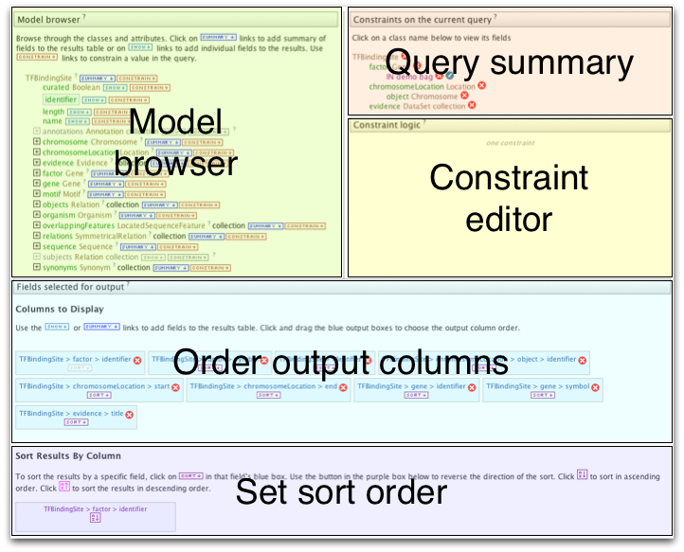

A. The model browser (left) allows you to browse through the FlyMine data model. This displays an initial starting class and its fields with classes containing related information listed below. Each class can be expanded to show the fields for that class and in turn, any classes related to that class. For example, if the starting class is 'Gene', the fields shown will include 'name', 'identifier' and 'symbol' and the classes of related information include 'Proteins', 'Transcripts' and 'Microarray results'. The model browser thus allows you to browse through the types of data that are available and select those that you wish to query. For each field within the model browser there is a 'SHOW' and a 'CONSTRAIN' option. These are used to either select a field to show in the results output or to constrain in the constraints list (see below).
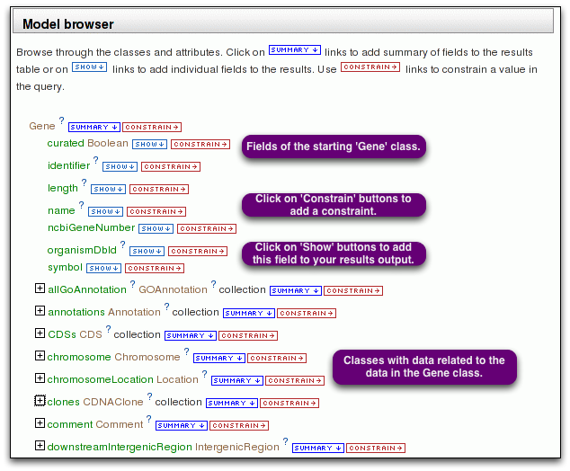

B. The constraints list (right) allows you to specify the constraints you wish to apply to particular classes and fields. A constraint is like a filter - you filter out a subset of objects in a class which have certain characteristics (defined by the constraint). To apply a constraint to a field, navigate to the field in the model browser and click on 'constrain' next to it. This will add the field to the constraints list and bring up a box (lower right) where you specify your constraint. You can change the relationship (and, or, grouping) between the different constraints using the 'constraint logic'.

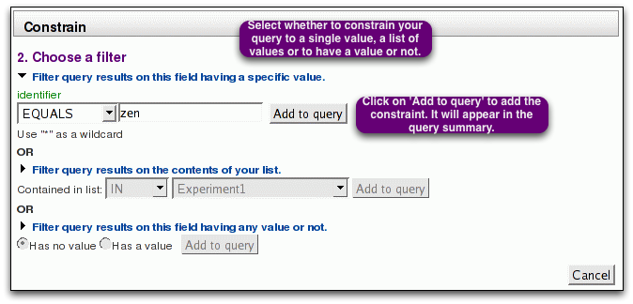

C. Underneath the model browser, the 'fields selected for output' displays the fields you have selected to show in your results. (Each field is represented by a box which will become a column in the results table, Initially, the output fields list will say 'No fields selected for output'). To select a field to show in the results output you press 'SHOW' next to the field. (Alternatively selecting 'SUMMARY' next to the class name will add the main fields for that class to your results output). The order of fields in the output fields list can be changed by dragging and dropping them. Fields can be deleted from the output fields list using the 'x'. Fields that have been selected for output will appear in a blue box in the model browser and constraint list. By default results will be sorted alphabetically, in ascending order, based on the first column. The column to sort on can be changed by clicking on the 'sort' box under the column name - note this changes the name of the column displayed under 'Sort Results By Column' . The direction of sorting (ascending/descending) can be changed by clicking on the box under the field name in this section.

Press 'Show results' to view your results in the results page. You can go back to edit your query by clicking on 'Query' in the trail. The results page will by default display just the first ten rows of your results (this can be changed using the drop-down box above the results table). Below the results table the total number of rows returned by your query is displayed (this will initially say 'Approximate rows' as the total number is calculated, changing to 'Total rows' once the exact number is known.
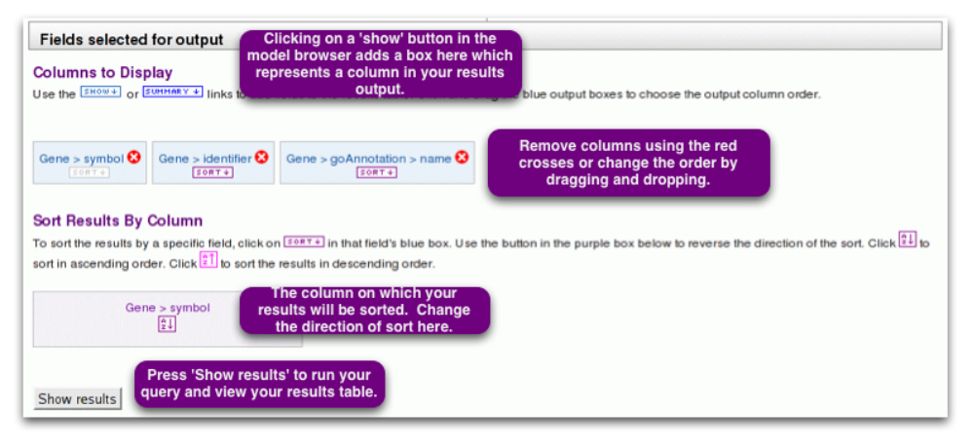
LOOKUP constraints
There are two ways in which you can add a constraint for the identifier for a particular object. For example, for a particular Drosophila melanogaster gene you may want to constrain either the CG identifier, the FBgn identifier, the gene symbol or the gene name. Each of these options is available as a field under the gene class (identifier holds the CG ids and organismDbId holds the FBgn ids) and so depending on the type of identifier you have you can select which field you need to constrain. Alternatively, however, FlyMine includes a feature called 'LOOKUP constraints', which allows you to add any type of identifier to the constraint. To add a LOOKUP constraint, click on the 'CONSTRAIN' button next to the actual class name. Such LOOKUP constraints also allow you to specify the organism in the same constraint (useful, for example, if you are using gene symbols which may occur in more than one organism).
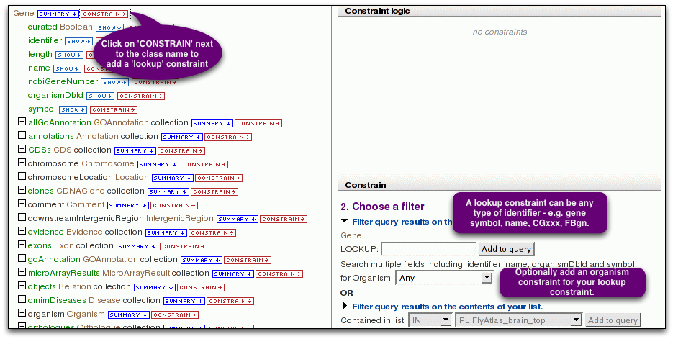
Exercises:

This example introduces the use of the Query Builder to alter an existing template. It will start with the template 'For the following gene symbol, show its gene identifier' and alter it to collect all gene identifiers from genes on the 4th chromosome of D. melanogaster.

8.1 Find the template 'Gene symbol --> Gene identifiers' and run the query for the default Drosophila gene.

8.2 Change the current query so that it also gives you the gene name.
- Click on 'Query' in the trail (near top of results page) to return to the template query form. Here, click on 'Edit Query' to display this query in the Query Builder.
- Note that 'primaryIdentifier', 'secondaryIdentifier' and 'symbol' in the left column have a blue background to indicate that they are selected for output (see further down on that page).
- To make the gene name appear on the result page as well, click on 'SHOW' next to 'name' under 'Gene'. 'name' will now appear in blue and can be found in the output section below. The order of the columns can be changed by clicking and dragging the output boxes.
- Scroll down and click 'Show results' to run the query again.

8.3 Change the current query to retrieve all genes on the 4th chromosome of D. melanogaster.
- Click on 'query' in the trail to return to the Query Builder.
- The right hand side summarises constraints in the current query. Note the constraint on Gene symbol is 'zen'. Clicking on the red cross next to 'symbol' will delete this constraint.

- To constrain the current query to D. melanogaster, click on the '+' sign next to organism in the column on the left. Click on 'CONSTRAIN' next to 'name' (under 'organism). This brings up a 'Constrain' section to the right (you might have to scroll down to view it). Select 'Filter query results on this field having a specific value' and choose Drosophila melanogaster from the drop-down menu. Click 'Add to query' next to the drop-down menu.

- Next , constrain the current query for genes on the 4th chromosome, by clicking on 'CONSTRAIN' next to 'primaryIdentifier' under 'chromosome'. In the 'Constrain' section to the right, enter a value for the chromosomal identifier: the identifier for the 4th chromosome is '4'. Click 'Add to query' next to the drop-down menu.
- Scroll down and click 'Show results' to run the query. How many genes did you find? (answer: 90 genes).

-Re-run the query with the results sorted Z-A on the organismDbId (FBgn).

Appendix I: Basic FlyMine - Terminology and concepts

Classes, Objects and Fields

The FlyMine database is built on top of an object-based data model. This data model defines the way in which the different types of data are related to each other and is made up of classes, which describe a particular type of data, and the relationships between classes.

- A class can be thought of as a holder to describe information about a specific type of thing. Things which have similar properties belong to the same class. Example: in FlyMine there is a 'Gene' class. The Gene class describes properties of genes.

- Every database entry is called an object and is an actual member of a class. Example: the Notch gene is a member of the Gene class.

- Each class has a set of fields (attributes) that provide information about the type of item being described. Example: the Gene class includes the fields 'name', 'symbol' and identifier' among others.

- Every object of a class has the set of properties (fields) that describe that class, although some of these fields may be empty (i.e. there may not be any data available for some fields).

- A class can be a parent class for more specialised classes (sub-classes). Example: the transcript class is a parent class for classes describing more specialised transcripts such as tRNA, snRNAs, etc.

References

- Classes are linked together through 'References'. A reference is a pointer from one class to another class. Example: the Gene class has a reference to the Transcript class.

- In some cases, a reference will link an object in one class to just one object in another class. Example: the Drosophila zen gene, has a link to the Organism object 'Drosophila' of the Organism class.

- In other cases, a reference will link one object in one class to more than one object in another class. Example: if a gene is made up of more than one exon, this gene object will link to several exons in the Transcript class. This type of reference is called a 'Collection' (list).
The FlyMine Data Model

- The set of classes and their references is known as the FlyMine Data Model.

- Where ever possible, any of the classes and their relationships have been determined by pre-existing ontologies and models. For example, a large part of the data model is defined by the Sequence Ontology (http://song.sourceforge.net), which describes the relationships between features annotated to a genomic sequence.

Appendix II: Help and Feedback

FlyMine Website www.flymine.org:
- On-line documentation: Help links for each page (? in top right); Tour available on home page. (Tutorials will be back soon).
- Mailing list for announcements from the FlyMine website

Contact:
- Email: support@flymine.org
- Use the FEEDBACK FORM accessible on every FlyMine page
- Call us: 01223 760262

We welcome any type of Feedback!

