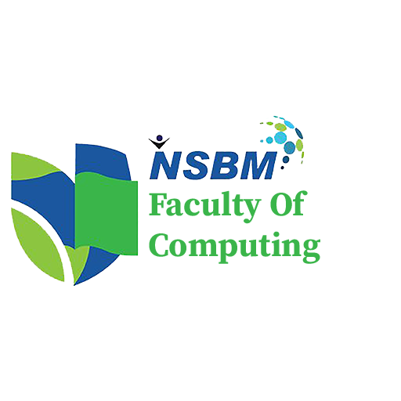

Research & Development
Document for Internship Internal Project

Group 01

- Project Brief
A centralized web platform designed for the Industry Collaboration Unit to streamline event management (workshops, guest lectures, attendance, and certificates) while providing an integrated vacancy portal. The platform enables both alumni and leading industry partners to post internship and career opportunities, allowing undergraduates to register for events and apply for verified positions through a single interface.

Stake Holders
- Students
- Managers (Staff, Coordinators, Management)
- Admin
- Industry Partners / Alumni

2. Platform Requirements by Module

2.1 Shared Platform Governance
Features spanning system health, access control, and platform-wide monitoring.
- System Administrator:
  - User Management: Create, update, deactivate, and delete user accounts; assign user roles and global RBAC permissions. Can only register Admin and Management accounts, not student/industry accounts.
  - Configuration: Manage faculty, department, and academic program records; configure system settings; manage notification templates and active maintenance banners.
  - Security & Maintenance: Monitor system activities, view system-wide usage analytics, access immutable audit trails (user ID, action, timestamp, IP), manage data backups, and perform system restorations.
- Faculty Management:
  - Access & Approvals: Review and approve/reject industry-partner platform onboarding requests based on assigned access levels.
  - Auditing & QA: View per-user change logs to audit modifications made to system data; generate faculty-level reports for accreditation and quality assurance.

2.2 Module 1: Event Management System
Handles guest lectures, workshops, and training programs, including registrations, check-ins, and certifications.
- Faculty Coordinator:
  - Event Lifecycle: Create, schedule (dates, venues, session times), edit, reschedule, or cancel events; configure certificate eligibility criteria.
  - Resource Management: Assign guest speakers and maintain a reusable speaker profile list; manage industry companies and organizations to prevent duplicate directory records.
  - Registrations & Limits: Approve or reject student event registrations to enforce attendance capacity.
  - Attendance & Certificates: Generate event QR codes, monitor check-ins in real time, identify certificate-eligible students, review student feedback, and generate event performance reports.
- Faculty Management:
  - Strategic Analytics: Review event statistics, evaluate student participation trends, analyze attendance and feedback summaries, and access historical event records.
  - Quality Assurance: Review certificate issuance reports to ensure participation standards are met; monitor industry collaborations to strengthen strategic partnerships.
- Academic Staff:
  - Student Engagement: View upcoming industry events, register students for an event when necessary, and encourage participation.
  - Monitoring: Verify student attendance, access student participation histories, review student feedback responses, and download departmental attendance reports.
- Administrative Staff:
  - Logistics: Maintain event schedules, manage venues and facility bookings, and maintain company/speaker contact information.
  - Records & Support: Manage participant lists, export registration/attendance records, and perform manual QR check-in overrides.
  - Communications & Certificates: Send event notifications and reminders to participants; prepare and distribute certificates to eligible students.
- Guest Speakers:
  - Invitation Access: Receive and directly accept or decline secure single-use email invitations; view assigned event details (date, time, venue, audience size, session topic/agenda).
  - Preparation: Update professional profile and contact information; upload presentation materials/slides prior to sessions and communicate with the Faculty Coordinator regarding requirements.
  - Reminders: Receive automated 2-day pre-session reminders detailing time, location, title, university expectations, and live participant counts.
  - Feedback: View anonymized post-session participant feedback summaries and speaking history.
- Students:
  - Discovery & Registration: Browse upcoming events filtered by track and date; register for an event.
  - Execution: Receive automated reminders before an event; check in by scanning a QR code.
  - Post-Event: Submit session feedback and download PDF certificates upon approval.
- Industry Partners / Alumni:
  - Collaboration: Apply to take part in collaboration events and view approved event details.

2.3 Module 2: Vacancy & Recruitment Portal
Connects students with corporate partners and verified alumni for internships and career placement.
- Industry Partners / Alumni:
  - Company Profile: Request to register the company profile.
  - Vacancy Management: Submit vacancy listings for faculty approval; manage applicant pipelines; view candidate profiles and download resumes; remove a posted vacancy once a position is filled.
  - AI Job Postings: Generate job descriptions automatically based on bullet points.
  - AI Talent Search: Search for talent using natural-language queries (e.g., "find talents with skills in frontend").
  - AI Sourcing: Receive automated candidate recommendations for open postings.
  - Academic Data: View applicant exam results and GPA.
- Students:
  - Job Search: Search for companies and view company information; browse and filter published vacancies by role, tech stack, and work model; toggle availability status between "Actively Looking" and "Not Available."
  - Applications: Upload multiple versions of a resume; submit one-click job applications; track application statuses in real time.
  - Notifications: Manage customizable email notification preferences for job alerts and status updates.
  - AI Resume Tools: Receive visual feedback on match rate against a vacancy; get feedback/keyword tips on uploaded resumes.
  - AI Career Tools: Generate cover letters automatically based on the selected resume; view a dashboard of university-wide trending skills.
- Faculty Management:
  - Approvals: Review, approve, or reject industry vacancy postings to ensure they meet university standards.
  - Strategic Analytics: View an executive dashboard detailing placement rates, partner engagement, and job market trends.

