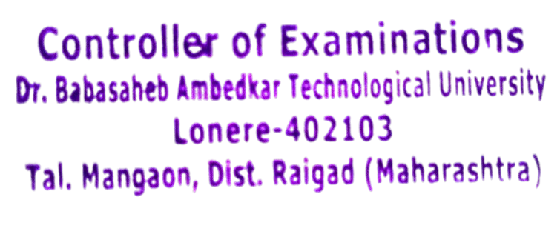
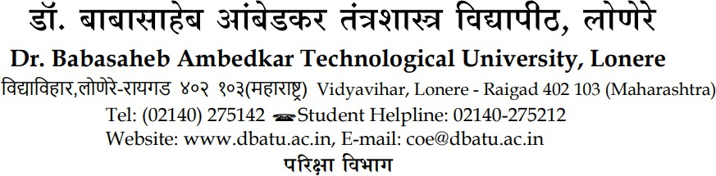

No. DBATU/EXAM/2025/0441 Date: - 09/01/2026

PROVISIONAL CERTIFICATE
This is to certify that Mr. / Miss. AVHAD PALLAVI GORAKH with Permanent Registration Number PRN. 2154391823004 from Dr Naikwadi College of D. Pharmacy, Jamgaon Sinnar has passed the Examination for the Final Year Bachelor of Pharmacy held in Summer 2025 and was
placed in the First Class and has become entitled to the said B.Pharm of Dr.Babasaheb Ambedkar Technological University.
The degree will be conferred upon him / her at the forthcoming convocation.



Seal Controller of Examinations

