|  |  |
| --- | --- |
| **Unit:** Waste not, Want not. | **Theme:** Poverty and World Resources. |
| **Lesson:** Getting Started & Announcement of the Project | |

**Pre-Task**

***A/ Check the pictures and then label them using words from the list.***

|  |
| --- |
| Wind Energy - Coal - Hydro Electric Energy- Natural Gas - Garbage/Wastes – Oil. |

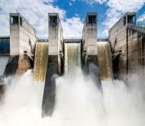 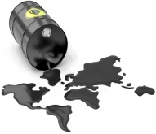 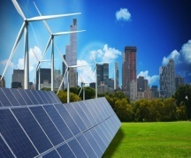

**A.** ………………...…… **B.** …………….…......... **C.** ……..….…………...… 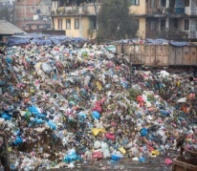 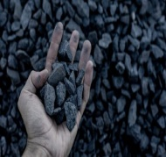 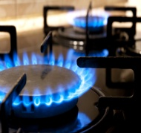

**D.** …………….……..…… **E.** ………….….……...… **F.** ………………..…...……

***B/ Classify the items above in the following chart.***

|  |  |
| --- | --- |
| **Renewable Energies**  (Products that can be used again) | **Non-Renewable Energies**  (Products that are used only one time) |
| ………………………………………  ………………………………………  ………………………………………  ……………………………………… | ………………………………………  ………………………………………  ………………………………………  ……………………………………… |

**During Task**

***Activity 01: Check the following definition then choose the suitable answer.***

***“WASTE NOT, WANT NOT”*** is an English quote **by Maria Edge Worth** which is said:

**1.** said to someone that he can [waste](https://dictionary.cambridge.org/dictionary/english/waste) all the useful things, because they will not need them in the [future](https://dictionary.cambridge.org/dictionary/english/future).…………

**2.** said to [advise](https://dictionary.cambridge.org/dictionary/english/advise) someone not to [waste](https://dictionary.cambridge.org/dictionary/english/waste) anything, because they might need it in the [future](https://dictionary.cambridge.org/dictionary/english/future) …………

***Activity 02: Complete the following table using the given suffixes as shown in the example.***

|  |  |  |
| --- | --- | --- |
| **Verb** | **Noun** | **adjective** |
| **E.g. To waste** | **Wastage/Wasting** | **Wasteful** |
| To sustain | ………..……...……**ability** | …………..…...……**able** |
| To reuse | ………..……...……/ ………..……...……**ing** | …………..…...……**able** |
| To reduce | ………..……...……**tion** | …………..…...……**ed /** …………..…...……**ible** |
| To recycle | ………..………...……**ing /** ………..……...……**ability** | …………..…...……**able /** …………..…...……**ed** |
| To protect | ………..…...………..…**ion** | …………..…...……**ed/** ……………..…...……**ive** |
| To develop | ………..…...………**ment** | …………..…...……**ed/** …………..…...……**ing** |

**Post Task**

***Unit Project***

On April 22nd, people around the world celebrate Earth Day to raise awareness

of conservation and support for environmental protection.

In honor of this international day, design earth-friendly crafts.

* ***Practical Part: Making a recycled product.***

 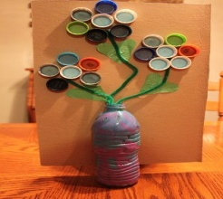 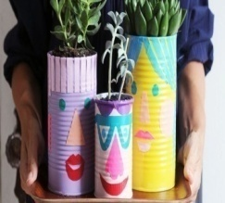

***a.*** *Household Craft.* ***b.*** *Vase and Flowers.* ***c.*** *Vase*

* ***Written Part: Writing a Presentation of your Product.***

Write a short paragraph in which you represent your recycled craft/product using the presentation style of a product in Sequence 02, linking words, and passive, active voice where necessary.

* **Check Youtube for more, by writing key words:** *MAKING RECYCLED CRAFTS.*

|  |  |
| --- | --- |
| **Unit:** Waste not, Want not. | **Sequence 01:** Discovering Language. |
| **Lesson:** Reading | |

**Pre-reading**

***A/ Check the countries’ flags (1-4) then match them with their main natural resource (A-D):***

 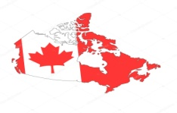 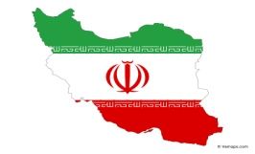 

|  |  |  |  |  |
| --- | --- | --- | --- | --- |
| ***Countries*** | **1. Australia** | **2. Canada** | **3. Iran** | **4. United States** |
| ***Natural Resources*** | ….………… | ….………… | ….………… | ….……………. |

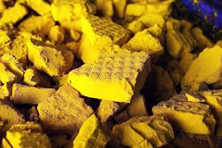 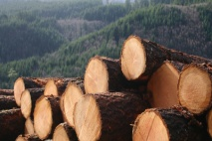  

**A. Uranium B. Timber C. Gold D. Natural Gas**

**During Reading**

***A/ Read the text silently, and then do the following activities.***

|  |
| --- |
| **A**lgeria is a wealthy country with natural resources that come directly from nature, such as: nuclear, renewable, and non-renewable sources. The non-renewable energy sources are considered the lion’s share for energy production (98%).  **A**lgeria’s efforts to strengthen ***its*** energy security will take an important step in the coming decades by commissioning new energy infrastructure based on intensive use of water, coal, nuclear, non-renewable, and renewable sources. The implementation of new power is expected to be operational from 2030. The renewable power realization in Algeria is relatively less compared to other African countries, i.e., Morocco, Egypt, South Africa, etc.  **T**he total renewable power installed capacity in Algeria reached 686 MW (megawatts) in 2020, as part of its national energy portfolio, although the Algerian government has spent tremendous efforts on introducing new sustainable technologies to enable the transition towards a cleaner and sustainable energy system. Indeed, the country announced its plan to install around 22 GW (gigawatts) of renewable energy capacity by 2030. ***It*** will include bio-power from the waste, concentrated solar power, geothermal, cogeneration, and finally, from wind. The scope of the present research provides general information about the usage of energy resources such as fossil, nuclear, and renewable sources in Algeria.  **T**he present effort is the first of its kind which discusses the application of the coal and nuclear as clean energy sources as part of renewable energy transition.  ***Adapted from:*** [https://encyclopedia.pub/entry/24825](https://l.facebook.com/l.php?u=https%3A%2F%2Fencyclopedia.pub%2Fentry%2F24825%3Ffbclid%3DIwAR0m5YVXQQNElMHukFvmyECsns8CHsCHBRqndDQcuZGuhbfNyKl8AIFsIGY&h=AT1lti_hgBkL2D2vKzvL5FOngfp88uzPPqYS5O2TE4hXgL6y8FnSU028TuIdoDN1gP7EM32eVg0jYSiU9MipJVHVi6Xs9dcGsf2_7ZFC3l8hgL4t3q9wj0NPXoircfJRzV03) |

***Activity 01: Say whether the following statements are “true” or “false”.***

**a.** Natural resources are made by man. ………..

**b.** Algeria leads the African countries in realizing the renewable power. ………..

**c.** The coal and nuclear are considered as a renewable energy source. ………..

***Activity 02: Answer the following questions according to the text.***

***a.*** The new Algerian energy security is based on what? ………..…….…………….. ………………..………..………..………….…………

…………………………………………………………………………..….....

***b.*** What is the plan being advertised by Algeria? ………..………………………….. ………………..……………..………..………..

……………………………………………………………………………....

**Activity 03: What or who do the underlined words refer to in the text.**

**Its =**……….………………………... **It =**…………….……………………...

**Post Reading**

***Activity 04: Complete the following table as shown in the given example.***

|  |  |  |  |
| --- | --- | --- | --- |
| **Adjective** | **Noun** | **Adjective** | **Noun** |
| **E.g. Poor** | **Poverty** | **Homeless** | **Home** |
| **Experimental** | ………..………… | **Environmental** | ………..………… |
| **Dangerous** | ………..………… | **Renewable** | ………..………… |
| **Operational** | ………..………… | **Sustainable** | ………..………… |
| **Polluted** | ………..………… | **Recycled** | ………..………… |

***Activity 05: Fill in the gaps using these words.***

**Renewable – Environmental – Solar – Production – Pollution**

Our planet is suffering from several types of ………..…………. A lot of ………………..……. problems would disappear if we reduce the use of petroleum, coal and natural gas as raw-materials for power ………….………The focus should entirely shift on ………..….………. sources of energy. The use of alternative sources of (…………..………. energy) would help saving the environment.

|  |  |
| --- | --- |
| **Unit:** Waste not, Want not. | **Sequence 01:** Discovering Language. |
| **Lesson:** Grammar Desk. | |

**Presentation**

***Activity 01: Match each sentences (a-c) from list ‘A’with its equivalent in meaning to sentences (1-3) from list ‘B’.***

|  |  |  |  |
| --- | --- | --- | --- |
| ***List ’A’*** | | | |
| **a.** Differenet countries are using renewable energies.  **b.** A lot of chemical industries pollute the rivers.  **c.** The government has protected the amazon basic ecosystem. | | | |
| ***List ’B’*** | | | |
| **1.** The amazon basic ecosystem has been protected by the government.  **2.** Renewable energies are being used by different countries.  **3.** The rivers are polluted by a lot of chemicals | | | |
| ***List ’A’*** | **a** | **b** | **c** |
| ***List ’B’*** | …………… | …………… | …………… |

***Activity 02: Classify each of the above sentences in the right columns.***

|  |  |
| --- | --- |
| **Active Voice** | **Passive Voice** |
| **-** …………………………………………..  …………………………………………….  **-**…………………………………………..  …………………………………………….  **-**…………………………………………..  ……………………………………………. | **-** ……………………………………  ………………………………………  **-**…………………………………….  ………………………………………  **-**…………………………………….  ……………………………………… |

***Activity 03: Check the sentences and say whether they are active or passive.***

**1.** Some farmers mustn’t overuse chemicals in their crops. → …………………

**2.** The world economoy will be improved by the invention of a cheap and non-polluting car. → ……………………

**3.** The students cleaned the beach after their picnic. → …………………………

**4.** The government has protected the environment from pollution. → ……………

**5.** A lockdown was imposed by many countries because of Corona virus. → ………

**Practice**

**Let’s Draw the Rule**

|  |  |
| --- | --- |
|  | **Active voice ;** Subject **+** Verb **+** Object.  **Passive Voice:** …………… + ……..…… + **verb (p.p)+**………….……… |
| ***Present Simple*** | **Active voice ;** Subject **+** Verb **+** Object.  **Passive Voice:** …………… + ……./.…… + **verb (p.p)+**………….…… |
| ***Past Simple*** | **Active voice ;** Subject **+** Verb **+** Object.  **Passive Voice:** …………… + ……./.…… + **verb (p.p)+**………………… |
| ***Future Simple*** | **Active voice ;** Subject **+** Verb **+** Object.  **Passive Voice:** …………… + ……./.…… + **verb (p.p)+**………………… |
| ***Modal & Semi-modal verbs*** | **Active voice ;** Subject **+** Verb **+** Object.  **Passive Voice:** …………… + ……./.…… + **verb (p.p)+**………………… |

**Use**

***Activity 01: Say in which tense each verb is conjugated.***

1. Too much plastic is thrown by people.🡪…..................................
2. Chemicals are being overused in agriculture.🡪 …..................................
3. Some rainforest ecosystems have been destroyed by deforestation.🡪..............
4. Some regions will be affected by global warming. 🡪 …..................................
5. Many water zones will be depleted. 🡪…..................................

***Activity 02: Turn the following sentences into passive voice.***

**a.** Environmentalists were protecting some animals in danger.

Some animals in danger…................................................................................

**b.** Global warming has caused the rise of temperature.

The rise of temperature …................................................................................

**c.** Air pollution destroys the environment.

The environment …...........................................................................................

**d.** The greenhouse effect causes climate changes around the globe.

Climate changes….........................................................................................

**e.** People are wasting water.

Water ….........................................................................................................

|  |  |
| --- | --- |
| **Unit:** Waste Not, Want Not. | **Sequence 01:** Discovering Language. |
| **Lesson 03:** Write it Right | |

**Pre-Writing**

***A/ Check the pictures then label each of them with the appropriate idea.***

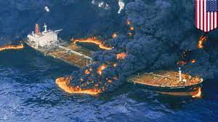 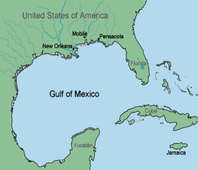 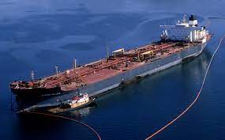 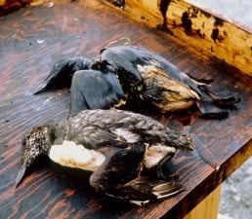

**1 2 3 4**

**a.** Death of millions of marine animals. → …………..

**b.** The explosion of ‘Deepwater Horizon’.→ …………..

**c.** The catastrophe occurred in the Gulf of Mexico.→ …………..

**d.** The oil spilled into the Gulf.→ …………..

***B/ Complete the report below putting the verbs in brackets in the simple past passive.***

The catastrophe happened in April 20th, 2010 when an oil platform named ‘*Deepwater Horizon'* **(explode)** ……………..………, causing an oil spill in the Gulf of Mexico. The shorelines of four Gulf States: Louisiana, Alabama, Mississippi, and Florida **(damage)**……………..……….. by the oil spill. In addition, the water **(pollute)**…………..……………, birds and animals **(kill)** …………..……………. Moreover, the fishing and tourism industry **(ruin)** …………..……………. Later, a press release **(make)**…………..……………. by the owner of the company to apologise for the damage and pledged reforms.

**Press release:** is an official written document that gives specific information about an event to newspapers, magazines and television news programs.

**Duing Writing**

**C/ *Imagine you were the owner of ‘Deepwater******Horizon’. Write a press release using the notes below and the future passive. You can add your own ideas.***

**-** 2000workers /recruit/ soon

**-** Oil/ recuperate with special machines

**-** Beaches /clean **-** Birds / wash out

**-** Marine life / restore

**-** Tourist industry / compensate / for its losses.

***Press Release***

We make our sincere apologies for the damage caused by the wreck of the Deepwater Horizon. We promise that ………………………………………………

…………………………………………………………………………………………………………………………………………………………………………………………………………………………………………………………………………………………………………………………………………………………………………………………………………………………………………………………………………………………………………………………………………………………………………………………………………………………………………………………………………………………………………………………………………………………………………………………………………………………………………………………………………………………………………………………………………………………………………………………………………………………………………………………………………………………………………………………………………………………………………………………………………………………………………………………………………………………………………………………………………………………………………………………………………………………………………………………………………………………………………………………………………………………………………………………………………………………………………………………………………………………………………………………………………………………………………………………………..……………………………………………………………………….………………………

**Post Writing**

**D/ Now, take turns to address your classmates to perform your press release on stage.**

* *Make the best use of gestures to express your deepest regret and sorrow.*
* *Ask forgiveness and promise to make the needed reforms soon.*

|  |  |
| --- | --- |
| **Unit:** Waste not, Want not. | **Sequence 01:** Discovering Language. |
| **Lesson 04:** Say it Loud and Clear | |

**Presentation**

***Activity 01: The following picture represents types and classification of natural resources.***

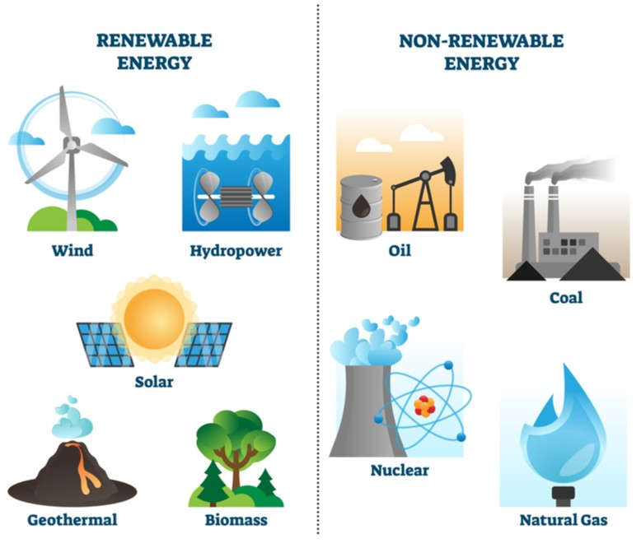

***A/ Listen to your teacher reading the text below and mark the intonation on the words written in bold type with appropriate arrows*** *(↗ or ↘).*

Natural resources are all those things that come directly from nature and are classified into two main types, resources present in unlimited quantities in  nature which can be used repeatedly and are known as renewable resources such as: **solar energy, hydroelectric power,** and **wind energy**…

Resources that are limited in quantity and can be exhausted by human activity in the future and are known as non-renewable resources which include fossil fuels like: **coal, petroleum,**and **natural gas**…

**Practice**

***Activity 02: Discuss your answers with your teacher and then complete the reminder below ‘’ Intonation in listing ‘’.***

|  |
| --- |
| ***Remark:***……………………………………………………………………………………………………………………………………………………………………………………………………………………………………………………………………………………………………………………………………………………………………………………………………………… |

***Activity 03: Go back to the press release, pick out all the verbs that end in (-ed) and classify them in the table below according to their pronunciation of final /id/.***

|  |  |  |
| --- | --- | --- |
| **/t/** | **/d/** | **/id/** |
| …………..………..…….  …………..………..…….  …………..………..…….  …………..………..…….  …………..………..…….  …………..………..…….  …………..………..…… | …………..………..…….  …………..………..…….  …………..………..…….  …………..………..…….  …………..………..…….  …………..………..…….  …………..………..…… | …………..………..…….  …………..………..…….  …………..………..…….  …………..………..…….  …………..………..…….  …………..………..…….  …………..………..…… |

* *Now, listen to your teacher pronouncing the verbs and check your answers to the exercise above.*
* *Draw the rule of final /ed/ pronunciation.*

|  |  |
| --- | --- |
| ***/t/*** |  |
| ***/d/*** |  |
| ***/id/*** |  |

**Use**

***Activity 04: Read the text below carefully and mark the right intonation on the words written in bold type with appropriate arrows*** *(↗ or ↘).*

There are five types of alternative energies: **solar, wind, biomas** and **hydroelectic** energies. All of them can be produced in our country because we have the following natural resources:the **wind,** the **sun,** the **mountains**…

However, solar energy is by far the most valiable.It is **cheaper, safer** andless **polluting.** Sonalgaz has already constructed power plants in **Biskra, Djelfa, Hassi Rmel** andother localities in the South of **Algeria.**

|  |  |
| --- | --- |
| **Unit:** Waste not, Want not. | **Sequence 02:** Developing Skills. |
| **Lesson 05:** Listening and Speaking | |

**Before you Listen**

*The* ***SDGs*** *(****S****ustainable* ***D****evelopment* ***G****oal****s****) which were set by United Nations in 2015 as a universal call to end poverty, hunger, protect the planet, and ensure that by 2030.*

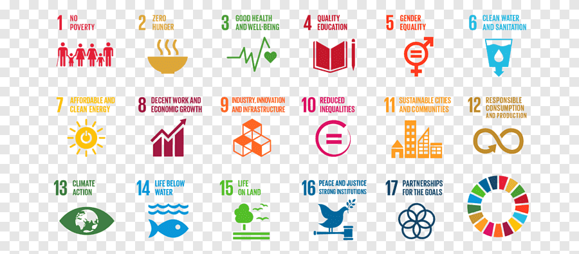

***Activity 01: Circle the letter that corresponds to the right answer.***

* The **S**ustainable **D**evelopment **G**oal**s** refer to**:**

**a-** Relying and using only non-renewable resources of energy.

**b-** Meeting the needs of the present, without harming the environment.

**c-** Using resources as if they will last long.

**While you Listen**

***Activity 02: Listen to the audio and say whether the following statements are ‘true’ or ‘false’.***

**a-** The **SDGs** aim at harming and affecting environment. → …….….……

**b-** The increase of the **SDGs** idea is linked to the industrial revolution. →….……

**c-** The **SDGs** was not created to reduce global warming. → ……….……

***Activity 03: Listen again to the audio and answer the following questions.***

1. What is sustainable development?

→ ………………………………………………………………………………………

……………………………………………………………………………………

**b-** How many components does the **SDGs** consist of ? what are they?

→ ………………………………………………………………………..……….……

***Activity 04: Consider the example below and do the following.***

* Sustainable development was created **so as to** reduce global warming.

**A/ What does the word ‘so as to’ express ? Tick the correct answer.**

**1)** obligation…………  **2)** Advice…….…… **3)** Purpose…………

***Activity 05: The following pairs are not in order. Use the connectors below to join column ‘a’ to column ‘b’. Make the necessary changes.***

|  |  |  |
| --- | --- | --- |
| **Sentence ‘A’** | **Connector** | **Sentence ‘B’** |
| **1-** People should recycle waste materials into new objects….  **2-** Overfishing must be prevented….  **3-** We must reduce global warming emissions…. | **so that**  **in order to**  **so as to** | **a-** our children can inherit from us.  **b-** (to reduce) the pollution caused by waste  **c-** (to save) the ecosystems and the balance of life in oceans. |

**1**→ People should recycle waste materials into new objects………………………

……………………………………………………………………………………

**2**→ Overfishing must be prevented ………………………………….………………

……………………………………………………………………………………

**3**→ We must reduce global warming emissions..………….………………………

……………………………………………………………………………………

**After you Listen**

***Activity 06: Rewrite the sentences below using :*** *Why don’t you…* ***/*** *If I were you, I would…* ***/*** *You’d better…* ***make the necessary changes.***

**1.** We must use eco-friendly products and materials.

→ **If I were you, I would**……………………………………………….……………

…………………………………………………………………………

**2.** You should buy less plastic and use reusable shopping bags.

→**You’d better**…………………………………………………………………………

…………………………………………………………………………

**3.** It is recommended to save energy and reduce wastage.

→**Why don’t you**……………..………………………………………………………

…………………………………………………………………………

**4.** It is better to join cleanliness campaigns to keep our society clean.

→ **If I were you, I would**……………………………………………………………

…………………………………………………………………………

**5.** It is not advisable to put chemicals into our water ways.

→**You’d better**…………………………………………………………………………

|  |  |
| --- | --- |
| **Unit:** Waste Not, Want Not. | **Sequence 02:** Developing Skills. |
| **Lesson 06:** Write it up | |

**Pre-writing**

***A/ Use the notes below in order to write a presentation of a tote bag******(****as shown the picture below****).***

You can **make it** with **an in-used Jeans** in less than**(20) twenty minutes.** No special skills needed. With just Basic cutting and sewing skills needed.

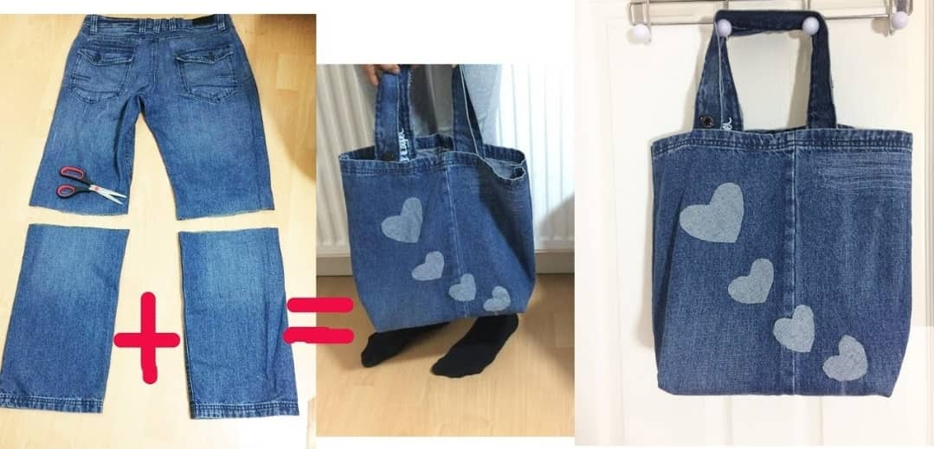

|  |
| --- |
| **Notes**   * Use in-used jeans / Cut the pants into pieces(legs). * Open them on both sides / Sew them together to have a base. * Cut the belt circle / Use it to have the hand straps. * Sew those cuts with sewed base / Use square jeans cuts. * Decorate the bag / Use square jeans cuts / Shape them as hearts |

***B/ Make the best use of the following items.***

* Use the appropriate **linking words.**
* Include **passive voice** sentences**.**
* Usethe **connectors to express purpose.**
* Use **sequencers (**first, then….)

**During Writing**

***Start like this;***

Ladies and gentlemen, this is our new shopping tote bag. It is better than other plastic bags because it is environmentally friendly………….……

……………………………………………………………………………………………………………………………………………………………………………………………………………………………………………………………………………………………………………………………………………………………………………………………………………………………………………………………………………………………………………………………………………………………………………………………………………………………………………………………………………………………………………………………………………………………………………………………………………………………………………………………………………………………………………………………………………………………………………………………………………………………………………………………………………………………………………………………………………………………………………………………………………………………………………………………………………………………………………………………………………………………………………………………………………………………………………………………………………………………………………………………………………………………………………………………………………………………………………………………………………………………………………

* *Correct your mistakes. Then exchange drafts with your partner for further error checking before writing a final version of your presentation.*

**Post Writing**

* *Now, after writing your final version of the presentation, address your classmates and read your revised presentation to the class.*

|  |  |
| --- | --- |
| **Unit:** Waste not, Want not. | **Sequence 02:** Developing Skills. |
| **Lesson 07:** Reading and Writing | |

**Pre-Reading**

***A/ Check the following pictures and then answer the questions below.***

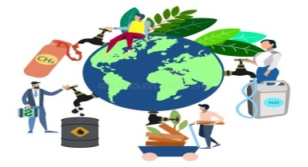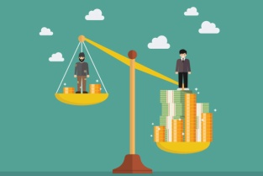 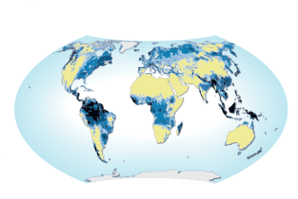

…………………….…… ………………………… …………………………

* What does each picture represent?
* What is the relationship between the three pictures?

**→** …………………………………………………………………………….…………

**During Reading**

***B/ Read the text and check your answers to the task above.***

|  |
| --- |
| **D**espite the efforts made since the foundation of the United Nations Organization, the international community has not succeeded to eliminate global poverty and prevent environmental degradation.  **T**here is a huge gap between the poor and the rich countries that has been increased by the global economy. Such gap led to conflicts among the countries’ natural resources, and resulted in an ecological crisis that endangers our life.  **T**oday, there’s a real and urgent need for managing the world’s resources on the basis of economic sharing and international cooperation. The Nation states might move beyond the pursuit of self-interests by implementing an international program of emergency assistance and a long term transformation of the global economy in order to eliminate poverty and hunger in the world. It would help if nations cooperate more effectively by sharing their natural and economic resources to help end poverty in many areas of the world.  Adapted from: <https://www.un.org/sustainabledevelopment/> |

***Activity 01: Choose the suitable idea that best sums up the text.***

1. The United Nations failed to end global poverty. ……………
2. The world’s natural resources ought to be shared. ……………

***Activity 02: Circle the letter that corresponds to the right answer.***

1. *The international community*………………………….….*put an end to poverty and preserve the environment.*

**a.** managed to. **b.** was not able to **c.** was not allowed to

1. *The global economy made the situation of the poor* ……….

**a.** worse  **b.** known to all **c.** better than before

1. *Cooperating and sharing resources is one of the ways to*…………………….
2. widen the gap between the poor and rich countries
3. end poverty and hunger in the world

***Activity 03: Pick out from the text words that are closest in meaning to.***

1. **Stop** (**§1**) **=** ……………..………….
2. **Wealthy** (**§2**) **=** ………………..……….
3. **Threatens** (**§2**) **=** …………………..…….

**Post Reading**

***Activity 04: Making Suggestions “Might / Could/ May”***

**A/ Pick out from paragraph (03) a sentence that expresses offering a solution (SUGGESTING) to manage the world’s resources.**

**→** ………………………………………………………………………………………

………………………………………………………………………….

* ***Use the following notes to prepare a list of suggestions on how the Algerian government can eradicate poverty.***

**1.** to speed up the pace of eco growth.

**2.** to increase the production of agriculture crops.

**3.** to provide opportunities for self employment.

**4.** to reduce the inequality of income.

|  |
| --- |
| ***My List of Suggestions***  **→** I suggest that Algeria **might** …………………………………………………  **→** …………………………………………………………………………………  **→** ……………………………………………………………………………………  **→** ……………………………………………………………………………………  **→** …………………………………………………………………………………  **→** …………………………………………………………………………………  **→** ……………………………………………………………………………… |

|  |  |
| --- | --- |
| **Unit:** Waste not, Want not. | **Sequence 02:** Developing Skills. |
| **Lesson 08:** Write it Out | |

**Pre-Writing**

***A/ Have a look at the tip box below then do the exercices that follow.***

|  |
| --- |
| ***TIP BOX***   * * There are generally **four types of sentences in a well-written paragraphs.**   **1-** A sentence which **focuses on the general / main idea (topic sentence).**  **2-** A sentencewhich **gives details to support/ develop the general idea** made in the topic sentence**. (supporting sentence)**  **3-**A sentencewhich **provides a smooth transition** from one idea to another **(transitional sentence).**  **4-** A sentence which **supports the new idea (supporting sentence).**  **5- Finally,** a sentence which **logically concludes the ideas discussed in the paragraph: (concluding sentence)** |

***Activity 01: Put the verbs in brackets into the correct form of the passive.***

**A.** Throughout the world, deserts (**create**)………………………… because pastures near arid lands heavily (**graze**) …………………..…………and (**trample**) ………………….………….

**B.** Around towns, adjacent forest belts (**denude**) ……...……………………

by people in their search for firewood.

**C.** More productive plants (**introduce**) …………..……………………into semi-arid lands. As a result, indigenous plants necessary for the maintenance of the soil (**nudge**) ………………..……………………out.

**D.** Many people think that desertification (**cause**) ……………………..…… only by a change in climate, but the truth is that deserts (**provoke**)

…………………………….. ……by human actions.

**E.** Because of intensive production of cash crops like cotton and groundnuts, soil nutrients (**dissipate**) …………..………………………and

the topsoil (**erode**) ………………….…………………by wind and water.

**F.** A long time ago, history (**make**) …………………….…… in the deserts.

**G.** Today, about 140 million people (**threaten**) …..………………………by the spread of the desert caused through the interaction of climatic fluctuations and man's abuse of his environment.

**H.** Desertification must (**stop**) …………….………………………now; otherwise

deserts (**transform**) ………………………………………into curse for man soon.

**I.** These civilizations (**build**) ………………………………………in deserts because people knew how to live in harmony with nature.

**J.** At least two great civilizations (**be** **established**) …….…………………… there.

**During Writing**

***Activity 02: The sentences in activity 01 are not in order. Re-order them into a coherent a newspaper article about desertification.***

|  |  |  |  |  |  |  |  |  |  |
| --- | --- | --- | --- | --- | --- | --- | --- | --- | --- |
| **1** | **2** | **3** | **4** | **5** | **6** | **7** | **8** | **9** | **10** |
| …… | …… | …… | …… | …… | …… | …… | …… | …… | …… |

* ***Follow this process***

***Topic sentence***

***Supporting sentence***

***Transitional sentence***

***Supporting sentence (****for a new idea****)***

***Concluding sentence***

***Desertification***

…………………………………………………………………………………….…………………………………………………………………………………………

……………………………………………………………………………………………………………………………………………………………………………………………………………………………………………………………………………………………………………………………………………………………………………………………………………………………………………………………………………………………………………………………………………………………………………………………………………………………………………………………………………………………………………………………………………………………………………………………………………………………………………………………………………………………………………………………………………………………………………………………………………………………………………………………………………………………………………………………………………………………………………………………………………………………………………………………………………………………………………………………………………………………………………………………………………………………………………………………………………………………………………………………………………………………………………………………………………………………………………………………………………………………………………………………………………………………………………………………………………………………………………………………………………………………………………………………………………………………………………………………………………………………………………………………………………………………………………………………………………………………………………………………………………………………………………………………………………………………..…………………………………………………………………………………………………………………………………………………………………………………………………………………………………………………………………………………………………………………………………………………………………………………………..……

**Post Writing**

***Activity 03: Pick out examples from the text of ’’ DEFORESTATION’’ to***

***complete the blanks below.***

|  |
| --- |
| **Topice sentence**  …………………………………………………………………………………………………………………………………………………………………………………………………………………………………………..………………  **Supporting sentence**  …………………………………………………………………………………………………………………………………………..………………………………………………………………………………………………..………………  **Transitional sentence**  …………………………………………………………………………………………………………………………………………..………………………………………………………………………………………………..………………  **Supporting sentence**  **(**for a new idea**)**  …………………………………………………………………………………………………………………………………………..………………………………………………………………………………………………..………………  **Concluding sentence**  …………………………………………………………………………………………………………………………………………..…………………………… |