**uesday, November 12, 2013**

**Faith is my kind of hero**

[0](http://www.nation.co.ke/lifestyle/Living/Faith-is-my-kind-of-hero/-/1218/2070164/-/ey6c76z/-/index.html#disqus_thread)

[Print](http://www.nation.co.ke/lifestyle/Living/Faith-is-my-kind-of-hero/-/1218/2070164/-/ey6c76z/-/index.html)

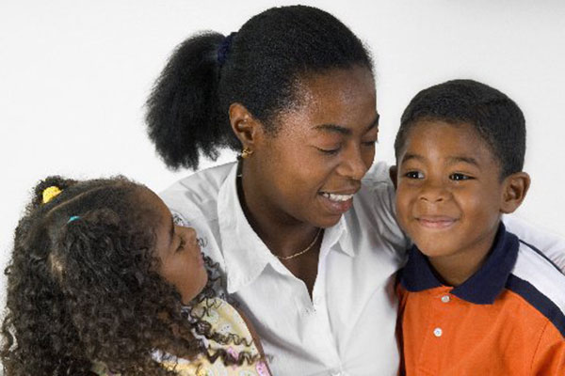

Smiling mother hugging two happy children. Photo/FILE

**In Summary**

* You will not find Faith calling press conferences to express her opinion on children’s predicament or the myriad challenges she faces.
* She has a big, big accommodating heart.
* These folks are nurturing over 3,000 children ranging from days old to some at university.

advertisement

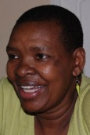**By Asunta Wagura**  
[More by this Author](http://www.nation.co.ke/-/1148/1955584/-/view/asAuthor/-/15km2a7z/-/index.html)

Nothing happens just for the heck of it. When I met Faith 20 or so years ago, I did not know I would later need her.

I often wondered why on earth a young woman like her would go out of her way to keep desperate babies in her apartment in Kayole. Was it not wise to rent it out and make money?

I later learnt that Faith had named her children’s home Imani, which is Kiswahili for her first name. How appropriate.

As fate would have it, I found myself caring for babies that had no one else. I did not know where to turn, especially when HIV-positive mothers died under our care.

I had put all attention on the recovery of the mothers and forgotten about the vulnerable children. I was still naïve and never attended to even a single child’s case, expecting that   
I would lose.

So it came as an emergency when I found myself with babies without caregivers. Most times I did not know where else to turn but to Faith for custody and   
upkeep.

**FAITH'S LABOUR OF LOVE**   
You will not find Faith calling press conferences to express her opinion on children’s predicament or the myriad challenges she faces.

She does her best to ensure that these children live humane lives. In essence, she is rescuing our abandoned future leaders.

If there are people who deserve tickets to heaven because of the selfless work they do on earth, it is Faith and her staff at Imani Children’s Homes.

She has a big, big accommodating heart. These folks are nurturing over 3,000 children ranging from days old to some at university.

There is another side to Faith that I admire. As opposed to KENWA (read me), she takes in any needy baby. Personally, to take or consider a child’s case,

HIV must be mentioned somewhere to justify it. It is either HIV or the highway.

To us, the child qualifies to be needy if both parents are dead and relatives are MIA. Even under such circumstances, we demand a letter from the local chief if we cannot get a death certificate indicating immune suppression… or such terms that “baptise” Aids-related deaths.

**WALK OF FAITH**

When I recently visited Faith in Kayole, she told me she is organising a walk from Nairobi to Malindi to raise funds to build a nyumba ya wazee.

Her workers are old and have nowhere to go. She wanted me to support her in whatever way I could.

“Faith, I can’t even attempt to walk from Kayole to Embakasi,” I sighed.

“No,” she went ahead with her usual smile, as if indicating that I cannot walk even three metres to save my life. “I don’t want you to walk; I just want you   
to flag it off.”

Faith has scheduled it for 1 December, which is World Aids Day (WAD). I asked her why she had settled on, of all days, WAD.

“No one ever told me 1 December is, er, WAD,” she countered.

Faith is not pretentious. She has no time to catch up with the same old same old “recurrent” affairs. Her world consists of babies from all walks of life.

“Asunta, please tell your friends about this walk so that they can join us.”

Me? I do not want to merely tell you about Faith’s walk.

**UNSUNG HEROINE**

I want to toot the horn of this unsung heroine who has committed her life to rescuing our needy children.

She has sacrificed wifely and biological mother ambitions and in return has become the mother of multitudes. Faith once told me that she cannot   
even keep a relationship.

“Which brother will date a sister with over 3,000 children all calling her Mom? When will she even have time for him?”

Speaking of time, Faith’s daily focus is how to get food, (formula) milk, clothes, firewood, and getting her sick children to hospital. As if that is not enough, she is always being called to take in more abandoned babies. At times she gets children who really need special care.

Recently Faith got a baby with no genital organs. They had to do a quick surgery to allow passage of stool and urine. More surgery is scheduled for the limbless and genderless angel.

After delivery, the baby’s mother walked away. She refused to have anything to do with the malformed baby. Faith says the baby is her favourite.

Do not ask me why.

I appreciate and celebrate this woman. I do not know how those who select our national heroes pass over Faith.

If you are reading this, kindly support this unsung hero in her walk and work.

*This is the diary of Asunta Wagura, a mother-of-five who tested HIV-positive 26 years ago. She is the executive director of the Kenya Network of Women with*   
*Aids (KENWA). Email: asuntawagura@hotmai.com*

advertisement