MEDIA COORDINATION GROUP AFGHANISTAN

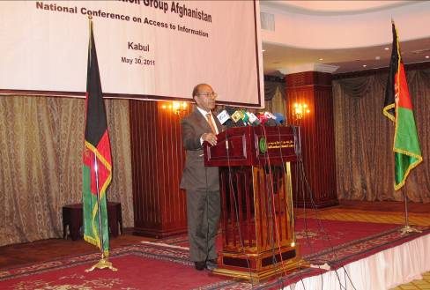

Progress Report

Round One of the Series of Forums
March 27th to June 1st, 2011

“This is the first time I have been asked to act on my issues and problems by myself which gives me a feeling of ownership and honor. This is the first time I am given the chance to participate in a discussion that is at a level of approval of a law in the country. Thank you to the Media Coordination Group of Afghanistan and the people of America to support the efforts!”

Ehsanullah Amini, Mazar-e-Sharif, April 30th, 2011.

Introduction:

Media Coordination Group Afghanistan (MG), under Component 4 of the Afghanistan Media Development and Empowerment Project is responsible for convening four national thematic forums and 16 regional discussion events during the period of the project to the end of October 2011. The MG Afghanistan started its work on the forums and the discussion events in April 2011 and planned to convene the four rounds of discussion in the provinces including the national forums, up to the end of September 2011. MG receives direct financial support from Nai which is an implementing partner of AMDEP.

Summary of Activities:
- Four regional discussion events were convened successfully including a discussion event in Kabul involving journalists from the central provinces, which was held one day before the National Forum in Kabul. The one day discussion events were held in the provinces below and involved journalists from the neighboring provinces. (Annex 1) Here are further details of the catchment areas:
  - Herat
    - Herat, Ghor, Farah, Nimroz and Badghis
  - Balkh
    - Balkh, Takhar, Kunduz, Baghlan, Fariyab, Sar-e-pul, Samangan and Jawzjan.
  - Nangarhar
    - Nangarhar, Laghman, Kunar, Nooristan
  - Kandahar
    - Kandahar, Helmand, Uruzgan and Zabul
  - Kabul (Central Provinces)
    - Parwan, Kapisa, Panjshir, Bamyan, Daikundi, Ghazni, Maidan Wardak, Khost, Paktia, Paktika and Logar.

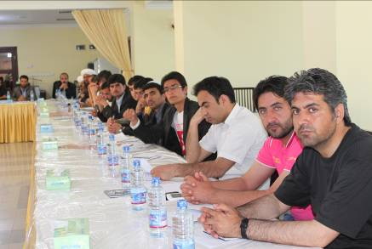
Figure 1, Herat discussion event

2. The National Forum (National Conference), first round, is convened successfully in Kabul involving Kabul Journalists, media organizations, representatives of journalists nationwide, Government high level officials, US Embassy officials, Donor organizations’ officials, and Civil society and Human Rights Organizations’ representatives.
Detail of Activities:
The MG started working on convening the first round of the discussion events on March 27th, 2011. A MG Coordinator/Project Manager, a Forums Coordinator and a Reporting Officer form the executive department of the MG under AMDEP. The MG coordination meetings attended by Internews Afghanistan, Nai – Supporting Open Media in Afghanistan and the MG Steering Committee Members (internal and external organizations) were held successfully with expected results and agreements on activities. The preliminary, introductory meetings between the organizations and related members were held. Coordination of planning and convening of the events included the agreement on cooperation of the MG members themselves and their support for the project.

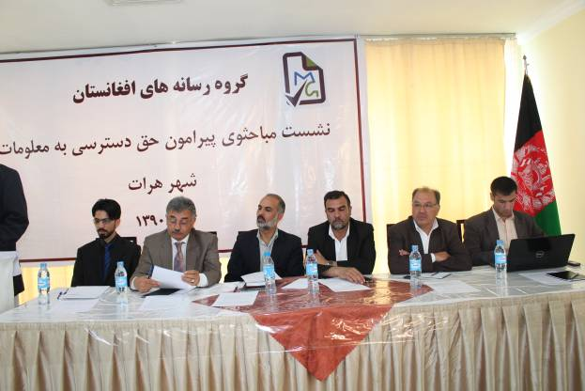
Figure 2, Herat event

Considering the dual status of the Access to Information Law in the country – one version drafted by the Afghanistan Civil Society and Human Rights Organization (CSHRO) in one hand, and the same law drafted by the Afghan Ministry of information and Culture -- and the weak involvement of the Afghan Journalists nationwide in the drafting process of the law by both organizations, the MG steering committee members decided that “Access to Information” should be the subject of the first round of the discussions and the National Conference. The MG believes that Access to Information is a very important element of the journalistic efforts. In addition and, aside from the right that every citizen of the country has to access information, based on article 50 of the Afghanistan Constitution, Afghan journalists are in direct contact with the issue alongside different governmental and nongovernmental organizations while they go about their daily work, collecting information for their reports.
The draft laws were attained by the MG from the CSHRO as well from the Ministry of Information and Culture. All the activities were coordinated with the executive department of the CSHRO.
Herat Event:
The first discussion event was successfully held in Herat on April 24th, 2011, with 61 registered journalists – recorded 75 in total including unregistered participants - from the provinces Herat, Ghor, Farah, Nimroz and Badghis.

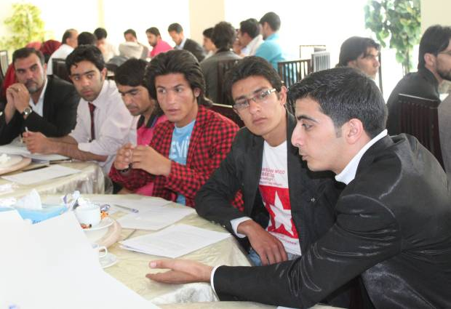
Figure 3, Herat event

In addition to the journalists, local government officials, civil society organizations, and representatives from Internews and, later, the US consulate attended the event.
Some key findings from the Herat discussion:
- The overall right to access information
  - Access to information law greatly supports freedom of expression.
  - The definition of the information should be clearly written in the law.
  - Cancellation of other laws and regulations which stand in the way of access to information law and article 50 of the Afghanistan constitution.
- Ways to access information
  - Awareness should be raised on what is information, and the related laws.
  - Impartiality of journalist creates trust among the sources.
  - Prior to referring to the source, fixing a meeting time.
  - Speed and accuracy of journalists work.
- Legal Framework that Restricts Access to Information
  - Having an unclear and poorly defined definition of what public gain is.
  - Ambiguity in military secrets.
  - No existence of penalty for those who avoid providing information.
  - Having no specific definition of National Security.
- Procedure for assessment of complaints and penalties for those who withhold information
  - Reasons causing lack of access to information:
    - Unresponsiveness of officials
    - Official limitations supervisors to give information
    - placed on some officials by their No official guarantee on implementation of related laws in Afghanistan
    - No existence of a special entity and/or court to assess the complaints recorded by journalists
    - Officials’ lack of information on media-related laws and regulations
  - Related courts must define penalties to punish those who avoid giving information, such as salary deduction, contract termination, and imprisonment.

The working journalists in Herat seemed to have a different understanding to the major media entities about their work. They were excited about the MG’s work which gathered the journalists together and asked their opinions and thoughts and comments on what was really important for their practices regarding Access to Information Law. Some of the journalists complained about a lot of obstacles in their way to get information for their reports and that there had been no recognized or legal entity to refer to and seek help or report the immorality and bad behavior they faced. The journalists were not surprised that the Ministry of Information and Culture, and the Civil Society and Human Rights Network drafted the two copies of the law with no involvement of journalists across the country, because they felt they were always ignored on the higher levels of decision-making even if the issue would affect their work and professional life directly. Media Coordination Group Afghanistan was welcomed and the participating journalists from the provinces Herat, Ghor, Farah, Nimroz and Badghis discussed the subject with a strong interest and were keen on working with Media Coordination Group.

The security situation in Herat was good and there was no problem in convening the event there.
Mazar-e-Sharif Event:
The second discussion event was well managed and successfully held in Mazar-e-Sharif on April 30th, 2011. In total, 134 registered journalists attended – recorded 184 in total including unregistered participants – from the provinces Balkh, Badakhshan, Takhar, Kunduz, Baghlan, Fariyab, Sar-e-pul and Jauzjan. Representatives from US consulate were invited but did not attend.
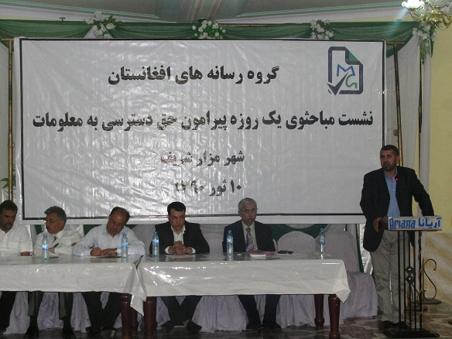

Figure 4, Mazar-e-Sharif event
In addition to the journalists, local government officials, civil society organizations, and representatives from Internews attended the event.
Some key findings in Mazar-e-Sharif discussion:
- The overall right to access information
  - People have the right to get information on government practices and the officials’ responsibilities and steps they take at national and international levels.
  - Journalists have the right to have access to the courts and the judicial system.
  - Journalists have the right to know that their safety is guaranteed while they are getting and distributing the required information.
  - The right to be treated well when asking for information.
  - The right to report from anywhere and anytime except avoided in the any of the Afghanistan laws.
  - It should be stated in the Access to Information Law that the right to access information is given to all the citizens of the country in article 50 of the Afghanistan constitution, so all the related official are aware of its base and the supporting documents.
  - Existence of Access to Information Law enables people to be aware of all the activities of government and nongovernmental organizations in the country and mostly results in eliminating corruption and creating a trustful, credible and peaceful environment between people and the mentioned organizations nationwide.
  - Identifying the personal limits in journalistic work.
- Ways to access information
  - Establishment of a Media Center – a press club – in each province.
  - Establishment of an easy mechanism to access to information.
  - The information about urgent news must be given within two hours, and for non-urgent news, must be given within 48 hours.
- Legal Framework that Restricts Access to Information
  - Some sources in the organizations avoid giving information saying that the information is being investigated and is not to be delivered to the media.
  - Any article in any law can be amended, which is against the right to access information.
  - Those who avoid giving information should be penalized.
  - Clarifying and defining some expressions such as defamation, mental safety, etc.
- Procedure for assessment of complaints and punishing those who withhold information

There are some problems to be identified under this title:
    - Officials avoid giving information, especially the security and police.
    - Lack of professionalism in the media and poor knowledge and capacity of journalists who are assigned to get information.
    - Financial and economic problems.
  - Establishing a joint committee from representatives of media, civil society, government officials such as Ministry of Information and Culture, provincial councils, attorney general, provincial government, national police and national security.
  - In the case where one avoids giving information he should be: 1. Given warning; 2. Expose his name and designation in the media; 3. Terminate his contract

The working journalists in Mazar-e-Sharif were excited about the MG’s work and the gathering. There were complaints about obstacles as well. It was said that when there is an incident and a journalist wants to gather information about it and tries to be the first to reach the sources, the source gives the information first to the journalist he knows or has any type of contact and delays reporting to other journalists to give some time of credit to the one he knows. In other cases it was said that when an incident happens, the sources immediately turn their phones off to avoid giving information and the journalists are therefore in trouble finding the correct information on the happenings; and when they turn their phones back on, the news loses its value and it is then so late for that to be reported, and unfortunately there is nowhere to record complaints against the sources doing so. The journalists didn’t know if the laws were drafted and were very keen to discuss on the issue and were exited being part of the discussion at the level of influencing a law which impacts their personal and professional lives. Surprisingly, the Director of Information in Culture in Maar-e-Sharif – complaining about the Ministry of Information and Culture – said he was not informed of the law drafted by the Ministry of Information and Culture officially. The participating journalists from the provinces Balkh, Taka, Kudzu, Baughman, Farina, Sir-e-pull, Namangan and Jazzman discussed the subject with a deep interest and supported the efforts by the Media Coordination Group Afghanistan.

The security situation in Mazar-e-Sharif was good and there was no threat felt in convening the event there.
Nangarhar Event:
The third discussion was successfully held in Jalalabad on May 5th, 2011. It was attended by 43 registered journalists – recorded 98 in total including unregistered participants. Policemen and guest speakers from the provinces Nangarhar, Laghman, Kunar and Nuristan also attended.

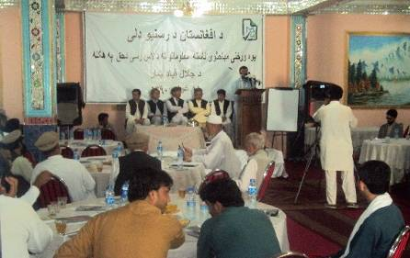
Figure 5, Nangarhar event
.Some key findings from Nangarhar discussion:
- The overall right to access information
  - According to article 50 of the Afghanistan constitution, every citizen of the country has the right to access the information.
  - Giving information to the media benefits all – improves quality of reporting, increases sense of responsibility and advances the country.
- Ways to access information
  - Internet
  - News Agencies
  - Governmental officials
  - Contact media officials
  - Interview ordinary people
  - Spokespersons of the government’s opposition
The sources can be divided into two sources as:
    - Official
    - Unofficial
  - It is noted that unofficial sources give the information quicker than the official ones do.
  - The lack of coordination is clearly observed between the official sources, resulting in different information and statistics given on the same incident or event.

- Legal Framework that Restricts Access to Information
  - The expressions in the laws – access to information and media laws – which need clarification, should be clarified. There are expressions such as defamation, national security, mental security of the ordinary people, etc. which need definition.
  - The officials should not cover them by using the expressions which are not clarified in the laws.
  - There should not be only the spokesperson who gives information to media; other officials should also be responsible to give the required information if asked.
  - Most of the officials are not aware of the laws, even the constitution, and they think people are not allowed to access the information required. Mostly officials knowingly avoid giving information and/or ask to bring letter from supervisor requesting him to give information.
- Procedure for assessment of complaints and punishing those who withhold information

  - If one avoids giving information, first his salary should be deducted, he should be suspended then, and should be terminated, and should be jailed for periods of not more than six months at last.
  - Sometimes even the supporters of journalists, such as the Director of Information and Culture in a province, avoid giving information. If so, he should be penalized twice as strongly as other officials.
  - There should be a procedure whereby a journalist who complains against the source should have the complaint assessed and referred to the courts.

The working journalists in Nangarhar were excited about the MG’s work and the gathering. As in other provinces, there were complaints about obstacles as well. Journalists seemed to be very limited and have had considerable problems in accessing the information. There are issues related to accessing the information which are similar in many ways in the provinces with media activists. The participating journalists from the provinces Nangarhar, Kunar, Laghman and Nuristan discussed the subject with a strong interest and supported the efforts by the Media Coordination Group Afghanistan.

The security situation in Nangarhar was a concern, but we coordinated with the National Police department and the security checkpoint was established out of the hall for a day full. The event went well with no unexpected incident.
Kandahar Event:
The fourth discussion event was successfully held in Kandahar on May 19th, 2011. It was attended by 27 registered journalists - recorded 40 in total including unregistered participants – from the provinces Kandahar, Helmand, Uruzgan and Zabul.

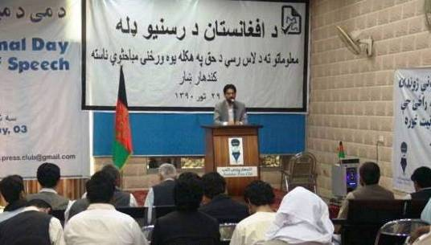
Figure 6, Kandahar event

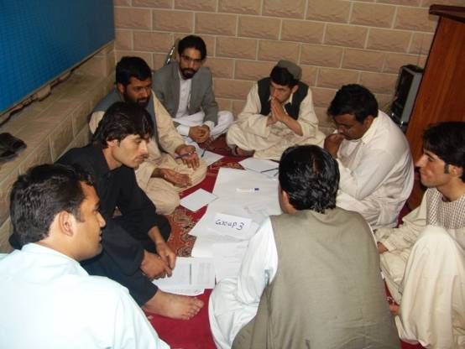
Figure 7, Kandahar event

Some key findings from Kandahar discussion:
- The overall right to access information and ways to access information
  - The spokesperson in every department should be highly educated and should be authorized to give information.
  - There should be workshops held on media law and how to interact with journalists and give information.
- Legal Framework that Restricts Access to Information
  - The officials and the journalist both should be trained on how to give and get information.
  - The journalists should use their professional skills to get information from officials.
  - The officials should understand legal privileges given to the journalists on accessing to information.
- Procedure for assessment of complaints and punishing those who withhold information
  - An impartial, independent and authorized entity should be established to record and assess journalists’ complaints against those who avoid giving information, without a legal reason.
  - The entity should clearly know the penalties and let the media and the government officials understand it so all parties are aware of their responsibilities and the outcomes.
  - The entity should have executive authorization and should not be corrupt or under influence by any governmental or non-governmental entity.

The working journalists in Kandahar were also excited about the MG’s work and the gathering. There were complaints about obstacles as well. Journalists seemed to be very limited and have had considerable problems in accessing the information. One of the journalists said he was working on a report, it took him two months trying, but he couldn’t still meet and interview the National Police Commander. There have been issues related to accessing the information which were similar in many ways in the provinces with media activists. The participating journalists from the provinces Kandahar, Helmand, Uruzgan and Zabul discussed the subject with a strong interest and supported the efforts by the Media Coordination Group Afghanistan.

The security situation in Kandahar was of serious concern. The Media Coordination Group coordinated with Chief of Kandahar National Police and the road to the Kandahar Press Club where the event was held was blocked and the participating journalists were searched. The organizers and the attendees felt unsafe and since the Media Coordination Group had sent an open invitation, they were likely to be reported and treated badly by the insurgent’s activities. But fortunately the event went well and no unexpected incident happened. The security situation resulted in a small number of participants – journalists from Uruzgan province said they had to join International troops’ military convoys so they can travel to Kandahar; otherwise it was not safe for them. They couldn’t carry ID cards, invitations, or any type of document or identification which could endanger them.
Kabul Event:
The fifth event was held successfully in Kabul one day before the National Forum for the journalists of the central provinces who were not expected to attend the rest of the event due to considerable distance and other security and/or safety problems. The event was held on May 29th, 2011, with 40 journalists – recorded 40 in total including unregistered participants – from the provinces Parwan, Kapisa, Panjshir, Bamyan, Daikundi, Ghazni, Maidan Wardak, Khost, Paktia, Paktika and Logar.

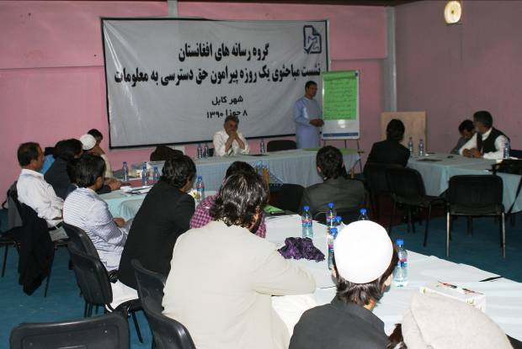
Figure 8, Kabul (Central Provinces) event 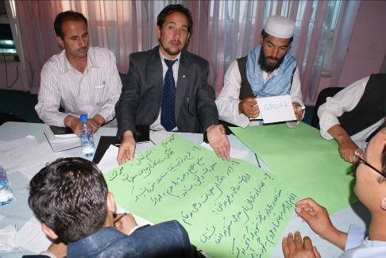
Figure 9, Kabul (Central Provinces) event

Some key findings from Kabul discussion:
- The overall right to access information
  - Access to information is one of the bases for a democratic society.
  - The media and the government officials should be aware of their responsibilities.
  - Personal rights and public benefits should be clarified in the law.
  - A press club should be established in each province.
  - Lack of professionalism.
  - Lack of information about laws.

- Ways to access information
  - Some measures should be taken on the basis of which the sources feel responsible to give information.
  - Establish information source banks and databases in all the governmental institutions.
  - The sources of information in the country – the related national and/or International organizations – should be convinced to give information on their activities to people of the country, nationwide.

- Legal Framework that Restricts Access to Information
  - Avoid asking questions which interfere with the operational activities of the security staff, interference to which is indicated and prohibited by the Afghanistan constitution (but the terms should be defined).
  - Avoid broadcasting or publishing the news that damages national unity.
  - Avoid broadcasting or publishing unbalanced news.
- Procedure for assessment of complaints and punishing those who withhold information

  - Establishing a joint committee to assess and evaluate the journalists’ complaints on access to information.
  - Follow up the complaints of the journalists on lack of access to information.

The working journalists in Kabul forum were also excited about MG’s work and the gathering. There were complaints about obstacles as well. Journalists were not free and were facing considerable problems in accessing the information from official sources. There have been issues related to accessing the information which were similar in many ways in the provinces with media activists. For example, Mr. Sediqullah Khaliq, the Chief Editor of Hewad TV in Kandahar; Ms. Nargiz Ahmadi, the Chief Editor of Saday Baanoo Radio in Sare Pul province; and Mr. Abdullah Azam, reporter of Kalagosh Radio in Nooristan Province complain about reaching officials in a timely way when an incident happens. They believe the officials avoid giving information to the journalists in many ways such as turning their phones off so the journalists can’t reach them when they need information for their reports. The participating journalists from the provinces Parwan, Kapisa, Panjshir, Bamyan, Daikundi, Ghazni, Maidan Wardak, Khost, Paktia, Paktika and Logar discussed the subject with a strong interest and supported the efforts by the Media Coordination Group Afghanistan.
The security situation in Kabul was not of any concern and the event went well.
In order to create a more comprehensive and updated list of journalists nationwide, MG developed detailed registration form which was distributed among the participants during the events and filled in by them. The forms were then collected and entered into a database format which was prepared by Internews. But the database does not yet have all the journalists in the country in it, because some have not filled the forms in, and some have not participated in the events due to various reasons, and some have not returned them. The database is expected to have the majority of journalists’ updated information and contacts in it before the final round of forums.
The MG developed evaluation forms in which participants could record the misses and/or shortcomings of the organizers and their expectations in Dari and Pashto languages. This helps MG improve the quality and satisfaction level of the participants in upcoming events.
The National Forum:
The National Conference, as a concluding event for round one of the series of forums, was convened successfully in Kabul. The Minister of Information and Culture, and the Director of Communication and Public Policy of the Embassy of the United States of America in Afghanistan were the honored guests. Both officials were the key speakers of the gathering as well. Some other colleagues from the Ministry USAID and the US Embassy also attended. The owners of major media entities, the donor agencies, civil society and human rights organizations, and international media representatives also attended the event. The conference had 77 registered representative journalists – recorded 109 in total including unregistered participants – from all 34 provinces of the country.

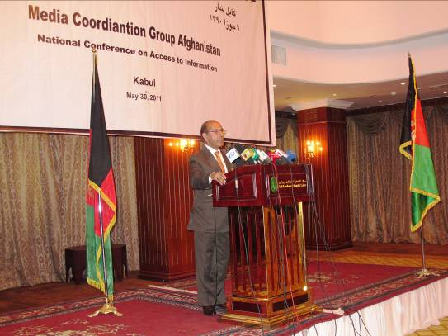
Figure 10, National Forum, Kabul
There were introductions on Afghanistan Media Empowerment and Development Project (AMDEP), the work and role of MG in AMDEP, and what AMDEP brings to media in Afghanistan. The outcomes of the regional discussions were presented by a MG member and in the second session, the journalists were divided into four working groups. They worked and finalized the outcomes of all the group work and each group presented their work.
Figure 11, National Forum, Kabul
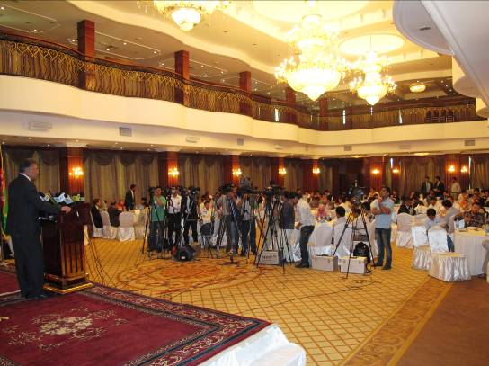

The Journalists’ demands on access to information law, in the form of outcomes of the provincial discussion events and the National Forum, will be submitted to the Ministry of Information and Culture by an official letter from MG. Based on the unofficial talks the MG had with the key officials of the Ministry, they are very much interested to have the journalists’ demands on the law through MG the soonest, so they can consider them before the law goes to the government’s legal departments.
The demands were submitted to the MOIC by an official letter and the MG will follow the process and observe the approach of the joint committee of the law, in which the demands are being considered.

Submission to Ministry of Information and Culture June 6 2011
First Round: Access to Information Law in Afghanistan
Discussion presented by the Afghan Media Coordination Group and attended by delegates from the provincial forums

In the first round of discussions the MG facilitated a forum on the ‘Right of Access to Information’ with media workers, including journalists and staff, from all over the country. The topic ‘Right of Access to Information’ was selected in recognition of the importance of access to information in the journalism profession. It was also intended to enable journalists have their say about the draft access to information law prepared by the Civil Society and Human Rights Network. The initial workshops were held in provincial capitals of the west, north, east and south provinces (i.e. Herat, Mazar-e-Sharif, Jalalabad and Kandahar) all of which saw active participation of journalists in the respective regions.

The provincial meetings began with an outline of the main purpose of the workshops and the efforts undertaken by Ministry of Information and Culture and the Civil Society and Human Rights Network to draft Access to Information Law. Then the participants of each workshop were organized into four working groups where each group discussed specified topics for two hours. The results of their discussions were then shared and further debated in a national gathering in Kabul city attended by government officials, media experts and journalists from Kabul and the provinces. An important objective of these workshops was to reflect the suggestions, viewpoints and demands of Afghan journalists and pinpoint their main issues and challenges so that the legislative bodies are aware of them as the bill goes through the formal process and is eventually passed by the parliament. The collated responses were shared with the Ministry of Information and Culture.

Group discussions consistently revolved around the following topics regarding the right to access information.

- The overall right to access information: the general definition of this right and its importance were discussed.
- Ways to access information: Discussions were focused on how to obtain information from pertinent sources.
- The Legal Framework that Restricts Access to Information: the legal framework that keeps journalists from accessing information was debated.
- Procedure for assessment of complaints and punishing those who withhold information: Discussions revolved around ways to handle complaints and how to punish individuals or entities that refuse to give information to journalists.
The results of these discussions are outlined below:

A: Definition and Importance of the overall right to access information

- It is in the public interest to obtain information about all activities of government and nongovernment agencies that are relate to the public’s right to know.
- Ensuring the right to access information helps institutionalize freedom of expression in the country.
- Access to information will enhance accountability and facilitates public oversight on the performance of government and nongovernment institutions.
- Free information-sharing helps citizens have a more realistic approach towards electing competent figures for senior government positions. That is, freedom of access to information plays an important role in helping citizens demonstrate their free will in choosing individuals as members of government administration.
- With freedom of access to information in place, corruption and narcotics can be fought more vigorously.
- Improved access to information will put an end to monotony of journalistic work and will further diversify the profession by opening the way for investigative and analytical journalism.
B: Mechanisms for obtaining information

- Establish databases in all Afghan administrations
- Develop websites for all government and nongovernment organizations to enable spontaneous access to information
- Establish an ‘Information sharing agency’ within government and nongovernment sectors
- Appoint qualified and professional individuals to provide the requested information
- Determine the timeline for access to information as follows:
- Information that can result in saving the life of a citizen should be made available no later than 24 hours from the time the request is made.
- Information needed for news reports should be made available no later than 48 hours from the time the request is made.
- Information needed for investigative and/or analytical reports should be made available no later than 20 days from the date the request is made.
C: Legal Framework that Restricts Access to Information

- National security, independence and territorial sovereignty;
- Military secrets;
- Commercial interests/benefits of private companies and corporations; and
- Individuals’ privacy/personal space.

Here participants emphasized that a clear definition of national interests must be articulated by the Access to Information Law.

D: Procedure for assessment of complaints and punishing those who withhold information

- Establish the media violations tribunal with a division to handle cases of denial by authorities to share information;
- Establish a dedicated branch of the Attorney General’s Office to deal with complaints in this respect;
- Determine a timeline for handling complaints; and
- Categorize, as below, consequences for authorities who intentionally and unreasonably withhold information:
    - Oral warning;
    - Written warning (to be recorded in personal file);
    - Demotion;
    - Termination; and
    - Imprisonment that will not exceed two years.
Impacts and success stories:
Journalists from across the country actively participated in the regional discussions. They were not expecting any media organization to allow them be involved in solving their own work-related issues and the challenges they face professionally. The journalists mostly think that all the decisions on their issues are made in the higher administrative levels in the media organizations and they are simply informed of them. Many of them said this was the first time they were asked to act on their issues and problems by themselves which gave them a feeling of ownership and honor.
The journalists thanked MG and the people of the United States for providing them the way to be practically involved in decision making and the processes of dealing with major issues. The level of commitment of the journalists seemed to be improved and they were encouraged to more actively participate in the gatherings and dialogue on the other major issues related to their work.
The MG, through the process and the progress, is gaining credibility among the journalists nationwide which is highly valuable for the future of the MG work. The MG would like to hold discussions about forming a National Federation of Journalists in the last round of the events. A majority of journalists in the provinces are familiar with MG’s work, its impartiality – MG is being recognized by its members and the members are recognized to be impartial – its aim to work for the rights and benefits of the journalists by involving themselves in the high level processes and major issues; and AMDEP’s value and role of the project on the future of media future in Afghanistan.
Challenges:
All the events were successfully held, however, there still were tensions because of the security situation that was an obstacle for the attending journalists and the MG members in both Nangarhar and Kandahar provinces. The MG coordinated with the security related governmental agencies in both provinces; however, still the nervousness of the attendees was clearly noticeable.
The Media Coordination Group steering committee members actively took part in the process and the events were photographed and filmed for future records.
Next steps: Round two discussion on journalists employment rights
MG, during some informal talks with the journalists in the margin of the regional discussions learned that most journalists feel they are under a bad pressure because of the conditions of their contracts with media employers across the country.
In some cases, when a journalist leaves a media organization, s/he is bound to not work for the similar media for a period of six months or in some cases even for one year which makes the journalist work under a lot of pressure and sometimes in the worst working environments in order to prevent the termination of their contract. This can result in them staying jobless for an undefined period of time and not be able to earn a living. In some other cases it was said that journalists don’t have medical insurance, life insurance, and sometimes were treated in a “dictatorship” environment. It was found out that most journalists in the country are worried about their working environment and conditions and most of them don’t know about the ‘Journalists’ Employment Regulation’ drafted by the Ministry of Information and Culture. They were keen to speak on the issues and to be seriously heard.
Considering that there is a period of time before the Draft Regulation is sent to the legal related organizations, the MG has decided to take the opportunity to make the ‘Journalists’ Employment Regulation’ the subject of the second round of the regional discussion events. The MG will then bring the demands of the journalists nationwide to the consideration of the Ministry of Information and Culture and the legal related entities before the Regulation is approved. MG believes the Regulation should take into consideration the demands of the journalists and what they experience in their practical working life to make the Regulation a comprehensive one and acceptable to journalists as well.
The MG has obtained the Draft Regulation by the Ministry of Information and Culture and broken down the broad subject of “Journalists’ Employment Regulation” into four specific group titles as:
- (Journalists’) Employment Contracts’ General Conditions
- Employment rights; dos and don’ts for media employees and employers
- Social guarantees, medical insurance, retirement benefits and journalists’ safety conditions
- Conflict resolution and discrimination between media employees and employers
The second round of the regional forums will address these concerns.

