TASKS

**1 .**  
### **\*\*First Set of Tasks for Interns – Week 1 at DoozieSoft\*\***Welcome,  
Your first week is all about onboarding, understanding our workflows, and getting hands-on with small tasks. The goal is to ensure both of you are on the same track and can collaborate efficiently.---### **\*\*:hammer_and_wrench: Onboarding Tasks (Day 1-2)\*\***  
1. **\*\*System Setup & Access\*\***  
   - Install required development tools (VS Code, Git, Node.js, Postman, MySQL Workbench, etc.).  
   - Get access to **\*\*GitHub, Redmine, Slack, and databases\*\***.  
   - Clone the repository and set up the project locally.2. **\*\*Understand DoozieSoft’s Codebase & Architecture\*\***  
   - Go through project documentation and watch the recorded walkthrough (if available).  
   - Explore folder structure, APIs, and database schema.  
   - Write a **\*\*short summary\*\*** (bullet points) of your understanding.3. **\*\*Intro to Git & Version Control\*\***  
   - Learn Git branching strategy (feature branches, commits, pull requests).  
   - Create a **\*\*test branch\*\***, make a small change (fix a typo or add a console log), and push a commit.  
   - Raise a **\*\*dummy pull request (PR)\*\*** for review.---### **\*\*:computer: Hands-on Coding Tasks (Day 3-5)\*\***  
Both of you will work on a **\*\*simple full-stack task\*\*** to get comfortable with our workflow.1. **\*\*Task: Create a “User Feedback” Feature\*\***  
   - Build a **\*\*basic form\*\*** (HTML/CSS + JavaScript) that takes user feedback (name, email, comments).  
   - Store the feedback in a **\*\*database table\*\***.  
   - Develop an **\*\*API endpoint\*\*** (`POST /feedback`) to save feedback into the database.  
   - Create an **\*\*API endpoint\*\*** (`GET /feedback`) to fetch all feedback data.2. **\*\*Additional Requirements:\*\***  
   - Use **\*\*React (if applicable) or simple HTML/JS\*\*** for the frontend.  
   - Backend to be implemented using **\*\*Node.js/PHP/Python (as per project stack)\*\***.  
   - Store feedback in a MySQL table.3. **\*\*Testing & Review\*\***  
   - Use **\*\*Postman\*\*** to test API requests and validate data storage.  
   - Create a simple **\*\*README file\*\*** explaining your approach.  
   - Raise a **\*\*pull request (PR)\*\*** for code review.---### **\*\*:pushpin: End-of-Week Checkpoint\*\***  
- **\*\*Demo session\*\***: Show your work and walk us through your approach.  
- **\*\*Feedback & improvements\*\***: Team will review your code and suggest improvements.  
- **\*\*Next steps\*\***: Based on progress, we will assign new tasks for the following week.

<https://www.youtube.com/watch?v=W6NZfCO5SIk>

<https://dooziesoft.slack.com/files/U08EP93UTEX/F08E9CZTRF1/student-sentiment-analysis-platform-intern-program-overview.pdf>

<https://www.youtube.com/watch?v=EUM78cxo0i8&list=PLDyQo7g0_nsVHmyZZpVJyFn5ojlboVEhE&index=3>

**2.**

**Day 1 Update (Installation & Setup)**  
:loudspeaker: **Intern Task Update – Day 1** :rocket:  
Hey Team,  
Your task for today is to **install and set up**[**Dify.AI**](http://dify.ai/) on a local or cloud environment. Follow these steps:  
:white_check_mark: **Understand**[**Dify.AI**](http://dify.ai/): Go through the official docs and learn about its features.  
 :white_check_mark: **Install Dependencies**: Ensure **Docker, PostgreSQL, Redis** are set up.  
 :white_check_mark: **Deploy**[**Dify.AI**](http://dify.ai/): Install and run it on your chosen environment.  
 :white_check_mark: **Verify Installation**: Access the web UI and check if it’s running.  
:pushpin: **Deliverables for Today:**  
 :one: Screenshot of a successful installation.  
 :two: Notes on any setup challenges you faced.  
Drop your updates in this Slack thread before EOD. Let’s get this up and running! :fire:**Day 2 Update (Chatbot Setup & Training)**  
:loudspeaker: **Intern Task Update – Day 2** :robot_face:  
Hey Team,  
Now that [Dify.AI](http://dify.ai/) is installed, today’s focus is **setting up the chatbot** for Engineering students on "AI & Machine Learning."  
:small_blue_diamond: **Tasks for Today:**  
 :white_check_mark: Create a **new chatbot project** in [Dify.AI](http://dify.ai/).  
 :white_check_mark: Set up **basic Q&A intents** (e.g., "What is AI?", "What is Deep Learning?").  
 :white_check_mark: Upload relevant **engineering-related datasets** or documentation.  
 :white_check_mark: Fine-tune responses using prompt engineering.  
:pushpin: **Deliverables for Today:**  
 :one: A working chatbot with at least **10 AI/ML-related questions & answers**.  
 :two: A brief note on how you set up and trained it.

**3.**

<https://dify101.com/>

dify101.com

[Dify 101 Tutorial: Comprehensive Guide to Master Dify.ai | No-Code AI Application Development Tutorial](https://dify101.com/)

Dify tutorial: Unlock the power of [Dify.ai](http://dify.ai/). Learn to build AI applications using LLMOps. From basics to advanced techniques, our tutorials cover prompt engineering, RAG, and low-code workflows. Perfect for developers and innovators. Let's Start! [dify.ai](http://dify.ai/)

<https://medium.com/@whiteking64/explore-dify-a-step-by-step-guide-to-building-a-simple-llm-powered-application-d1dd361a33ad>

MediumMedium

[Explore Dify: A Step-by-Step Guide to Building a Simple LLM-Powered Application](https://medium.com/@whiteking64/explore-dify-a-step-by-step-guide-to-building-a-simple-llm-powered-application-d1dd361a33ad)

Introduction to Dify

use online version

<https://docs.dify.ai/>

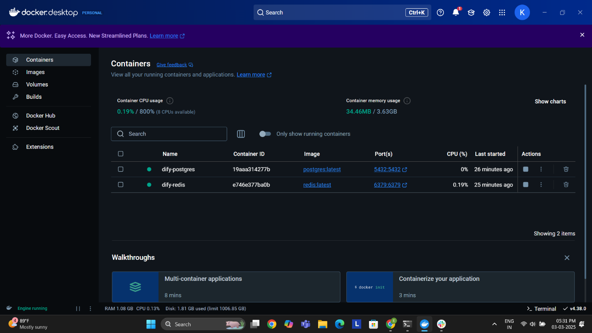

**4.**

**Task for Interns: Chatbot Development for Solar ERP Assistance**  
**Objective:**  
Develop a chatbot using [**Dify.AI**](http://dify.ai/) and **Grok** that assists users in navigating and troubleshooting the **custom ERP for solar installers**.  
**Task Breakdown:**

1. **Get Access to the ERP & Resources**
   * **ERP Access:**
     + <https://dg.digantarashmi.com/login>
     + username : MSM
     + password : MSM#123
   * **Google Drive Documentation:** <https://drive.google.com/drive/folders/1pk57AKIjV3heljyz0cxqT8d6Wb--XxeB?usp=sharing>
   * [**Dify.AI**](http://dify.ai/)**Access:** Create an account on [Dify.AI](http://dify.ai/) and explore the platform.
   * **Grok Integration:** Learn about Grok's API and capabilities.
2. **Understand Use Cases**
   * Review **common user queries** and ERP workflows.
   * Identify **top 5 frequent issues** users face.
3. **Design Chatbot Flow & Prompts**
   * Use **[Dify.AI](http://dify.ai/" \t "_blank)’s prompt builder** to create structured responses.
   * Design a **decision tree** for guiding users step-by-step.
   * Ensure chatbot responses are **ERP-specific and solution-oriented**.
4. **ERP API Integration**
   * Work with the dev team to get ERP API endpoints.
   * Test **basic API calls** like fetching project status, invoice details, or pending tasks.
5. **Testing & Debugging**
   * Deploy a **beta version** inside the ERP.
   * Collect **user feedback** and refine responses.
6. **Documentation & Handover**
   * Document the chatbot workflow and API integration.
   * Add a troubleshooting guide.

**Expected Deliverables:**  
:white_check_mark: Working chatbot prototype in [**Dify.AI**](http://dify.ai/)  
 :white_check_mark: Integrated API calls for **real-time ERP data fetching**  
 :white_check_mark: Documented guide on chatbot usage & troubleshooting  
:small_blue_diamond: **Deadline: 10 March 2025**  
 :small_blue_diamond: **Mentor/Reviewer:** *Akshay*  
Let me know if you need refinements! :rocket: (edited)

white_check_markeyesraised_hands

[9:51](https://dooziesoft.slack.com/archives/C063UD66KPH/p1741234878221429)

akshay

create user and workflow documents

[9:51](https://dooziesoft.slack.com/archives/C063UD66KPH/p1741234891618359)

akshay

and feed to chatbot knowledge

[9:51](https://dooziesoft.slack.com/archives/C063UD66KPH/p1741234910701489)

akshay

there is high chances this would be improved upon and used in live setup

[9:51](https://dooziesoft.slack.com/archives/C063UD66KPH/p1741234919113259)

akshay

so do your best

<https://www.youtube.com/watch?v=SWP3k-24jT4>

<https://youtu.be/sTeoEFzVNSc?si=kZeI4GXWhbkMKPUP>

<https://youtu.be/H4YK_7MAckk?si=A8RYLRF_BM01JlI7>

<https://youtu.be/_ZvnD73m40o?si=ky11PzkEgEXs2FhF>

<https://www.youtube.com/watch?v=XVO3zsHdvio>

**5.**

**Maanay**

<https://www.figma.com/design/z3TV5YPOf8yTm7EjIdAVGM/TIEI-NEXUS?node-id=0-1&t=s9S30n0IPe02S7dt-1>

figma to html/react  
  
  
**6.**

<https://demos.pixinvent.com/materialize-html-laravel-admin-template/demo-1/dashboard/crm>

<https://www.figma.com/design/LZbFxbGOXT41nKWD4hBMjV/Manpower-Planning?node-id=0-1&p=f&t=k9KFeVHmpP5SQkWW-0>

Say better

<https://app.wordtune.com/>

<https://tools.dsshub.in/>

<https://it-tools.tech/>

<https://www.youtube.com/watch?v=1SNZRCVNizg>

<https://laracasts.com/series/30-days-to-learn-laravel-11>

<https://www.youtube.com/watch?v=CkVrmLLHmuI>