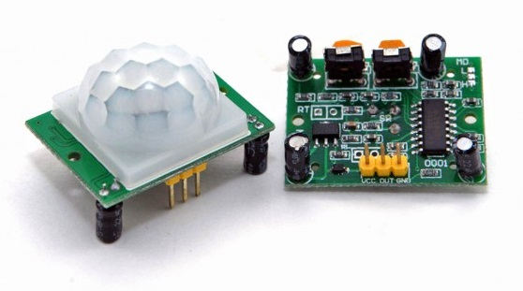

LAB-0  
**Install pir motion sensor**

authors: **Ahmadriza sewruttan & soufyan Hilali**  
datum: **25-02-2021**   
VERSIE: **0.1.0**

Index

1. Intro 3

2. about motion sensors 3

3. Parts required 3

4. Install the parts 3

5. function report 4

6. End results 4

# Intro

in this step by step guide I will explain how to install a pir motion sensor. There will of course be pictures to help you with this guide. The photos also make the guide shorter and clearer for the person who wants to perform this installation. What's so great about this Iot project is that it doesn't end here. This is a series of different Iot projects. It starts of course with some simple projects but then it gets more difficult and of course more challenging.



# about motion sensors

The first motion sensor was invented in the year 1950 by Samuel Bango named as a burglar alarm. He applied the basics of a radar to ultrasonic waves – a frequency to notice fire or robber and that which human beings cannot listen to. The Samuel motion sensor is based on the principle of “Doppler Effect”.

Source: [Different Types of Motion Sensors And How They Work (elprocus.com)](https://www.elprocus.com/working-of-different-types-of-motion-sensors/)

# Parts required

1. 1x batterij rond de 9v (volt)

2. 5x connection cables

4. 1x resistor

5. 1x led

6. 1x pir motion sensor

7. 3x jumpwires (female to male)

8. 1x anti static band

# Install the parts

Use this photo as a reference point to connect all the parts together. You can use two batteries but you can also use one like we did.

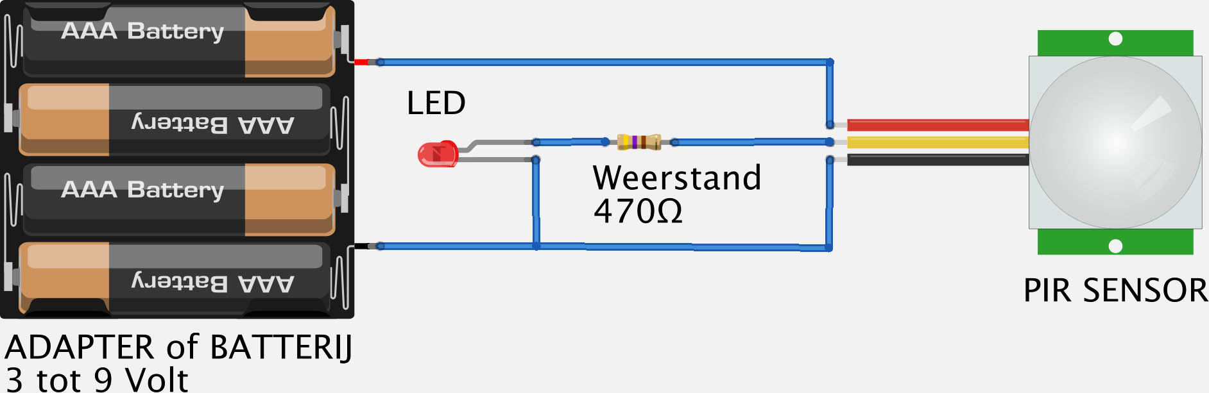

Source: [Tweaking4All.com - Testing and Playing with PIR sensors (motion sensor)](https://www.tweaking4all.com/hardware/pir-sensor/)

# function report

Test the sensor and check that everything is reported to be working properly. If everything works fine and the light is on on command, the installation is complete. If not, you should check that all cables are properly connected and then you should test it again. After this tip everything should work fine and this pir motion sensor installation is successful.

# End results

This is what the end product should look like:

