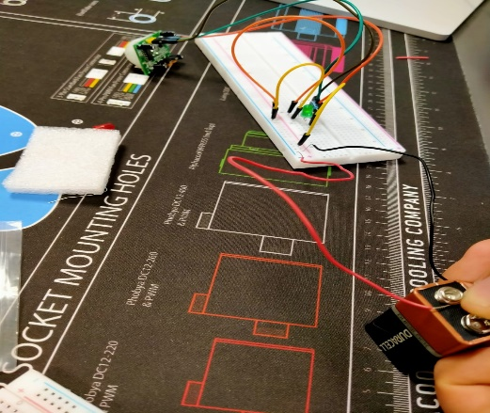

LAB-0  
**Install pir motion sensor to breadboard**

authors: **Ahmadriza sewruttan & soufyan Hilali**  
datum: **01-03-2021**   
VERSIE: **0.2.0**

Index

1. Intro 3

2. about motion sensors 3

3. Parts required 3

4. Install the parts 3

5. end product 4

# intro



in this step by step test guide I will explain how to install a pir sensor on a breadboard. There will of course be pictures to help you with this test guide. The photos also make the test guide shorter and clearer for the person who wants to perform this installation. What's so great about this Iot project is that it doesn't end here. This is a series of different Iot projects. It starts of course with some simple projects but then it gets more difficult and of course more challenging.

# about motion sensors

The first motion sensor was invented in the year 1950 by Samuel Bango named as a burglar alarm. He applied the basics of a radar to ultrasonic waves – a frequency to notice fire or robber and that which human beings cannot listen to. The Samuel motion sensor is based on the principle of “Doppler Effect”.

Source: [Different Types of Motion Sensors And How They Work (elprocus.com)](https://www.elprocus.com/working-of-different-types-of-motion-sensors/)

# parts required

3x jumping wires (male to male)

1x pir motion sensor

1x breadboard

1x 9v battery

2x connecting cables

3x jumping wires (female to male)

# install the parts

First you are going to install the pir motion sensor on the breadboard. Follow the steps in this photo to complete this installation process:

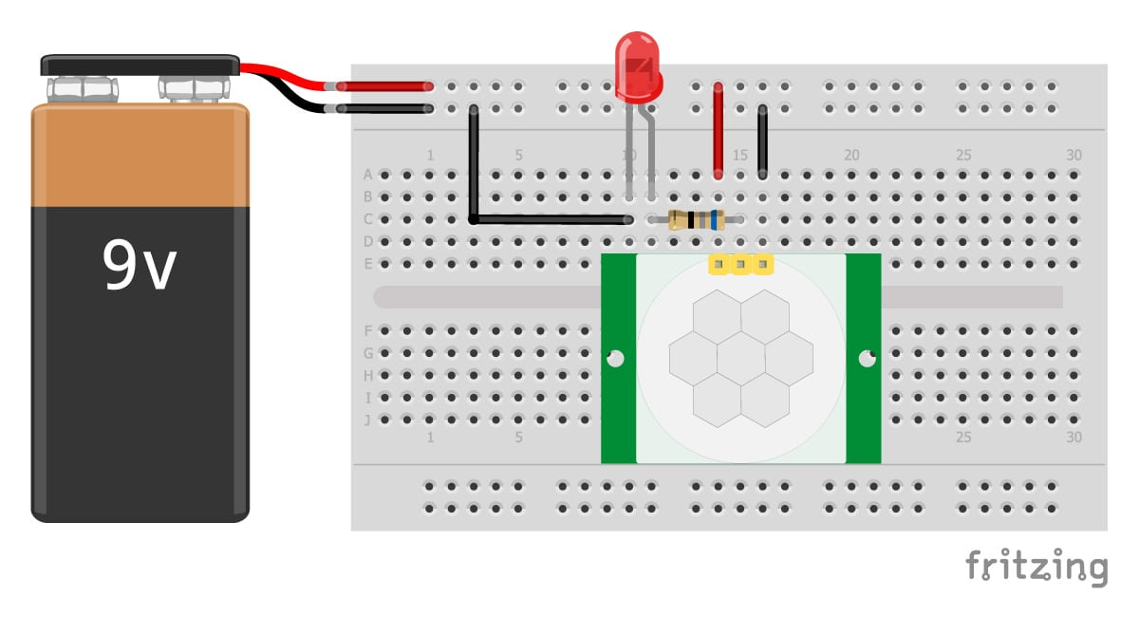

Source: https://fritzing.org/

# end product

Everything should work now. If not, you should check the cables and see if you can install them better. After that, everything should work as indicated.

This is how the final product should look like:

