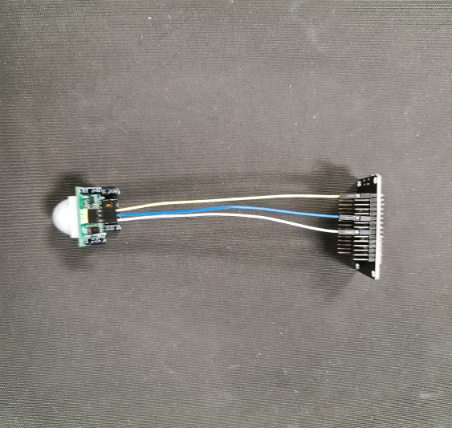

LAB-2  
**install pir motion sensor to esp8266**

authors: **Ahmadriza sewruttan & soufyan Hilali**  
datum: **25-02-2021**   
VERSIE: **2.2.0**

Index

1. Intro 3

2. Short history ESP8266 3

3. Parts required 3

4. Install the parts 3

5. Install/configure Arduino 4

6. The code and com explanation 6

7. End results 8

# Intro



in this step by step guide I will explain how to install a pir motion sensor to esp8266-01. There will of course be pictures to help you with this guide. The photos also make the guide shorter and clearer for the person who wants to perform this installation. What's so great about this Iot project is that it doesn't end here. This is a series of different Iot projects. It starts of course with some simple projects but then it gets more difficult and of course more challenging.

# Short history ESP8266

It is a WiFi microchip module, introduced by Espressif Systems, that comes with both TCP/IP and Microcontroller capability.ESP8266 is very user-friendly, features low cast and develops a simple TCP/IP connection by connecting microcontrollers with WiFi. It has an ability to hosting or offloading all WiFi function to other processors. The first chip in this series was ESP-01 that gained a sheer attention in the market but created language barrier as it came with Chinese documentation.Later many features are added to this device that mainly comes with English documentation. It is easy to use and even an average person can make their feet wet with the learning of this device.In this tutorial, we discuss ESP8266 WiFi module, its features, specifications, applications and everything you need to know to make it run in a real-time. Let's dive in and nail down everything related to this device.

Source: <https://www.theengineeringprojects.com/2018/08/introduction-to-esp8266.html>

# Parts required

1x Pir motion sensor

1x Esp8266-01

3x Jumping wires (female to female)

1x micro usb cable

# Install the parts

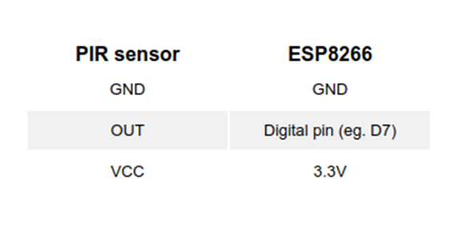

Source: [How to connect a PIR sensor to an ESP8266 - Wia Community](https://community.wia.io/d/56-how-to-connect-a-pir-sensor-to-an-esp8266)

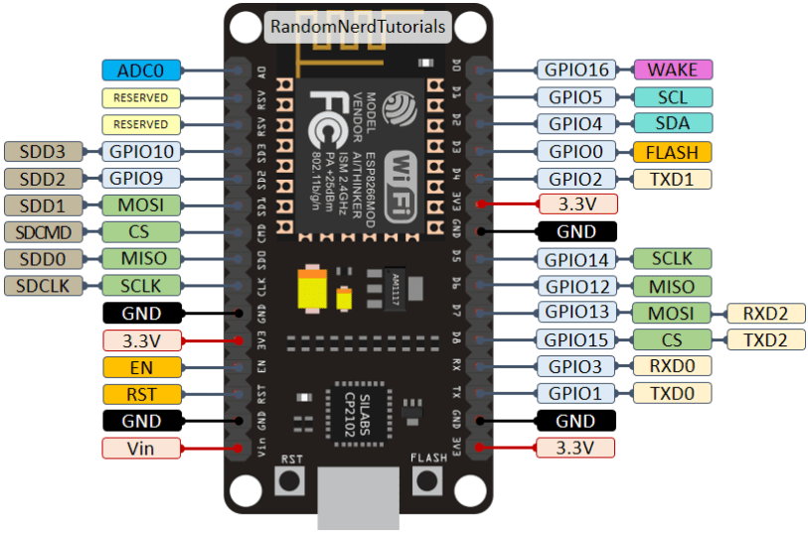

Source: [Getting Started with ESP8266 WiFi Transceiver (Review) | Random Nerd Tutorials](https://randomnerdtutorials.com/getting-started-with-esp8266-wifi-transceiver-review/)

# Install/configure Arduino

Install the Arduino IDE (Integrated development environment). You can download it for Mac OS X, Windows and Linux.

Start the Arduino application and open Preferences

Enter http://arduino.esp8266.com/stable/package_esp8266com_index.json into the Additional Board Manager URLs. If you need more than one, they can be separated with commas

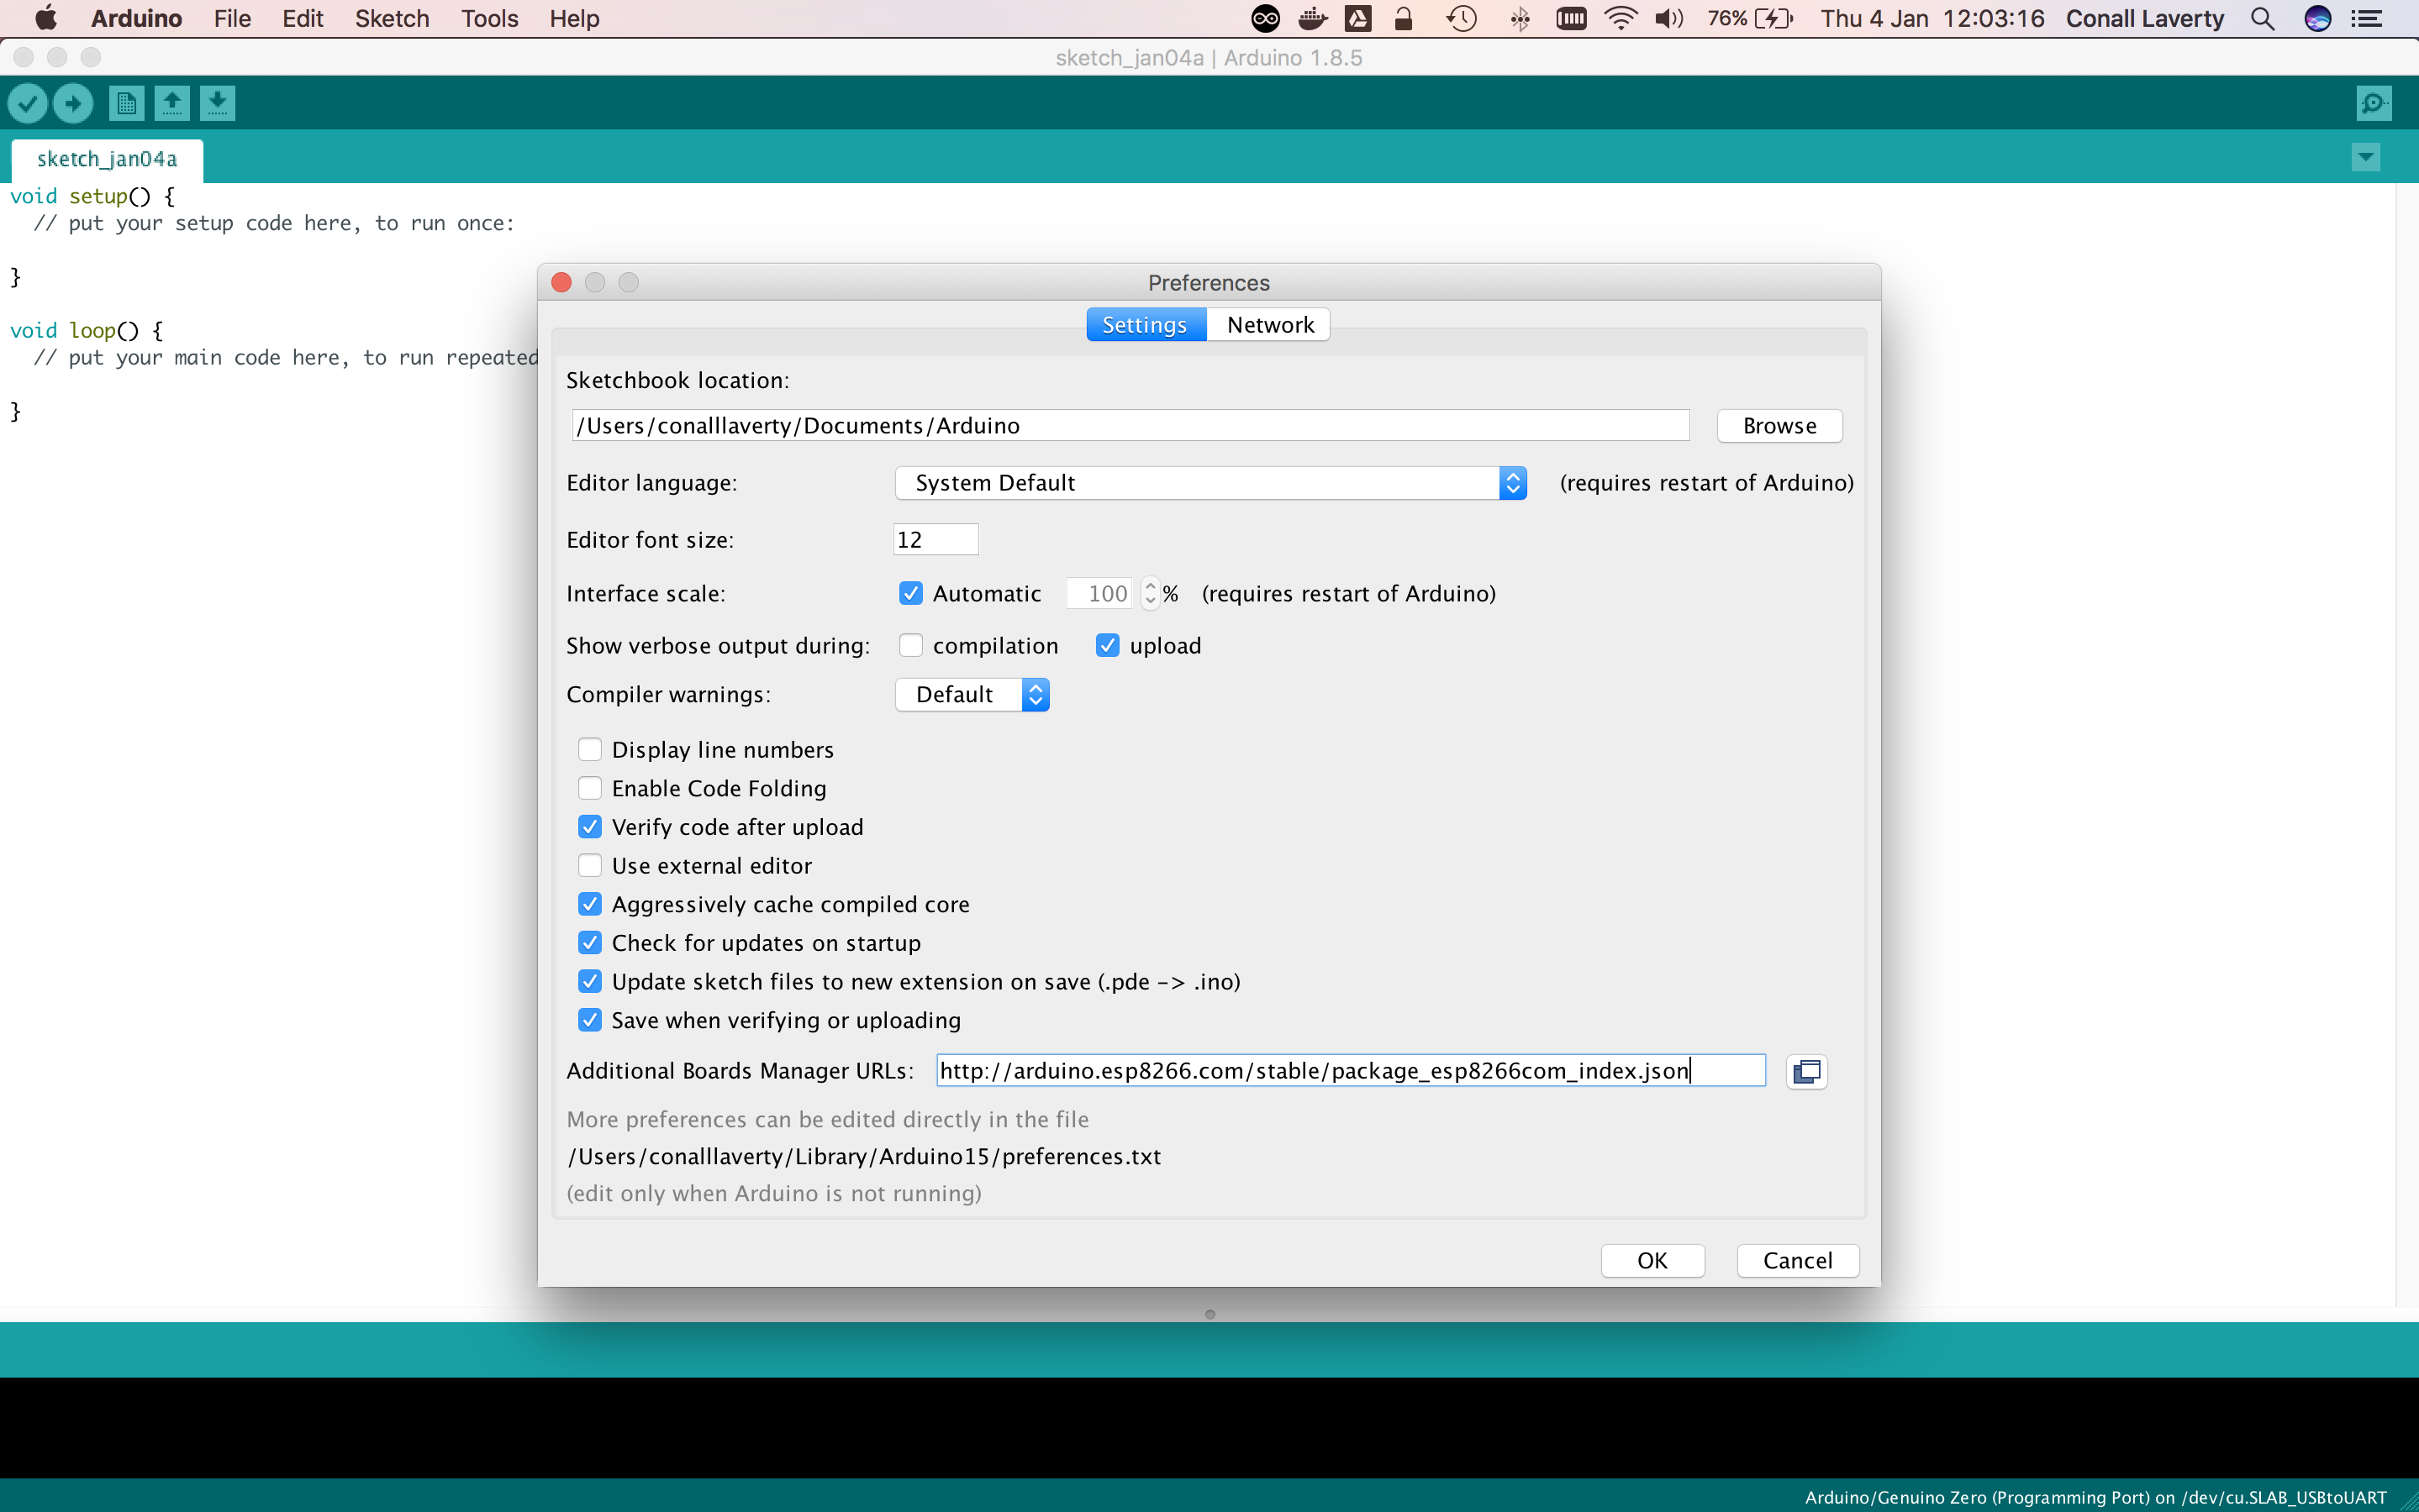

Go to Tools > Board > Boards Manager

Search for esp8266. When found, click Install

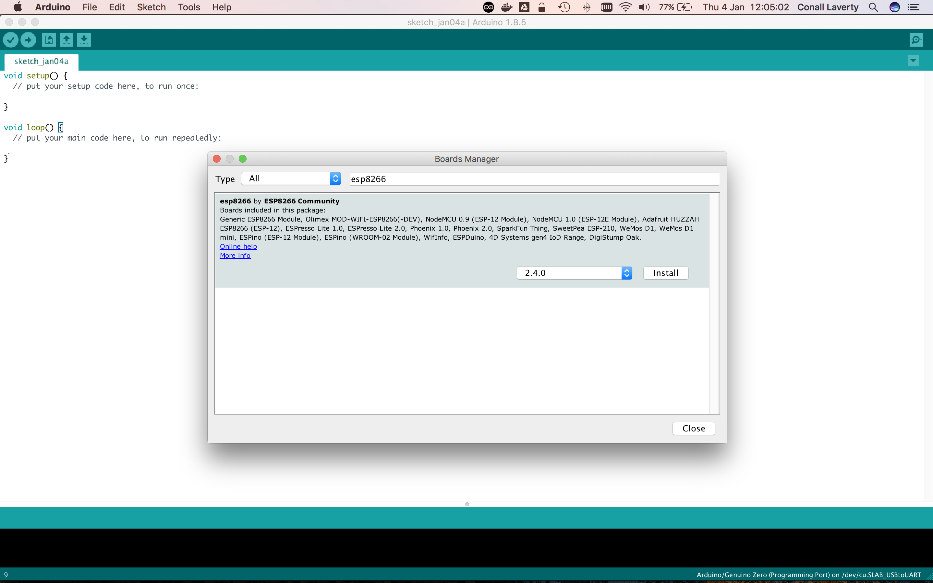

Plug in the ESP8266 to your USB port

Select your ESP8266 board type by going to Tools > Board, then choosing your type. For this example, you can use NodeMCU 1.0 (ESP-12E Module)

Check that Upload Speed is set to 115200

Select the correct port for the board

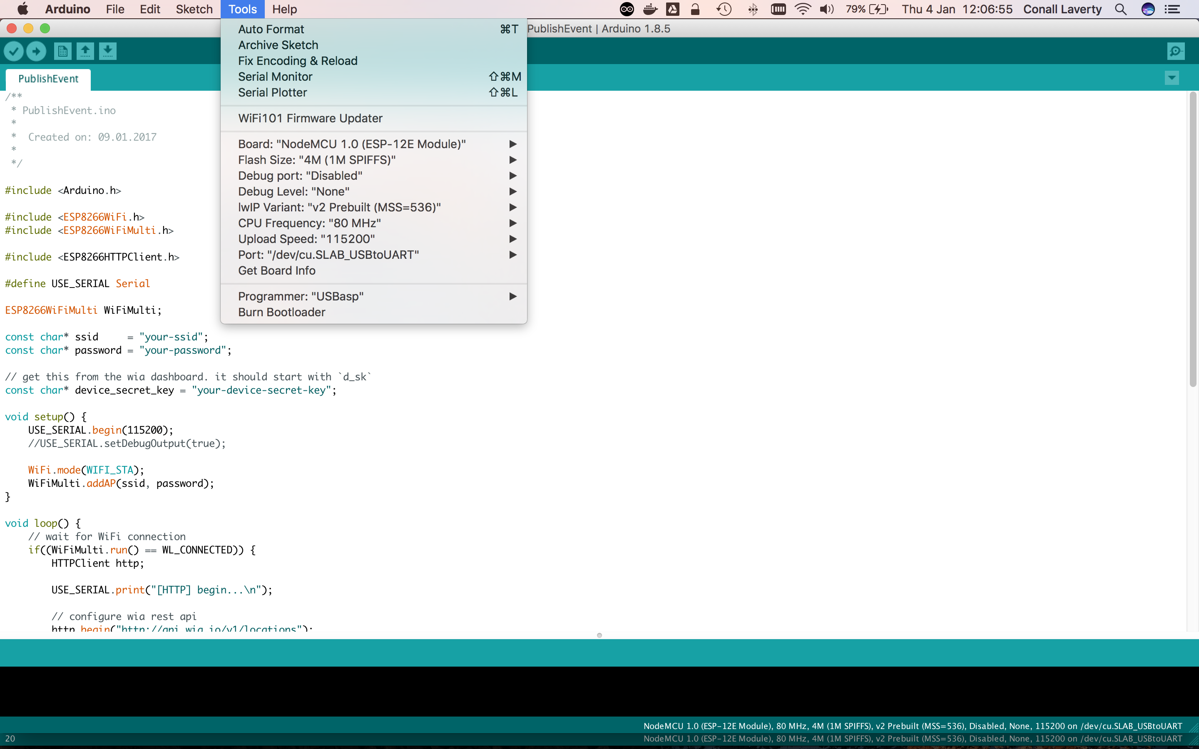

# code and COM explanation

Now that everything is set up, here's a basic sketch you can use to get started with detecting motion:

**int** sensor = 13; // Digital pin D7

**void** **setup**() {

pinMode(sensor, INPUT);

Serial.begin(115200);

}

**void** **loop**() {

**long** state = digitalRead(sensor);

**if** (state == HIGH) {

Serial.println("Motion detected!");

delay(1000);

}

**else** {

Serial.println("No motion detected.");

delay(1000);

}

}

* Open the Arduino IDE software.
* Go to Tools menu and click on the Port option. You’ll be able to see all of the available ports.
* This option will enable only after connecting the board.
* Select the correct port that is connected with the board by clicking on it.

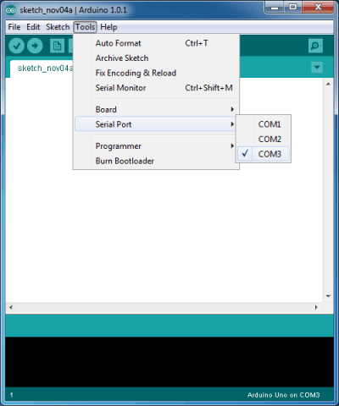

# End results

Now everything should work if you have followed all these tips. If there are still problems, you have to adjust the sensitivity and then everything should work. Now you are ready to use the sensor, goodluck!!!

This is what the end product should look like:

