**Exchange Server Up gradation**

**Objective: -** Exchange server space and Service pack up gradation from SP1 to SP3.

**Phase1:-** Exchange Server’s Space up gradation.

**Phase2:-** Exchange server’s Service Pack up gradation from SP1 to SP3.

**Phase1:-** Exchange Server’s Space up gradation.

I have observed that email database size increasing rapidly and need some proactive action to running it smoothly.

In the time of one exchange host down I have found that mail flow is working fine except few things are not working. But the current server space not sufficient to run the email system smoothly after 2-3 months.

**I have found that current server setting and space available in the exchange server will impact the mail flow in future.**

**Observation: -**

1. Bothe Exchange server’s Hyper-V host INTNNOIHVS01 and INTNOIHVS02 have no space (Only 10 GB available) for further grow not the physical hardware slot available in the server to upgrade the Hard Disk.
2. Both Exchange Database server NOIEX01 and NOIEX02 hold the Kolkata and San Jose database respectively.
3. Both the Exchange Database server has 50 GB space available after flushing the exchange transaction logs.
4. Before flushing the transaction logs exchange have 15-25 GB space available for Database and logs.
5. In the time of one exchange database server down another exchange server have only 2-3 GB free space available.
6. Both Exchange Database servers have static disk configured means it’s not the flexibility to increase and decrease the disk space.

**INTNOIHVS01**

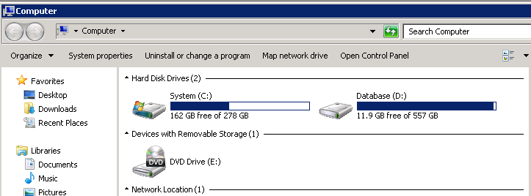

**INTNOIHVS02**

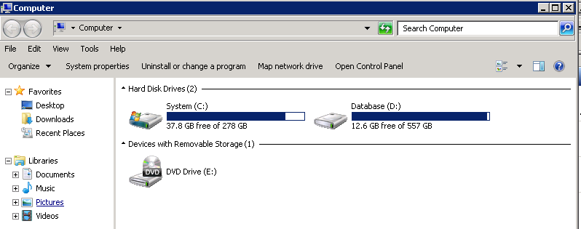

**Further Action:-**

Requesting to Biman to please arrange a meeting with attendee of Biman Roy, Ravi Gupta, Subhrodeep Sarkar and Anil Kumar to know more about the same and come up in the same page for the action.

**Phase2:-** Exchange server’s Service Pack up gradation from SP1 to SP3.

As last discussed with Microsoft 1 year back he will not giving the support for the exchange if the exchange server don’t have SP3, The current exchange server is running with SP1 only, So its need to upgrade with Exchange service Pack 3.

**Note: -** Exchange server’s service Pack up gradation is the one way task it’s not possible to revert the exchange server’s service pack after up gradation.