I want to share with the community code recently posted in OpenExchange, that builds on the Business Activity Monitoring features available with InterSystems IRIS’s integration framework.

**Background:**

For some time, IRIS (and previous products like Ensemble), provided developers with the ability to define interoperability metrics, (Business Metrics), and a way of repeatedly collecting values for these metrics, then visually representing these in dashboards.

This feature is implemented with Business Metric classes (which are subclasses of Ens.BusinessMetric) that are developed and included within interoperability productions. A Business Metric class defines metrics as properties:

For example, an IoT solution receiving regular environmental readings on a site may expose the following metrics from all data collected:

Property AverageDailyTemp as Ens.DataType.Metric (Units = “Degrees”);

Property AirQuality as Ens.DataType.Metric (Units = “AQI”) [Multidimensional];

…

The implementation of the Business Metric functionality requires a developer to provide code to gather and populate the values of each metric property, which is executed within the class’s OnCalculateMetrics() method.

The online documentation for defining Business Metric classes can be found here: <https://docs.intersystems.com/irislatest/csp/docbook/DocBook.UI.Page.cls?KEY=EGDV_bmetric>

Once values are captured, developers can also define Web-based Dashboards to display business metrics or other data (such as Analytics pivot tables) in widgets of IRIS Analytics User Portal

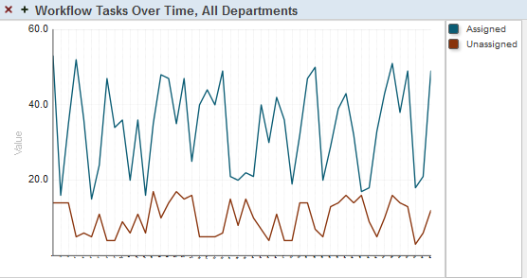Documentation for consuming this data and displaying it in dashboards can be found here: <https://docs.intersystems.com/irislatest/csp/docbook/Doc.View.cls?KEY=ECONFIG_dash>

**Enhancement:**

The functionality introduced here extends on existing, pre-defined Business Metric mechanism as follows:

Using already built, and running Metric class:

1. Capture and push (using HTTP POST) the metric values to a nominated REST endpoint.

This is useful if you want to capture metrics and update a remote system. For example – using this feature one can push the metric values to a Power BI DataSet which can be then consumed by Microsoft PowerBI Dashboards for real-time visualization in that framework.

Interoperability Production

HTTP **POST**

pre-Implemented Business Metric Service(s)

new Business Operation functionality to post Metric data

1. Propose a REST API that can act as an endpoint for external systems to call in and retrieve:
   1. The list of business metric classes running in a production
   2. JSON for the metrics of a given enabled Business Metric Class
   3. JSON for the metrics of all enabled Business Metric Classes

Interoperability Production

**REST Api**

pre-Implemented Business Metric Service(s)  
 New API Class functionality to retrieve Metric data

1. Options (1) and (2) should be done without needing to modify any existing Business Metric class code, but instead, tap into the tables currently defined by IRIS, that holds the latest metric values.

**Installation**

Please follow the instructions outlined in the Open Exchange Details section here:

xxxxxxxx

More documentation can be found there.

**Example:**

Consuming IRIS BusinessMetrics within PowerBI by publishing to a Microsoft Power BI dataset.

Step 1: