**Thearchy Nodes Wanted | INT Foundation Announces Node Plan**

**Catalogue:**

1. **INT Chain Node Related Terms**
2. **INT Chain Node Plan Ecological Blueprint**
3. **INT Chain Node Plan Timeline (Mainnet Live Phase)**
4. **INT Chain Node Election Details (Mainnet Live Phase)**
5. **INT Chain Node Incentives**
6. **INT Chain Node Incentive Details**
7. **INT Chain Node Penalty Mechanism**
8. **INT Chain Thearchy Node Configuration Requirements**
9. **FAQ**

**Annex 1. INT Node Deployment Guide**

**Annex 2. Node Supplementary Information Form**

**Annex 3. Wallet Vote Guide**

The “Thearchy Chain” is the core of the INT’s entire architecture, which consists of servers provided by device manufacturers, community leaders and ecological enterprises (namely Thearchy Nodes). The basis for Thearchy Node generation is the INT consensus algorithm -DPoS+dBFT, which realize high TPS while ensuring the fairness of node election. INT Chain “Thearchy Node” will be generated by the community voting and there will be 13 Thearchy Nodes. The INT Foundation will officially launch the Thearchy Node election at the time of mainnet launch. By then 13 Thearchy Nodes will jointly build the INT Chain global ecosystem.

**INT Chain Node Related Terms**

|  |  |  |
| --- | --- | --- |
| **No.** | **Term** | **Description** |
| **1** | INT Chain | An economy driven solution to improve the device interconnection of Internet of Things. |
| **2** | Thearchy Node | The node responsible for the block generation and data synchronization. |
| **3** | Candidate Node | The node responsible for forwarding the block info, the candidate node could become a Thearchy Node by voting. |
| **4** | Reward Node | In each round of voting, under the pre-condition that a block is successfully generated, the top 100 candidate nodes are reward nodes and can obtain system rewards, which will be recorded in real time. |

**INT Chain Node Plan Ecological Blueprint**

INT Chain Node plan is divided into two phases:

1. **Mainnet live phase**: the number of Thearchy Nodes is 13 and the rest are candidate nodes. Top 100 nodes voted are eligible for incentives, called “reward node”. The Thearchy Node provides INT Chain with networking, storage, computing, etc. INT Chain encourages each Thearchy Node to build and develop their own communities and hopes that all the global community members with different backgrounds can jointly grow the whole INT Chain global ecosystem.
2. **Node expansion phase**: it could happen at least one year later. The specific time and number of nodes depend on the development of the community. The longer-term node expansion plan will be determined by the community in the future.

**INT Chain Node Plan Timeline (Mainnet Live Phase)**

* INT Foundation Release Node Plan: January 10th, 2019
* Election Launch: at the time of mainnet launch
* Duration: long term

**INT Chain Node Election Details (Mainnet Live Phase)**

1. All registered nodes are considered as candidate nodes. Please check **Annex 1** for the Node Deployment Process. A block is generated every 10 seconds. The voting circles every 360 blocks successfully generated, approximately 1 hour. The top 100 candidate nodes will be recorded as reward nodes in real time every time a block generates, and the top 13 reward nodes will be the Thearchy Nodes in the voting cycle.
2. In the initial stage of mainnet launch, considering the security of the mainnet, the INT team will initiate the first 13 Genesis Thearchy Nodes and will provide 5,000,000 INT for voting for the 13 Genesis Nodes.
3. The Thearchy Nodes elected are responsible for block generation during the next round of voting as well as other related works such as transaction verification, bookkeeping, block packing and confirmation in the INT Chain. The Thearchy Nodes will receive the corresponding rewards and be supervised by the INT Chain global community.
4. Any individual or institution holding an INT can vote for candidate nodes during the election. Each INT can vote for up to 20 candidate nodes. Voters can cancel or change their votes at any time. The corresponding INT for voting will be locked and cannot be traded. Voters can cancel their votes at any time for trade.
5. The candidate nodes can come from industries include but are not limited to: Internet of Things, media, exchanges, capital, e-commerce, logistics, biomedical, network security, etc.

6. The influence factors of becoming a Thearchy Node include server configuration, network bandwidth, deployment status. There is no requirement for holdings of INT.

**INT Chain Node Incentives**

In order to better maintain INT Chain network, the INT team expects to spend 20 million INT per year as node rewards by 2023. The reward will be all paid out of the INT Chain Foundation's dedicated wallet.

The specific reward distribution rules are as follows:

1. The Thearchy Node will receive 30% of the rewards mentioned above. Whenever a block is generated, the Thearchy Node who is responsible for generating the block will receive the corresponding block reward. It is beneficial to motivate the node maintainer to continuously upgrade the device and improve the TPS in the whole network.
2. The Reward Node will receive 50% of the rewards according to the number of votes every time a block is generated. This rule is to solve the problem that the distribution rule is too single and improve the activity and stability of the entire network.

3）20% of the reward will be distributed to all voters. This is for encouraging the whole community to actively participate in the voting.

Remark: All the rewards will be issued within seven working days.

After the success of block generation, Thearchy Node can obtain not only the rewards issued by the INT Chain Foundation and the block reward but also the transaction fee for the corresponding block which will be granted in real time. At the same time, candidate nodes can also obtain a certain amount of rewards.

In the future, any adjustments to the above distribution rules may be proposed by any one of 13 Thearchy Nodes based on community opinions. After more than 2/3 of the Thearchy Nodes agree with the proposal, the new distribution rules can take effect.

**INT Chain Node Incentive Details**

1. **As a Thearchy Node**

* Block reward

For each block, the Thearchy Node will receive 1.9025874 INT.

*Note: 1.9025874 INT = (total reward amount per year/total block number per year) *30%*

* Transaction fee

The Thearchy Node will receive the transaction fee for the generated block in real time.

1. **As a Reward Node (Thearchy Node is also a Reward Node)**

The Reward Node will receive INT according to the proportion of votes obtained in each round of voting as long as a block is successfully generated.

For example, in the first round of voting, when the 50th block is generated, the Candidate Node A ranks 50th and the number of votes obtained at this time is 1000, and the total number of votes on the whole network is 10000 (which is the total votes of the top 100 candidate nodes at that moment), therefore, the vote ratio of the candidate node A is 1000/10000*100%=10%, and the candidate node will obtain 10%*3.170979=0.3170979 INT.

*Note: 3.170979 INT = (total reward amount per year/total block number per year) *50%*

1. **As a voter**

Assume that from the beginning of the first round of the voting cycle to the end of the second round, voter A, voter B, and voter C simultaneously participate in the voting, and the sum of votes is as follows:

|  |  |  |
| --- | --- | --- |
| **Voter** | **Sum of votes at the end of the first round of voting** | **Sum of votes at the end of the second round of voting** |
| Voter A | 50 | 40 |
| Voter B | 50 | 50 |
| Voter C | 50 | 100 |

The system will calculate the reward at the end of the second round of voting:

(Remarks: 40+50+50 refers to the sum of all valid votes at the end of the second round of voting cycle; 360 refers to the sum of blocks in the first round of voting cycles; 1.2683916 refers to the number of INT that voters will receive when each block is generated)

User A will get: 40/(40+50+50)*360*1.2683916=195.69470 INT

User B will get: 50/(40+50+50)*360*1.2683916=244.61838 INT

User C will get: 50/(40+50+50)*360*1.2683916=244.61838 INT

*Note：1.2683916 INT = (total reward amount per year/total block number per year)*20%*

**INT Chain Node Penalty Mechanism**

In order to ensure the stability of the network, we have determined the corresponding punishment mechanism. If a Thearchy Node did not generate any block during a consecutive 2160 blocks generation period, it would be automatically removed from the node list and disqualified from block generation in the current and next 24 rounds (about 24 hours). We will immediately launch a temporary election.

**INT Chain Thearchy Node Configuration Requirements**

Thearchy Node is required to own a strong performance server. Otherwise, the function of Thearchy Node cannot work, and the Thearchy Node will be automatically disqualified. For all Thearchy Nodes, the server configuration must meet at least the following specifications:

|  |  |  |
| --- | --- | --- |
| **Classification** | **Configuration** | **Remarks** |
| **CPU** | 8 CORE, 2.0GHz or above |  |
| **Memory** | 16G |  |
| **Hardware** | 2T，7200RPM；SAS，HDD/SSD |  |
| **Network** | Bidirectional bandwidth exceeds 50Mbps,  100Mbps is recommended. |  |
| **System** | Windows or Linux | All systems need to be installed in English. |

**FAQ**

**Q: What if I don’t have the technical skills to run a node, how does it work, what return can I expect, what support will INT give to me, etc.**

A: Please refer to Annex 1 (INT Node Deployment Guide) to complete the configuration of the node running environment. If you just want to become a normal node (i.e. a candidate node), there is no need to have a dedicated server and the normal network environment will be fine. If you want to be a Thearchy Node, you must meet the INT Chain Thearchy Node configuration requirements. When a candidate node is listed in the top 100 list in each round of voting cycle and in the block generation period, it will become a reward node and obtain rewards.

**Q: Will the elected Thearchy Nodes be able to share a portion (%) of their profits to their voters? If yes, will the Thearchy Nodes decide how often (daily, weekly, monthly, etc.) they distribute these rewards?**

A: The INT team will spend 4 million INT per year as the reward to encourage community members to participate in the voting. Whether Thearchy Nodes share their profits or not depends on the Thearchy Nodes themselves.

**Q: Is there a minimum time (lock-up) when mortgaging INT tokens? If yes, could you explain the impact on vote + profit sharing when un-mortgaging our tokens.**

A: There is no lock-up period and users can unmortgage them at any time. Once unmortgaged, the corresponding number of votes will be canceled and so will the possible voting rewards.

**Q: When running another node than Thearchy (Supernode for example), do you also need to store your tokens in the INT-wallet? If yes, can you run such a node (Supernode in our example) and vote at the same time for a Thearchy node? In that way you can generate double profits?**

A: No need. Only when the user wants to participate in voting, INT must be stored in the INT wallet to mortgage and vote.

**Annex 1. INT Node Deployment Guide**

Preparation: Please register a new INT wallet address through the Web wallet, save the node address and the corresponding private key.

1. Start a peer node according to the GitHub tutorial (https://github.com/intfoundation/int).
2. Register a candidate node with INTjs code or RPC request (http://docs.intchain.io/intjs/#register>). If successful, you can find your INT node address in the node list page of block explorer.
3. Try to vote for yourself by using the web wallet to see whether it is successful or not.
4. Start a miner on the server by using your private key of the candidate node. Only starting the miner can a Thearchy Node generate the blocks.

Remark: After finishing the above process, the node address will be automatically updated to the node voting list on INT Web wallet and the node list on INT explorer.

1. Please fill out the Annex 2-Node Supplementary Information Form and send it to intfoundation@intchain.io. The supplementary information will be updated to the node list on INT explorer for people to learn more about the node.

**Annex 2. Node Supplementary Information Form**

|  |  |
| --- | --- |
| **Node Supplementary Information Form** | |
| Team Name |  |
| Website* |  |
| Node Address# |  |
| Country |  |
| City |  |
| Email* |  |
| Social Media* |  |
| Other* |  |
| Remarks:  1. " * " refers to the item is optional.  2. “ # ” refers to the item shall be filled out only after completing the node deployment process. | |

**Annex 3. Wallet Vote Guide**

Please login INT’s Web wallet link: <http://wallet.intchain.io> and find the vote section, which includes mortgage, vote and unmortgage. You must mortgage INT before you can vote.

1. **Mortgage**

1. Unlock the wallet by either Keystore or Private Key.

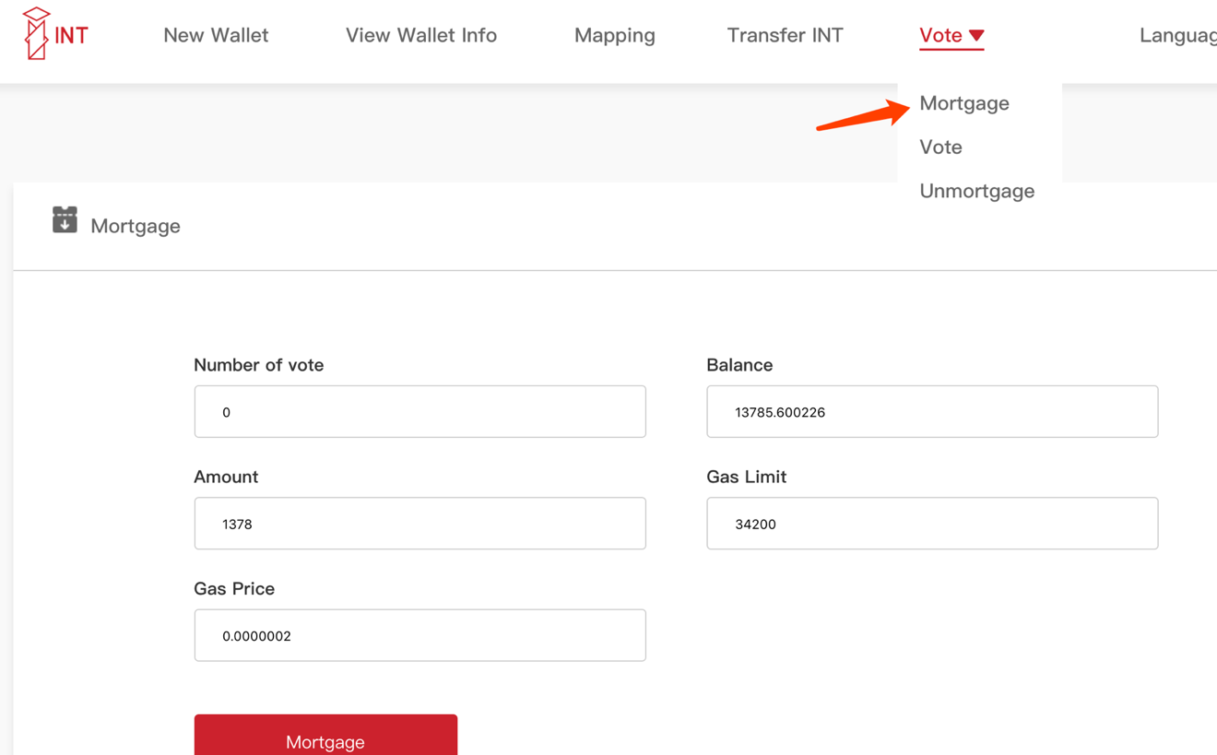

2. After confirming the number of vote, the balance of wallet, the amount of INT to be mortgaged and gas fee, click on mortgage.

(The system default gas limit and price can be modified as needed)

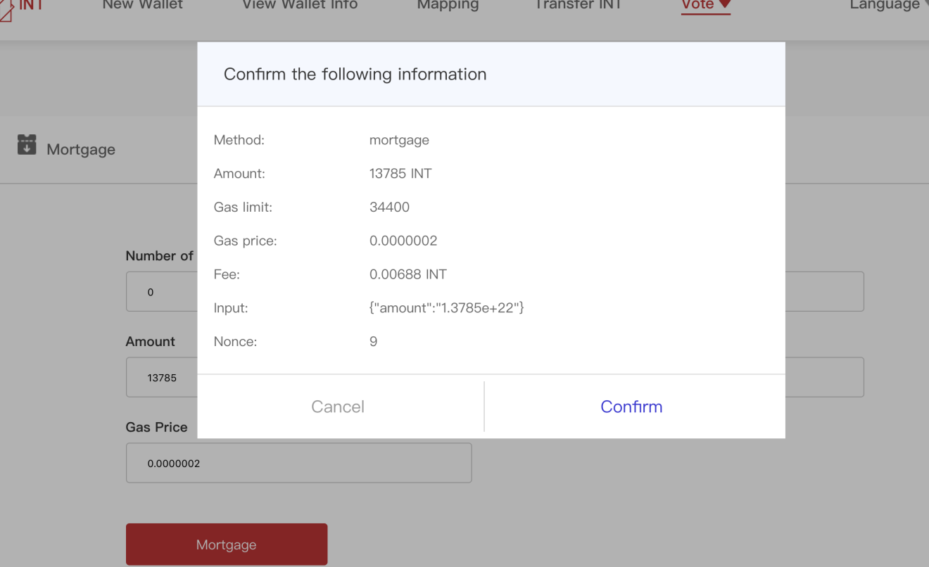

3. Please confirm the above information:

Cancel if there is an error;

Confirm if it is correct.

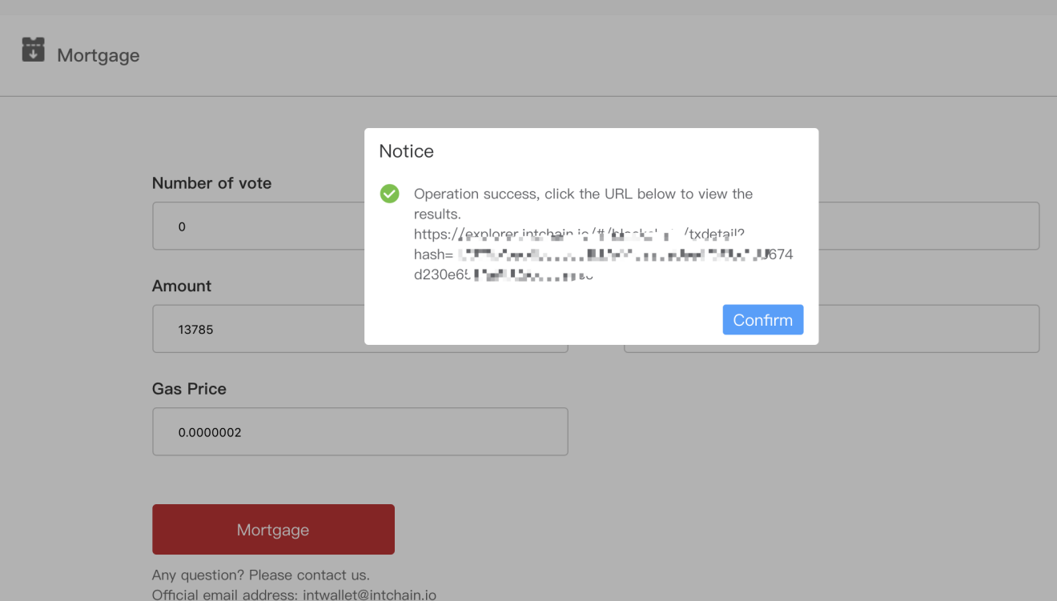

4. This page shows “operate successfully”, you can click on URL to check whether to mortgage INT successfully. Under normal circumstances, all can be successful.

1. **Vote**
2. Unlock the wallet by either Keystore or Private Key.

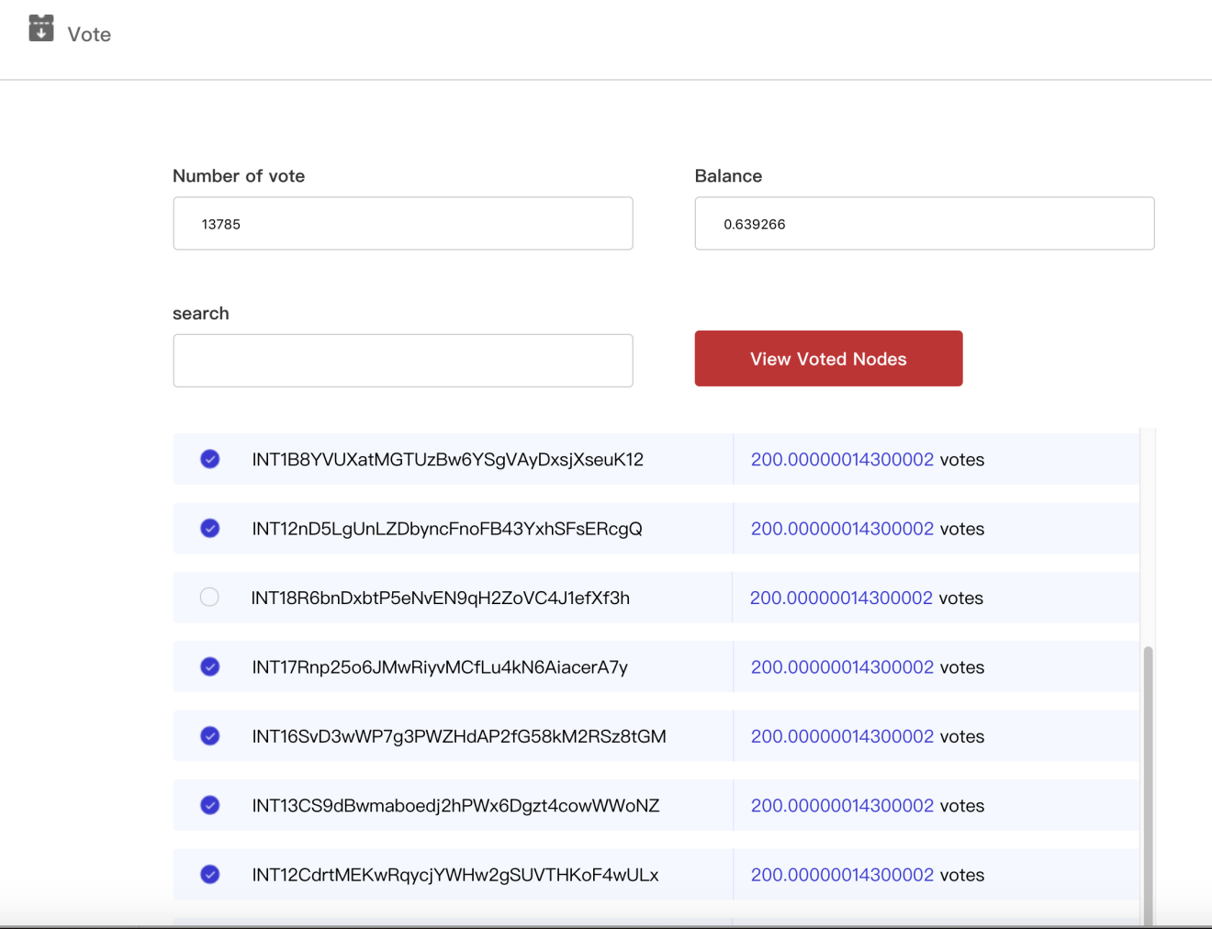

1. Confirm the number of votes (the votes for every node are equal to the amount of your mortgaged INT), and the voting address, click on vote.

Note:

1) Each wallet can vote for up to 20 nodes at a time, and you can search for the address you want to vote on as needed;

2) The vote depends on the latest operation, and the previous number of votes for the nodes is invalid;

3) The system default gas limit and price can be modified as needed.

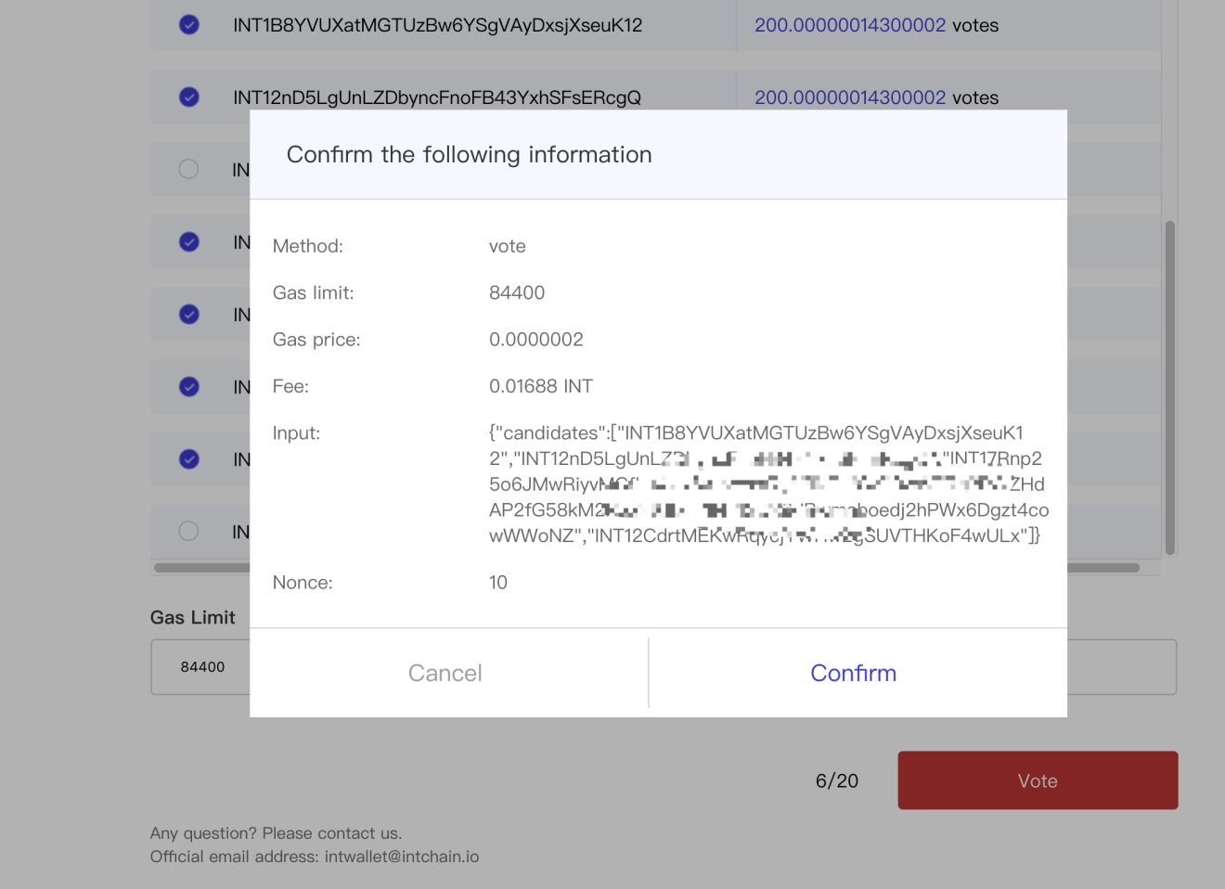

1. Please confirm the above information:

Cancel if there is an error;

Confirm if it is correct.

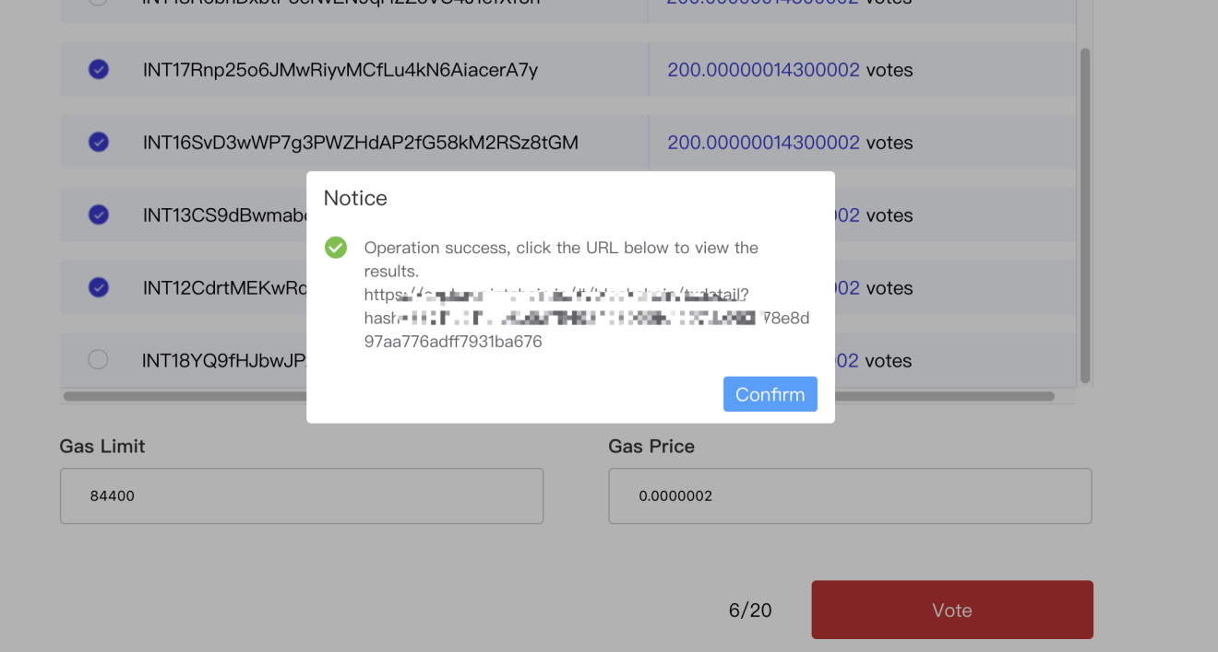

1. This page shows “operate successfully”, you can click on URL to check whether to vote successfully. Under normal circumstances, all can be successful.
2. Click on the “View Voted Nodes” below to view the list of currently voted nodes; there will be no data if not voting.

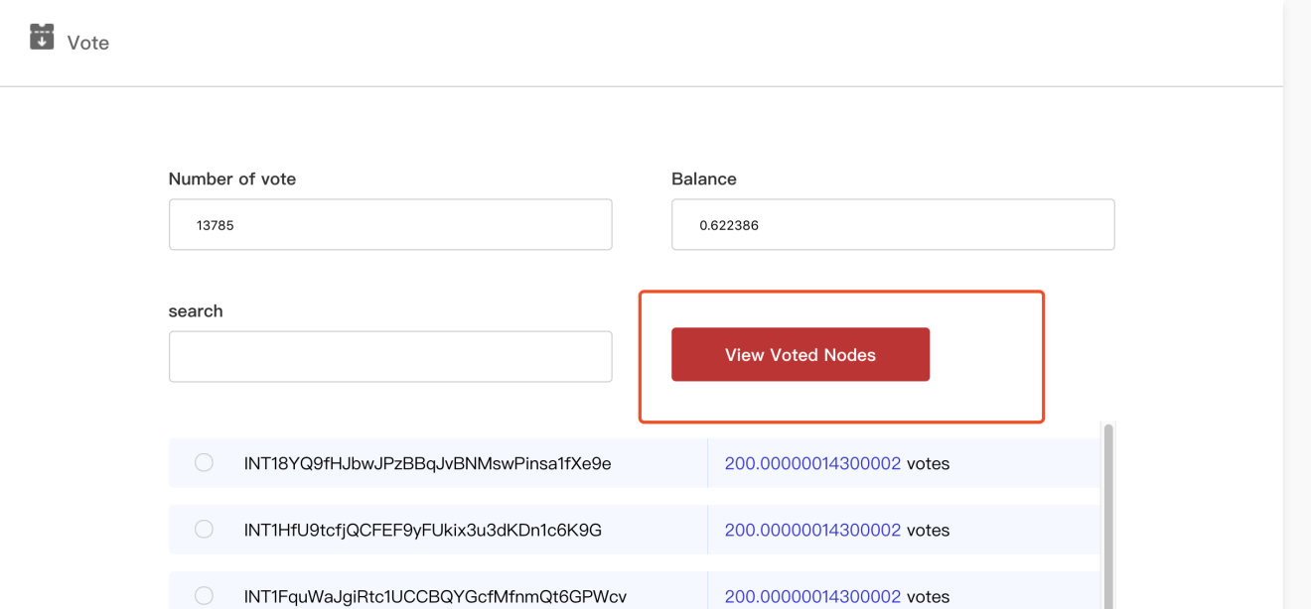

The list of currently voted nodes.

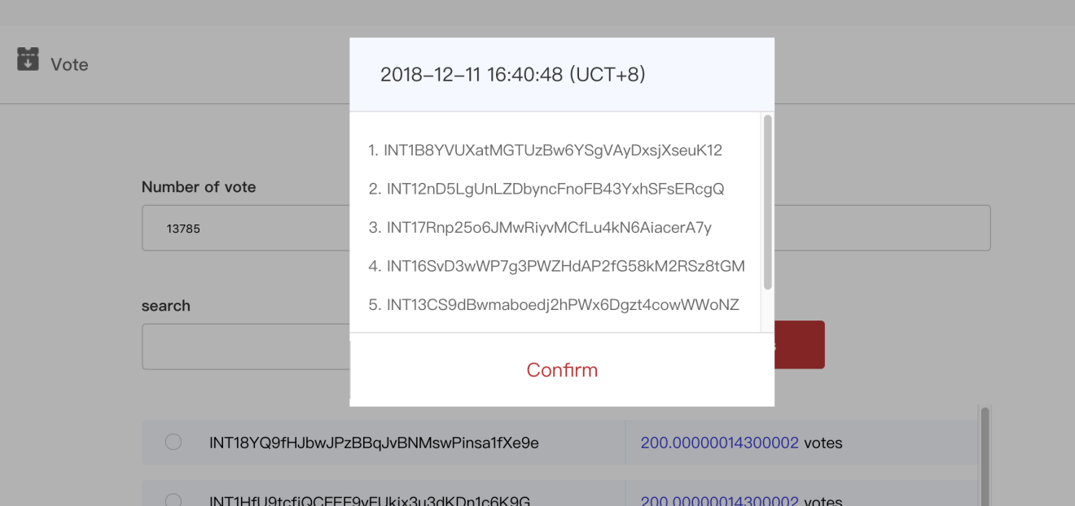

1. **Unmortgage**

1. Unlock the wallet by either Keystore or Private Key.

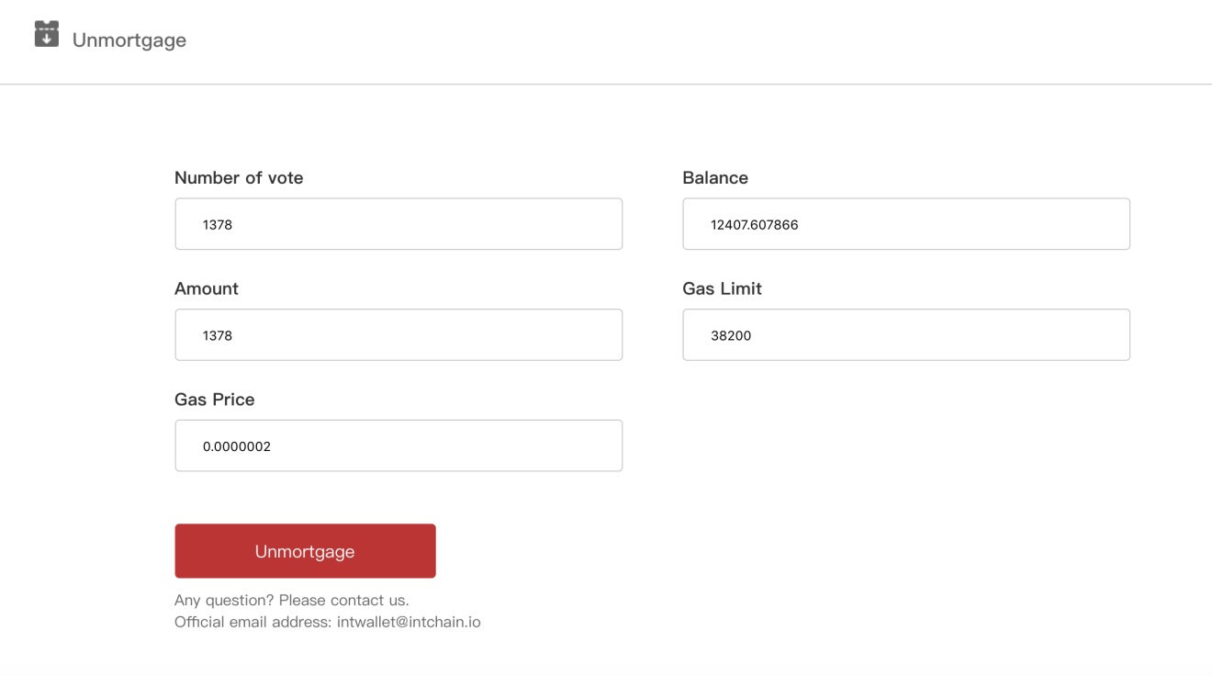

2.After confirming the number of vote, the balance of wallet, the amount of INT to be unmortgaged and gas fee, click on unmortgage.

(The system default gas limit and price can be modified as needed)

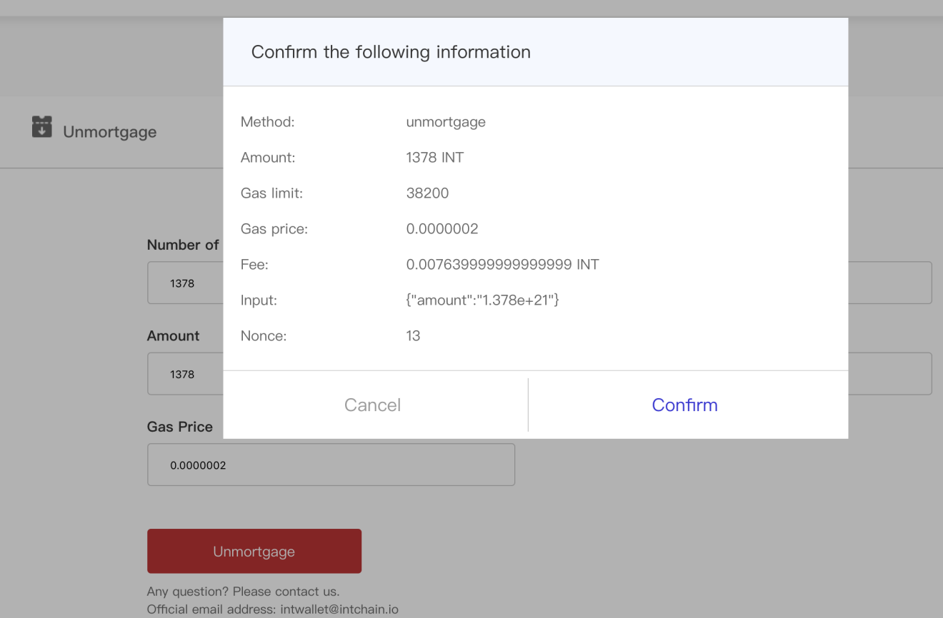

3.Please confirm the above information:

Cancel if there is an error;

Confirm if it is correct.

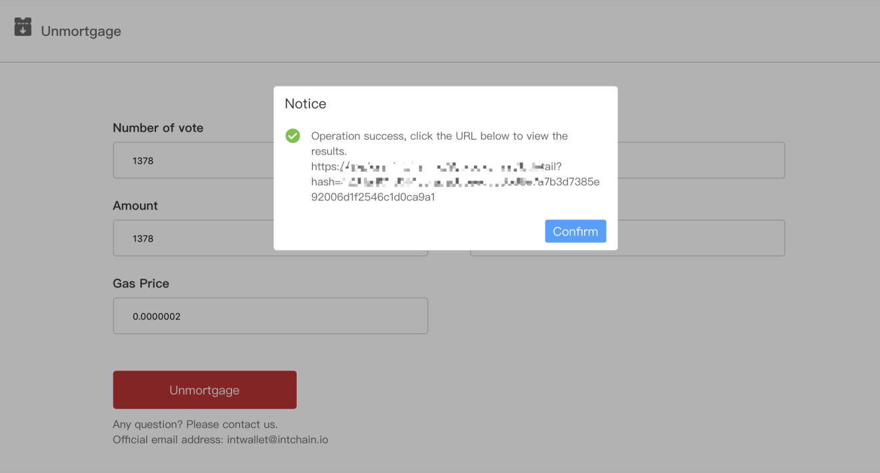

4.This page shows “operate successfully”, you can click on URL to check whether to unmortgage successfully. Under normal circumstances, all can be successful.