**Steps to follow to be able to run the console application:**

1. Download the zipped file called “**VISMA**”:
   1. Using github.com press on **[<>Code**] and then [**Download ZIP**]

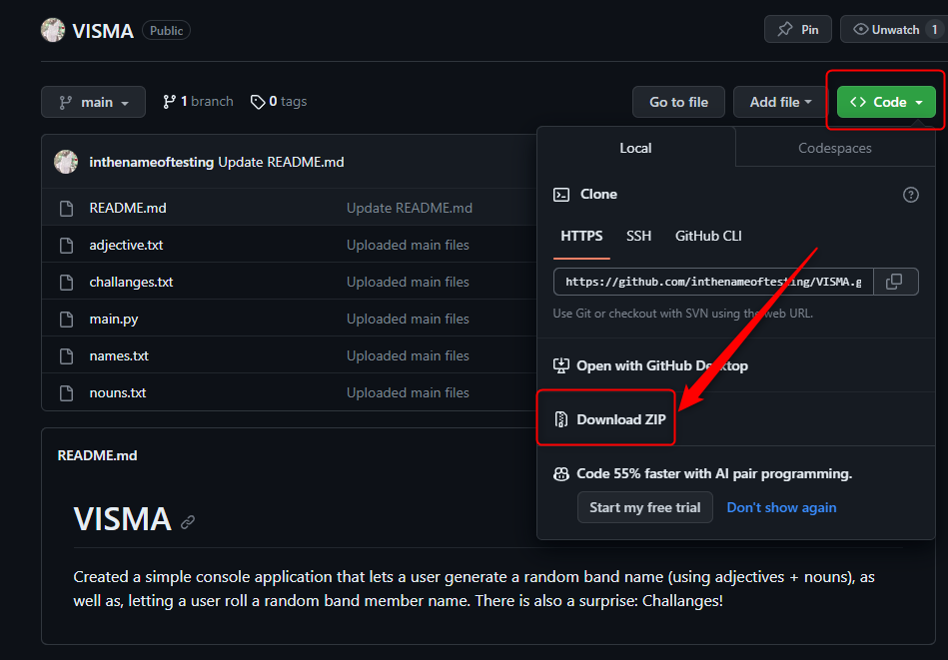

* 1. Using email address press download on the attached file

1. Navigate to your downloads folder
2. Right-click on the “**VISMA-main**”
3. Unzip the folder
4. Navigate to the folder called “**dist**”
5. Double-click on “**main**”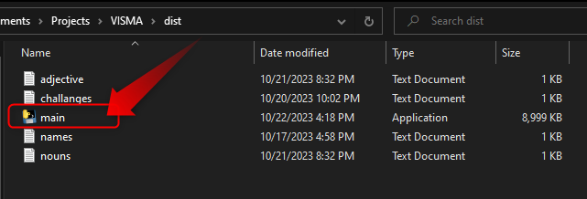

**How to open the source code to view or edit**

1. Download the zipped file called “**VISMA**”:
   1. Using github.com press on **[<>Code**] and then [**Download ZIP**]



* 1. Using email address press download on the attached file

1. Navigate to your downloads folder
2. Right-click on the “**VISMA-main**”
3. Unzip the folder
4. Open an IDE (integrated development environment) of your choice, this example will be using Visual Studio Code
5. Click on “**Open Folder**”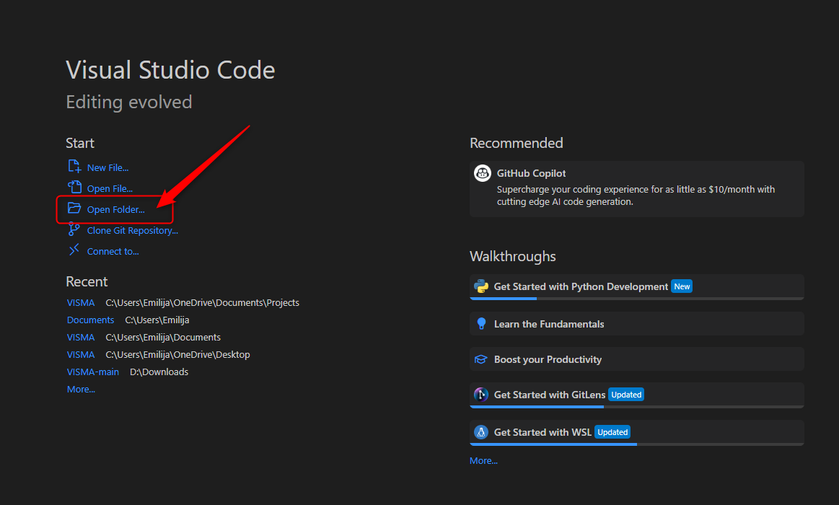
6. Navigate to the folder “**VISMA**”, select the “**Documentation_source_code**” folder and press [**Select Folder**]

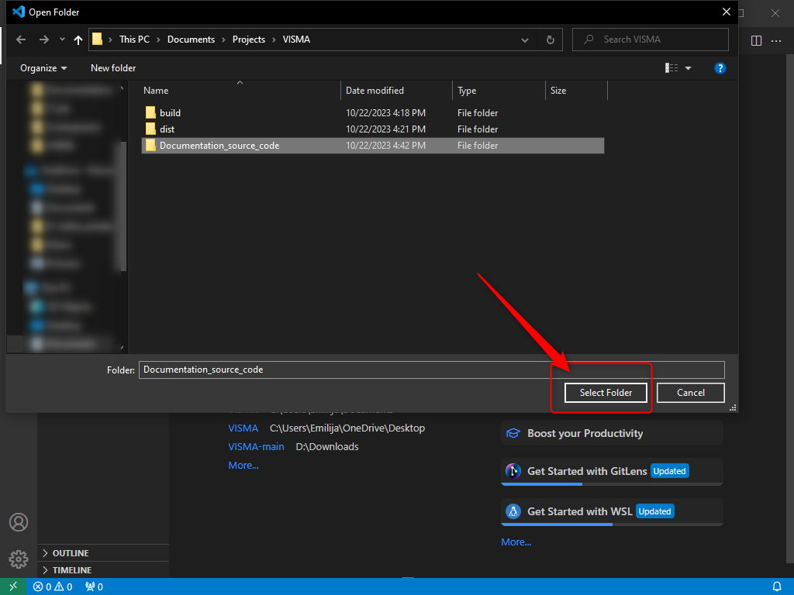

1. Press on the file „**main.py**“ and click the button [**Run Python File**] 