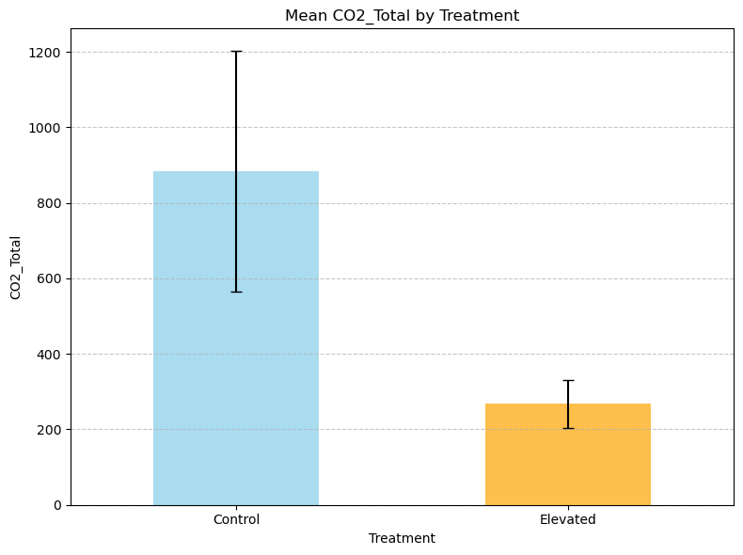

Descriptive Statistics:

count mean std min 25% 50% 75% max

Treatment

Control 5.0 883.4 712.326681 191.0 622.0 681.0 840.0 2083.0

Elevated 5.0 267.6 141.493109 48.0 217.0 305.0 364.0 404.0

Performing T-test...

T-test Results:

T-statistic: -1.8960

P-value: 1.2561e-01

