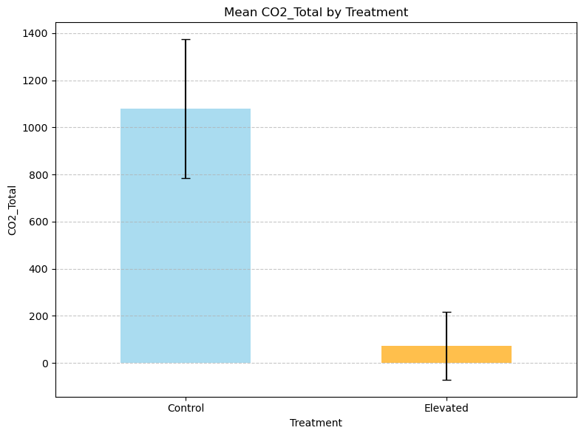

Descriptive Statistics:

count mean std min 25% 50% 75% \

Treatment

Control 9.0 1078.711111 884.219232 191.0 513.0 681.0 1488.00

Elevated 10.0 72.800000 454.529500 -1015.0 64.5 261.0 354.25

max

Treatment

Control 2850.4

Elevated 404.0

Performing T-test...

T-test Results:

T-statistic: -3.0676

P-value: 1.0050e-02