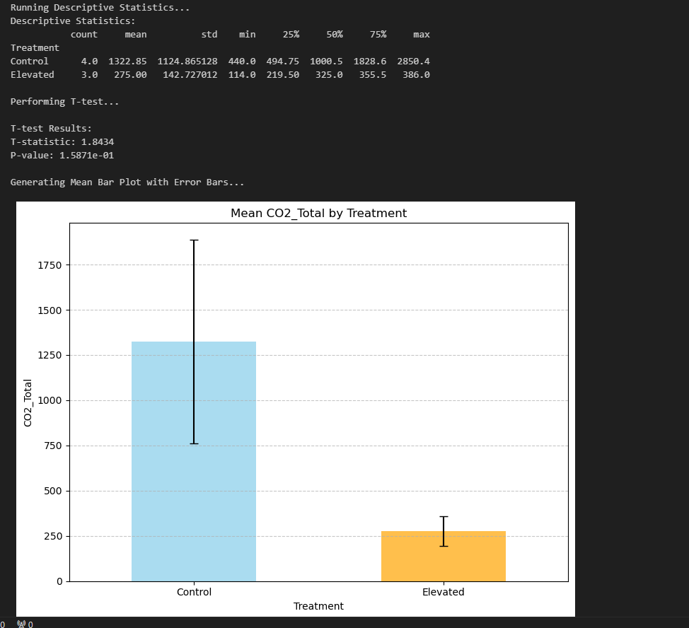

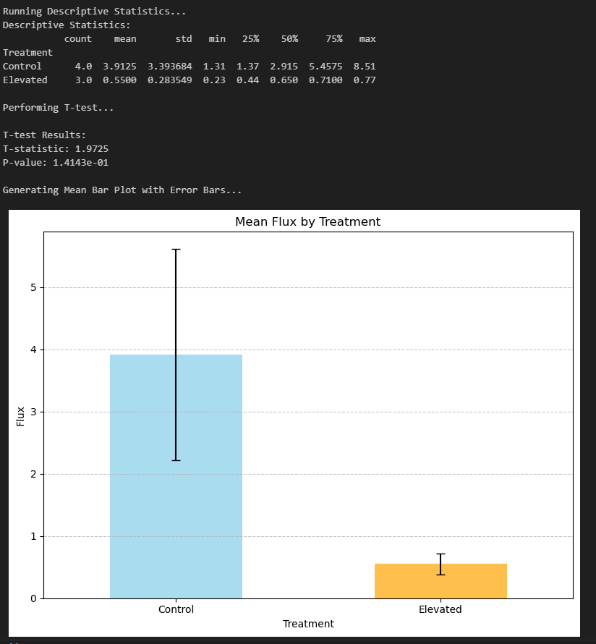

* Magnitude (Accumulation)
  + 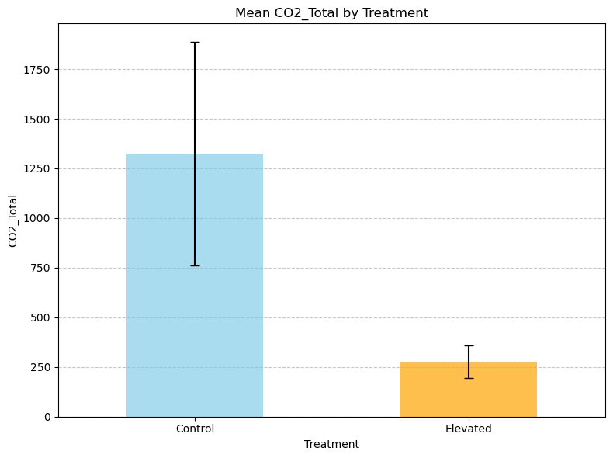
  + Descriptive Statistics:
  + count mean std min 25% 50% 75% max
  + Treatment
  + Control 4.0 1322.85 1124.865128 440.0 494.75 1000.5 1828.6 2850.4
  + Elevated 3.0 275.00 142.727012 114.0 219.50 325.0 355.5 386.0
  + Performing T-test...
  + T-test Results:
  + T-statistic: 1.8434
  + P-value: 1.5871e-01
* Flux CO2
  + 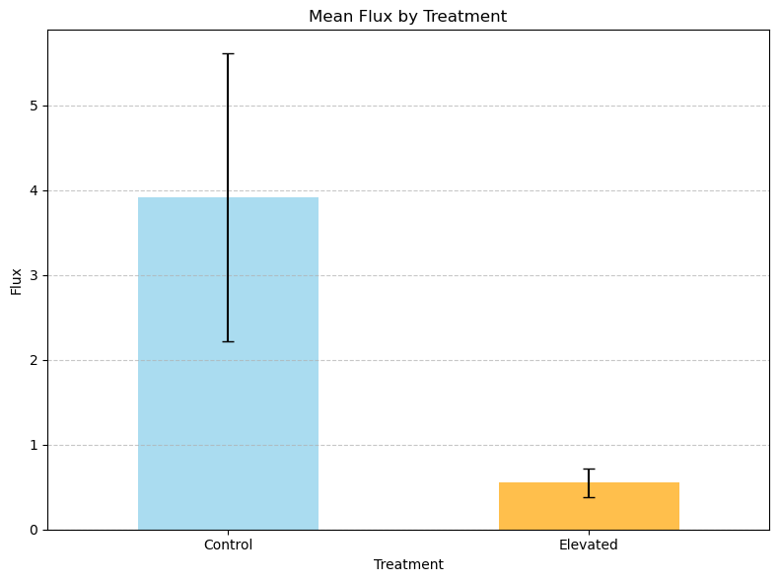
  + Descriptive Statistics:
  + count mean std min 25% 50% 75% max
  + Treatment
  + Control 4.0 3.9125 3.393684 1.31 1.37 2.915 5.4575 8.51
  + Elevated 3.0 0.5500 0.283549 0.23 0.44 0.650 0.7100 0.77
  + Performing T-test...
  + T-test Results:
  + T-statistic: 1.9725
  + P-value: 1.4143e-01