[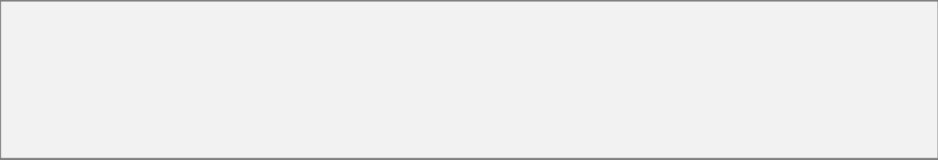](mailto:dev.trace.off@gmail.com)Rana Awais

Python Developer | Full Stack Developer | DevSecOps Engineer

Lahore, Pakistan – Ph: +923237455131 – [dev.trace.off@gmail.com](mailto:dev.trace.off@gmail.com)

PROFFESSIONAL EXPERIENCE SUMMARY

▪ 3+ years of **DevOps**, **DevSecOps** and **CloudOps** experience post-graduation.

▪ 6+ years of **Web**, **CLI** and **API** development experience including pre-graduation.

▪ Experience in application **life-cycle management** i.e. development, testing, staging, deployment and **CI / CD** with Jenkins as well as Docker containerization and Kubernetes (K8) Deployments.

▪ Experience in **scalable** and **highly available** deployment of applications on AWS and GCP.

▪ Experience in **K8 cluster deployment and management** on bare metal servers, AWS and GCP.

▪ Experience in **Disaster Recovery Architecture** and Implementation for Cloud applications.

▪ Experience in Scripting, **SDK** development, **GUI** development, **API & WEB** development.

▪ Experience in **Test-Driven Development** i.e. Unit / Functional Testing.

|  |
| --- |
| DEVOPS & CLOUDOPS PROJECTS  Cloud Migration  ▪ *AWS to GCP Migration of EC2 instances, RDS, Cloud*  *Monitoring and Alerting.* Cloud Automation  ▪ *Setup CI/CD for application deployment.*  ▪ *Deploy K8 jobs to automate export / import of data*  *from services like MongoDB and RabbitMQ.* Cloud Native SFTP  ▪ *Build & Deploy Cloud Native SFTP service on K8.*  ▪ *Configurable user key management directly on Cloud.*  Disaster Recovery  ▪ *Architect and implementation of 2-hour RPO and 30*  *min RTO for entire Cloud infrastructure.* |
| DATA SCIENCE WITH MACHINE LEARNING *Netlytics – A predictive solution for SDN vendors*  ❖ ***Prediction*** *and* ***Monitoring*** *of SDN logs for crashes and*  *critical warnings / abnormalities.*  ❖ ***Python3*** *in backend that parses log files and* ***trains ML***  ***model(s)*** *for prediction of abnormalities in any SDN.*  ❖ *Uses* ***NLTK*** *for log’s language parsing,* ***SciPy*** *for*  *calculation of entropy, KDD* ***(information theory),*** *and* ***SVM*** *for machine learning.*  ❖ ***Open-source*** *and flexible enough for any SDN vendor to*  *deploy.* |

CERTIFICATIONS

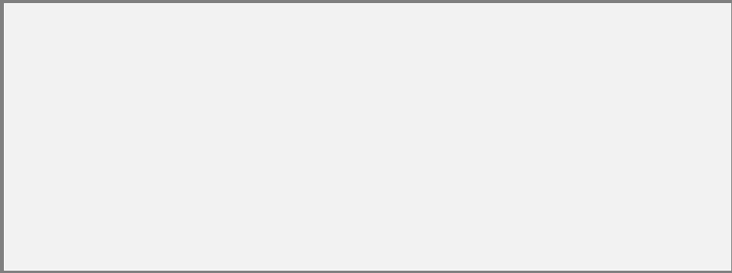



Google Associate Cloud Engineer

WEB DEVELOPMENT PROJECTS

[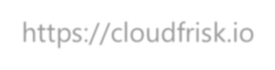https://cloudfrisk.io](https://cloudfrisk.io/)

▪ *Web application to assess your* ***AWS configuration*** *and*

*check* ***health status against security*** *best practices and compliances.*

▪ *Used* ***Angular5,*** *Django, Celery Workers, RabbitMQ,*   
***Docker, Jenkins, Web Sockets and AWS tech.***

[https://animetacchi.net](https://animetacchi.net/)

▪ *Website about anime shows with their information and*

*allowing user to interact with them extensively.*

▪ *Developed purely in* ***python using Pyramid Framework***

***with NoSQL*** *which is even faster than MongoDB. Includes*   
*extensive* ***data scraping and mining for data source.***

[https://rokoz.com](https://rokoz.com/)

• *Website about smartphones in market with their*

*specifications and estimated prices.*

• *Developed purely in* ***python using Django Framework with***

***MySQL.*** *Includes data scraping and mining in backend.*

EDUCATION

✦ GCU, Lahore (2009 – 2011)

*- Attained 89% Marks*   
*(Intermediate in Pre-Eng.)*

✦ NUST, Islamabad (2013 – 2017)

*- Attained 3.19/4.00 CGPA*   
*(Software Eng.)*

AREAS OF RESEARCH

➢ Data Analysis & Prediction – Analysis of log data of SDN (software defined network) to

predict crashes, downtime and resource usage with the help of ideas based on   
information theory and deep learning. Also, involves language processing for   
predicting crash types and estimation of SDN architecture and system states.

➢ Video Processing & Encoding Automation – New ways of processing videos for better   
compression, better sharing of content with less bandwidth usage and better ways to

automate encoding processes of modern age’s entertainment videos. Involves x264, x265 (HEVC), ffmpeg low level processes and automation at higher abstract level.

DEVOPS & DEVSECOPS

▪ Image Creationusing **Packer.**

▪ Version Control using **Git**. Static Code Analysis with Git hooks.   
▪ Application Deployment using **Docker** and **Docker Compose**.   
▪ CICD using **Jenkins**.Incorporate Dynamic Code Analysis,

Security Testing, Vulnerability Assessment and Platform Testing.   
▪ Server Administration mostly on LINUX servers using **Bash** and

occasionally on Windows servers using **PowerShell**.

▪ **Kubernetes** for infra-as-code and container orchestration.

▪ **Ansible** for simple automation tasks.

▪ Application Profiling, Logging and Performance Monitoring.

CLOUDOPS (AWS & GCP)

▪ **AWS** to **GCP** Migration and vice-versa.

▪ Enabling **CI/CD**, implementing **infra-as-code** and introducing

**logging solutions** using cloud native services.

▪ **Secure Networking, Load Balancing** and **SSL Handling** on cloud.

▪ **Serverless Computing Architecture** using cloud native services.   
▪ **Security Assessment** using cloud and open-source projects.

▪ Various other tasks on cloud.

SECURITY

▪ Python Library for **Symmetric Encryption**.

Interchangeable with OpenSSL utility.

▪ Python Library for Monitoring **Stale DNS**.

Utilizes AWS Route53 service.

▪ Python Library for **Static Code Analysis** on Git.

Introduces integration with Git hooks as well.   
▪ Monitoring of **AlienVault USM**.

Utilizes AWS Lambda with Selenium.

▪ Syncing AlienVault Event Alarms with **JIRA**.

Utilizes AWS Lambda, Selenium, AV and JIRA APIs.   
▪ Syncing **QRadar** Events with JIRA.

Utilizes AWS Lambda, QRadar and JIRA APIs.   
▪ **Endpoint** Monitoring.

Utilizes AWS Lambda and configurable conditionals.   
▪ Web Service for **Security Assessment** of AWS.

Utilizes Open-Source Scout Suite.

▪ **Slack Alerting** on Various Critical Scenarios.

Works for AWS CloudWatch and / or ELK logs.   
Alerts on MySQL & Postgres Connection Changes. Alerts on HTTP/HTTPS Flooding.

PYTHON LANGUAGE

✓ Strong grip on core Python language.

✓ **Multi-Threading** and Parallel programming.

✓ **Restful API** Development in Flask framework.

✓ **AI-bots** development using **AIML.**

✓ Web Development with **NoSQL** in **Pyramid.**

✓ **Web Scraping** in BeautifulSoup, lxml and HTML

parsers.

✓ **GUI Programming** using Tkinter, PyQt & PyGame.

✓ **Web Development** in Django and Django REST.   
✓ Application Development with **Couchbase.**

✓ **Browser Programming** on WebKit engine.

✓ Web Scraping using **Selenium** with **PhantomJS.**   
✓ **Test-Driven Development** with unit-testing

and Selenium.

✓ **Background Workers** using **celery.**

✓ **ORM development** for NoSQL.

✓ **Automation Scripting** including various domains.

JAVA LANGUAGE

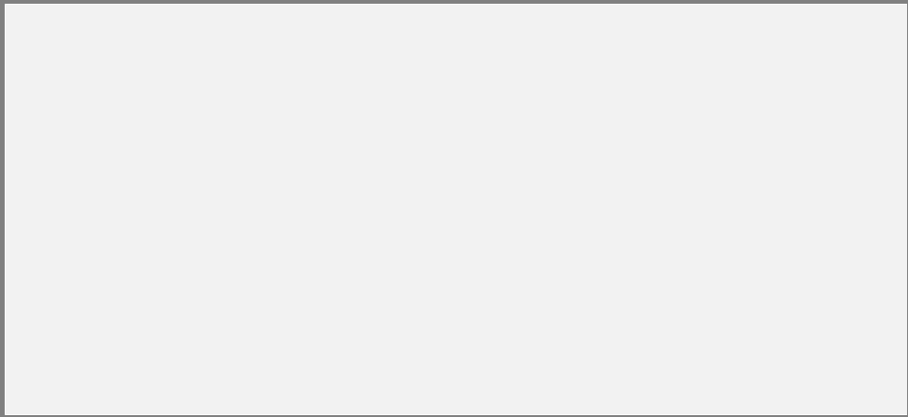✓ Proficient in core **JAVA** programming**.**

✓ Familiar with **Hibernate ORM, Maven** and **Spring Boot**

**Framework** for JAVA.

✓ Familiar with **jVLC** for creating media player applications.

✓ Familiar with **JSoup** usage for web-parsing of HTML and

scrapping data from web pages.

✓ Familiar with **JUnit** for unit-testing JAVA applications.

WEB DEVELOPMENT

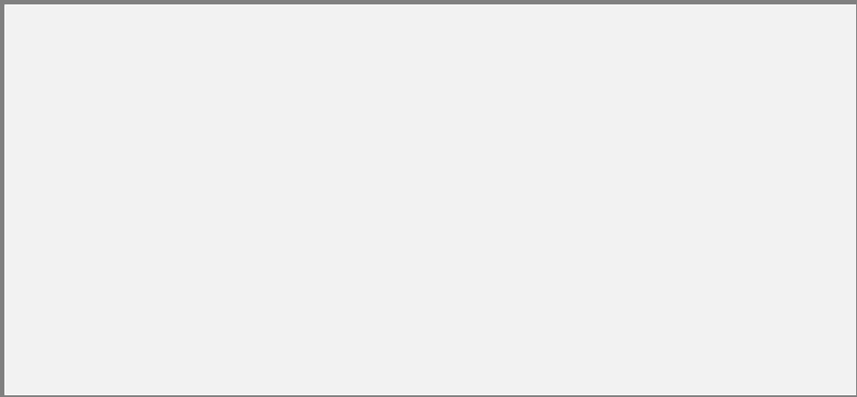✓ Experienced in **JavaScript** (and **JQuery**)**, HTML5 & CSS3.**   
✓ Experienced in **Angular4+** framework of **JS.**

✓ Experienced inDjango, Pyramid and Flask frameworks of

**Python**.

✓ Experienced in **NodeJS** in general and Express Framework.

✓ Experienced in Web **Workers**, **Push** & **Polling,** Async Response

handling etc.

|  |  |
| --- | --- |
| ✓ **Data Scraping & Analysis** using **NumPy** and **NLTK.**  ✓ **Socket & Network programming**.  ✓ **Database Handling** using ORMs.  ✓ Queue Implementation using **ZeroMQ**. | AREAS OF INTEREST  ➢ Networking, DevOps & Security – The idea of deploying  applications that can connect to each other whenever we want and the ability to access digital world for a wide variety of reasons is really intriguing. Not to mention the infra- security and defensive security domains it opens  consequently is very thrilling especially for DevOps  engineers.  ➢ Machine Learning & NLP – Develop machines / apps that can  understand humans and understand what they want them  to do and how humans communicate with each other  (language processing). Let the machines develop a set of learning environment of their own to help humans ease the load of work. |
| PAST EXPERIENCE  ▪ Summer Internship  @ **Carbyne** (Summer 2016, ~3 months)  ▪ Python Developer  @ **Green Origins** (July 2017 – Oct 2017)  ▪ Software Engineer  @ **Ebryx Pvt. Ltd.** (Oct 2017 – Present) |