**Challenge Name : Mirage**

**Challenge Category : Misc**

**Description (for Players) : Everything You See is not always True**

**Challenge Made by Bijoy Sonari (R4nd0mSys)**

Hey Guys , so this a challenge made by me and I have named it **MIRRAGE .**This reason behind this name is that **everything you see is not always true**.So lets have a look to the writeup of this challenge.

1. First you will get a Website link. It will look something like this.



1. After viewing the source code of the website you will find a hint.

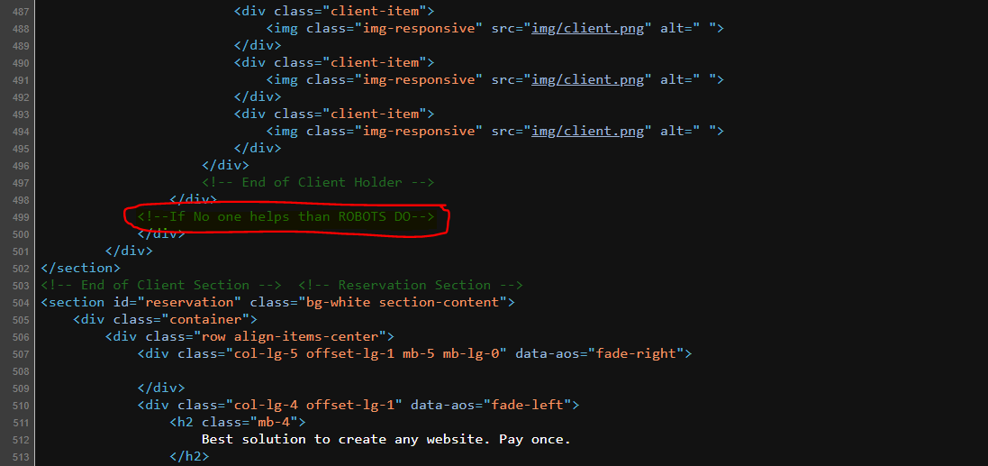

1. The hint is referring you to something related to robots. Yes you are right just go and check the robots.txt directory.

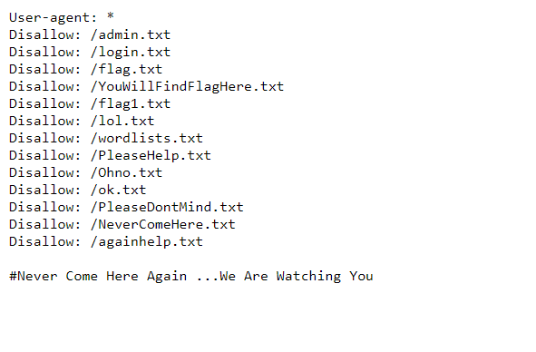

1. Here you have some disallow entries. So anyone with this robots.txt with will feel that they have found the flag in the **flag.txt.** So lets check what there in the flag.txt directory.

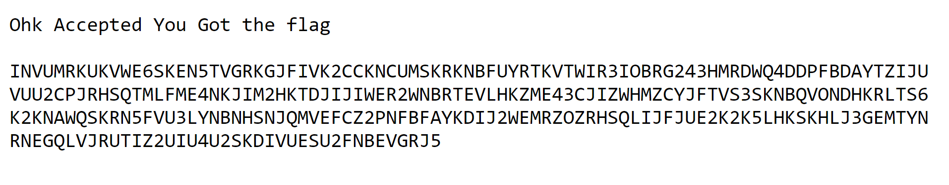

1. Now lets Decode the this encrypted text in the cyberchef - <https://gchq.github.io/CyberChef/>

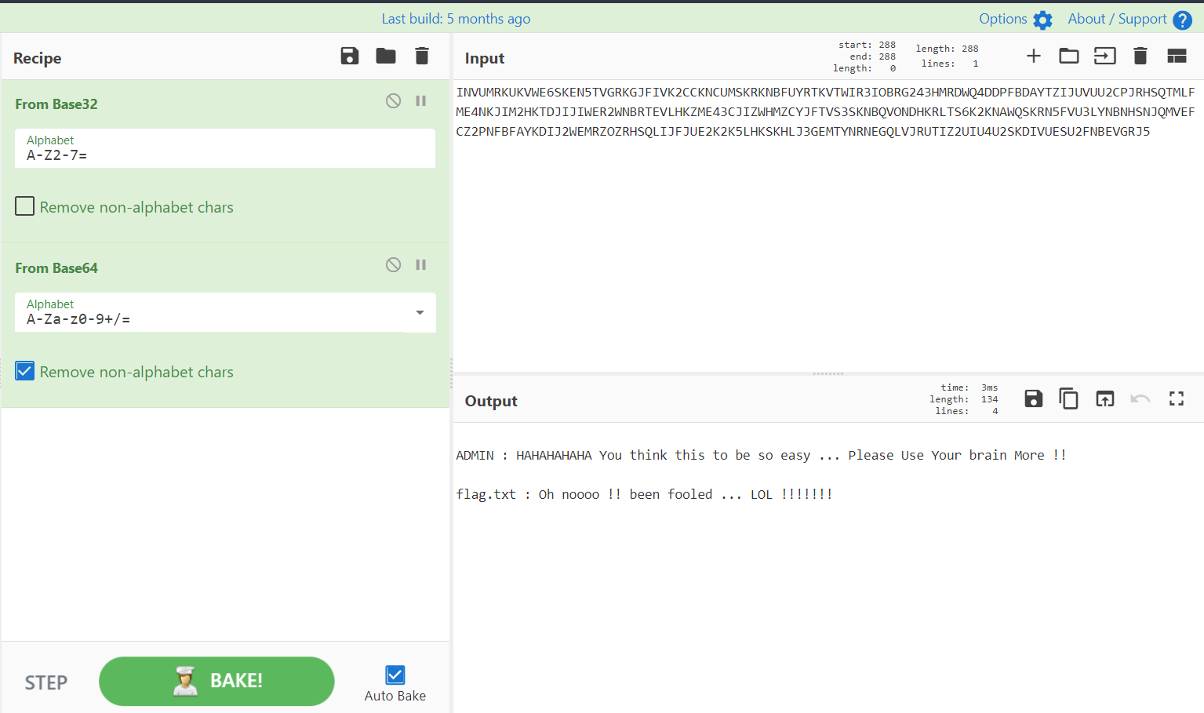

1. After base32 and base64 decode we have got the idea that we have been fooled this whole time.
2. So lets go and check the other directories that were mentioned in the robots.txt
3. The Next interesting entry there is **flag1.txt.**So lets check what it got for us

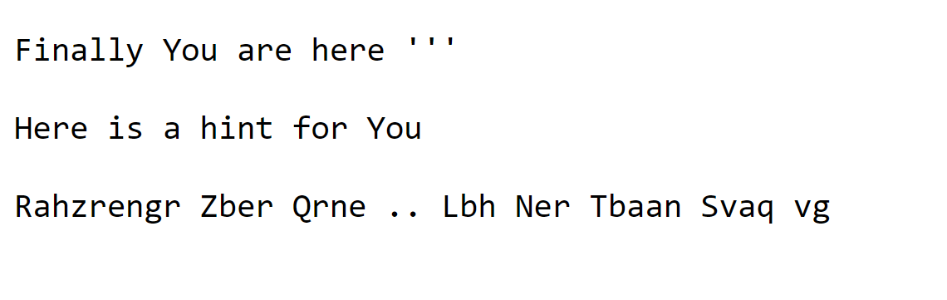

1. Not it seems that we haven’t got the flag here but we have found another hint here.

And clearly it is ROT13 encoded. So lets decode it again with cyberchef

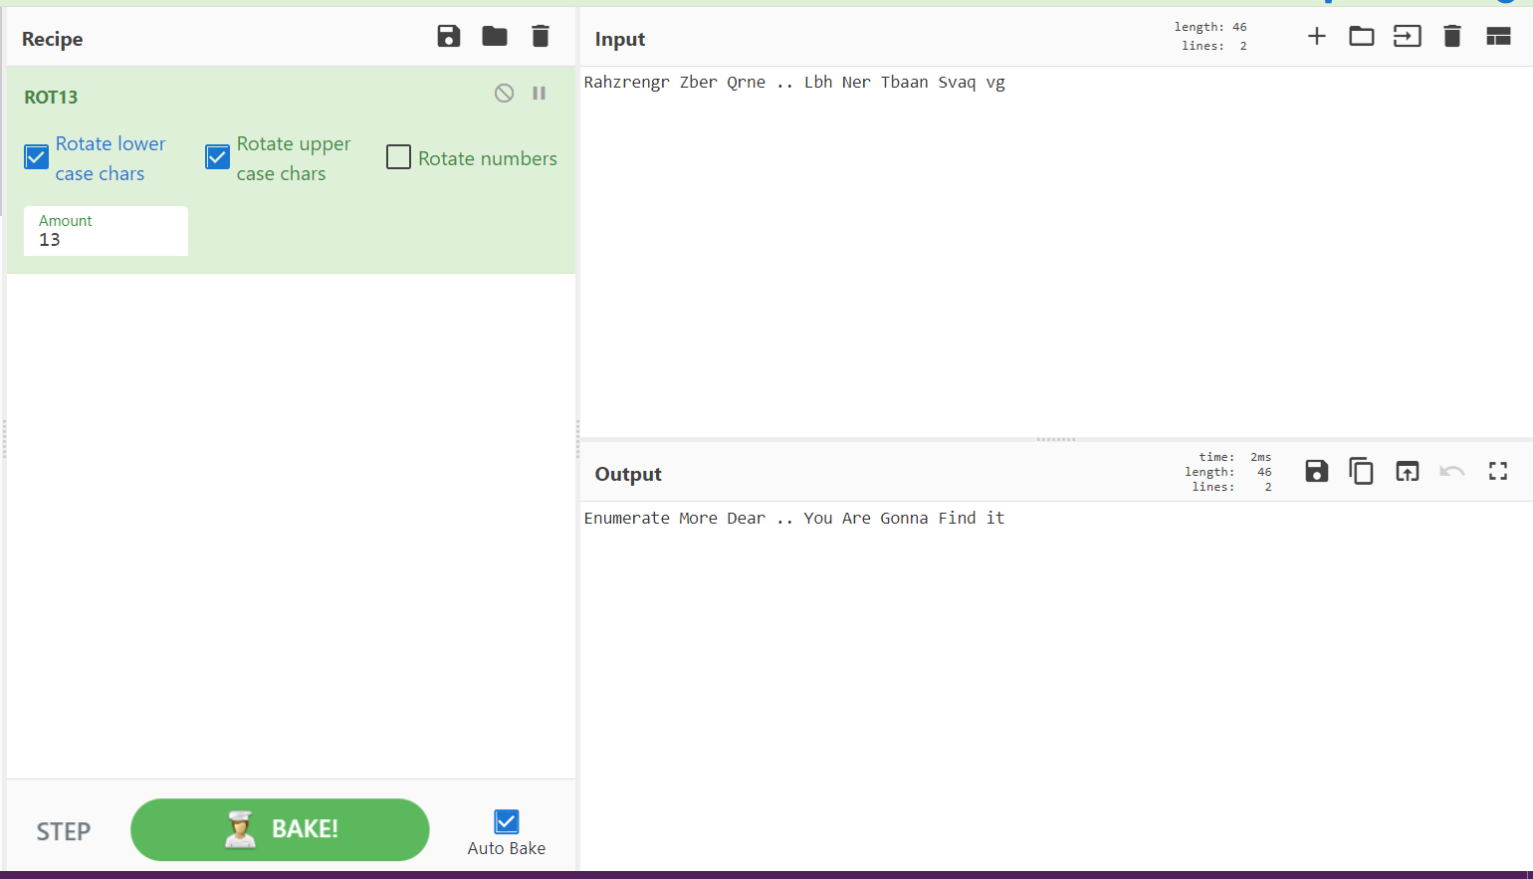

1. Its again saying us to enumerate more. So lets go back to our robots.txt again !!! . Lets check **/lol.txt**. But it is 404 not found.

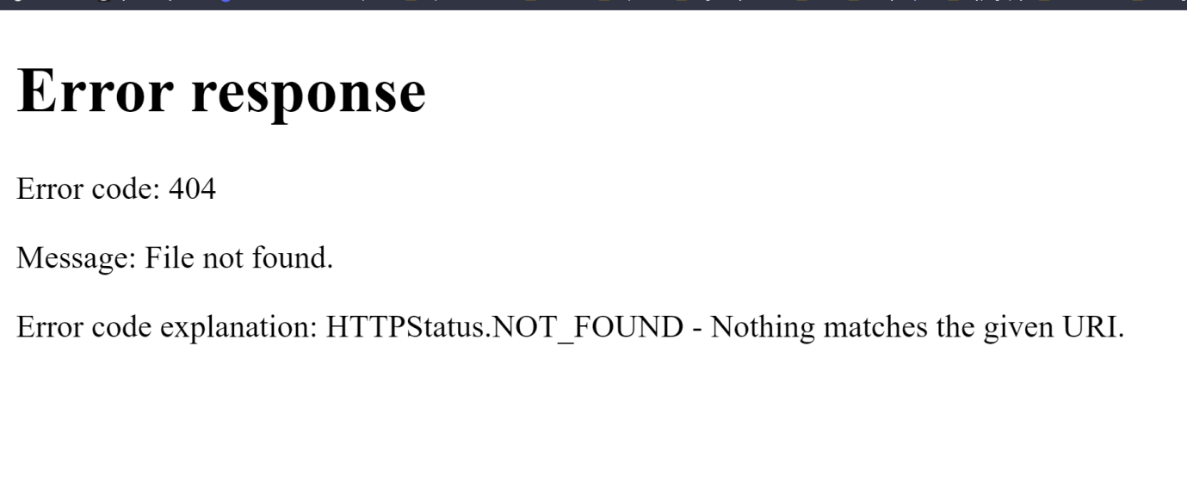

1. Lets check another interesting entry in the robots.txt i.e **wordlists.txt.** And it has got a huge list of words so I think it will help us in the future.
2. Not lets check another entry **PleaseHelp.txt.** Its again **404 not found**



1. Lets check **Ohno.txt.**But as before it is too **404 not found**



1. Now lets check ok.txt.

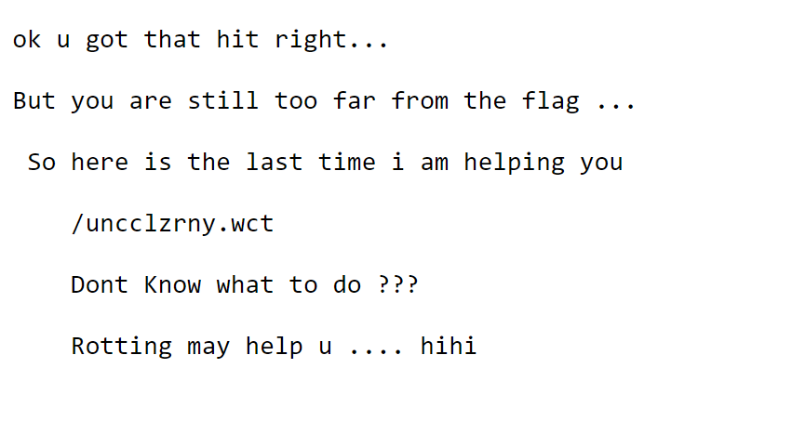

1. SO finally again we have got something. And here the hint says something **Rotting**. Yes you are right its again Rot13 .So lets go and decode **/uncclzrny.wct** it again with Cyberchef

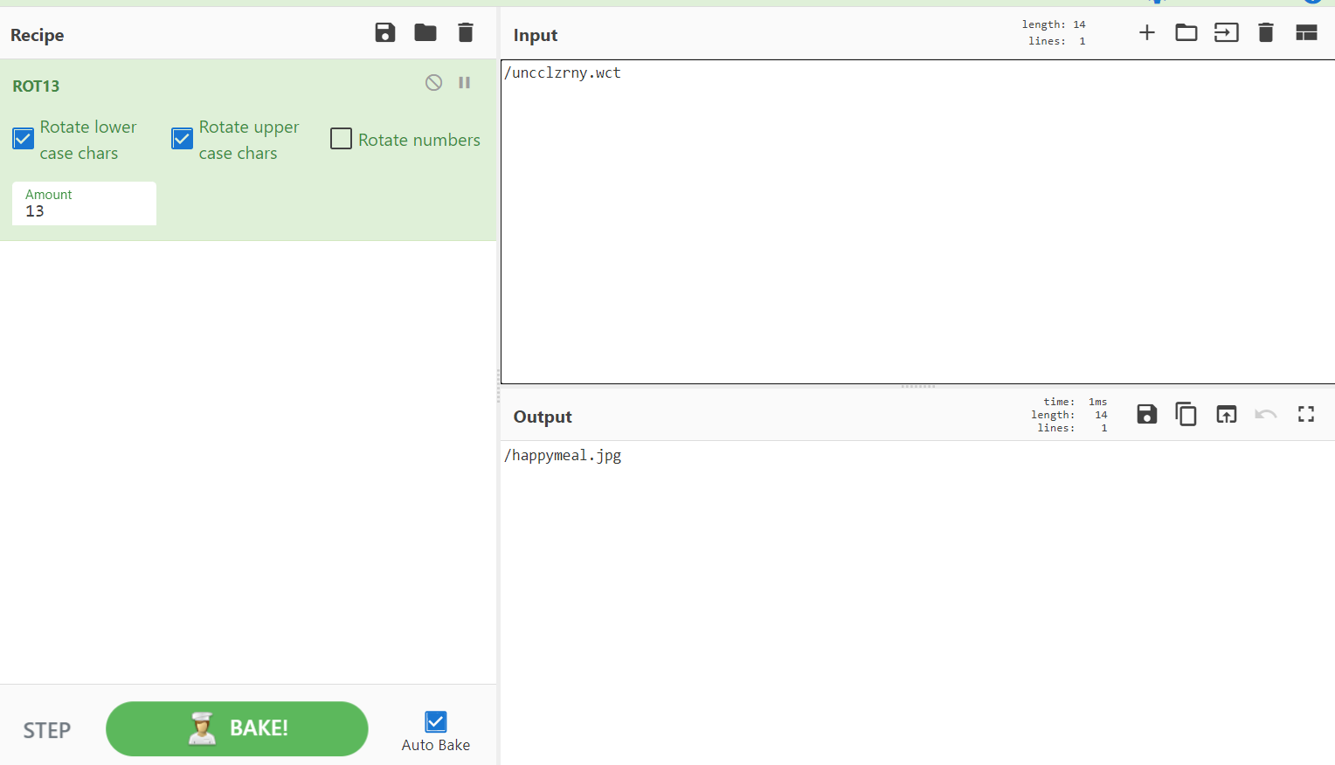

1. So after decoding we have got **/happymeal.jpg** and most you are right it’s a directory. So lets go and check what this directory has got for us.
2. The **/happymeal.jpg** directory has a image



1. Clearly we can see that the image is again referring us to a directory called **/HelpMeOut.txt.** So lets go and check what this new directory has got for us.

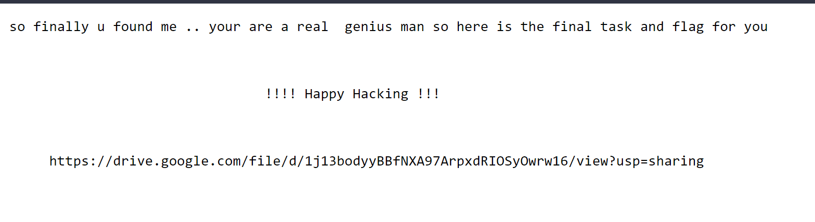

1. So the directory is giving us a drive link and most you must be thinking that you have got the flag. So lets download the contents of this drive and see what we have got.
2. So after downloading the file in my linux machine, I found that the file is named as **Flag.zip**.
3. And finally after unzipping this Flag.zip we will get the flag. 😊

