Boehringer lngelheim | Corporate Center GmbH | 55216 Ingelheim am Rhein
TO WHOM IT MAY CONCERN

Alteplase TPA-05 drug substance batch numbering system at drug substance manufacturing site Boehringer Ingelheim RCV GmbH & Co KG
We, Boehringer Ingelheim RCV GmbH & Co KG, Dr.-Boehringer-Gasse 5-11, A-1121 Vienna, hereby summarize the applied batch numbering system at the drug substance manufacturing site Boehringer Ingelheim RCV GmbH & Co KG.
Boehringer Ingelheim RCV GmbH & Co KG uses an SOP-defined and GMP-compliant batch numbering system to assure traceability of production, history and distribution for each manufactured bulk drug substance.
For alteplase TPA-05 an eight-digit batch number (numeric code) is generated. The first four digits are derived from the Boehringer Ingelheim global Labware, the last four digits are continuous and ascending assigned at the local manufacturing site in the electronic system BioMES. The derived batch number is product- and site-specific. The batch number assignment is performed continuously and in an ascending manner.
Yours sincerely,
BOEHRINGER INGELHEIM RCV
GmbH & Co KG

 | Firmado en DocuSign por: |  |  | Firmado en DocuSign por:
 | Elisabeth Donhauser |  |  | Vanessa Hradecky
 | CC65E267864C490... |  |  | FE8EDC0ECEBD4A6...

Elisabeth Donhauser  TechRA Austria  Biopharma Quality Austria | Vanessa Hradecky  Head of Tech RA  Biopharma Quality Austria

Boehringer lngelheim
RCV GmbH & Co. KG

Boehringer Ingelheim RCV GmbH
& Co KG
Dr.-Boehringer-Gasse 5-11 | 1121
Vienna | Austria

Phone +43 1 801 05-0
Fax +43 1 801 05-2482
boehringer-ingelheim.com

Elisabeth Donhauser
T +43 1 801 05-5963
F +43 1 801 05-2482
elisabeth.donhauser@
boehringer-ingelheim.com



Certificate Of Completion
Envelope Id: 1BFE7518-1D98-4307-BC84-6058F64C5FFA |  | Status: Completed
Subject: Complete with Docusign: TPA-05 BI RCV_batch numbering system.pdf
Source Envelope:
Document Pages: 1 | Signatures: 2 | Envelope Originator:
Certificate Pages: 4 | Initials: 0 | Elisabeth DI Donhauser
AutoNav: Enabled |  | Binger Straße 173
EnvelopeId Stamping: Enabled |  | Ingelheim, Rheinland-Pfalz CT 55216
Time Zone: (UTC+01:00) Amsterdam, Berlin, Bern, Rome, Stockholm, Vienna |  | elisabeth.donhauser@boehringer-ingelheim.com
 |  | IP Address: 10.111.40.7
Record Tracking
Status: Original | Holder: Elisabeth DI Donhauser | Location: DocuSign
5/6/2025 10:51:55 AM
 | elisabeth.donhauser@boehringer-ingelheim.com
Signer Events | Signature | Timestamp
Elisabeth DI Donhauser | 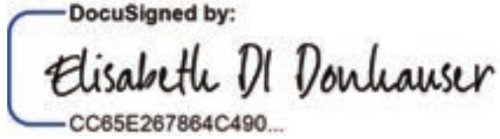 | Sent: 5/6/2025 10:53:04 AM
elisabeth.donhauser@boehringer-ingelheim.com |  | Viewed: 5/6/2025 10:53:09 AM
Boehringer Ingelheim Standard |  | Signed: 5/6/2025 10:53:19 AM
Security Level: Email, Account Authentication (None) | Signature Adoption: Pre-selected Style
 | Using IP Address: 93.82.19.139
Electronic Record and Signature Disclosure:
Accepted: 12/19/2024 2:05:08 PM
ID: a828fa68-dda7-457c-b9cb-64dd8d92fe3c

Vanessa Hradecky | 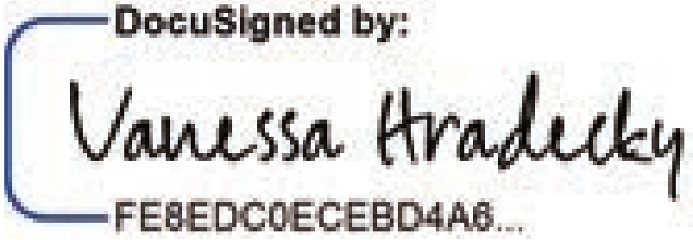 | Sent: 5/6/2025 10:53:20 AM
vanessa.hradecky@boehringer-ingelheim.com |  | Viewed: 5/6/2025 1:28:29 PM
Boehringer Ingelheim Validated Production |  | Signed: 5/6/2025 1:29:01 PM
Security Level: Email, Account Authentication (None) | Signature Adoption: Pre-selected Style
 | Using IP Address: 213.164.6.186
Electronic Record and Signature Disclosure:
Accepted: 12/19/2024 2:28:39 PM
ID: b4827562-7f98-4c45-a30f-072a06ba3e9a

In Person Signer Events | Signature | Timestamp
Editor Delivery Events | Status | Timestamp
Agent Delivery Events | Status | Timestamp
Intermediary Delivery Events | Status | Timestamp
Certified Delivery Events | Status | Timestamp
Carbon Copy Events | Status | Timestamp
Witness Events | Signature | Timestamp
Notary Events | Signature | Timestamp
Envelope Summary Events | Status | Timestamps
Envelope Sent | Hashed/Encrypted | 5/6/2025 10:53:04 AM

Envelope Summary Events | Status | Timestamps
Certified Delivered | Security Checked | 5/6/2025 1:28:29 PM
Signing Complete | Security Checked | 5/6/2025 1:29:01 PM
Completed | Security Checked | 5/6/2025 1:29:01 PM
Payment Events | Status | Timestamps
Electronic Record and Signature Disclosure
Electronic Record and Signature Disclosure created on: 12/6/2024 6:29:19 PM
Parties agreed to: Elisabeth Di Donnhauser, Vanessa Hradecky

Attention Boehringer employees: If you are signing from a country that is not your country of employment, you are not allowed to sign binding agreements with external parties (e.g. speaker agreements, sponsoring agreements or consultancy agreements. Workaround: Please postpone your signature or forward the envelope to an authorized signatory in your country of employment). This rule does not apply to the following groups: i) All employees for country combination Germany / USA. ii) AH + Group Function employees for country combination Germany / France / USA

Boehringer Ingelheim

Consent to Proceed with Electronic Signatures

This document describes the frame conditions with regard to the use of the DocuSign® system by the authorized user (‘you’) for electronic signing and/or processing of documents concerning the business with Boehringer Ingelheim International GmbH, Binger Strasse 173, 55216 Ingelheim am Rhein, Germany or any of its affiliated companies (‘we, us or Company’).
Via the DocuSign® system, you will be able to complete, review, and even print documents you will electronically sign using only your web browser via the link sent to you by e-mail. Before using the DocuSign® system, please make sure that you are able to meet the technical system requirements, which can be accessed via the DocuSign® website. Please read the information below carefully and thoroughly.

Contractual documents and notices may be sent to you electronically
If not otherwise agreed in a given contract between you and us, we will provide electronically to you through your DocuSign® user account all contractual documents, notices and other documents that are required to be provided or made available to you during the course of our business relationship with you. To reduce the chance of you inadvertently not receiving any notice or document, we will provide all of the required notices and documents to you by the contractually agreed method(s) and to the address(es) provided therein. Subject to the provisions of the given contract you may receive documents and notices electronically or in paper format.

Getting paper copies
As long as you are an authorized user of the DocuSign® system, you will have the ability to download and print any documents we send to you through your DocuSign® user account for a limited period of time (usually 30 calendar days) after such documents are first sent to you. In case a mandatory local legal requirements exists, we will provide paper copies of the contractual documents upon your request which has to be sent to the respective Company contact nominated in the contract.

Consequences of changing your mind
In exceptional cases (f.e. contractually agreed option, mandatory local legal requirement) you may be entitled to elect to receive required notices and disclosures only or additionally in paper format. If you decide to exercise a given option you have to liaise with your respective Company contact nominated in the contract by using the address(es) in accordance with the process contractually foreseen.

Changing your e-mail address
If your e-mail address changes please arrange for your new e-mail address to be reflected in your DocuSign® account by following the process for changing e-mail in the DocuSign® system.

Acknowledging your access and consent to receive materials electronically
To confirm to us that you can access this information electronically, please verify that you were able to read this electronic consent and that you (i) also were able to print on paper or electronically save this disclosure for your future reference and access or that you (ii) were able to e-mail this disclosure and consent to an address where you will be able to print on paper or save it for your future reference and access.
By checking the ‘I Agree’ box, I confirm that:
- I can access and read this CONSENT TO PROCEED WITH ELECTRONIC SIGNATURES document; and
- I can print on paper the disclosure or save or send the disclosure to a place where I can print it, for future reference and access; and
- Until or unless I have notified my respective Company contact as described above, I consent to receive through electronic means all contractual documents, notices and other documents that are required to be provided or made available to me by the Company during the course of the business relationship with you.

