Analytical Procedure

Fine particle dose ≤ 5.0 µm  Laser diffraction | Identificación global - Versión  206893_2854718_6.0
Fine particle dose ≤ 5.0 µm  Laser diffraction | 10 de junio de 2025
Fine particle dose ≤ 5.0 µm  Laser diffraction | Página 1 de 8
Información confidencial protegida por derechos de propiedad intelectual.
© 2025 Boehringer Ingelheim International GmbH o sus empresas afiliadas. Reservados todos los derechos.
Quedan prohibidas la transmisión, reproducción, publicación y toda otra utilización, total o parcial, de este documento sin autorización previa por escrito

TABLE OF CONTENTS
TABLE OF CONTENTS 1
LIST OF FIGURES 1
LIST OF TABLES 1
1. GENERAL NOTES 2
1.1 CARTRIDGE INSERTION 2
1.2 PRIMING THE INHALER 2
1.3 PRIMING PROCEDURE 2
2. EQUIPMENT 3
3. PROCEDURE 4
3.1 PRINCIPLE OF MEASUREMENT 4
3.2 PREPARATION OF THE HUMIDIFIER AND FLOW CONTROL UNIT 4
3.3 EQUILIBRATION OF THE SYSTEM 5
3.3.1 Focal length 5
3.3.2 Sampling of the aerosol plume 5
3.4 SETTINGS ON THE SYMPATEC HELOS UNIT 5
4. MEASUREMENT 6
5. EVALUATION 7
5.1 EVALUATION OF A SINGLE MEASUREMENT (OF A SINGLE ACTUATION) 7
5.2 PRESENTATION OF RESULTS 7

LIST OF FIGURES
Figura 1 Figure 1 Overall schematic apparatus set-up 4

LIST OF TABLES
Table 1 Actuation schedule 2
Table 2 Product data 5
Table 3 Trigger conditions 6
Table 4 Disperser 6
Table 5 Presentation of the results 7

1. GENERAL NOTES
Determine the fine particle dose on 3 inhalers by laser diffraction with 4 actuations at the start of the labelled number of actuations in a cartridge and 4 actuations at the end of the labelled number of actuations in a cartridge.

1.1 CARTRIDGE INSERTION
- Remove the base of the inhaler.
- Insert a cartridge containing the inhalation solution into the inhaler and push the cartridge into place. Slight resistance must be overcome during the insertion procedure as the plastic cap is pierced.
- Replace the base of the inhaler.
Table 1 Actuation schedule
Actuation no. | Comments | Test parameter
P1 to Pn⁽¹⁾ | Discharge until an aerosol cloud is visible (until at least 1.0 mg delivered mass) | Variable priming
-2 to 0 | Discharge further 3 actuations to waste | Fixed priming
1 to 4 | Start of the labelled number of actuations (s) | Fine particle dose
5 to (E-4) | 5 until (E-4) | Discard
(E-3) to E⁽²⁾ | End of the labelled number of actuations (e) | Fine particle dose
- P1 to Pn denote the variable number of priming actuations
- E is the number of actuations in accordance to the acceptance criteria “Number of actuations”
Actuations discarded to waste should be released into a suitable fume hood or equivalent.

1.2 PRIMING THE INHALER
“(P1 to Pn) + 3” actuations are discarded during priming. “P1 to Pn” is the number of actuations which are required until the delivered aerosol shows a delivered mass of at least 1.0 mg (equivalent to 1.0 µL). “P1 to Pn” can vary from inhaler to inhaler. After “P1 to Pn” actuations have been delivered, discard a further 3 actuations.
The number of variable actuations required (“P1 to Pn”) is documented for information. For the testing schedule, actuation 1 is the first actuation after the sum of “(P1 to Pn) + 3” actuations. After priming, immediately start the next determinations without delay!

1.3 PRIMING PROCEDURE
Pull and remove the cap of the inhaler.
Whilst holding the case upper part with the mouthpiece pointing straight up, rotate the case bottom part through 180° until it clicks audibly into place. This action compresses the spring of the inhaler, cocking the inhaler so that the dose release button is pushed out by about 2 mm. The button is now level with the flanges at either side, indicating that the inhaler has been cocked.
After cocking, wipe the nozzle, union nut and mouthpiece thoroughly using a soft tissue. Place the inhaler on a balance with the mouthpiece pointing straight down. Tare the balance.
Remove the inhaler from the balance and generate the aerosol by pressing the dose release button; the inhaler can be in any position.
After the actuation, the inhaler must be reweighed within 30 seconds with the mouthpiece pointing straight down. The balance should therefore be close at hand. The read-off value multiplied by the factor “-1” produces the delivered mass. Repeat this procedure until an aerosol cloud is visible. The delivered mass should be at least 1.0 mg.
Then discard a further 3 actuations.

2. EQUIPMENT
• Laser Diffraction apparatus by Sympatec (Helos) with lens R3 (focal length = 100 mm) and suitable software
• Suitable humidifier
• Humidity chamber
• Suitable relative humidity probe (e.g. Rotronic)
• Suitable flow control unit
• Modified Sample Induction Port (SIP)
• Sample Collection Tube (SCT) including vacuum connector, holding grid, filter, Oring and adapter or other suitable exhaust system
• Suitable vacuum pump or an in-house vacuum able to pull a constant air flow rate of 28.3 L/min
• Suitable connection for pressurized air
• Suitable mouthpiece adapter for the inhaler

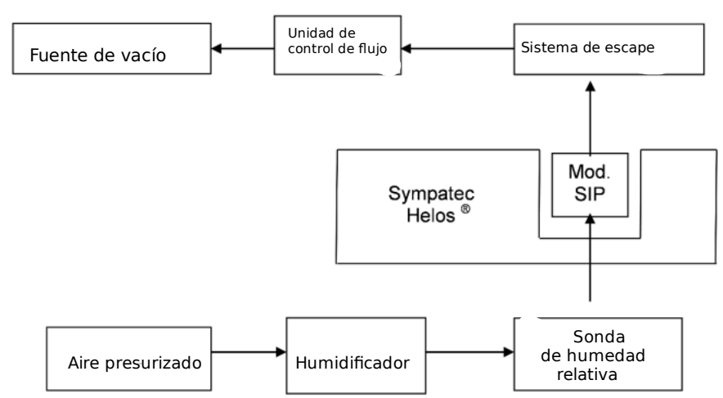
Figura 1 Figure 1 Overall schematic apparatus set-up

3. PROCEDURE

3.1 PRINCIPLE OF MEASUREMENT
Each aerosol particle produces a certain diffraction of the laser beam according to its size. The diffracted light of all particles is recorded by the detector and particle size is calculated from the integral function of the light intensity (this calculation includes the information from all sizes of particles captured by the laser beam). In the test for particle size distribution by laser diffraction at about 100 % relative humidity, the actuated dose of the inhaler is carried into the path of the laser beam by air of about 100 % relative humidity. The integral is converted by the computer software to display a report of the particle size distribution in different categories (relatively for all detected particles) of particle sizes.

3.2 PREPARATION OF THE HUMIDIFIER AND FLOW CONTROL UNIT
Perform the measurement at a relative humidity level of 98 ± 2 % and with a flow rate of 28.3 L/min (± 1.4 L/min).
Feed the pressurized air through the humidifier. Use tubing to connect the outlet of the humidifier with the relative humidity probe. Subsequently connect the tube from the relative humidity probe to the modified SIP using the inhaler adapter. The inlet of the SIP should be facing the front, and the outlet pointing upwards.
To generate the air flow, connect the SIP outlet to the flow control unit via a suitable adapter, inserting the exhaust system between the two. The latter is used to collect the spray discharged during the measurement and then to remove it from the apparatus.
Connect the flow control unit to the vacuum source.
During flow rate adjustment connect the exhaust system to the modified SIP.
Set the timer for interrupting the air flow on the flow control unit to a cycle of 6 seconds.
The operator should adjust the flow rate once before each series of measurements.

3.3 EQUILIBRATION OF THE SYSTEM
Start the flow through the humidifier by setting the rocker switch of the flow control unit to “Dauer” [Duration].
The system takes 5 – 10 minutes to reach a constant relative humidity and is equilibrated when a constant reading of 98 ± 2 % r.h. is shown on the relative humidity probe.

3.3.1 Focal length
Perform the measurement with the lens R3.
(focal length 100 mm, measuring ranges 0.5/0.9 µm to 175 µm)

3.3.2 Sampling of the aerosol plume
Start measurement and data collection immediately after the software shows the notice to start by pushing the actuation button of the device (obscuration of the detector element more than or equal to 0.1 %). The measurement is finished if the obscuration falls below 0.1 % or at maximum after 6 seconds. Particle size distributions are collected each 100 ms over the entire spray time and the total amount of particles is summed up in the 31 size classes of the detector.

3.4 SETTINGS ON THE SYMPATEC HELOS UNIT
Table 2 Product data
Software | Suitable software
Evaluation mode | Mie Theory
Refractive index | 1.330
Density | 1.000 g/cm3
Form factor | 1.00
Table 3 Trigger conditions
Reference measurement
Duration | 10 s
Time basis | 100 ms
Normal measurement
Start | 0s
After | Channel 30 ≥ 0.1 %
Valid | Always
Stop after | 0 s, channel 30 ≤ 0.1 %
Or after real time | 6.00 s

Table 4 Disperser
Disperser | e.g. Sprayer / Cuvette

4. MEASUREMENT
Before measurement, perform a signal test to confirm no stain is in the light path. During the signal test the amount of scattered light is measured by the analyser. The signal test is passed if the intensities of the detector rings 10 – 31 are not more than 6 %. If the signal test is failed, the glass surfaces have to be cleaned.
The air flow should be switched on and the modified SIP inserted into beam path of the Helos device.
Once the equilibration is complete and satisfactory results have been achieved for the signal test, switch off the air flow. Disconnect the air supply tube.
Cock the inhaler, wipe dry the mouthpiece, union nut and nozzle. Attach the inhaler to the adapter and reconnect the air supply tube.
Perform the background measurement once a constant humidity level of 98 ± 2 % has been achieved.
Then perform the sample measurement.
Whilst releasing an actuation from the inhaler, set the timer to automatic suction shutdown.
The actual measurement only starts when particles in the released aerosol are detected in the unit´s laser beam.
A report on the measurements, which contains the data from the reference and the actual measurements, is printed out automatically or can be displayed in the software.

Check the measurement conditions:
• c_{opt} has to be in the range of 5 – 35 %
• measurement time has to be ≥ 1.0 sec
When using the sample collection tube, the filter in the container should be changed every working day or, at the latest, after 48 measurements. After changing the filter, the flow rate has to be adjusted again.

5. EVALUATION

5.1 EVALUATION OF A SINGLE MEASUREMENT (OF A SINGLE ACTUATION)
Document the value shown on the report for the related fractions of a single actuation (FPF, distribution of particles in the aerosol cloud which are ≤ 5.0 µm) for each measurement to two decimal places in [%].
Calculate the total mean MV_{(T)} for the aerodynamic fine particle fraction (FPF, particles ≤ 5.0 µm) in [%] from all single actuations of all inhalers.

Convert the MV_{(T)} of the determination of the fine particle fraction (FPF) [%] into the aerodynamic fine particle dose (FPD) in [µg] for each drug substance (DS) with reference to its target dose (TD) with one decimal place:

5.2 PRESENTATION OF RESULTS
Table 5 Presentation of the results
FPD (fine particle dose) | [µg] | to 1 decimal place

