Unit 3 Sight Singing Assignment

**Intervals Warm-Up: Perfect and Imperfect Consonances from the Tonic Triad**

Sing and conduct.

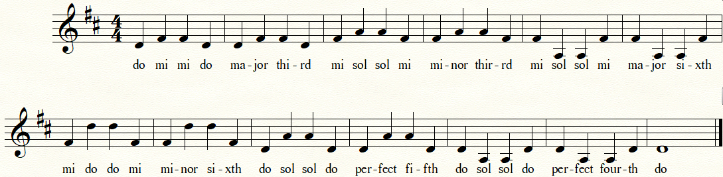

**Navigating your way around the tonic triad**

Conduct yourself in duple, triple, or quadruple time as appropriate, and sing using solfege.

Step 1: check your clef

Step 2: check your key signature and ascertain which solfege degree you need to start on. Play a tonic triad on the piano, sing up and down it a few times (“do-mi-sol-mi-do”) and find your starting pitch.

Step 3: check your time signature. Remember, the numerator determines whether you will conduct in two, three, or four.





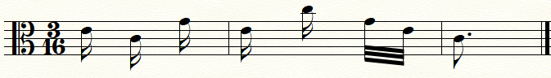

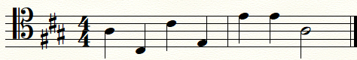

**The “Find Do” Game**

The instructor will play a pitch on the piano. The instructor will then tell you that this pitch is *mi* or *sol*. Basing your answer on the given pitch, navigate your way to *do*. Tip: use an intermediary step to produce your final answer.

**The “Find Sol” and “Find Mi” Game**

The instructor will play a pitch on the piano. This pitch may be *do, mi,* or *sol*. Basing your answer on the given pitch, navigate your way to *mi* or *sol* as directed by the instructor.

**Well-Known Melodies Based on the Tonic Triad**

Many folk songs and diatonic compositions in all genres are based on the tones of the tonic triad. Not all of them start on *do*. It is very common for a composition to begin on *mi* or *sol* too.

W. A. Mozart, *Maytime*

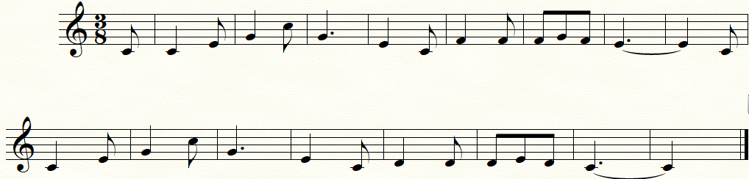

W. A. Mozart, *Eine kleine Nachtmusik* K. 525

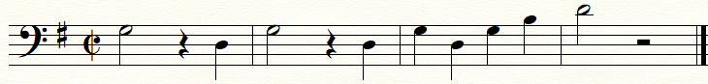

Johannes Brahms, *Wiegenlied* (Lullaby) Op. 49

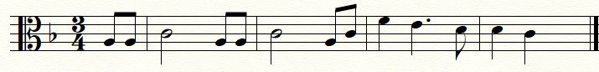

“Skip to My Lou” (American folk song)

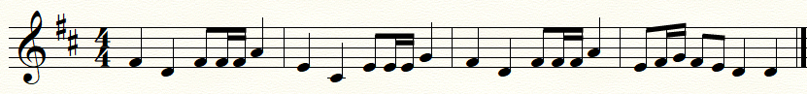

George Frideric Handel, “Chorus” from *Judas Maccabaeus* HWV 63

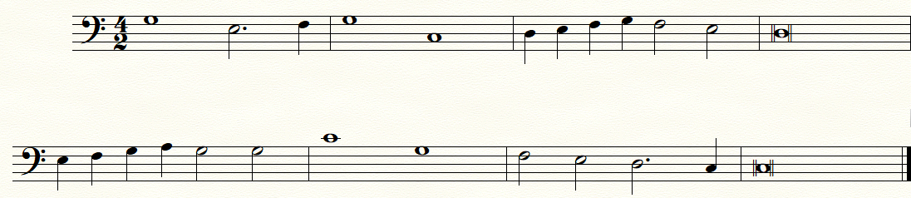

**Round of the Week: Oliver Cromwell**

This folk song can be sung as a round or as a call-and-response song. Practicing with a partner, sing it as a round (you will be asked to sing it this way with your instructor). The second singer begins when the first singer reaches the starred measure. You may sing it using the text or using solfege – be prepared to sing both ways for your instructor. You may choose to conduct it in a quick three, or in one.

“Oliver Cromwell” (English folk song, seventeenth century)

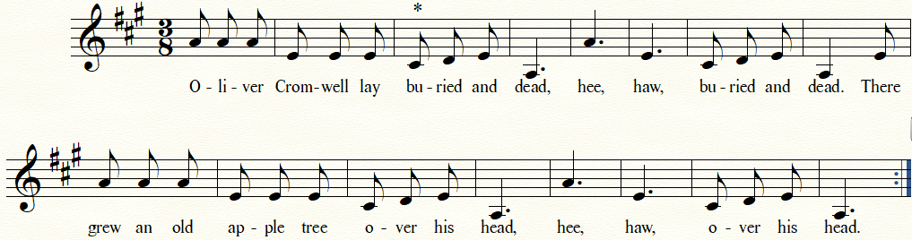

**Duets of the Week: “Bei Männern” and “Au clair de la lune” (adapted)**

Please perform the bass lines while your instructor plays the treble lines on the piano. Be sure to locate *do, mi,* and *sol* as signposts before you begin. Stick to your line and try not to be distracted by the melodic line. Practicing with a partner is essential.

W. A. Mozart, “Bei Männern, welche Liebe fühlen” from *Die Zauberflöte* K. 620

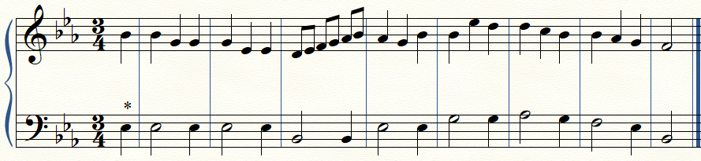

“Au clair de la lune” (French folk song, eighteenth century)

