Bangladesh University of Engineering and Technology
Department of Electrical and Electronic Engineering

EEE 416 (January 2026)
Microprocessor and Embedded Systems Laboratory
Project Proposal

Section: | C2
Group No: | 04
Student ID(s): | 2106181,2106182,2106183,2106184
Section Teachers: | Tanushri Medha Kundu, Abrar Assaeem Fuad
Project Title: | Design and Implementation of a Bi-directional Bangla Braille Translation Device

Abstract

This project aims to build a bi-directional Braille learning device that helps visually impaired people read and write in Braille in Bangla. In reading mode, Bangla text is converted into the corresponding Braille pattern, going letter by letter, raising six tactile push-pull solenoids. In writing mode, there is a separate cell in which the user enters a letter using six latching push buttons to spell a word, which is later displayed on an OLED display.

Background
Braille is the primary means for reading and writing for visually impaired people. However, learning materials in Bangla Braille are scarce and mostly imported, which makes them expensive. Our project aims to build an affordable, low-powered device that allows the user to both read any text file uploaded to the device in real time and also use it as a “Braille Typewriter” to type any word or sentence. This gives learners a self-directed way to practice their reading and writing skills from memory, and can be extended into classrooms and homes where dedicated Braille instructors are not available.

Complexity Analysis

Our project handles multi levels of complexity which includes-
- Embedded Hardware Integration: Interfacing the ESP32 with the OLED display, six latching push buttons, speaker module, and Wi-Fi communication.
- Web-Based File Management: Hosting a web server on the ESP32 to receive text files from a browser and storing them in the LittleFS file system.
- Braille Translation: Implementing efficient lookup tables to convert Bangla characters into Braille patterns (Reading Mode) and Braille patterns into Bangla characters (Writing Mode).
- Bangla Text Composition: Processing consonants and vowel signs (কার) to determine the correct character combinations before display.
- Custom Bangla Rendering: Designing and storing custom bitmap glyphs for Bangla characters since the OLED and U8g2 graphics library do not provide native Bangla font support.
- Firmware Development: Developing embedded firmware to coordinate hardware control, Braille decoding, file handling, display rendering, and audio feedback in real time.
- Memory Optimization: Efficiently managing flash memory for firmware, lookup tables, bitmap glyphs, and uploaded text files while minimizing RAM usage during execution.

KPA mapping (the relevant ones from the course outline):

Knowledge Attribute | Application in the Project
K5: Knowledge that supports engineering design in a practice area | The project applies engineering design principles to develop a portable Bangla Braille reading and writing device. The system design includes selecting appropriate hardware components (microcontroller, six tactile Braille buttons, audio output module, and storage), designing separate Reading and Writing modes, implementing Bangla Braille encoding and decoding, and developing a user-friendly interface suitable for visually impaired users.
K6: Knowledge of engineering practice (technology) in the practice areas in the engineering discipline | The project demonstrates engineering practice through the implementation of embedded-system technologies, including microcontroller programming, GPIO interfacing for six tactile button outputs and latching button inputs, file handling for reading Bangla text, Braille pattern generation, Braille input recognition, audio feedback, firmware development (writing the codes in C), and integration of hardware and software into a functional assistive device.
K7: Comprehension of the role of engineering in society and identified issues in engineering practice including ethics, public safety, economic, social, cultural, environmental, and sustainability considerations | The proposed device promotes inclusive education by enabling visually impaired users to read and write in our mother tongue, Bangla. By utilizing low-cost embedded hardware and focusing on the Bangla language, the system improves accessibility, supports independent learning, and demonstrates the role of engineering in developing socially responsible technology.

Technical Requirements

1.Microcontroller | A programmable microcontroller ( ESP32 ) capable of handling GPIO operations, memory management, and peripheral interfacing.
2. Braille Interface | One cell built of 6 push-pull solenoids for reading mode and another cell with 6 latching buttons for braille writing mode, along with normal push buttons for navigation (read the next letter or take the reading of the next input in writing mode) and mode selection (reading or writing).
4, Speaker | One speaker for audio feedback of the letter just given as input so that the user can confirm if they type correctly.
5. OLED display | One OLED display to show the word typed for others
6. MOSFETs | We need six MOSFETs to drive the output tactile solenoids as they draw large currents, and connecting the solenoids directly to the ESP32 will cause damage.
3. Power Supply | We shall use an adapter that connects to the grid directly to turn on the device and use it as the main power source driving the tactile buttons.

Proposed Methodology
Reading Mode:
Setup phase (Once per text file)
- The user connects phone/laptop to the ESP32's WiFi network and opens its IP address in a browser.
- The ESP32 runs a small web server that serves a simple upload page.
- The user selects and uploads the Bangla .txt file through that page.
- The ESP32 receives the raw bytes over WiFi and writes them, unchanged, into a file in its own flash storage using the library LittleFS.h.
Reading loop (runs continuously while displaying)
5. The program opens that saved file and keeps a File object that automatically tracks which byte to read next.
6. On each step, it reads bytes starting at the current position. Since Bengali code points are 3 bytes in UTF-8, it reads 1 first byte to detect a 3-byte sequence, then reads the other 2, and combines all 3 into a single Unicode code point.
7. That code point is looked up in the pre-saved Braille mapping table to get a 6-bit dot pattern.
8. The ESP32 drives the six actuators according to that pattern, raising the correct dots.
9. It waits for the user's "next" button press.
10. On the next press, it loops back to step 6 and reads the next character — continuing from exactly where the file cursor left off, with nothing about the previous character kept in memory.

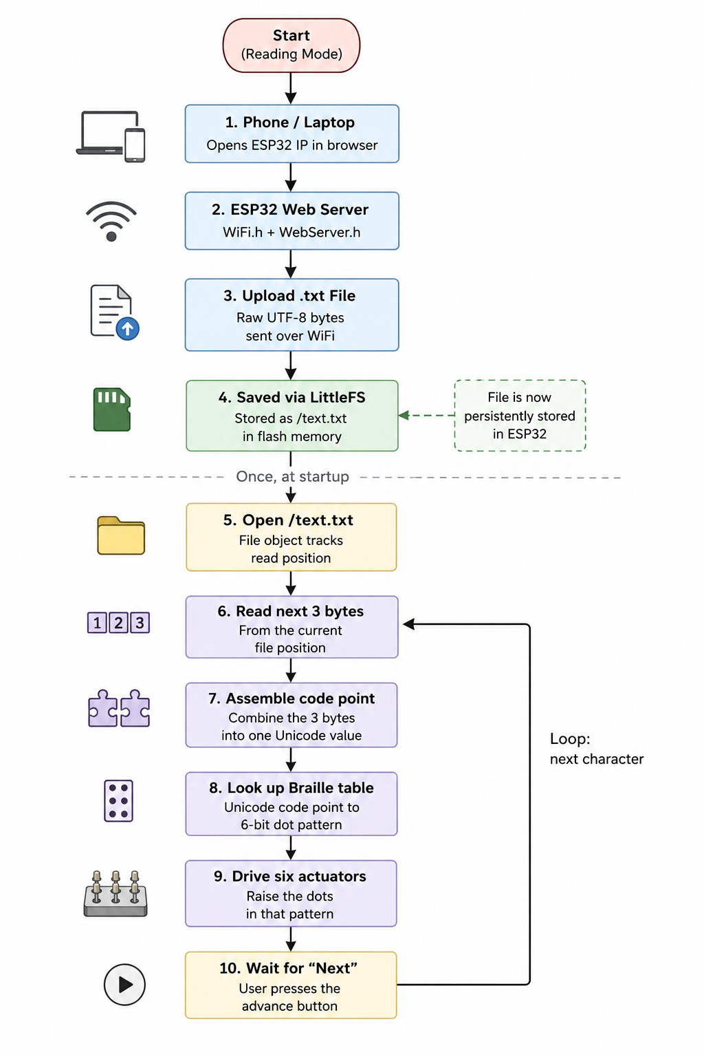
Fig: Reading Mode

Writing Mode:

There are two main concerns regarding the writing mode,

1. The OLED display does not provide native support for rendering Bangla Unicode characters. Although the U8g2 graphics library manages communication with the OLED and provides drawing functions, it does not include Bangla fonts by default. Therefore, custom bitmap glyphs must be created for each Bangla character (and required character combinations with vowel signs) so that the microcontroller can accurately render the intended text on the display. For simplicity we will map the bitmaps of each individual letter and their vowel attached form in the memory (rather than “building” the “kaar” attached form of that letter from the input) so the whole thing can be used as a look up table.

2. Since Bangla language have “kaar” and the Braille system does not have a separate encoding for “kaar” and assumes that if a vowel appears after consonant it has to be a “kaar” attached to it, we will need to logically implement it using “lookahead buffer” approach before displaying it on OLED. It takes one input and then waits for the next one. If it is a standalone vowel, it directly shows the output but if it is a consonant and the next letter is vowel it combines them to display the text format with “kaar” attached.

The pipeline for the writing mode is as below-

- The user types a single letter using the 6 latching push buttons.
- The device waits for the Enter push button
- It reads the states of the six push buttons and generates the corresponding 6-bit Braille pattern.
- Searches the Braille lookup table (six bit pattern to direct OLED display glyph Bitmap) to identify the corresponding Bangla character.
- Determines whether the recognized character is a consonant. If No, retrieve its display glyph from the glyph lookup table and proceed to Step 10.
If Yes, continue to Step 6.

- Peeks at the next Braille input without permanently processing it.
- Determines whether the next character is a vowel sign (কার). If Yes, combine the consonant and vowel sign into a composed character (e.g., ক + ি → কি) and retrieve the corresponding glyph from the lookup table. If No, retrieve the glyph corresponding to the consonant alone.
- Updates the text buffer with the final character or composed character.
- Generates the corresponding audio output and announces the recognized character through the speaker.
- Renders the selected glyph on the OLED using the U8g2 graphics library.
- Repeats the process for the next Braille input until the writing session is complete.

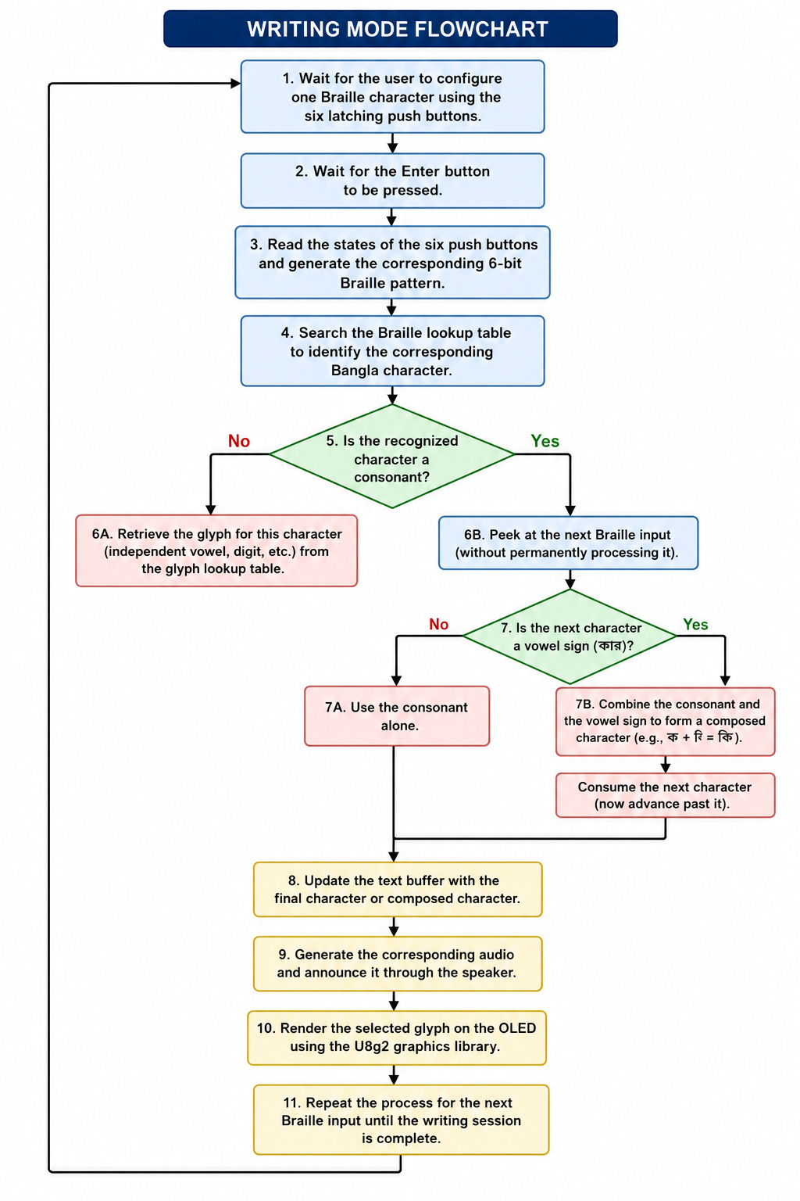
Fig: Writing mode pipeline

References
- https://www.sciencebuddies.org/science-fair-projects/project-ideas/Elec_p109/electricity-electronics/refreshable-braille-display?ytid=D0-yi5dm2qw&ytsrc=description

- [1] M. S. Rahman, M. M. Rahman, and M. Kaykobad, "Bangla Braille Adaptation," in Technical Challenges and Design Issues in Bangla Language Processing, M. A. Karim, M. Kaykobad, and M. Murshed, Eds. Hershey, PA, USA: IGI Global, 2013, ch. 2, pp. 17–34.

