Contrast Check: Gradient Background Problems

Me:
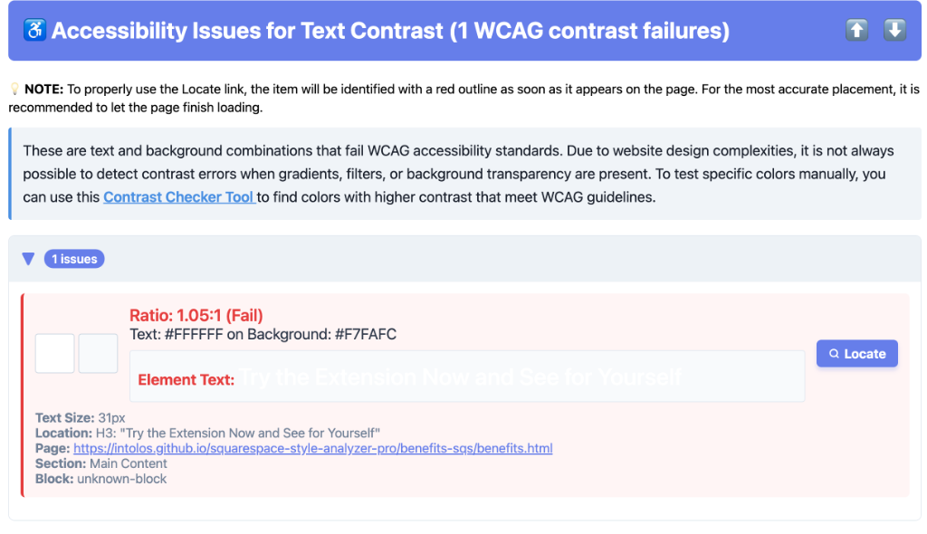

I am uploading two screenshots. One shows the accessibility issue that are captured however it is entirely wrong as you can see in the other screenshot that shows the website portion that I captured. This button was used on this page several times with the exact same code and it only caught this one instance of it and as I said it was wrongly captured.

Gemini 3 Pro High:
You are completely right. This is a classic "Gradient Blind Spot" in automated accessibility testing.
Here is what is happening technically:
- The Flaw: The underlying auditing tool (axe-core, which we use) is looking for a solid background-color value (e.g., #000000).
- The Confusion: Your button uses a linear-gradient (likely styled via background-image or the shorthand background property). Automated tools often cannot calculate the "average" color of a gradient.
- The Mistake: When the tool can't "read" the gradient, it falls back to looking at the background-color behind it. In your case, it seems to be seeing a very light grey/white (#F7FAFC), and correctly warning you that "White Text on White Background" is unreadable. It doesn't know the purple gradient exists visually.
Why only one instance? This is the most interesting part. Since the code is identical, it is likely that this specific button instance is sitting on top of a different container than the others.
- The other buttons might have a "transparent" fallback that resolves to a dark parent, or the tool simply gave up on them.
- This specific button likely sits on a container that explicitly defines that light #F7FAFC color, giving the tool just enough information to make a (wrong) guess.
Proposed Solution (When you are ready): I can update the content.ts logic to add a "Gradient Check." Before reporting a contrast error, the code will check: "Does this element (or its parent) have a gradient background?" If the answer is Yes, we should filter it out of the text contrast report entirely, because we know the automated math will be wrong. This will eliminate these false positives.

