

JSignPdf Quick Start Guide
Digital signatures for your PDF documents
version 1.4.1
http://jsignpdf.sourceforge.net/
Table of Contents
1 JSignPdf Introduction 4
1.1 Benefits of digital signatures (source: Wikipedia) 4
1.1.1 Authentication 4
1.1.2 Integrity 4
1.2 License 4
1.3 History 4
1.4 Author 5
1.5 Getting support 5
2 Prerequisites 6
2.1 Java 6
2.2 Keystore 6
2.2.1 Exporting PKCS12 certificates from Internet Explorer 6
2.2.2 Java Key and Certificate Management Tool 6
3 Installation 8
3.1 Windows installer 8
3.2 Zip package 10
3.3 OpenOffice.org/LibreOffice Add-On 10
4 Launching 11
4.1 Windows Start menu 11
4.2 Without start menu 11
4.3 OpenOffice.org/LibreOffice Add-On 11
5 Using JSignPdf – signing PDF files 12
5.1 Simple version 12
5.2 More detailed version 12
5.2.1 Select Key Store Type 12
5.2.2 Keystore file and password 12
5.2.3 Input and Output PDF files 12
5.2.4 Reason, location, contact 13
5.2.5 Remember passwords 13
5.2.6 Sign It 13
5.3 Advanced view 14
5.3.1 Key alias 14
5.3.2 Key password 14
5.3.3 Append signature 14
5.3.4 Certification level 14
5.3.5 Hash algorithms 15
5.4 Encryption 16
5.4.1 Encryption: Passwords 17
5.4.2 Encryption: Certificate 17
5.4.3 Rights 17
5.5 Visible signature 17
5.5.1 Page 18
5.5.2 Signature corners 18
5.5.3 Preview / Select button 19
5.5.4 Display 19
5.5.5 Acrobat 6 layers 20
5.5.6 Texts and Images 20
5.6 TSA – timestamps 20
5.7 Certificate revocation checking 20
5.7.1 CRL 20
5.7.2 OCSP 21
5.8 Proxy settings 21
6 Advanced application configuration 22
6.1 conf.properties 22
6.2 Java VM options using EXE launchers 22
7 Uninstall 23
7.1 Windows uninstaller 23
7.2 Zip package 23
7.3 OpenOffice.org/LibreOffice Add-On 23
8 Solving problems 24
8.1 Out of memory error 24
8.1.1 OpenOffice.org/LibreOffice Add-On 24
8.2 Changing the application language 24
8.2.1 Change language when running through Windows EXE launcher 24
8.3 Other problems – consult online FAQ 24
9 Command line (batch mode) 25
9.1 Program exit codes 28
9.2 Examples 28
9.2.1 Simplest signature on windows 28
9.2.2 PKCS12 signature with encryption 28
9.2.3 Listing KeyStore types 28
9.2.4 Listing key aliases in a KeyStore 29
10 Other command line tools 30
10.1 InstallCert Tool 30
10.2 Verifier 30
10.2.1 Program exit codes 31
10.3 SignatureCounter 31
10.3.1 Program exit codes 31

JSignPdf Introduction
JSignPdf is an open source application which adds digital signatures to PDF documents. It's written in Java programming language and it can be launched on the most of current OS (MS Windows, Linux, Mac OS X, ...). User can control the application using simple Swing GUI or command line arguments. Main features:
- supports visible signatures
- can set certification level
- supports PDF encryption with setting rights
- timestamp support
- certificate revocation checking (CRL and/or OCSP)

Benefits of digital signatures (source: Wikipedia)
Below are some common reasons for applying a digital signature to communications:

Authentication
Although messages may often include information about the entity sending a message, that information may not be accurate. Digital signatures can be used to authenticate the source of messages. When ownership of a digital signature secret key is bound to a specific user, a valid signature shows that the message was sent by that user. The importance of high confidence in sender authenticity is especially obvious in a financial context. For example, suppose a bank's branch office sends instructions to the central office requesting a change in the balance of an account. If the central office is not convinced that such a message is truly sent from an authorized source, acting on such a request could be a grave mistake.

Integrity
In many scenarios, the sender and receiver of a message may have a need for confidence that the message has not been altered during transmission. Although encryption hides the contents of a message, it may be possible to change an encrypted message without understanding it. (Some encryption algorithms, known as nonmalleable ones, prevent this, but others do not.) However, if a message is digitally signed, any change in the message will invalidate the signature. Furthermore, there is no efficient way to modify a message and its signature to produce a new message with a valid signature, because this is still considered to be computationally infeasible by most cryptographic hash functions

License
JSignPdf is released under LGPL and/or MPL license. It means, it can be freely used for personal use, for academic use, by government institutions, by non-profit making organizations and by commercial organizations. JSignPdf, or parts of it, can also be freely incorporated into commercial products. For more details look directly to license files.

History
Project started on the beginning of 2008 as a response for a request for PDF-signing Add-On to OpenOffice.org which came up from Czech OpenOffice.org users community.
Active development stopped by the author on September 2012.

Author
Author of the JSignPdf is a Czech developer Josef Cacek. He works in Java from 2000. Some links to the Josef's projects:
- https://sourceforge.net/users/kwart/
- https://github.com/kwart/

Getting support
If you don't find the relevant information in this document or on JSignPdf web page (http://jsignpdf.sourceforge.net/) use JSignPdf Google Group to ask the community.
https://groups.google.com/d/jsignpdf/

Prerequisites

Java
If you want to use JSignPdf, and you don't install it on Windows using the installation program, you will need Java Runtime Environment (JRE) version 5 or newer on your computer (recommended is the Java 6). If you don't have it, you can download it freely from web pages, for instance:
http://java.sun.com/
If you use JSignPdf OpenOffice.org/LibreOffice Add-On, you have to allow Java in OpenOffice.org preferences.
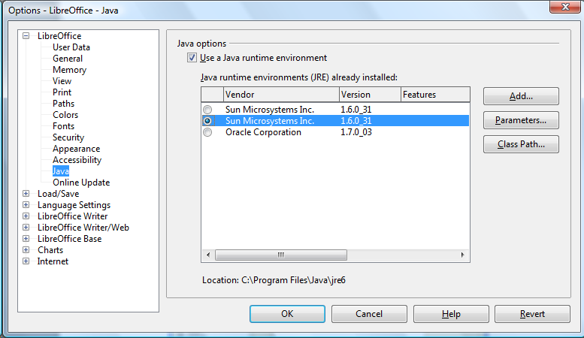
Start OpenOffice.org/LibreOffice, go to menu Tools → Options... Select OpenOffice.org/LibreOffice → Java in tree menu and choose Java installation from the list

Keystore
To sign PDF documents you need a keystore with your private key. The most common keystores supported by Java are:
- PKCS#12 – keys stored in .p12 and .pfx files
- JKS (Java Key Store)
- WINDOWS-MY – supported only on MS Windows with Java 6 and newer. You can use directly your certificates imported in your system.

Exporting PKCS12 certificates from Internet Explorer
Guide of National Bank of Belgium:
http://www.nbb.be/doc/dq/E_pdf_dq/certificates_management_v.1.0_EN.pdf

Java Key and Certificate Management Tool
Keytool can handle JKS keystore files. It is a part of Java Runtime installation.
Documentation for keytool from Java 6 is here:
http://java.sun.com/javase/6/docs/technotes/tools/windows/keytool.html

Installation
This chapter describes how to install JSignPdf using Windows installer, zip package and how to enable JSignPdf as OpenOffice.org/LibreOffice Add On.

Windows installer
Windows installer contains ready to use version – the Java Runtime is also included in the package.
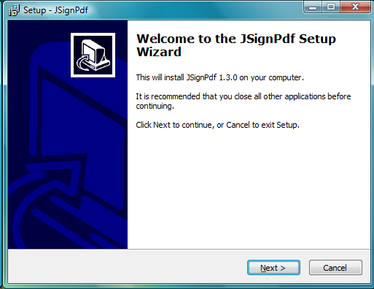
Download file JSignPdf_setup_1.4.1_wjre.exe and run it.
Accept the license agreement.
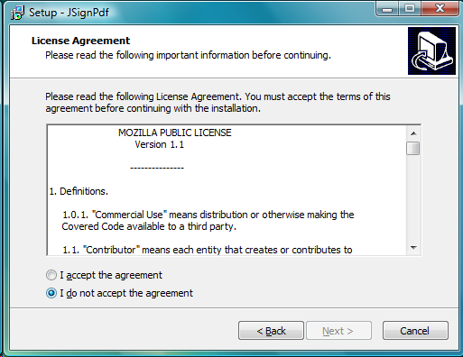
Choose the installation path.
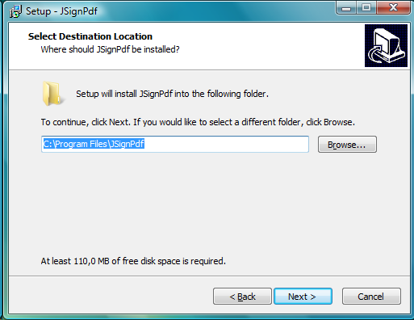

Choose a Start menu Group name.
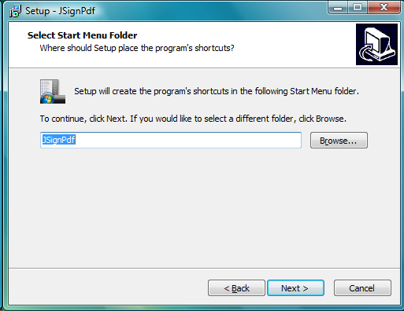
Verify your settings and let it Install.
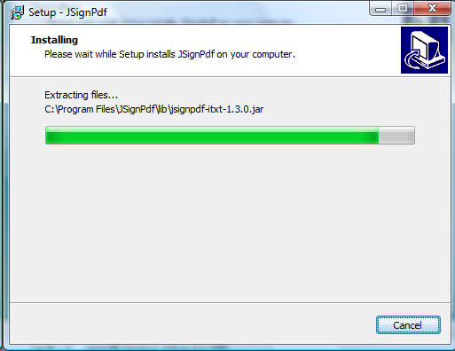

Zip package
If you are advanced user or you have another OS than MS Windows, you can install JSignPdf from the zip archive file. Download file JSignPdf-1.4.1.zip and unpack it into your preferred directory with your preferred archiver or simply using the command line:
unzip JSignPdf-1.4.1.zip -d /my/preferred/path

OpenOffice.org/LibreOffice Add-On
Download file JSignPdf-1.4.1.oxt from JSignPdf download page.
Run OpenOffice.org/LibreOffice and from Tools menu choose item Extension Manager...
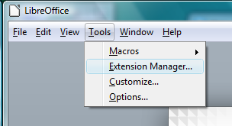
In extension manager window press Add... button, select extension file JSignPdf-1.4.1.oxt in the displayed open-file dialog and press Open button.
Restart your OpenOffice.org/LibreOffice (quickstarter too) and check presence of the new JSignPdf toolbar icon and menu item PDF Signer in the menu Tools → Add-Ons
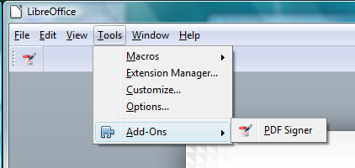

Launching

Windows Start menu
If you've installed JSignPdf from the windows installer package, there is a new Group in your system Start menu: Start → Programs → JSignPdf → JSignPdf 1.4.1

Without start menu
All platforms (with Java installed) should support launching of jar file JSignPdf.jar. Use following command in the directory, where the application is located.
$java -jar JSignPdf.jar
If you don't need see console output, use javaw command instead of java.

OpenOffice.org/LibreOffice Add-On
Press JSignPdf icon in OpenOffice.org/LibreOffice toolbar or choose in menu Tools → Add-Ons → PDF Signer

Using JSignPdf – signing PDF files

Simple version
Fill text fields and press Sign It button.
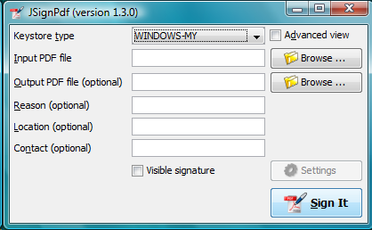

More detailed version

Select Key Store Type
Keystore means location where the certificates (private or public keys) are located. Java 5 should support at least JKS and PKCS#12 keystores. Java 6 also supports native Windows certificate keystore “WINDOWS-MY”.
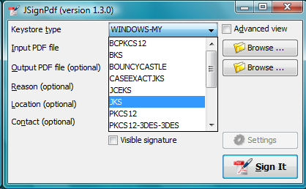
By default, JSignPdf displays keystore types provided by Java (Sun Provider) and Bouncy Castle cryptographic provider.
More info: http://java.sun.com/javase/6/docs/technotes/guides/security/SunProviders.html

Keystore file and password
If you use JKS or PKCS#12 keystores, you have to select file where the keys are stored and provide password of this file. Path to the keystore file can be inserted directly by typing or you can use Browse button to navigate through the file system with Open File Dialog.

Input and Output PDF files
Input PDF file is an existing PDF file to which should be added digital signature.
Output PDF file is a name of result PDF file. If the value is not filled, automatically will be used the Input PDF file with additional suffix “_signed” (e.g. input test.pdf will result in test_signed.pdf)
The Input and Output files has to be different!

Reason, location, contact
Reason, location and contact fields provide additional information about signature. Filled values will be stored in the result PDF.

Remember passwords
JSignPdf stores filled information when you are exiting application, so it's present when you run it the next time. Passwords are not stored by default, but you can allow it by selecting checkbox Remember passwords.
Even if the password is stored in the encrypted form, we do not recommend to store passwords if your computer is used by more users!

Sign It
Button Sign It starts the signing process. It displays console window and you can see what the program is doing.
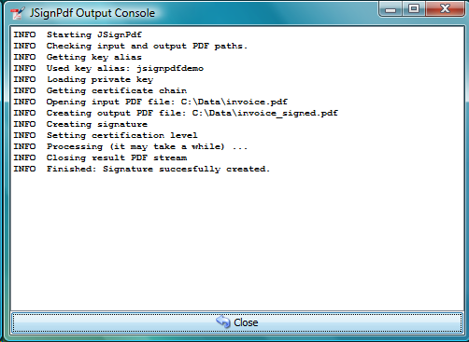

Advanced view
If you are more experienced user or you have to handle with encrypted PDFs or you have more keys stored in your keystore, you can use Advanced view checkbox to enable additional functionality.
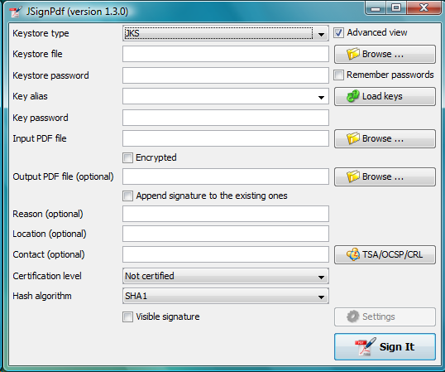

Key alias
When you have more private keys stored in the keystore, you can select which one will be used to sign PDF file by filling Key alias field. Either you can type alias name directly (combo box is editable) or you can load all names by pressing Load keys button and then select one from drop-down list.
If you don't fill Key alias field the first alias read from keystore will be used.

Key password
Each key in keystore can be protected with its own password. If this password differs from the password of keystore, fill it to Key password input field.

Append signature
JSignPdf can work in two signing modes. It replaces existing signatures with the new one by default. If you select Append signature checkbox, the new one will be appended and the old signatures will stay unchanged. This option is disabled for encrypted documents.

Certification level
The JSignPdf application is able to add certificate to the signed PDF. There are four levels of certification as you can see from the screenshot:
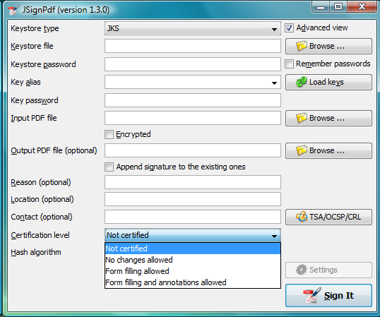

Hash algorithms
You can choose, which hash function will be used for signature. SHA-1 is the most common and should be supported by all keystore types. For better protection of signatures you can choose another one, but you can get then exception in console window during signing, if it's not supported by the chosen keystore provider. (Bouncy castle provider has better support than the Java one, so if you use for instance BCPKCS12 keystore type, all hash algorithms should work properly.)
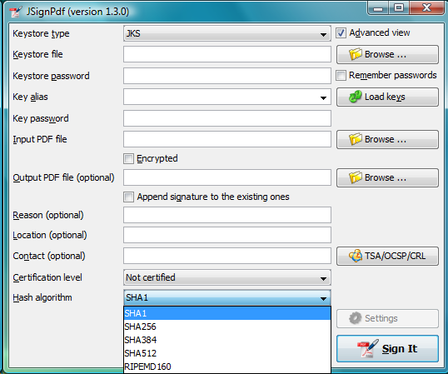
In Acrobat reader, you can display signature properties and on tab Document is the information about used algorithm.

Encryption
PDF Encryption combobox enables additional fields for support of PDF security. By using this you can either sign secured PDFs (and change the rights and user password) or you can add encryption to unencrypted PDF during signing.
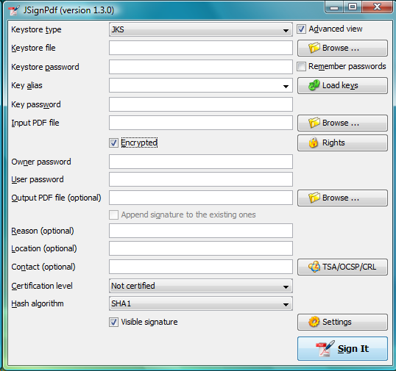Outdated screenshot (without certificate encryption support)

Encryption: Passwords
Fill owner and user passwords to set it in secured result PDF. If the input PDF is encrypted, the Owner password field has to match to owner password of input PDF.

Encryption: Certificate
Fill path to a certificate file (*.cer, *.crt, …) which should be used for the PDF encryption. Only the user, which has the private key for the certificate will be able to open the file.

Rights
You can set allowed actions in encrypted result PDF by pressing Rights button. A new modal window will be displayed and you can set the possible options there.
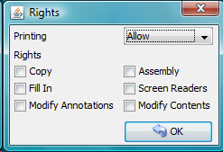
Normal rights are represented by checkboxes. Printing right has 3 levels, so the combobox is used for it.

Visible signature
Checkbox Visible signature allows you to create visible field with signature directly in the signed PDF. If the checkbox is checked, button Settings is enabled and you can configure parameters (position/texts/images) of visible signature.
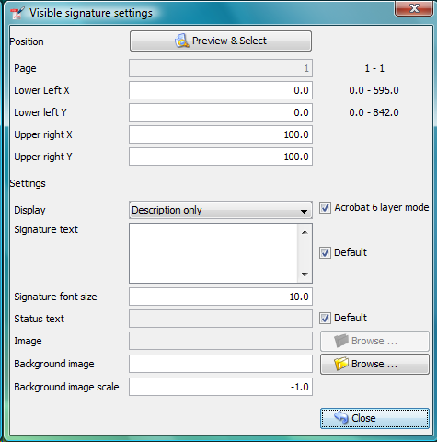
Read ToolTip texts, which are assigned to some input fields. You will get information, how to fill them correctly.

Page
Page number (counted from 1) to which the signature will be added.

Signature corners
Next four inputs Lower Left (X, Y) and Upper Right (X, Y) defines position of signature on the page. You can fill in float numbers (with decimal places) as input. If you have already selected input PDF in the main window you will see possible range for X and Y values on the right side of Lower Left (X, Y) input fields.
Position of signature on page is bounded by lower left corner and upper right corner. Position of elements in PDF has base on the left bottom corner of page([0,0]).

Preview / Select button
PDF preview is supported from version 1.0.0. The borders of visible signature are displayed on the chosen page. You can select new position by pressing left mouse button at start corner, moving to end corner and releasing the mouse.


Display
In combobox Display you can set which fields will be generated to visible signature.

Acrobat 6 layers
The checkbox Acrobat 6 layer mode (checked by default) allows you to control which signature layers will be added to the signed document. Acrobat 6.0 and higher recommends that only layer n2 and n4 be present. If the checkbox is not selected then all layers will be created.

Texts and Images
Signature Text, Status Text, Image and Background Image inputs define content of fields in visible signature. Signature Font Size is used for setting size of Signature Text, it should contain positive decimal number.
Background image scale defines size of background image. Any negative number means, the best-fit algorithm will be used. Zero value means stretch, which fills whole field – it doesn't keep image ratio. Positive value means the multiplicator of original size.

TSA – timestamps
To add timestamp into signature you will need some timestamping authority (TSA) . Fill server address into TSA URL field and if the server requires authentication choose the authentication type and fill either TSA User and TSA Password fields or path to the certificate's private key (it has to be PKCS#12 keystore) and the password. You can also set TSA Policy OID, which will be send to TSA server in the request, but probably you will not need to do so and the server use the right policy by itself.
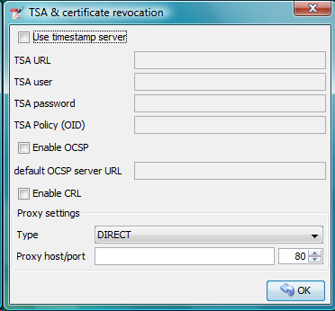
You can try following URL for testing (doesn't require authentication):
http://dse200.ncipher.com/TSS/HttpTspServer

Certificate revocation checking
JSignPdf supports two standard ways of certificate revocation checking – CRL and OCSP. Most of the X.509 certificates supports CRL, but it has some disadvantages (for instance the size of list and possibly outdated information). The second – OCSP solves the mentioned issues, but not all Certification Authorities (CA) supports this protocol.

CRL
RFC 3280, Internet X.509 Public Key Infrastructure, Certificate and Certificate Revocation List (CRL) Profile.
Wikipedia says: In the operation of some cryptosystems, usually public key infrastructures (PKIs), a certificate revocation list (CRL) is a list of certificates (or more specifically, a list of serial numbers for certificates) that have been revoked or are no longer valid, and therefore should not be relied upon.
Such a list will be downloaded from CA and stored in PDF during signing process.

OCSP
RFC 2560, X.509 Internet PKI Online Certificate Status Protocol-OCSP.
Wikipedia says: The Online Certificate Status Protocol (OCSP) is an Internet protocol used for obtaining the revocation status of an X.509 digital certificate. It is described in RFC 2560 and is on the Internet standards track. It was created as an alternative to certificate revocation lists (CRL), specifically addressing certain problems associated with using CRLs in a public key infrastructure (PKI). Messages communicated via OCSP are encoded in ASN.1 and are usually communicated over HTTP. The "request/response" nature of these messages leads to OCSP servers being termed OCSP responders.
If OCSP is enabled in JSignPdf and the protocol is supported for the certificate, the OCSP request will be created and response will be stored in signed PDF. The URL of OCSP server is retrieved from certificate. If the OCSP part is not found in the signing certificate, the value from default OCSP server URL field will be used.

Proxy settings
If some “online” feature (TSA, CRL, OCSP) is enabled and JSignPdf runs behind a firewall, you can set the proxy, which will be used for all internet connections. Proxy type DIRECT means no proxy will be used.

Advanced application configuration

Some advanced options are not controlled from GUI or command line. They can be only set directly in the appropriate configuration file.

conf.properties
The property file conf/conf.properties contain several option groups:
- visible signature font settings
- control the certificate checks
- PKCS#11 support
- enable more strict SSL handling

Java VM options using EXE launchers
If the Java VM properties has to be changed (e.g. maximum memory allowed) and the EXE wrapper is used, you can edit the appropriate .l4j.ini file (e.g. JSignPdf.l4j.ini).
The arguments should be separated with spaces or new lines, environment variable expansion is supported, for example:
# Launch4j runtime config
-Dswing.aatext=true
-Dsomevar="%SOMEVAR%"
-Xms32m
-Xmx512m

Uninstall
This chapter describes how to uninstall/remove JSignPdf from a computer.

Windows uninstaller
Choose Programs → JSignPdf → Uninstall and confirm the uninstallation.
If you've installed OpenOffice.org/LibreOffice Add-On during installation, you have to remove it manually, see chapter 7.3.

Zip package
Remove unpacked JSignPdf folder and you can also remove configuration file .JSignPdf, which is stored in user home directory.

OpenOffice.org/LibreOffice Add-On
From main menu choose Tools → Extension Manager ... select JSignPdf entry and press Remove button.
Restart OpenOffice.org/LibreOffice to complete uninstallation.

Solving problems

Out of memory error
If you will see OutOfMemoryError in the program console, you need to allow java to use more memory.
Add -Xmx<size> switch to your java. Following example allows java to use 512MB (heap size).
$java -Xmx512m -jar JSignPdf.jar

OpenOffice.org/LibreOffice Add-On
Configure this parameter in Tools → Options... → OpenOffice.org/LibreOffice → Java by pressing Parameters... button.

Changing the application language
The language used by the program should be fit the regional settings in your system (if the translation is available), or the English is used (the default).
If you want use another translation, specify the java system property user.language and as the value use the country code (cs, de, fr, ja, pl, ...).
E.g. for the czech language:
$java -Duser.language=cs -jar InstallCert.jar

Change language when running through Windows EXE launcher
Open JSignPdf.l4j.ini (or JSignPdfC.l4j.ini) in any text editor like Notepad.exe and add a line with user.language specified at the end of file:
-Duser.language=cs

Other problems – consult online FAQ
http://jsignpdf.sourceforge.net/en_US/faq.html

Command line (batch mode)
usage: java -jar JSignPdf.jar [file1.pdf [file2.pdf ...]] [-a] [--bg-path
<file>] [--bg-scale <scale>] [-c <contact>] [-cl <level>] [--crl] [-d
<path>] [--disable-acrobat6-layer-mode] [--disable-assembly]
[--disable-copy] [--disable-fill] [--disable-modify-annotations]
[--disable-modify-content] [--disable-screen-readers] [-e] [-ec <file>]
[-fs <size>] [-h] [-ha <algorithm>] [--img-path <file>] [-ka <alias>]
[-ki <index>] [-kp <password>] [-ksf <file>] [-ksp <password>] [-kst
<type>] [-l <location>] [--l2-text <text>] [--l4-text <text>] [-lk]
[-lkt] [-llx <position>] [-lly <position>] [-lp] [-lpf <file>] [--ocsp]
[--ocsp-server-url] [-op <prefix>] [-opwd <password>] [-os <suffix>] [-pe
<mode>] [-pg <pageNumber>] [-pr <right>] [--proxy-host <hostname>]
[--proxy-port <port>] [--proxy-type <type>] [-q] [-r <reason>]
[--render-mode <mode>] [-ta <method>] [-ts <URL>] [--tsa-policy-oid
<policyOID>] [-tscf <file>] [-tscp <password>] [-tsct <ks-type>] [-tsp
<password>] [-tsu <username>] [-upwd <password>] [-urx <position>] [-ury
<position>] [-V] [-v]
JSignpdf is an application designed to digitally sign PDF documents. If you
start the program without any command line argument, the GUI will be started,
otherwise you can use JSignPdf in command line batch mode.
-a,--append add signature to existing ones. By
default are existing signatures replaced
by the new one.
--bg-path <file> background image path for visible
signatures
--bg-scale <scale> background image scale for visible
signatures. Insert positive value to
multiply image size with the value.
Insert zero value to fill whole
background with it (stretch). Insert
negative value to best fit resize.
-c,--contact <contact> signer's contact details (a signature
field)
-cl,--certification-level <level> level of certification. Default value is
NOT_CERTIFIED. Available values are
NOT_CERTIFIED,
CERTIFIED_NO_CHANGES_ALLOWED,
CERTIFIED_FORM_FILLING,
CERTIFIED_FORM_FILLING_AND_ANNOTATIONS
--crl enable CRL certificate validation
-d,--out-directory <path> folder in which the signed documents
will be stored. Default value is current
folder.
--disable-acrobat6-layer-mode disables the Acrobat 6 layer mode i.e.
all signature layers will be created.
Acrobat 6.0 and higher recommends that
only layer n2 and n4 be present.
--disable-assembly deny assembly in encrypted documents
--disable-copy deny copy in encrypted documents
--disable-fill deny fill encrypted documents
--disable-modify-annotations deny modify annotations in encrypted
documents
--disable-modify-content deny modify content in encrypted
documents
--disable-screen-readers deny screen readers in encrypted
documents
-e,--encrypted This property is deprecated, use
-encryption PASSWORD instead!
-ec,--encryption-certificate <file> path to the certificate file, which is
used to encrypt output PDF in case of
-encryption CERTIFICATE
-fs,--font-size <size> font size for visible signature text,
default value is 10.0
-h,--help prints this help screen
-ha,--hash-algorithm <algorithm> hash algorithm used for signature.
Default value is SHA1. Available values
are SHA1, SHA256, SHA384, SHA512,
RIPEMD160
--img-path <file> image path for visible signature
-ka,--key-alias <alias> name (alias) of the key, which should be
used for signing the document. If this
option is not given, the first key in
the keystore is used. (List the key
aliases using -lk)
-ki,--key-index <index> zero based index of the key, which
should be used for signing the document.
If neither this option nor alias is
given, the first key (index=0) in the
keystore is used. (List the key aliases
using -lk). This option has lower
priority than alias.
-kp,--key-password <password> password of the key in keystore. In most
cases you don't need to set this option
- only keystore is protected by a
password, but just in case :)
-ksf,--keystore-file <file> sets KeyStore file - as the value use
the path on which is file with private
key(s) located (.p12, .pfx, .jks, ...).
Some keystores haven't keys stored in a
file (e.g. windows keystore -
WINDOWS-MY), then don't use this option.
-ksp,--keystore-password <password> password to KeyStore
-kst,--keystore-type <type> sets KeyStore type (you can list
possible values for this option -lkt
argument)
-l,--location <location> location of a signatue (e.g. Washington
DC). Empty by default.
--l2-text <text> signature text
--l4-text <text> status text
-lk,--list-keys lists keys in choosen keystore
-lkt,--list-keystore-types lists keystore types, which can be used
as values -kst option
-llx <position> lower left corner postion on X-axe of a
visible signature
-lly <position> lower left corner postion on Y-axe of a
visible signature
-lp,--load-properties Loads properties from a default file
(created by GUI application).
-lpf,--load-properties-file <file> Loads properties from the given file.
The file can be create by copying the
default property file .JSignPdf created
by the GUI in the user home directory.
--ocsp enable OCSP certificate validation
--ocsp-server-url default OCSP server URL, which will be
used in case the signing certificate
doesn't contain this information
-op,--out-prefix <prefix> prefix for signed file. Default value is
empty prefix.
-opwd,--owner-password <password> owner password for encrypted documents
(used when -e option is given)
-os,--out-suffix <suffix> suffix for signed filename. Default
value is "_signed". (e.g. sign process
on file mydocument.pdf will create new
file mydocument_signed.pdf)
-pe,--encryption <mode> encryption mode for the output PDF
Default value is NONE. Possible values
are NONE, PASSWORD, CERTIFICATE. Use
togethter with -upwd and -opwd in case
of PASSWORD mode, and -ec in case of
CERTIFICATE
-pg,--page <pageNumber> page with visible signature. Default
value is 1 (first page)
-pr,--print-right <right> printing rights. Used for encrypted
documents. Default value is
ALLOW_PRINTING. Available values are
DISALLOW_PRINTING,
ALLOW_DEGRADED_PRINTING, ALLOW_PRINTING
--proxy-host <hostname> hostname or IP address of proxy server
--proxy-port <port> port of proxy server, default value is
80
--proxy-type <type> proxy type for internet connections.
Default value is DIRECT. Possible values
are DIRECT, HTTP, SOCKS
-q,--quiet quiet mode - without info messages
during process
-r,--reason <reason> reason of signature. Empty by default.
--render-mode <mode> render mode for visible signatures.
Default value is DESCRIPTION_ONLY.
Possible values are DESCRIPTION_ONLY,
GRAPHIC_AND_DESCRIPTION,
SIGNAME_AND_DESCRIPTION
-ta,--tsa-authentication <method> authentication method used when
contacting TSA server. Default value is
NONE. Possible values are NONE,
PASSWORD, CERTIFICATE
-ts,--tsa-server-url <URL> address of timestamping server (TSA). If
you use this argument, the timestamp
will be included to signature. (For
testing purposes you can try following
URL
http://dse200.ncipher.com/TSS/HttpTspSer
ver)
--tsa-policy-oid <policyOID> TSA policy OID which should be set to
timestamp request.
-tscf,--tsa-cert-file <file> path to keystore file, which contains
private key used to authentication
against TSA server, when CERTIFICATE
authentication method is used
-tscp,--tsa-cert-password <password> password used to open PKCS#12 file (see
-tscf option) with a private key
-tsct,--tsa-cert-file-type <ks-type> keystore type for TSA CERTIFICATE
authentication - the default is PKCS12
-tsp,--tsa-password <password> TSA user password. Use this switch if
you use timestamping (-ts) and TSA
server requires authentication.
-tsu,--tsa-user <username> TSA user name. Use this switch if you
use timestamping (-ts) and TSA server
requires authentication.
-upwd,--user-password <password> user password for encrypted documents
(used when -e option is given)
-urx <position> upper right corner postion on X-axe of a
visible signature
-ury <position> upper right corner postion on Y-axe of a
visible signature
-V,--visible-signature enables visible signature
-v,--version shows the application version

Program exit codes
Code | Meaning
0 | program finished without errors
1 | command line is in a wrong format
2 | no operation requested - e.g. no file for signing provided
3 | signing of some, but not all, files failed
4 | signing of all files failed

Examples

Simplest signature on windows
$ java -jar JSignPdf.jar -kst WINDOWS-MY mydocument.pdf
creates copy of mydocument.pdf with name mydocument_signed.pdf, which is digitally signed with the first certificate found in default windows certificate store

PKCS12 signature with encryption
$ java -jar JSignPdf.jar -kst PKCS12 -ksf my_certificate.pfx -ksp myPrivateKeystorePassword -ka cert23 -e -opwd xxx123 -upwd 123xxx -pr DISALLOW_PRINTING mydocument.pdf
creates signed and encrypted file mydocument_signed.pdf, printing of the new file is not allowed. For signature is used key with alias cert23 from the file my_certificate.pfx

Listing KeyStore types
$ java -jar JSignPdf.jar -lkt
lists keystore types

Listing key aliases in a KeyStore
$ java -jar JSignPdf.jar -kst PKCS12 -ksf my_certificate.pfx -ksp myVeryPrivatePassword -lk -q
list names (aliases) of keys stored in my_certificate.pfx file using the password for keystore. Quiet mode is enabled so no debug info is printed.

Other command line tools

InstallCert Tool
In some cases, when the JSignPdf connects to server through HTTPS protocol (e.g. to TSA server for timestamping), it can fail with console message “SSLHandshakeException”. It's caused because Java uses keystore (named “cacerts”) with preinstalled well-known certification authorities root certificates and if the HTTPS server doesn't have certificate signed by a such registered authority, the connection is refused.
If you trust the server, which was refused, you can add its certificate (or some parent certificate in the certificate chain) to the Java cacerts keystore. JSignPdf comes with command line utility for it – InstallCert.
Usage:
$java -jar InstallCert.jar
or
$java -jar InstallCert.jar hostname[:port] [cacertPwd]
If you don't provide a hostname argument, you will be asked for it.
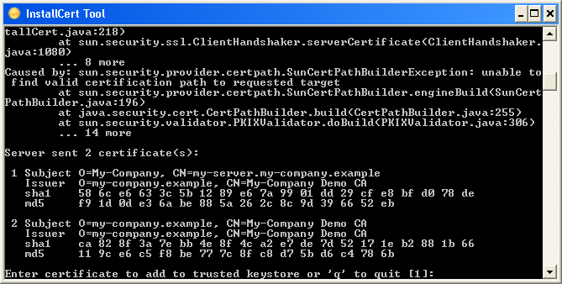
The certificate chain will be displayed and you can choose which one will be imported.

Verifier
usage: java -jar Verifier.jar [file1.pdf [file2.pdf ...]] [-c
<certificates>] [-e <folder>] [-ff <arg>] [-h] [-kf <file>]
[-kp <password>] [-kt <keystore_type>] [-lc] [-lk] [-p
<password>]
JSignPdf Verifier is a command line tool for verifying signed PDF
documents.
-c,--cert <certificates> use external semicolon
separated X.509 certificate
files
-e,--extract <folder> extract signed PDF revisions to
given folder
-ff,--fail-fast <arg> flag which sets the Verifier to
exit with error code on the
first validation failure
-h,--help print this message
-kf,--keystore-file <file> use given keystore file
-kp,--keystore-password <password> password for keystore file
(look on -kf option)
-kt,--keystore-type <keystore_type> use keystore type with given
name
-lc,--list-certificates list certificate aliases in a
KeyStore
-lk,--list-keystore-types list keystore types provided by
java
-p,--password <password> set password for opening PDF

Program exit codes
Code | Meaning
0 | SIG_STAT_CODE_INFO_SIGNATURE_VALID
20 | SIG_STAT_CODE_WARNING_NO_REVOCATION_INFO
30 | SIG_STAT_CODE_WARNING_TIMESTAMP_INVALID
40 | SIG_STAT_CODE_WARNING_NO_TIMESTAMP_TOKEN
50 | SIG_STAT_CODE_WARNING_SIGNATURE_OCSP_INVALID
60 | SIG_STAT_CODE_WARNING_CERTIFICATE_CANT_BE_VERIFIED
61 | SIG_STAT_CODE_WARNING_CERTIFICATE_EXPIRED
62 | SIG_STAT_CODE_WARNING_CERTIFICATE_NOT_YET_VALID
63 | SIG_STAT_CODE_WARNING_CERTIFICATE_REVOKED
64 | SIG_STAT_CODE_WARNING_CERTIFICATE_UNSUPPORTED_CRITICAL_EXTENSION
65 | SIG_STAT_CODE_WARNING_CERTIFICATE_INVALID_STATE
66 | SIG_STAT_CODE_WARNING_CERTIFICATE_PROBLEM
70 | SIG_STAT_CODE_WARNING_UNSIGNED_CONTENT
110 | SIG_STAT_CODE_ERROR_CERTIFICATION_BROKEN
120 | SIG_STAT_CODE_ERROR_REVISION_MODIFIED

SignatureCounter
usage: java -jar SignatureCounter.jar [file1.pdf [file2.pdf ...]] [-d]
[-h] [-n] [-p <password>]
JSignPdf SignatureCounter is a command line tool which prints count of
signatures in given PDF document.
-d,--debug enables debug output
-h,--help print this message
-n,--names print comma separated signature names
instead of the count
-p,--password <password> set password for opening PDF

Program exit codes
Code | Meaning
0 | program finished without errors
1 | command line is in a wrong format
5 | unable to read the file from given path
6 | counting signatures in the PDF failed

Only the private keys, which are valid (at the time of the signing) are displayed in the list. If the certificate supports Key Usage extension, the private key will only be displayed if it is meant for signing.

