|  |  |  |  |
| --- | --- | --- | --- |
| **校徽－2** | BUPT name |  | QM logo large black |

**For examiners’ use only**

|  |  |
| --- | --- |
| **Total** |  |

**BBC6406 A**

**Joint Programme Examinations 2020/21**

**BBC6406 Wireless Sensor Networks**

**Paper A**

**Complete the Report Before the Given Deadline.**

**Complete the information below about yourself very carefully.**

|  |  |  |  |  |  |  |  |  |  |  |  |
| --- | --- | --- | --- | --- | --- | --- | --- | --- | --- | --- | --- |
| **QM student number** | |  |  |  |  |  |  |  |  |  |  | | --- | --- | --- | --- | --- | --- | --- | --- | --- | --- | |  | **1** | **9** | **0** | **0** | **1** | **9** | **5** | **4** | **3** | |
| **BUPT student number** | |  |  |  |  |  |  |  |  |  |  | | --- | --- | --- | --- | --- | --- | --- | --- | --- | --- | | **2** | **0** | **1** | **8** | **2** | **1** | **3** | **1** | **7** | **6** | |
| **Class number** | |  |  |  |  |  |  |  |  |  |  | | --- | --- | --- | --- | --- | --- | --- | --- | --- | --- | | **2** | **0** | **1** | **8** | **2** | **1** | **5** | **1** | **2** | **0** | |

|  |
| --- |
| **Instructions**   1. Write **in English** and **print form**. 2. **Read the instructions on the inside cover.** |
|
|
|

Examiners

Dr Liang Liu, Dr Dong Zhao

**Copyright © Beijing University of Posts and Telecommunications & © Queen Mary, University of London 2020**

Filename: 2021_BBC6406_A No answerbook required

**You are required to write a well-organized report to describe your design of a WSN system in detail.**

1) The length of the report should be no less than 5000 English words;

2) The targeted application scenario should be proper to cover all the requirements described below. For example, since a single-hop network doesn’t need routing protocol, direct communication model that any node can directly communicate with the sink is NOT proper because it will not satisfy the routing design requirements. Missing the design of any part can lead to significant rating downgrade.

3) Plagiarism is strictly forbidden. You can refer to existing WSN system designs but MUST write your own report based on your own designs. You MUST provide explicit reference when you refer to other published papers. Any plagiarism will directly lead to fail of the exam.

**Description:**

Please design a WSN application system for a specific domain such as industry, agriculture, environment monitoring, and etc. The design should contain:

1) the hardware and software design of WSN nodes. You should select the appropriate node hardware and the appropriate operating system, taking the functional requirements and efficiency requirements (e.g. energy efficiency) into consideration.

2) the network architecture and deployment design of your application system. Consider the application coverage and the hardware ability of your selected nodes, calculate the number of needed nodes and provide a deployment plan to cover the whole target area. The expected network topology should be presented.

3) the MAC layer design of your application system. Considering the requirements and the features of your application system, design the appropriate MAC protocol.

4) the network layer design of your application system. You should first describe the prior requirements such as reliability or low latency and then select the appropriate routing metric. Then the routing protocol should be designed with the consideration of the features of your application system.

5) application supporting service design. You should first define the functions of your application system. And then targeted these functions, you should discuss and present the supporting services that your system should provide to fulfill these functions. For example, for a fire alarm WSN system, you have to provide the real-time synchronized data with location information. Hence, your system should provide time synchronization and localization service.

Sensor network for monitoring wild birds based on Birdsong* (use style: paper title)

*Abstract*—Birds

Keywords—component, formatting, style, styling, insert (key words)

# Introduction

In recent years, with the destruction of the natural habitat of wild birds by human activities, resulting in the destruction of forest and swamp environment, or the destruction of food chain which causes the food shortage of birds, the survival of birds in the wild has been greatly challenged.

According to [2], the report of Ministry of environment,the analysis of 78 breeding season bird sample plots from 2011 to 2017 showed that 50% of the 556 bird species showed a downward trend, and the bird population density in inland water and swamp showed a significant downward trend. It can be seen that it is imperative to monitor the population density of wild birds as soon as possible, so as to help guide the work of protecting wild birds.

In order to monitor birds, traditional monitoring methods deploy infrared cameras with night vision function in the field to monitor birds day and night. It requires a lot of human participation to select the optimal location, which is also a great challenge to the sensor bandwidth. While the method of catching the movement of birds by birdsong has great adaptability. Therefore, In view of the disadvantages of using camera to monitor the bird population in the wild, this paper puts forward an innovative method of monitoring birds by using bird calls based on WSN.

# Related work

## Monitoring of Bird Population at Home and Abroad

Scholars at home and abroad have done a lot of work on the monitoring of bird population in the wild. In the field bird population survey, song playback method has been considered as an important method.

As shown in the figure below, the black browed warbler is closely related to the limestone warbler, which is difficult to distinguish in appearance, but there is a big difference in song, which can be seen in the sound diagram.



1. Sound diagram of two species of warblers

It can be seen that there is great potential to distinguish different birds and monitor them by birdsong.

The existing neural network models can distinguish birds by their calls with high accuracy. However, how to combine these neural networks or analysis methods with field sensor nodes to form a complete monitoring system is still a lack of relevant work. At the same time, it also faces many challenges, such as energy, background noise and so on.

## Deploying Sensors in A Forest Environment

The deployment of sensors in forest environment to monitor such problems as forest fire and illegal cutting of trees is a long-term concern of scientific researchers. [7] proposed a forest fire monitoring and early warning system based on NB-IoT and multi-sensor networking technology. [8] proposed a research on urban noise monitoring system based on hybrid sensing. Based on these works, this paper proposes a sensor network dedicated to birdsong monitoring.

# Hardware design and Software design

Forest birdsong has the characteristics of discontinuous spatiotemporal. In time, birdsong is irregular and transient. In space, birdsong is widely distributed in the whole forest. If sensors continuously monitor and send signals, it is a great challenge to the energy consumption and bandwidth of sensor networks.

Therefore, the design of hardware and software is based on the following principles：

* Sensor nodes generate a "listening event" based on certain trigger conditions.
* The sensor node has limited computing performance, because it must adopt low-power processor, so the noise filtering algorithm can not be too complex.

T o comply with these two design principles, the sensor must have the ability to carry out local processing and preliminary filtering on the monitoring sound channel to reduce the sending frequency. In voiceprint recognition, MFCC (Mel-Frequency Cepstral Coefficients)[5] [9] is often used for feature extraction and dimension reduction of sound data. MFCC can also be used in birdsong feature extraction to distinguish between birdsong and other sounds. However, MFCC involves complex wavelet operations (better than DFT) after frame splitting and windowing, which is difficult to realize on sensor nodes. Therefore, this paper refers to [5], filter noise frames mainly through energy density .

Firstly, the special filter circuit can be used for the preliminary test of the input audio signal. As shown in the figure, the frequency domain analysis of the black browed warbler is carried out by using MATLAB. We can see that the frequency domain characteristics of the birdsong of the black browed warbler are very obvious.

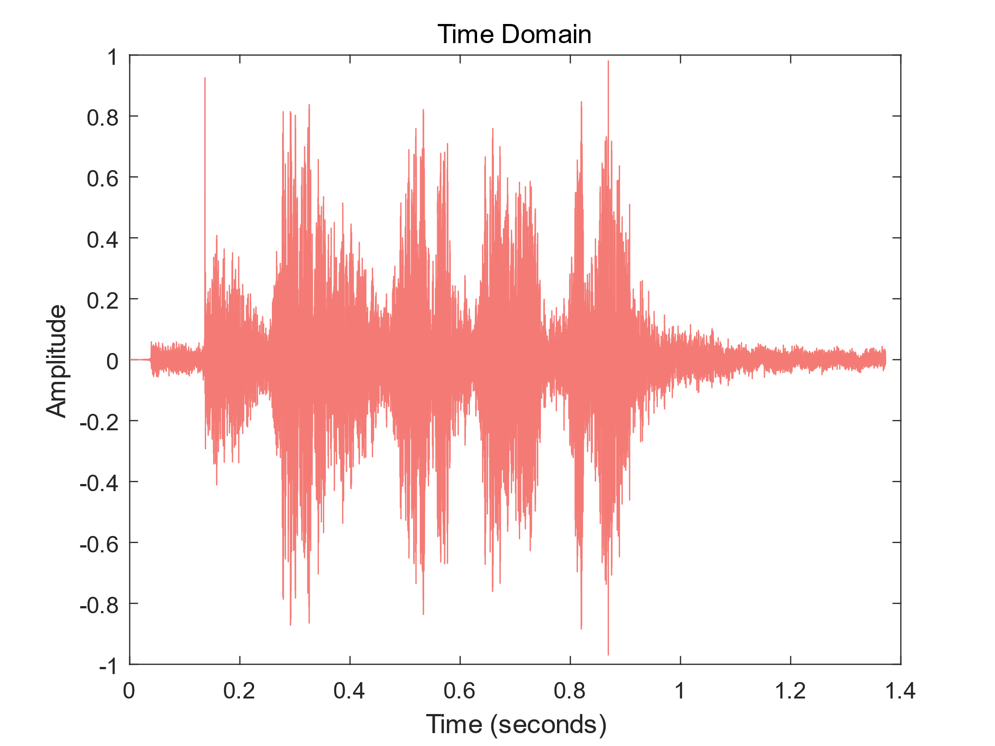 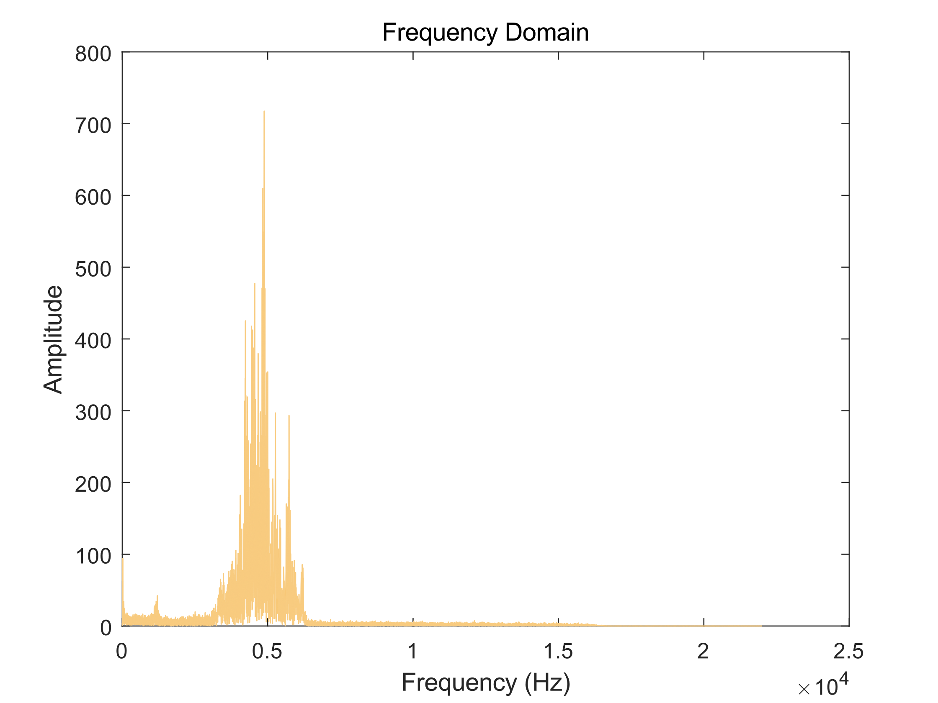

1. Sound diagram and spectrum of the birdsong of the black browed warbler

According to the investigation, the song frequency of most birds is between 1500 Hz and 8000 Hz, so a large number of low-frequency noise signals (such as the sound of wind, the sound of leaves and the call of most wild mammals) can be filtered through a high pass filter. Then, the energy detection threshold can be used to extract the effective frames[5].

Suppose that the discrete sound signal received by microphone is *s(i)*, and the ambient noise is *n(i).*

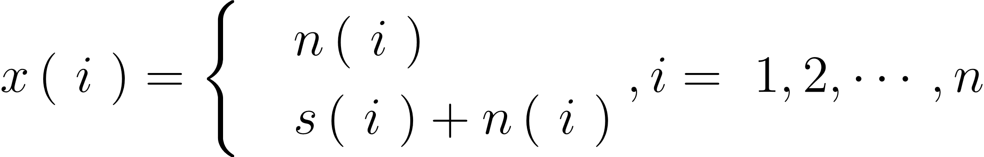     

(1)

So the test threshold is obtained by method in[5] as:

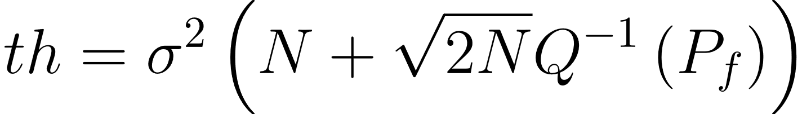

(2)

In the future, low-power high-performance chips or ASICs can also be used in sensor design to better distinguish birdsong from background noise.

## Hardware Design

The hardware design is based on the above analysis.

### Sensor Node Design

#### Selection: Highlight all author and affiliation lines.

The world's lowest power consumption PDM microphone t3902 from TDK

#### Selection: Highlight all author and affiliation lines.

The world's lowest power consumption PDM microphone t3902 from TDK

#### Selection: Highlight all author and affiliation lines.

The world's lowest power consumption PDM microphone t3902 from TDK

### Sink Node Design

The world's lowest power consumption PDM microphone t3902 from TDK

1. Sensor node shell

## Software Design

In addition, this paper designs a hook lock structure for the sensor shell as shown in the figure. The hook is made of elastic material.

In addition, this paper designs a hook lock structure for the sensor shell as shown in the figure. The hook is made of elastic material.

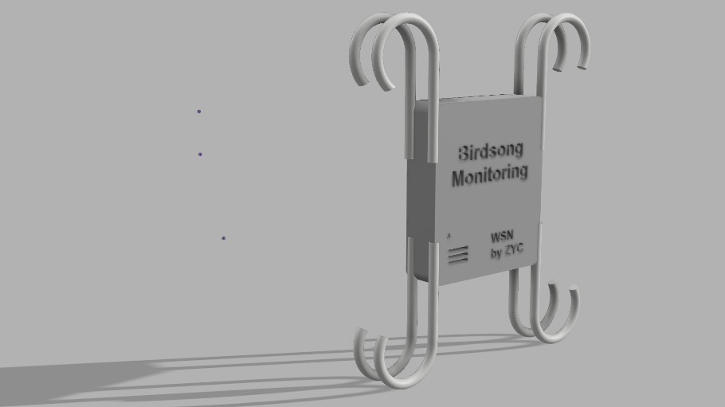

1. Sensor node shell

In this way, sensor nodes and parachutes can be airdropped into the forest by low altitude UAVs. When the sensor falls to the height of the tree crown, the hook can hook the trunk. Even if the sensor falls, its elastic structure can also effectively prevent collision. In this way, the sensors can be deployed at high altitude to better monitor the birds, and the cost of human deployment can be reduced.

# Network architecture and Deployment plan

## Network overview



1. Network architecture

缺一张物联网三层的图

**The template is designed for, but not limited to, six authors.** A minimum of one author is required for all conference articles. Author names should be listed starting from left to right and then moving down to the next line. This is the author sequence that will be used in future citations and by indexing services. Names should not be listed in columns nor group by affiliation. Please keep your affiliations as succinct as possible (for example, do not differentiate among departments of the same organization).

### For papers with more than six authors: Add author names horizontally, moving to a third row if needed for more than 8 authors.

### For papers with less than six authors: To change the default, adjust the template as follows.

#### Selection: Highlight all author and affiliation lines.

#### Change number of columns: Select the Columns icon from the MS Word Standard toolbar and then select the correct number of columns from the selection palette.

#### Deletion: Delete the author and affiliation lines for the extra authors.

## Deployment Plan

Based on previous hardware design，

Taking Songshan National Nature Reserve as an example, the sensor deployment plan is estimated as follows.

## Mac Layer Design

|  |  |  |  |  |  |  |  |
| --- | --- | --- | --- | --- | --- | --- | --- |
| **Octets:2** | **1** | **0/2** | **0/2/8** | **0/2** | **0/2/8** | **variable** | **2** |
| **Frame control** | **Sequence number** | **Destination PAN identifier** | **Destination address** | **Source PAN identifier** | **Source address** | **Frame payload** | **Frame check squence** |
| **Addressing fields** | | | |
| **MAC header** | | | | | | **MAC payload** | **MAC footer** |

1. Mac Frame

#### Positioning Figures and Tables: Place figures and tables at the top and bottom of columns. Avoid placing them in the middle of columns. Large figures and tables may span across both columns. Figure captions should be below the figures; table heads should appear above the tables. Insert figures and tables after they are cited in the text. Use the abbreviation “Fig. 1”, even at the beginning of a sentence.

1. Table Type Styles

| Table Head | Table Column Head | | |
| --- | --- | --- | --- |
| Table column subhead | Subhead | Subhead |
| copy | More table copya |  |  |

1. Sample of a Table footnote. (*Table footnote*)
2. Example of a figure caption. (*figure caption*)

Figure Labels: Use 8 point Times New Roman for Figure labels. Use words rather than symbols or abbreviations when writing Figure axis labels to avoid confusing the reader. As an example, write the quantity “Magnetization”, or “Magnetization, M”, not just “M”. If including units in the label, present them within parentheses. Do not label axes only with units. In the example, write “Magnetization (A/m)” or “Magnetization {A[m(1)]}”, not just “A/m”. Do not label axes with a ratio of quantities and units. For example, write “Temperature (K)”, not “Temperature/K”.

## Network Layer Design

## Mac Layer Design

# Application design

##### Acknowledgment *(Heading 5)*

The preferred spelling of the word “acknowledgment” in America is without an “e” after the “g”. Avoid the stilted expression “one of us (R. B. G.) thanks ...”. Instead, try “R. B. G. thanks...”. Put sponsor acknowledgments in the unnumbered footnote on the first page.

##### References

1. 范宗骥,欧阳学军,黄忠良,邹发生,Richard W.Lewthwaite,张强.鼎湖山的鸟类与考察研究历史[J].动物学杂志,2021,56(03):449-468. *(references)*
2. Nanjing Institute of environmental science, National Biodiversity Observation Report in 2017[S]. 2017.
3. 郎添娇, 王锐, 孔少洋,等. 鸟类目标电磁散射特性仿真及振翅频率提取[C].十二届全国信号和智能信息处理与应用学术会议论文集. 2018.
4. 戴天虹, 李野, 孙鹏. 基于MATLAB鸟叫声特征提取方法的研究[J]. 森林工程, 2013(02):132-136.
5. 张小霞,李应.基于能量检测的复杂环境下的鸟鸣识别[J].计算机应用,2013,33(10):2945-2949.
6. Y. Yorozu, M. Hirano, K. Oka, and Y. Tagawa, “Electron spectroscopy studies on magneto-optical media and plastic substrate interface,” IEEE Transl. J. Magn. Japan, vol. 2, pp. 740–741, August 1987 [Digests 9th Annual Conf. Magnetics Japan, p. 301, 1982].
7. 秦钰林,周若麟,张珂欣,范训礼,冯瑞航.基于NB-IoT窄带通信和多传感器组网技术的森林火灾监测预警系统[J].物联网技术,2020,10(06):14-16+19.
8. 郑磊. 基于混合感知的城市噪声监测系统研究[D].内蒙古大学,2020.
9. M. Young, The Technical Writer’s Handbook. Mill Valley, CA: University Science, 1989.
10. HOSSAN M A， MEMON S， GＲEGOＲY M A． A novel approach for MFCC feature extraction［C］/ / Proceedings of the 4th International Conference on Signal Processing and Communication Systems． Piscataway: IEEE， 2010: 1 － 5．
11. H. Urkowitz, "Energy detection of unknown deterministic signals," in Proceedings of the IEEE, vol. 55, no. 4, pp. 523-531, April 1967, doi: 10.1109/PROC.1967.5573.