
Genie Magnet OS
Architecture, build plan and SaaS roadmap
One software for Genie Magnet today, built from the first day to become a SaaS product for digital-marketing agencies and creators.
Item | Detail
Prepared for | Genie Magnet — Janarthanan (Founder & Managing Director), Ashwin (Company Manager)
Prepared by | InTouch Global Tech
Date | 30 September 2026
Version | 1.3 — onboarding essentials first; AI model recommendation aligned with the development plan
Status | Draft. Figures marked “indicative” are estimates to be confirmed together.

About this document
This document brings together two pieces of work: the clickable demo of Agency OS that InTouch Global Tech has already built for Genie Magnet, and the Growth OS–style architecture Genie Magnet shared for the complete product. It explains how the whole software will look, how it will be built, and how it becomes a SaaS product that other agencies can subscribe to.
It is written to be discussed in a meeting. Section 15 collects every open question in one place, and Appendix C holds the draft onboarding questions for Genie Magnet to correct.
If you want to know… | Read
What has been built so far and what is new | Section 2
How the agency's work flows through the software | Sections 5 and 6
The Growth OS–style onboarding questionnaires | Section 7 and Appendix C
What Genie Assistant (the AI) will and will not do | Section 8
WhatsApp and social-media integration | Section 9
The shared technical architecture | Section 10
The architecture for Genie Magnet only | Section 11
The build plan and timeline | Section 12
The SaaS architecture, plans and pricing | Section 13

Contents
About this document 2
1. Executive summary 4
2. Where we are today 5
3. Product vision and principles 6
4. Users and roles 7
5. How the agency works in the software 9
6. Product map: modules 11
7. Onboarding questionnaires (Growth OS style) 14
8. Genie Assistant: the AI layer 17
9. Integrations 19
10. Technical architecture 21
11. Architecture for Genie Magnet (stage 1) 25
12. Build plan 27
13. The SaaS plan 29
14. Risks and how we handle them 33
15. Open questions and next steps 34
Appendix A — Naming glossary 36
Appendix B — Modules in the current demo 37
Appendix C — Onboarding question bank (draft) 37

1. Executive summary
Genie Magnet OS is one web application, over one database, that runs a content-marketing agency end to end: from the first sales call, through content planning, shoots, editing, client approvals and publishing, to the monthly report and the agency's own finances and people. An AI layer, Genie Assistant, watches across all of it, flags what has slipped and drafts the next step for a person to approve.

The two-stage path
- Stage 1 — Genie Magnet runs on it. The software is built around Genie Magnet's own workflow: the client lifecycle, the 9-step editing process, video codes, revisions versus billable change requests, the daily data sheet and the 45-day Round Table. Genie Magnet goes live in about 14 weeks from the start of the build.
- Stage 2 — it opens as a SaaS product. Because every record carries an agency identifier from day one, other agencies can sign up and run on the same platform with their own data kept separate. The SaaS beta is planned for about week 26.

What the merged plan adds to the demo
- Growth OS–style onboarding questionnaires: one for each new client and one for the agency itself. The answers build the Business Canvas, Customer Product Matrix, Client Fitment Map, goals and the STOP review calendar automatically. Only the essential questions are needed to start; the deeper ones are completed within 7 days, with Genie Assistant reminders.
- A Content module: ideas, client topic selection, research, scripts and script approval.
- Genie Assistant: rules that spot problems, AI drafts, and approval before anything happens.
- Social-media connectors where each agency can add any platform: Instagram, YouTube, X (Twitter), LinkedIn and more.
- WhatsApp Business integration for approvals, reminders and confirmations.
- Posting quotas and schedules per package, and a revenue cascade from a revenue target down to team size.
- Multi-agency (multi-tenant) foundations and, later, sign-up, subscription billing and a platform admin console.

What stays
Everything already designed in the demo stays. The broader modules the demo has, such as HR, payroll, attendance, true costing, reviews, Round Table and assets, become add-on suites that each agency can switch on. This makes the SaaS stronger than a narrow production tool.
The architecture is shown twice, separately: Genie Magnet's own system (section 11: one agency, its own server and accounts) and the SaaS platform (section 13: many agencies, self-serve sign-up, billing and shared infrastructure).

Headline plan
Milestone | Target | What it means
Demo sign-off | Week 2 | Genie Magnet approves the merged scope on the updated demo
Genie Magnet goes live | Week 14 | Live clients, videos and approvals run in the system; spreadsheets retire
Genie Assistant live | Week 17 | Rules and AI drafts working on real data
All add-on suites | Week 21 | HR, finance and management suites complete
SaaS beta | Week 26 | First pilot agencies sign up and are billed automatically

Decisions confirmed on 30 September 2026
Package tiers stay configurable by each agency (the current structure is fine).
Social media works as “add a platform”: Instagram, YouTube, X (Twitter), LinkedIn and others.
WhatsApp will be integrated. The team roles proposed are confirmed.
Onboarding questionnaires in the Growth OS style are part of the product, for clients and for agencies. Only the essential questions are required to start; the deeper ones are completed within 7 days, with reminders.
Growth OS names are used as they are; only the AI assistant is renamed from “QI” to Genie Assistant.

2. Where we are today

2.1 The demo that is already built
InTouch Global Tech has built a clickable, front-end demo of the complete system with realistic sample data. It shows 47 modules: 46 internal modules plus the Client Hub (client portal). It has a role switcher (Founder, Manager, Editor, Finance, HR and Client), a premium design system, dark mode, and works on phones and laptops.
Depth in the demo | Count | Examples
Fully clickable | 15 | Dashboard, CRM, Agreements, Video Production, Shoots & Kit, Internal QC, Revisions & CRs, Daily Data Sheet, True Costing, Goals, Reviews, Round Table, Financial Planner, Client Hub
Preview (sample screens) | 23 | Onboarding, Recurring Cycles, Publishing, Client Health, HR, Attendance, Payroll, Billing, Expenses, Calendar, Settings
Planned (overview page) | 9 | AI Assistant, Automation, Integrations, Audit Log, Business Diagnostic, Scenario Planner, Offline Field App

The demo is ready to host with an access code, a Feedback button on every screen and a feedback inbox, so the Genie Magnet team can review it on their own and leave comments against the exact screen. There is no backend yet: data lives in the browser. Building the real backend is the core of this plan.

2.2 How the demo compares with the Growth OS architecture
Area | Growth OS architecture | Demo today | Action
Sales & CRM | Leads, calls, deals, invoices | Built, deeper (pipeline, proposals, discount approval) | Keep
Clients | Profile, package, WhatsApp group, team | Agreements, onboarding, cycles, client health | Keep; add WhatsApp group link
Onboarding questions | Discovery and onboarding questionnaire | Onboarding checklist only (brief, brand files, approver) | New: onboarding engine
Content | Ideas → topics → research → scripts → approval | Only a “Scripting” stage on each video | New module
Production | Shoots, tracking sheet, codes, clips | Built (codes such as KVR-0926-05, kit checklist) | Keep; add tracking-sheet view
Editing | Kanban, 8 craft stages, reviews | Built with 9 steps (adds Final overview) and Internal QC | Keep
Change loop | Client review until approved | Built, deeper: correction vs included revision vs billable CR | Keep
Publishing | Output, thumbnails, captions, schedule | Preview only | Deepen: platforms, slots, quotas
Client portal | Own projects, approvals, report | Built (review player, requests) | Keep; add topic and script approval
AI layer | Rules + drafts + approval | Planned page only | New: Genie Assistant
Revenue goal | Target → clients → content → team | Goals and Scenario Planner, no cascade | Add revenue cascade
Multi-agency | agency_id on every table | Not present (no backend) | Build in phase 1
Integrations | WhatsApp, social, payments | Planned page only | Build: connectors hub
HR, finance, reviews, assets | Not in scope | Built or previewed | Keep as add-on suites

2.3 Naming
The product uses the Growth OS vocabulary as it is (STOP reviews, Business Aspiration, Business Functional Assessment, Customer Product Matrix, Client Fitment Map, Business Canvas, PSS, Health score). STOP is the Strategic, Tactical and Operational review rhythm (section 5.6). The only change is that the AI assistant is called Genie Assistant, with an Ask Genie box. The demo's Client Health labels will be aligned to the Growth OS Client Fitment Map quadrants: Amazing, Bread-winning, Convenience and Dangerous. Appendix A lists every term.

3. Product vision and principles
Vision: the calm, single place where a content agency plans, produces, delivers and gets paid for its work, with an assistant that notices problems before clients do.
Principle | What it means in practice
The agency's own workflow is the backbone | Screens follow how Genie Magnet already works (lifecycle, video codes, 9 edit steps, change requests) rather than forcing a generic process.
One database, one source of truth | Every module writes to the same records, so a video, its cost, its approvals and its invoice are always consistent.
Approve before acting | Genie Assistant drafts and recommends; a person approves. Every change is recorded in the audit log.
Multi-agency from day one | Every record carries agency_id and the database enforces separation, so opening as a SaaS needs no rebuild.
Configure, don't customise | Packages, stages, checklists, roles, templates and labels are settings, so each agency adapts the product without code changes.
Core first, add-ons later | Production and delivery modules come first; HR, finance and management suites follow and are switched on per agency.
Premium and simple | One design system (Royal, Sapphire and Quicksand), three text sizes, fast screens, mobile-friendly, English first.

4. Users and roles
The roles below were confirmed with Genie Magnet. In the SaaS, each agency can rename roles and adjust permissions, starting from these defaults.
Role | Who | Main work in the system
Owner / Founder | Janarthanan | Sees everything; approves discounts, exceptions and payroll; owns goals and the revenue cascade
Manager / Team Leader | Ashwin and team leads | Plans cycles, allocates editors and shoots, runs Internal QC and reviews, handles client escalations
Editor | Video editors | Works assigned videos through the 9 edit steps, self-review, fixes revisions, fills the daily sheet
Shooter / Videographer | Camera team | Shoot sheets, kit checklist (dual or single camera), clip logging against video codes
Script writer | Content team | Ideas, research and scripts; sends topics and scripts for client approval
Social media manager | Publishing team | Thumbnails, captions, scheduling, posting proof, monthly posting quota
Finance | Accounts | Invoices, collections, expenses, true cost per video, financial reports
HR | People team | Hiring, attendance, leave, payroll, performance, learning
Freelancer | External editors and shooters | Only their assigned work; no finance or HR data
Client approver / viewer | Client's decision-maker and team | Client portal: approve topics, scripts and videos; see reports and invoices
Platform admin (SaaS) | InTouch Global Tech | Agencies, plans, usage and support; no access to agency data without consent

4.1 Default permissions
Area | Owner | Manager | Creator* | Social | Finance | HR | Client
Sales & CRM | Full | Full | — | — | View | — | —
Clients & agreements | Full | Full | Assigned | Assigned | Edit terms | — | Own
Content & scripts | Full | Full | Own | Edit | — | — | Approve
Production & editing | Full | Full | Own | View | — | — | Review
Publishing | Full | Full | View | Full | — | — | View
Finance & costing | Full | View | — | — | Full | — | Own invoices
HR & payroll | Full | Team | Self | Self | Payroll view | Full | —
Reviews & Round Table | Full | Runs | Self | Self | Self | Self | —
Settings & billing | Full | Limited | — | — | — | — | —
Genie Assistant | All data | Team | Own work | Own work | Finance | HR | —

*Creator = editor, shooter or script writer. Freelancers follow the Creator column limited to assigned work. “Own” means records assigned to or created by that person.

5. How the agency works in the software

5.1 Client lifecycle
The team's client-servicing lifecycle is grouped into five phases. Each phase is handled by one or two modules, so the software follows the way the agency already runs. Every client has a lifecycle tracker that shows where they are.
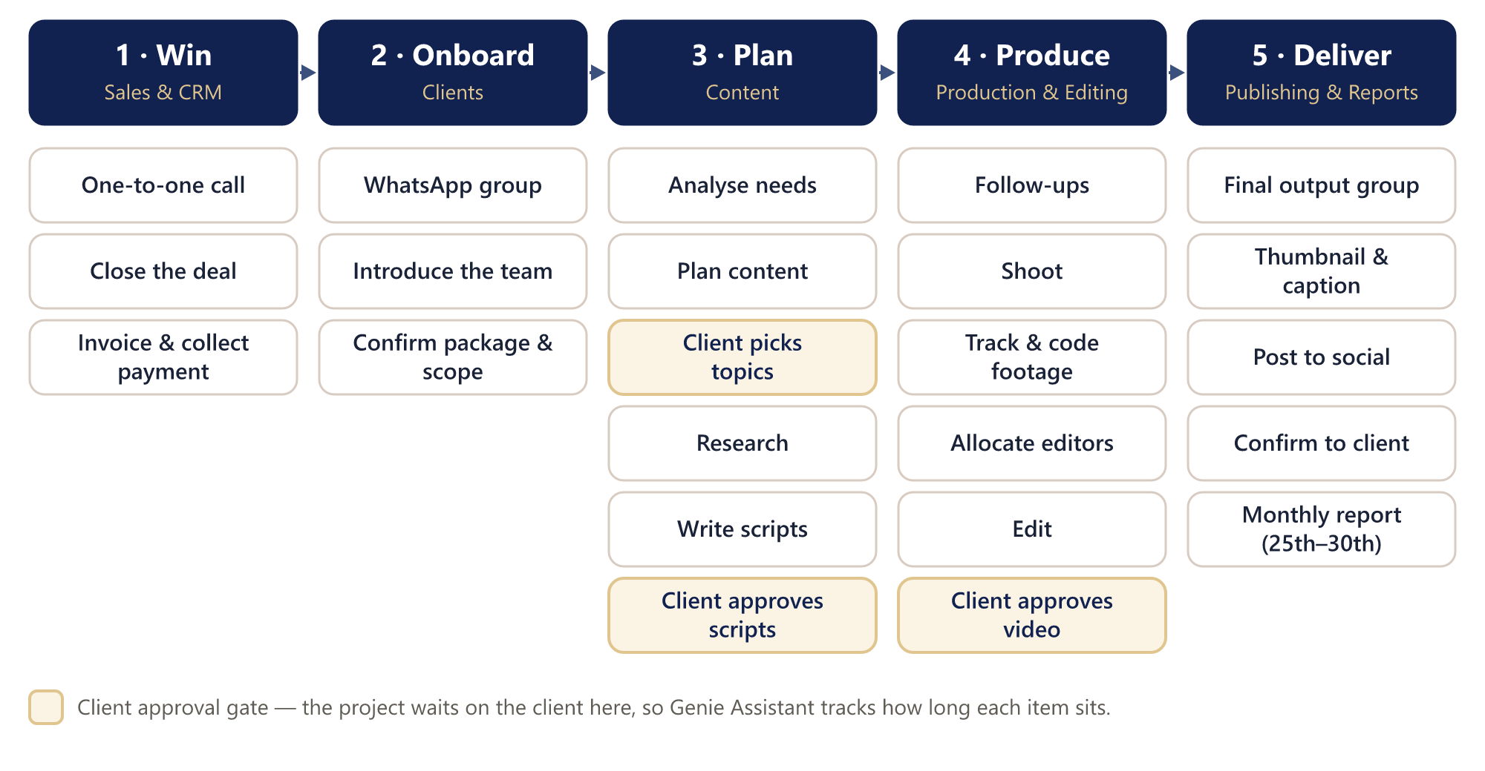
Figure 1 — Client lifecycle in five phases, with the client approval gates highlighted
Three approval gates matter most: the client picks topics, approves scripts, and approves the finished video. At each gate the project waits on the client, so the system records how long it waits. That waiting time is one of the first things Genie Assistant watches.

5.2 Production pipeline
Inside the Produce phase, every video is a card that moves through the same stages. The editor works through the 9-step checklist, then the video passes three reviews before it is published: the editor's self-review, the team leader's Internal QC, and the client's review.
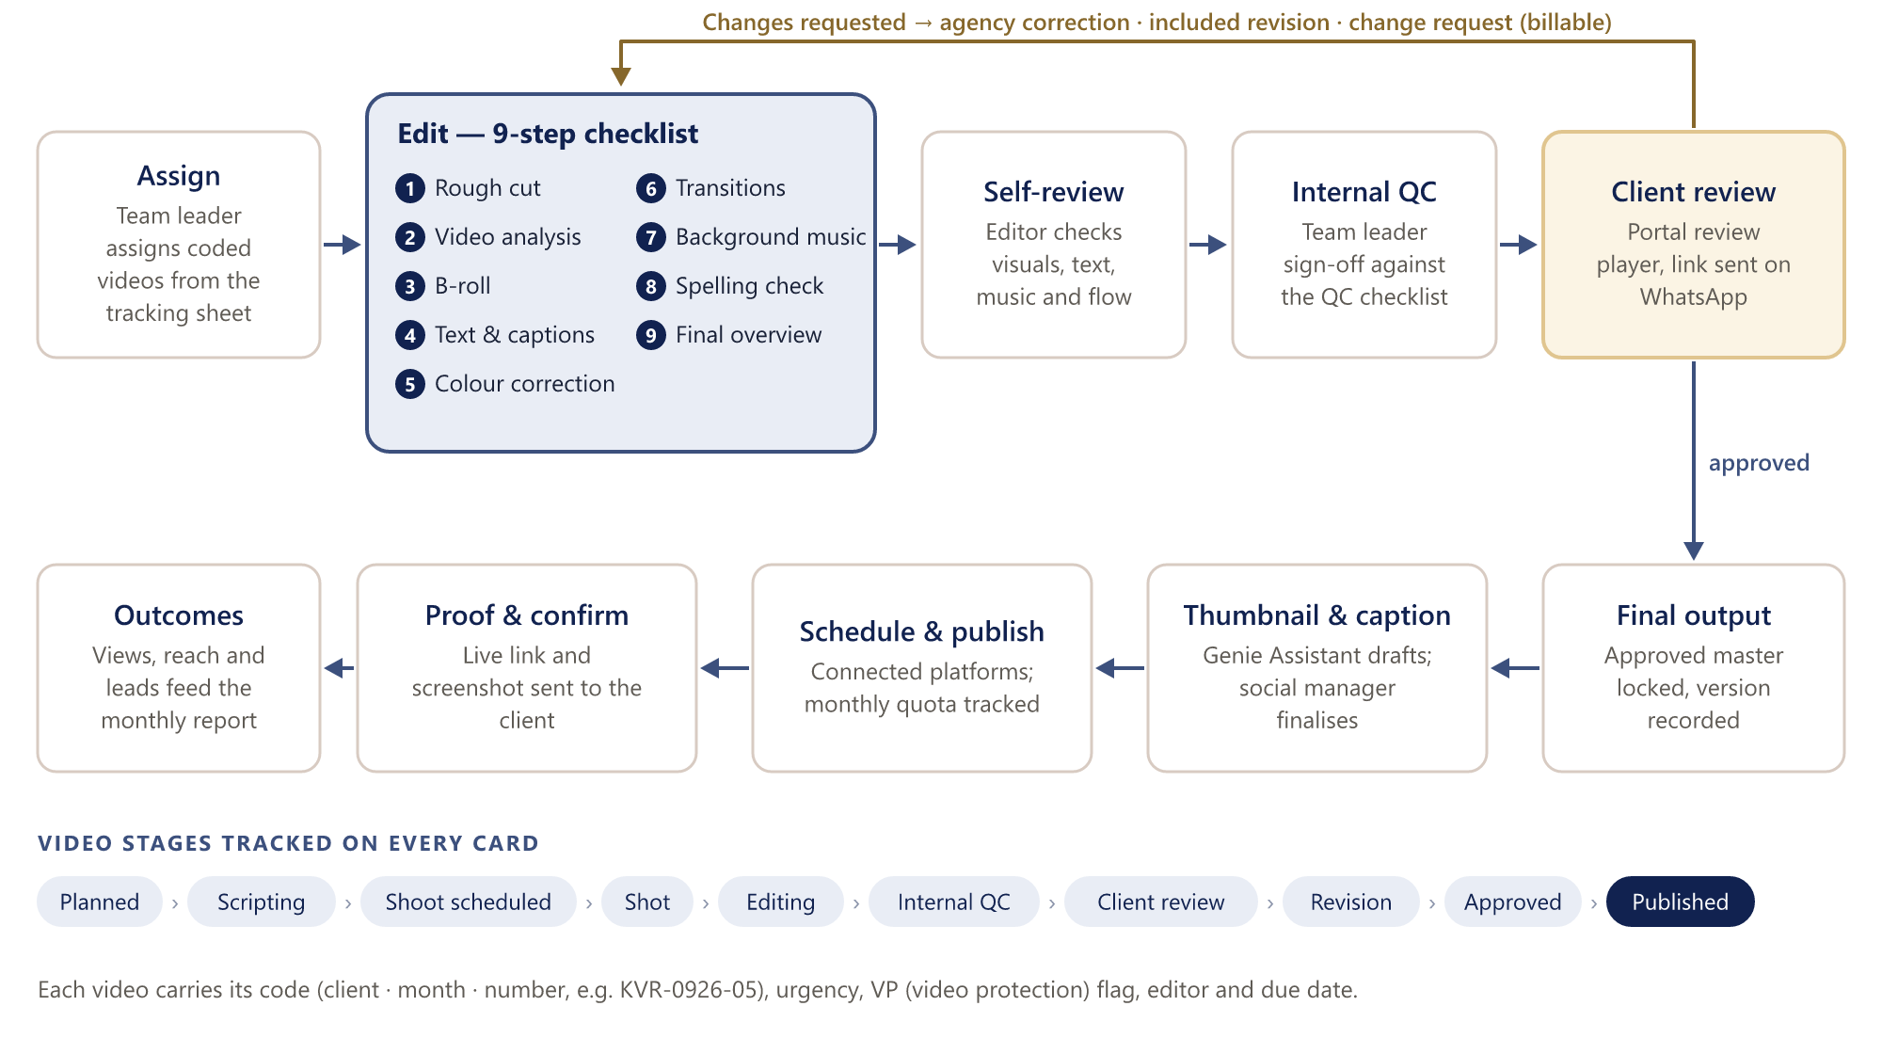
Figure 2 — Production pipeline: 9 edit steps, three review gates and the change loop

5.3 Revisions and change requests
When a client asks for changes, the team classifies the request. This is what protects the agency's margin:
Type | Meaning | Effect
Agency correction | Our mistake (spelling, wrong clip, missed brief) | Fixed free; counts against the team's quality score
Included revision | A change within the package's revision allowance | Fixed free; allowance counter goes down
Change request (CR) | Outside scope or beyond the allowance | Quoted, approved by the client, billed; logged against the agreement

5.4 The monthly cycle and the report
Each agreement generates a monthly cycle automatically: the number of videos and posts planned, shoot days, and the revision allowance. As work is delivered, the cycle fills up. Between the 25th and 30th the monthly client report is prepared from published posts and their results, and the cycle is reconciled: what was delivered, what carries forward, what is billed.

5.5 Revenue cascade
The owner sets a monthly revenue target and the software works backwards to the clients, content, shoot days and team that the target needs. The ratios come from the agency's own history, not fixed guesses, and Genie Assistant flags when the plan needs more clients than sales can close or more output than the team can deliver.
Step | Calculation | Illustrative example
Revenue target | Set by the owner | ₹10,00,000 per month
Retainer clients | Target ÷ average package price | ₹10,00,000 ÷ ₹50,000 = 20 clients
Content volume | Clients × videos per package | 20 × 12 = 240 videos a month
Shoot days | Videos ÷ videos per shoot day | 240 ÷ 8 = 30 shoot days
Editors needed | Videos ÷ output per editor | 240 ÷ 40 = 6 editors

The example numbers are illustrative only; the real ratios are calculated from Genie Magnet's past months.

5.6 STOP review rhythm
STOP is the Growth OS review system: Strategic, Tactical and Operational reviews at three speeds, tracked on an Achievement Tracking Mechanism (ATM) dashboard. It drives the Reviews & Meetings module and the Round Table.
Level | How often | Length | Focus | In the software
Strategic | Once in 45 days | Full day | Completion, competence development, celebration, creation of the next plan | 45-day review, Round Table, goals and Strategic Road Map update, onboarding re-run
Tactical | Weekly or every 2 weeks | 2 hours | Coaching and development | 7-day and 14-day reviews, decisions and commitments
Operational | Every day | 10–15 minutes | Clarity for the day | Daily stand-up with Genie Assistant insights, daily data sheet

Genie Magnet's own daily, 7-day, 14-day and 45-day reviews map onto these levels; the detailed agendas are still to be confirmed.

6. Product map: modules
The product has three layers: core modules every agency gets, add-on suites that each agency switches on by plan, and platform services shared by every module. Genie Magnet has everything switched on.
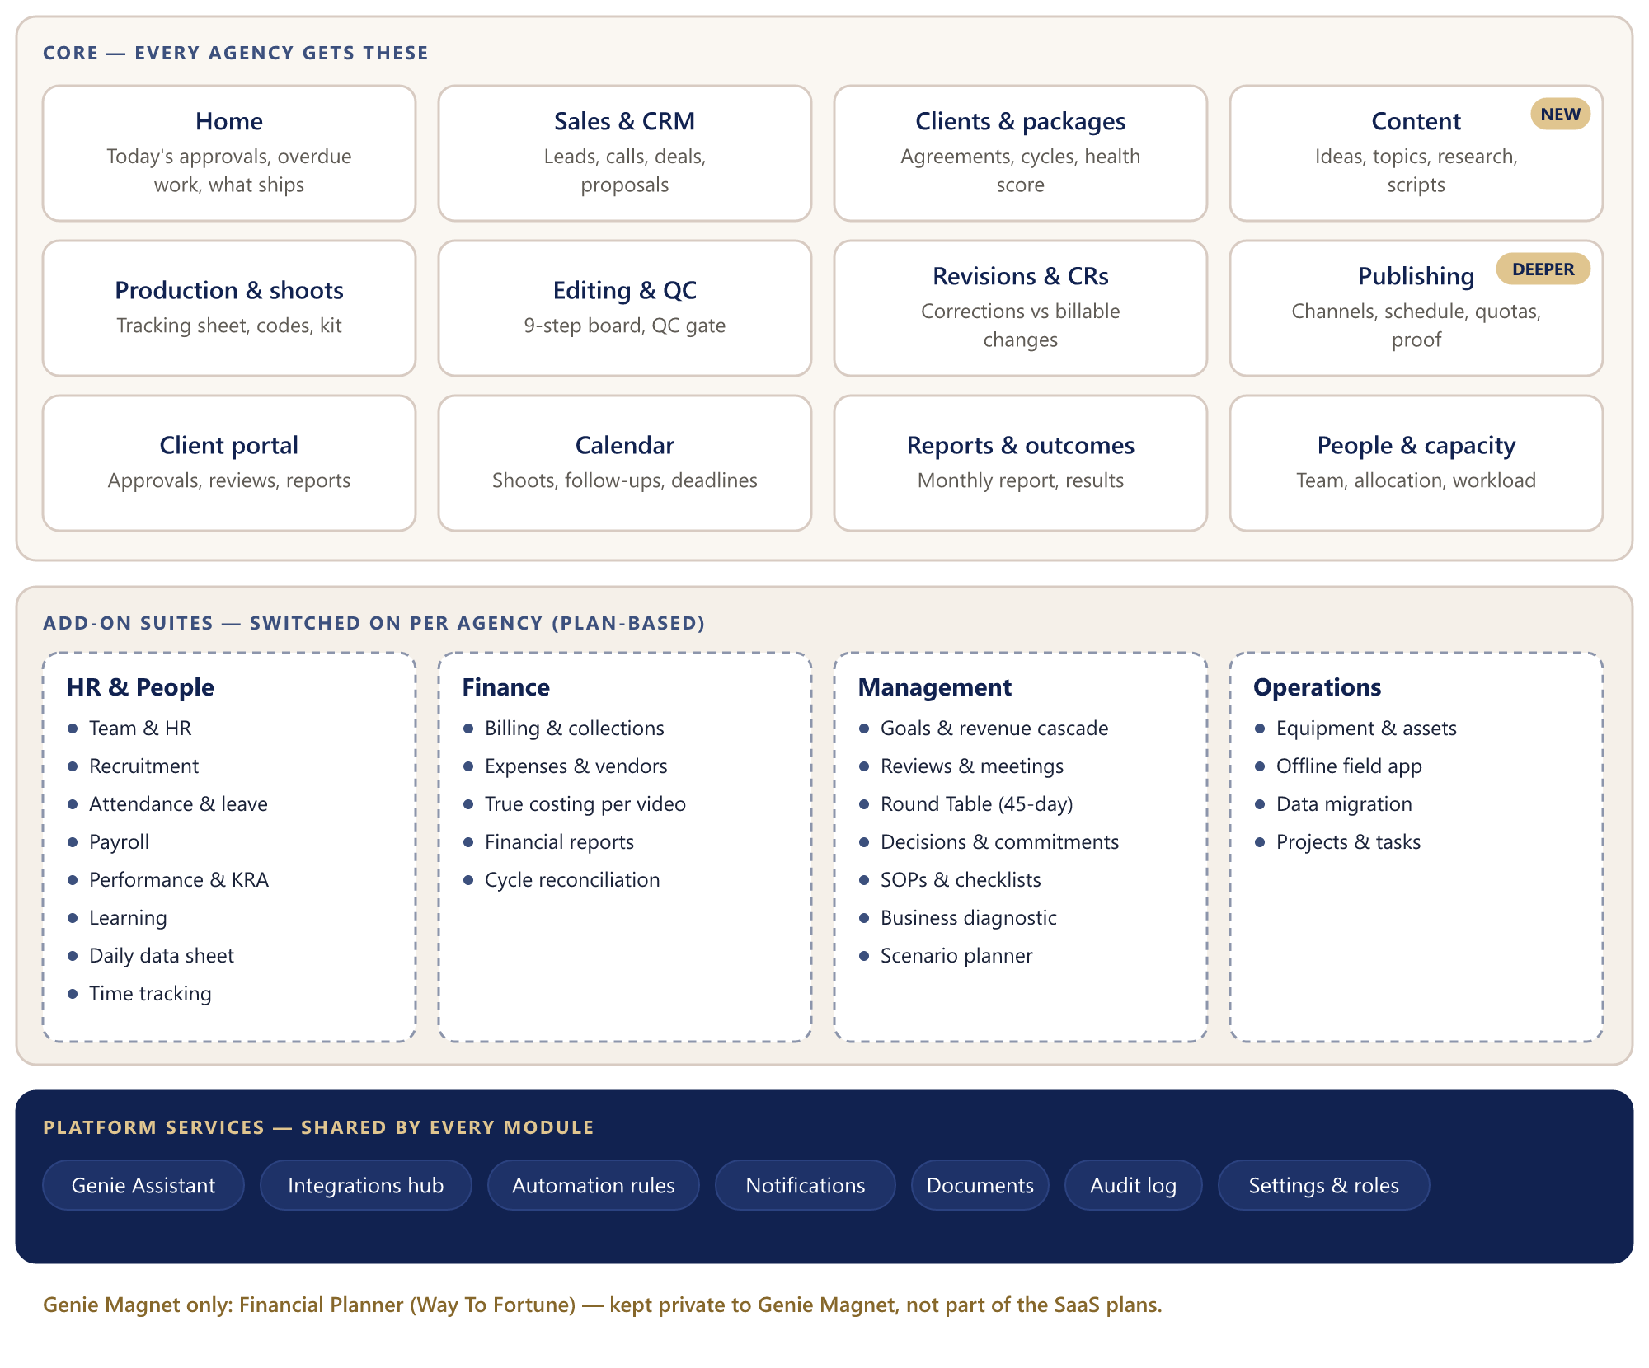
Figure 3 — Product map: core modules, add-on suites and platform services

6.1 Core modules
Module | What it does | Key records
Home | The day at a glance per role: approvals waiting, overdue work, what ships today, Genie Assistant insights | —
Sales & CRM | Leads, one-to-one calls, pipeline, proposals, discount approval, won → client | Lead, deal, proposal
Clients & packages | Client profile, onboarding questionnaire and checklist, agreements, packages, monthly cycles, Business Canvas, Customer Product Matrix, Client Fitment Map, Health score, WhatsApp group link | Client, agreement, package, cycle, response
Content (new) | Idea bank, client topic selection, research notes, scripts with versions, script approval | Idea, script, approval
Production & shoots | Tracking sheet, video codes, shoot sheets, kit checklists, clip logging | Shoot, video, clip
Editing & QC | Kanban board, 9 edit steps, self-review, Internal QC checklist, allocation | Video card, QC result
Revisions & CRs | Client change rounds, correction vs included revision vs billable CR | Revision, change request
Publishing | Connected platforms, schedule slots, monthly quota, captions, thumbnails, posting proof | Post, schedule slot
Client portal | Client's own projects, approvals (topics, scripts, videos), review player with time-coded comments, reports, invoices | (views of the above)
Calendar | Shoots, follow-ups, review deadlines, posting schedule, leave, locked events | Event, reminder
Reports & outcomes | Monthly client report, reach, views, leads; agency dashboards | Report, metric
People & capacity | Team directory, skills, allocation, workload and capacity planning | Employee, allocation

6.2 Add-on suites
Suite | Modules | Status in demo
HR & People | Team & HR, Recruitment (role task document, STAR scorecards), Attendance & leave (Hikvision or Excel import), Payroll, Performance & KRA (A/B player rating), Learning, Daily data sheet (GM and HR sign-off), Time tracking | Daily sheet clickable; others preview
Finance | Billing & collections, Expenses & vendors, True costing per video (labour, equipment, overhead, rework), Financial reports, Cycle reconciliation | True costing clickable; others preview
Management | Goals and revenue cascade, STOP reviews & meetings (daily, 7, 14 and 45-day), Round Table, Decisions & commitments, SOPs & checklists with PSS and KRAs, Business diagnostic (BFA), Strategic Road Map, Scenario planner | Goals, Reviews, Round Table clickable
Operations | Equipment & assets (custody, maintenance, depreciation), Offline field app, Data migration, Projects & tasks | Preview or planned

6.3 Platform services
- Onboarding engine — questionnaire templates, scoring and generated outputs (section 7).
- Genie Assistant — the AI layer (section 8).
- Integrations hub — social platforms, WhatsApp, payments, Google, Hikvision (section 9).
- Automation rules — triggers, reminders, retries and an exception queue.
- Notifications — in-app, email and WhatsApp, with per-user preferences.
- Documents — uploads, Drive links and previews attached to any record.
- Audit log — who changed what, when and why.
- Settings & roles — packages, stages, checklists, templates, labels, roles, module switches.
Genie Magnet only
The Financial Planner (Way To Fortune) personal-finance tool stays private to Genie Magnet and is not included in the SaaS plans.

7. Onboarding questionnaires (Growth OS style)
Like Growth OS, the product starts with questions. Two questionnaires run on one onboarding engine: a client onboarding questionnaire for every new client Genie Magnet wins, and an agency onboarding questionnaire for the agency itself. The answers are not just stored: each one flows into the right record, and together they build the client's Business Canvas and the agency's goals, Client Fitment Map and review calendar.
The question sets are taken from Genie Magnet's Growth OS consulting workbook (the Discovery Details, Onboarding, Business Aspiration, Business Functional Assessment and Business Model sheets) and adapted for a content agency.
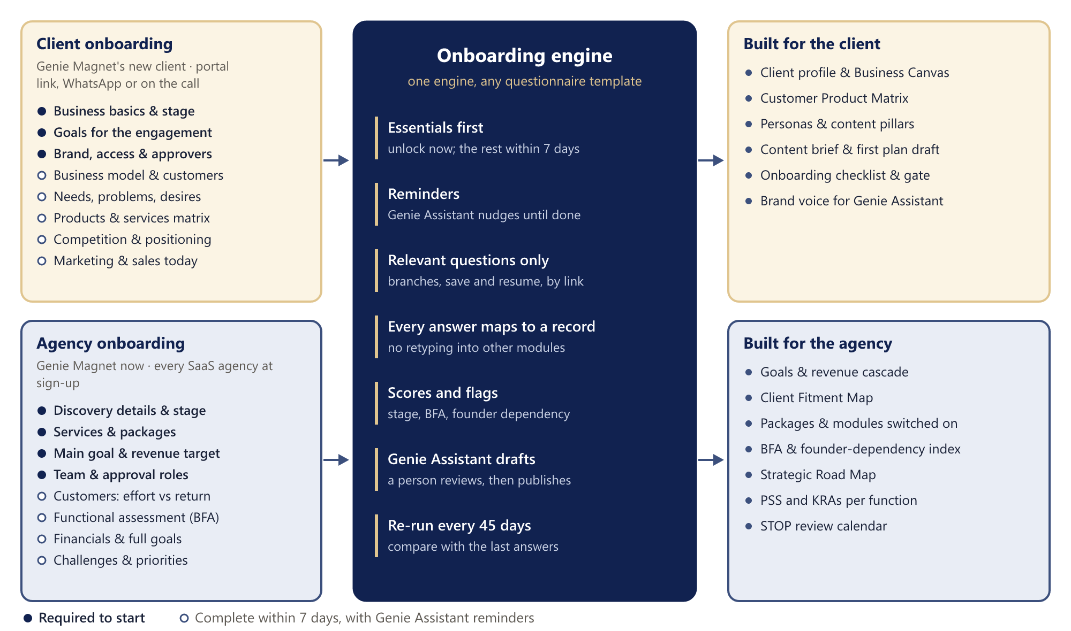
Figure 4 — Onboarding engine: two questionnaires, one engine, outputs built automatically

7.1 Client onboarding questionnaire
Sent as soon as a sale is confirmed. The client fills it through a portal link sent on WhatsApp, or the account manager fills it with them on the onboarding call. Only the required sections (about 5–10 minutes) must be answered before work starts; the rest are marked complete within 7 days. Production starts when the required sections and the onboarding checklist are complete, or an authorised person approves an exception.
Section | What we ask | What it builds | When
Business basics | Names, owners, contacts, years in business, business type, location, website and social handles, business stage (Struggle, Survival, Stability, Success, Scale) | Client profile | Required
Goals for the engagement | What success looks like at 3, 6 and 12 months; target reach and leads; budget; priorities | Engagement goals and report targets | Required
Brand, access and approvers | Brand files, tone, do's and don'ts, topics to avoid, languages, on-camera people, locations, account access, approvers, billing and GST details | Brand kit, Genie Assistant brand voice, onboarding checklist and production gate | Required
Business model and customers | B2B, B2C or through channel partners; for each: who they are, how many, revenue share, profitability; segments not yet explored | Personas and target audience | Within 7 days
Needs, problems and desires | Problems solved, needs met, non-negotiable expectations, deep-rooted desires, unmet needs | Content pillars and messaging | Within 7 days
Products and services | Name, price, margin, share of revenue, effort to deliver | Customer Product Matrix | Within 7 days
Competition and positioning | Top 5 competitors and how they compete; cheaper, faster or better | Positioning in the Business Canvas | Within 7 days
Marketing and sales today | Marketing team, lead sources, what has worked, active channels, sales process and strengths | Channel plan and the results baseline | Within 7 days

7.2 Agency onboarding questionnaire
Genie Magnet answers it once in phase 1 to set up its own goals and reviews. In the SaaS, every new agency answers it at sign-up: the workspace unlocks as soon as the required sections are answered (about 10 minutes), and the deeper diagnostic is completed within 7 days. It can be repeated at each 45-day strategic review to measure progress.
Section | What we ask | What it builds | When
Discovery details | Agency name, owners, years, business type, location, business stage | Agency profile and stage | Required
Services and packages | Services offered; packages with price, videos and posts per month, platforms, shoot days, revision allowance | Packages and posting quotas, set up automatically | Required
Main goal (BA) | Aspiration goal, timeline and the WHY; current and target revenue | Goals and the revenue cascade | Required
Team and approval roles | Team members, roles and who approves what | Roles, permissions and team invitations | Required
Customers: effort vs return | Customer types, number, share of revenue, average billing, effort to acquire and deliver | Client Fitment Map (Amazing, Bread-winning, Convenience, Dangerous) and return-to-effort ratio | Within 7 days
Business Functional Assessment (BFA) | For Marketing, Sales, Operations, R&D, Accounts & Finance, HR and Management: consistency, owner dependency, results, what works, team, second-line leader, hire / develop / delegate / outsource | BFA scorecard, founder-dependency index, business diagnostic | Within 7 days
Full goals (BA) | Quarterly revenue break-up, profitability, owner's income and cash flow | Quarterly targets | Within 7 days
Financials | Turnover, gross and net profit for recent years; fixed and variable expenses; owner's salary; loans | Finance baseline and overheads for true costing | Within 7 days
Review practice | Role clarity, how performance is reviewed, appraisals and training | PSS and KRA drafts, STOP review calendar | Within 7 days
Challenges and priorities | Challenges per function rated 1–10; what the agency expects from the system | Strategic Road Map and a first 90-day action plan (Genie Assistant draft, owner approves) | Within 7 days

7.3 Essentials first, the rest within 7 days
Answering more than 30 questions before anyone can start is too much, so each questionnaire is split in two. The essentials unlock the work; the deeper questions follow within a week.
Questionnaire | Required to start | Complete within 7 days
Client | 14 questions: business basics, goals for the engagement, brand, access and approvers. Unlocks the onboarding gate (with the checklist), so production can start. | 19 questions: business model and customers, needs and desires, products and services, competition, marketing and sales today.
Agency | 7 questions (10 in the SaaS, with workspace setup): discovery details, services and packages, main goal and revenue target, team and approval roles. Unlocks the workspace. | 18 questions: customers by effort and return, the Business Functional Assessment, full goals, financials, review practice, challenges and priorities.

- The 7-day sections appear as a checklist with a progress bar: on Home for the agency, and on the client's page for the account manager.
- Reminders: Genie Assistant sends a reminder on day 2 and day 5, in the app and by WhatsApp or email, with a link that opens at the next unanswered question.
- After day 7 the questionnaire is flagged to the account manager (client) or the owner (agency). Nothing is locked, so work never stops because of an unanswered question.
- Outputs fill in as answers arrive: the Customer Product Matrix, content pillars, Client Fitment Map, BFA scorecard and Strategic Road Map show “waiting for answers” until their section is done, then build automatically.
- The account manager can finish the remaining sections with the client on a call. Each agency can change which questions are required, and the 7-day window, in Settings.

7.4 How the engine works
- Question types: short and long text, number and currency, single or multiple choice, yes/no, 1–10 rating, tables (for example the products matrix or the seven functions) and file uploads.
- Branching: only relevant questions are shown; B2B questions appear only if the business sells to businesses.
- Mapping: every question is linked to a field in the system, so answers flow into the client profile, packages and goals without retyping.
- Scoring: rules work out the business stage, BFA scores, the founder-dependency index and the Client Fitment Map position.
- Drafting and approval: Genie Assistant writes the onboarding summary, Business Canvas and first plan; the account manager (for a client) or the owner (for the agency) reviews and publishes them.
- Versions: question sets are versioned templates; each set of answers keeps its version, and a re-run shows what changed.
- Templates: Genie Magnet's Growth OS set is the default. In the SaaS each agency can edit, add or reorder questions and share templates through the template library.
For Genie Magnet to review
The full draft question bank is in Appendix C. Please mark any question to add, remove or reword before phase 1 starts.

8. Genie Assistant: the AI layer
Genie Assistant is rules plus a language model, not a model alone. Rules watch the data and find what has slipped; the model turns a finding into a readable draft; a person always approves before anything happens. That keeps every number traceable and stops the assistant from acting on its own.
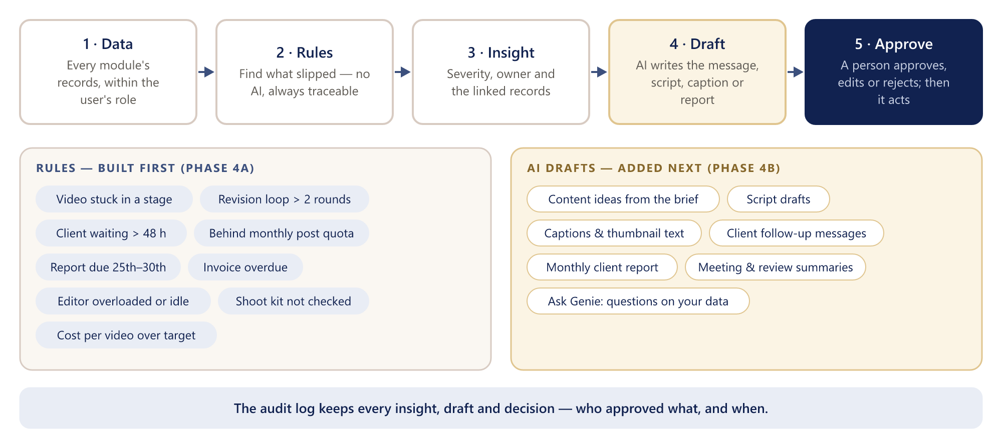
Figure 5 — Genie Assistant: from data to an approved action

8.1 Rules (built first)
Rules are plain calculations on the agency's data. They are most of the value, never invent anything, and each threshold can be changed in Settings.
Signal | Default trigger | Goes to
Video stuck | No stage change for 3 working days | Team leader
Revision loop | More than 2 client change rounds on one video | Manager
Client waiting | Topic, script or video approval pending over 48 hours | Account owner, with a WhatsApp reminder draft
Behind quota | Posts published below the expected pace for the month | Social media manager
Report due | 25th of the month and the client report not started | Manager
Invoice overdue | Due date passed without payment | Finance
Editor load | Assigned work above 110% or below 50% of capacity | Manager
Shoot readiness | Kit checklist incomplete 24 hours before a shoot | Shoot lead
Margin | True cost per video above the package budget | Owner
Client health | Health score drops a band on the Client Fitment Map | Owner
Onboarding incomplete | 7-day onboarding sections still unanswered after 7 days | Account manager (client) or owner (agency)

8.2 Drafts (added next)
Genie Assistant drafts | Built from | Approved by
Content ideas | Client brief, Business Canvas, past approved topics | Script writer / manager
Script drafts | Selected topic, brand voice, past approved scripts | Script writer, then client
Captions and thumbnail text | Final video's script and platform | Social media manager
Client follow-ups | Pending approvals, overdue items | Account owner
Monthly client report | Published posts, metrics, delivered units | Manager
Meeting and review summaries | Review notes, decisions, commitments | Meeting owner
Onboarding summary and 90-day plan | Onboarding questionnaire answers | Account manager / owner

8.3 Ask Genie
A question box on every screen (“Which videos for Kaveri are waiting on the client?”, “What did we deliver for Nova in September?”). Answers are built only from records the user is allowed to see and always link back to those records.

8.4 Safeguards
- Nothing is sent, changed or published without a person's approval; every insight, draft and decision is in the audit log.
- Permission-aware: Genie Assistant sees only what the user's role may see, and only the user's own agency.
- Agency data is not used to train AI models; the provider is chosen on those terms, and personal data is kept out of prompts where possible.
- A provider adapter keeps the AI model swappable. Recommended: Anthropic Claude Opus 5.5, with the effort level set per task (lower for short captions and follow-ups, higher for scripts and the monthly report) to balance quality and cost.
- Usage is metered per agency and capped by plan, so AI cost stays predictable.
- Quality is measured: approval rate and how much people edit each draft, used to improve the prompts.

9. Integrations

9.1 Social media: “add a platform”
Each agency switches on the platforms it uses and connects them per client. Every platform plugs into the same connector framework, so adding a new platform is one new connector and needs no change to the modules.
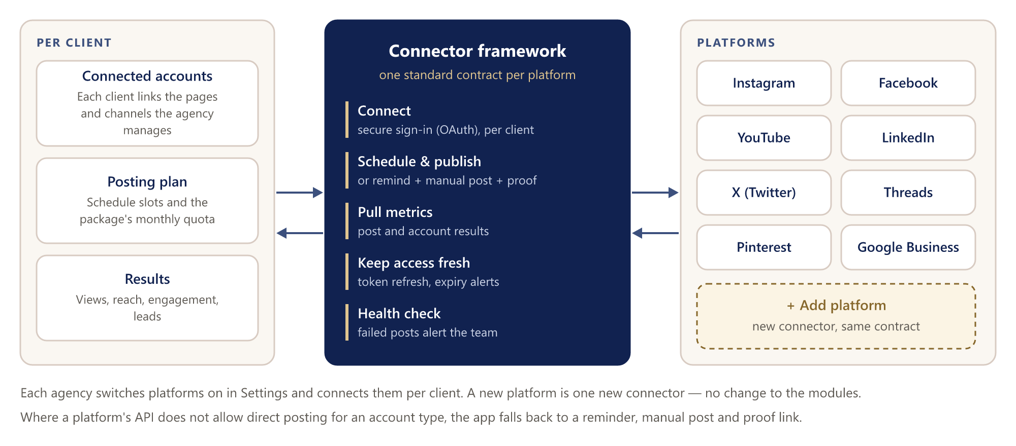
Figure 6 — Social connector framework: any platform, one standard contract
Platform | Publish / schedule | Metrics | Notes
Instagram | Yes (business and creator accounts) | Yes | Meta app review required
Facebook Pages | Yes | Yes | Meta app review required
YouTube | Yes (upload and schedule) | Yes | Google API compliance audit needed for public uploads
LinkedIn | Yes (company pages) | Yes | Requires LinkedIn API access approval
X (Twitter) | Yes | Depends on tier | Paid API tiers
Threads, Pinterest, Google Business Profile | Yes | Yes | Added as connectors after launch

Where a platform does not allow direct posting for a particular account or format, the app falls back to a reminder, a manual post by the social media manager and a proof link, so quotas and reports still work.

9.2 WhatsApp Business
WhatsApp is how Genie Magnet's clients already talk to the team, so it becomes the fastest route to approvals.
Message | When | What the client can do
Approval request | Topics, script or video ready | Tap Approve or Request changes, or open the portal link
Reminder | Approval pending, shoot tomorrow, invoice due | Open the item or reply
Confirmation | Video published | Open the live link
Monthly report | Report released (25th–30th) | Open the report in the portal
Team alerts (optional) | Genie Assistant insight for a team member | Open the item in the app

How it works
- Uses the official WhatsApp Business Platform (Meta Cloud API or a Meta business solution provider). Each agency connects its own verified business number; in the SaaS this is done through Meta's embedded sign-up.
- Messages the business starts use templates approved by Meta; replies and button taps come back to the app and are recorded against the script or video as the approval record.
- Today's client WhatsApp groups stay for conversation. The official API's support for automating groups is limited, so the system does not depend on groups: it sends updates from the business number and links to the portal.
- Meta charges per message by category (for example marketing or utility). Genie Magnet pays Meta directly; in the SaaS, usage is passed through within plan limits.

9.3 Other integrations
Integration | Used for | Phase
Razorpay / Stripe | Client invoice payments; SaaS subscriptions | 3 (clients), 6 (SaaS)
Google Drive | Raw footage and brand files stay in Drive; the OS stores links, exports and thumbnails | 2
Google Calendar | Two-way sync of shoots, meetings and deadlines | 3
Google Sheets / Excel | One-time migration and ongoing imports (tracking sheet, attendance) | 3
Hikvision attendance | Import punches for attendance and payroll | 5
Email (transactional) | Invites, password resets, notifications, reports | 1
Public API and webhooks | Let agencies connect their own tools (SaaS) | 7

10. Technical architecture

10.1 System overview
One web application over one database. The team works in the modules, clients approve through the portal, outside services sync in through background jobs, and Genie Assistant reads across everything and drafts the next step for someone to approve.
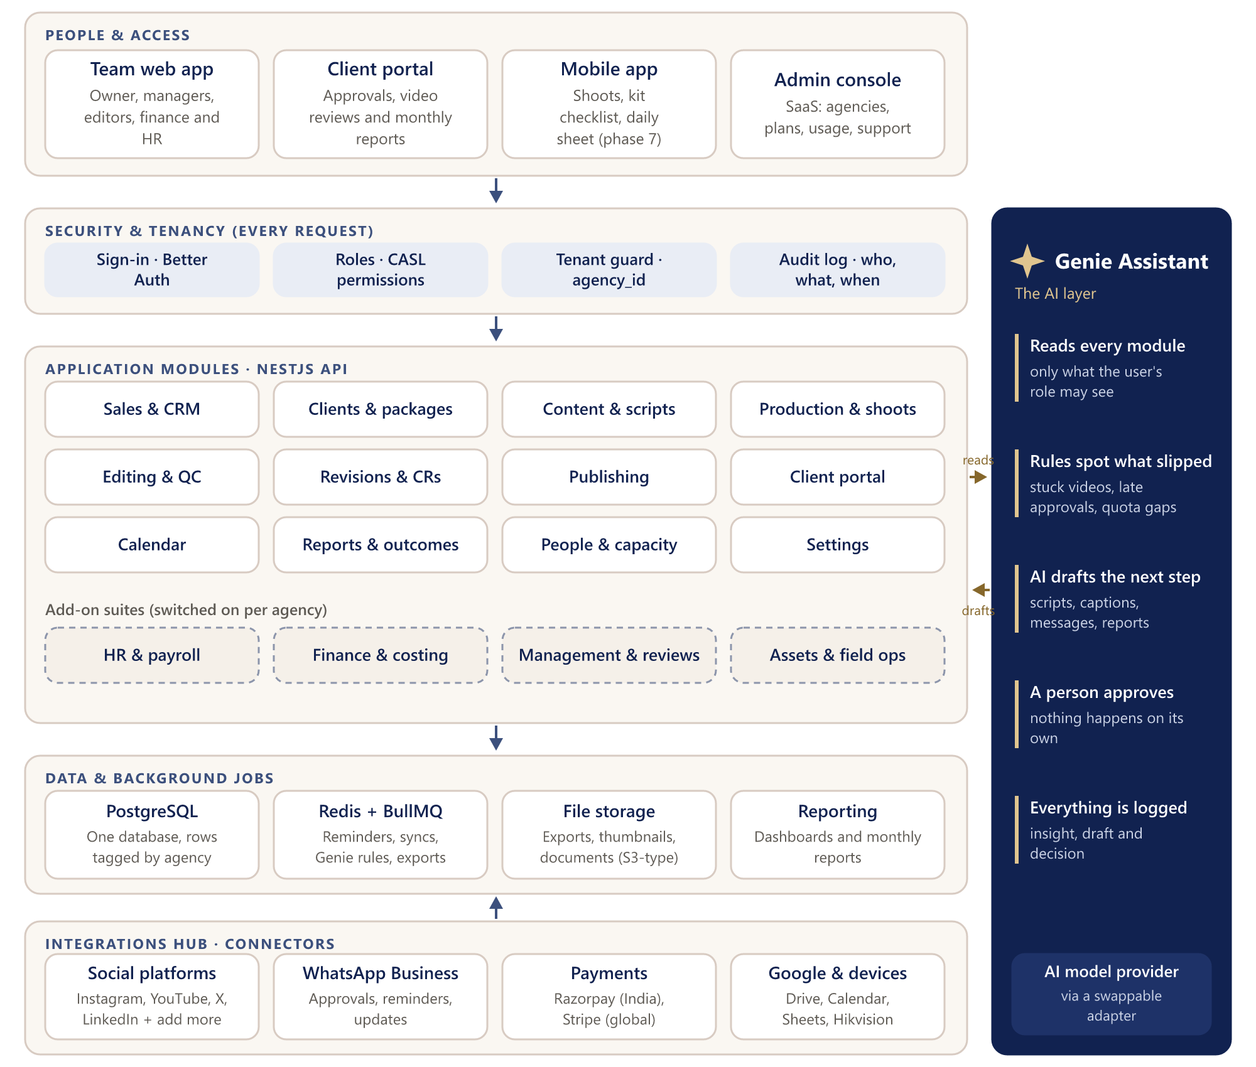
Figure 7 — System architecture: layers, integrations and Genie Assistant

10.2 Technology stack
Layer | Choice | Why
Web app | Next.js 16, React 19, Tailwind CSS, Radix UI | Already used for the demo; one codebase for the team app and the client portal
Mobile app | React Native + Expo (phase 7) | Shares TypeScript and the design system; offline shoot and kit checklists
API | NestJS (TypeScript), modular monolith | Clear module boundaries, easy to test, one deployable to run
Database | PostgreSQL + Prisma | Relational data, row-level security for agency separation, strong reporting
Background jobs | Redis + BullMQ | Reminders, WhatsApp and social sync, Genie Assistant rules, exports, with retries
Sign-in | Better Auth | Email and password, Google sign-in, two-factor, organisations and invitations
Permissions | CASL | Role and record-level rules shared by API and UI (for example “editors edit their own videos”)
Files | S3-compatible storage | Signed links and per-agency folders; raw footage stays in Drive or a NAS
AI | Provider adapter; Anthropic Claude recommended | Drafting quality, swappable provider, metered per agency
Messaging | WhatsApp Business Platform; transactional email | Official channels with delivery receipts
Payments | Razorpay (India), Stripe (international) | Client invoices and SaaS subscriptions
Quality and delivery | GitHub, GitHub Actions, Docker, Sentry | Automated tests and deploys; errors caught before users report them

10.3 Why a modular monolith
The API is one application split into clear modules (CRM, Clients, Content, Production, Publishing, Finance, HR and so on). Modules talk through defined service interfaces and events, never through each other's tables. This is much faster to build and run than many separate services, and any module that later needs to scale on its own can be split out without rewriting it.

10.4 Data model
About 60 tables cover the system. The spine below is the path every piece of client work follows; supporting records hang off it. The video code the team already uses (client · month · number) stays the human-readable key, and the tracking sheet becomes a real table.
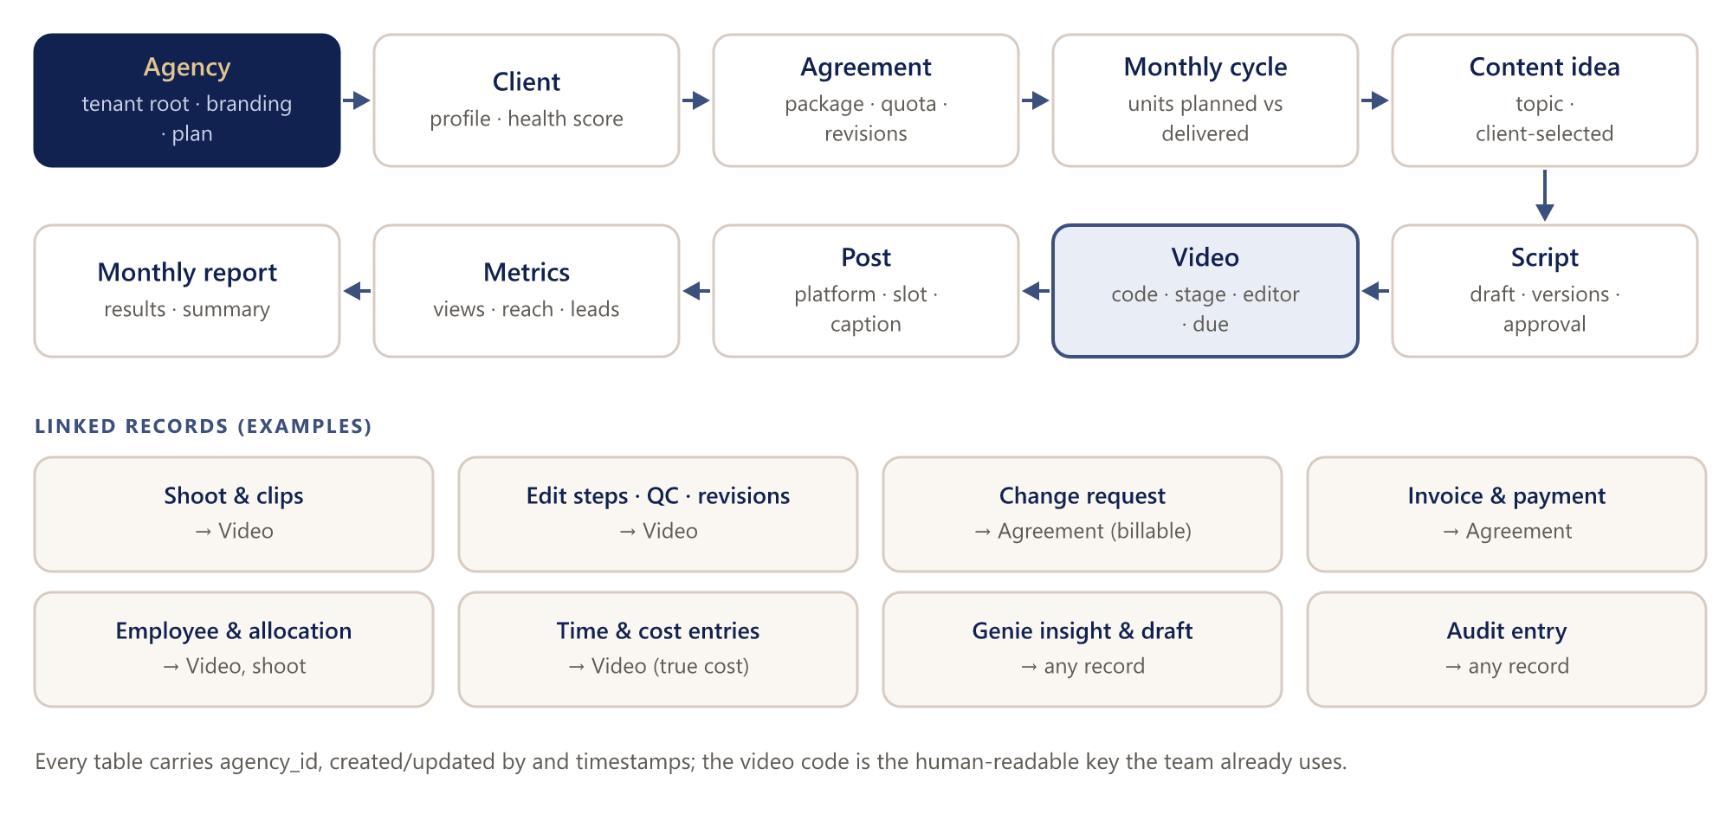
Figure 8 — Data spine: from agency to monthly report, with linked records
Group | Main tables
Platform | Agency (tenant), User, Membership, Role, Permission, Plan, Subscription, Usage, AuditEntry, Notification
Sales & clients | Lead, Deal, Proposal, Client, ClientContact, Package, Agreement, Cycle, HealthScore
Content & production | ContentIdea, Script, ScriptVersion, Approval, Shoot, KitChecklist, Video, Clip, EditStep, QCResult, Revision, ChangeRequest
Publishing & outcomes | ConnectedAccount, Post, ScheduleSlot, PostMetric, MonthlyReport
People | Employee, Skill, Allocation, Attendance, Leave, DailySheetEntry, TimeEntry, Review, RoundTableSession
Finance | Invoice, Payment, Expense, Vendor, CostEntry, PayrollRun, Payslip
Onboarding | QuestionnaireTemplate, Question, QuestionMapping, QuestionnaireResponse, Answer, Score, GeneratedOutput
Genie Assistant | Rule, Insight, Draft, DraftDecision, AIUsage

10.5 Keeping each agency's data separate
- Every agency-owned table has a required agency_id column, indexed and part of its unique keys.
- Each request is signed in, the user's active agency is resolved (or, on the client portal, the agency's custom domain), and that agency is set for the database transaction.
- PostgreSQL row-level security allows a query to see only rows with that agency_id, so a coding mistake cannot leak another agency's data.
- Background jobs carry the agency_id; files are stored under a per-agency folder and served with short-lived signed links.
- Automated tests in every build try to read across agencies and must fail. A penetration test is done before the SaaS launch.
- Large Enterprise customers can be given a dedicated database with the same code.

10.6 Security and privacy
- Encrypted connections (HTTPS) everywhere; data encrypted at rest; secrets kept outside the code.
- Two-factor sign-in for owners and admins; session timeouts; sign-in alerts.
- Least-privilege roles, record-level permissions and a full audit log.
- Designed for India's Digital Personal Data Protection Act 2023: clear notices, purpose limits, and the ability to export, correct or delete a person's data.
- Each agency can export all its data, and delete its workspace, at any time.
- Platform staff can open an agency's workspace only with that agency's consent, time-limited and logged.

10.7 Service levels (targets)
Area | Genie Magnet (stage 1) | SaaS (stage 2)
Availability | 99.5% monthly | 99.9% monthly
Speed | Main screens load in under 2 seconds | Same, with API responses under 0.5 s for 95% of requests
Backups | Daily backups kept 30 days | Daily backups plus point-in-time restore (7 days)
Recovery | Restore within 4 hours | Restore within 1 hour
Access | Latest Chrome, Edge, Safari, Firefox; phones and tablets | Same, plus the mobile app
Accessibility | WCAG 2.1 AA target | WCAG 2.1 AA target

10.8 Hosting and environments
Environment | Purpose | Hosting
Demo | Client review of screens with sample data | Railway (current)
Staging | Testing each release with Genie Magnet before it goes live | Same setup as production, smaller
Production — Genie Magnet | Live system for Genie Magnet (stage 1) | Genie Magnet's VPS (Docker: web, API, workers, PostgreSQL, Redis, HTTPS proxy, off-site backups) or a managed cloud
Production — SaaS | All agencies (stage 2) | Managed cloud with managed PostgreSQL, autoscaling and an India region

Recommendation: the VPS is fine for Genie Magnet alone (suggested minimum 4 vCPU, 8 GB RAM, 100 GB SSD, Ubuntu 22.04 or 24.04). For the SaaS, a managed cloud is safer, because paying agencies need guaranteed backups, uptime and scaling. The code is the same in both; only the hosting changes.

11. Architecture for Genie Magnet (stage 1)
This is the system exactly as Genie Magnet will run it: one agency, every module switched on, hosted on Genie Magnet's own server (or a managed cloud), and connected to Genie Magnet's own WhatsApp number and its clients' social accounts. The code already carries agency_id for the SaaS later, but only one agency exists.
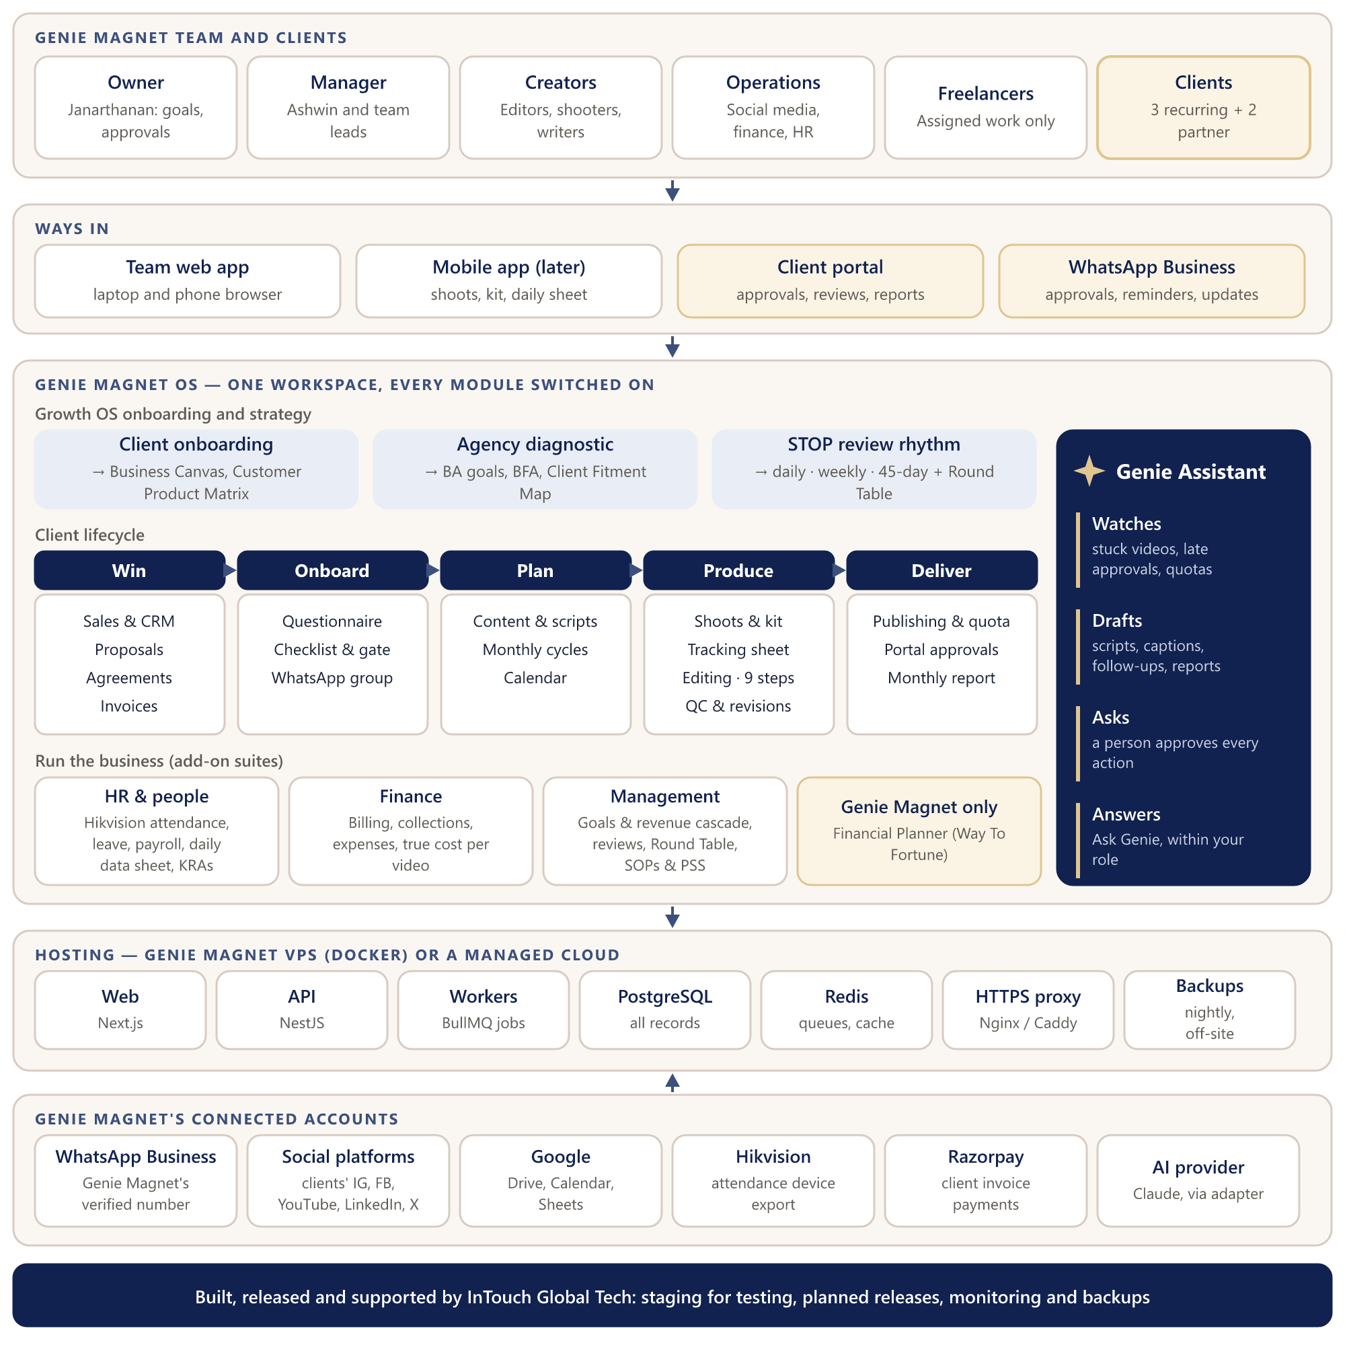
Figure 9 — Genie Magnet OS architecture — stage 1, one agency

11.1 How a normal month flows
- Win and onboard: a sale is confirmed in CRM, the agreement is created, and the client receives the onboarding questionnaire link on WhatsApp. The answers build the Business Canvas and content brief; the onboarding gate opens production.
- Plan: the monthly cycle is created from the agreement. Writers plan content; the client picks topics and approves scripts in the portal or on WhatsApp.
- Produce: shoots are scheduled with the kit checklist, footage is coded on the tracking sheet, editors work the 9 steps, the team leader runs Internal QC, and the client approves or requests changes.
- Deliver: the social media manager publishes, sends proof and tracks the monthly quota. Between the 25th and 30th the monthly report is prepared, the cycle is reconciled and invoices go out.
- Run the business: Genie Assistant flags what is stuck; the daily operational stand-up, weekly tactical review and 45-day strategic review (with the Round Table) follow the STOP rhythm; HR, payroll and true costing run alongside.

11.2 Deployment
Component | Runs as | Notes
Web app | Next.js container | Team app and client portal on Genie Magnet's own sub-domains
API | NestJS container | All business rules and permissions
Workers | BullMQ container | Reminders, WhatsApp and social sync, Genie Assistant rules, exports
Database | PostgreSQL (container with a mounted volume, or a managed database) | All records; nightly backups
Queue and cache | Redis container | Jobs and sessions
HTTPS proxy | Nginx or Caddy | Free certificates, compression, rate limits
Backups | Nightly dump to off-site storage | Kept 30 days; a restore is tested monthly
Monitoring | Uptime checks, error tracking, disk alerts | Alerts go to InTouch Global Tech

Recommended server: 4 vCPU, 8 GB RAM, 100 GB SSD, Ubuntu 22.04 or 24.04. Raw footage stays in Google Drive; the system stores links, exports and thumbnails.

11.3 What is specific to Genie Magnet
- Every module switched on, including the Financial Planner (Way To Fortune), which stays private to Genie Magnet.
- Genie Magnet's own Growth OS question sets, video code format, 9-step edit checklist, kit checklists (dual and single camera), QC checklist and SOPs.
- Hikvision attendance import, the daily data sheet with manager and HR sign-off, and the 45-day Round Table.
- Genie Magnet owns its data and every connected account (WhatsApp number, social access, Google, Razorpay, AI provider).

11.4 Genie Magnet system vs the SaaS platform
Aspect | Genie Magnet (stage 1) | SaaS platform (stage 2)
Agencies | One: Genie Magnet | Many; Genie Magnet is tenant #1
How an agency starts | Set up by InTouch with Genie Magnet | Self-serve sign-up and the agency onboarding questionnaire
Modules | All switched on | By plan: core plus add-on suites
Hosting | Genie Magnet's VPS or a managed cloud | Managed cloud, autoscaling, India region
Data separation | agency_id present, one agency | Enforced per agency by row-level security; optional dedicated database
WhatsApp and social | Genie Magnet's own accounts | Each agency connects its own
AI usage | Genie Magnet's own budget | Metered per agency, with plan limits
Billing | None (project delivery) | Subscriptions, GST invoices, usage add-ons
Branding | Genie Magnet | Each agency's own branding and domain
Support | InTouch team directly | Help centre, in-app chat, admin console with consented access
Releases | Scheduled with Genie Magnet | Continuous, with feature flags and gradual roll-outs

12. Build plan
The parts the agency touches every day are built first. Genie Assistant waits until real videos, approvals and schedules exist for its rules to read, and the SaaS opening comes last, once Genie Magnet has proven the whole flow. Each phase ends at a gate that can be demonstrated.
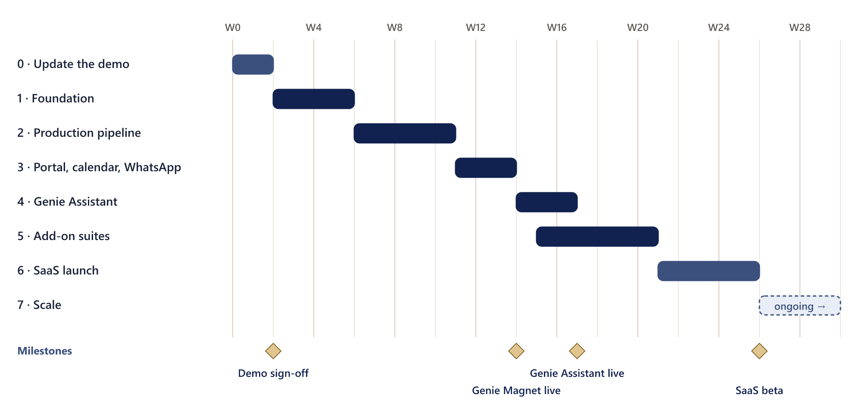
Figure 10 — Build roadmap by week, with milestones
Phase | Weeks | Scope | Done when
0 · Update the demo | 0–2 | Onboarding questionnaire screens (client and agency); Content module screens; Genie Assistant inbox and Ask Genie panel; connected platforms with “Add platform”; publishing quotas and schedule; WhatsApp message previews; client lifecycle tracker; revenue cascade; Growth OS names; host with feedback | Genie Magnet signs off the merged scope
1 · Foundation | 2–6 | Monorepo, CI/CD, environments; database with agency_id and row-level security; sign-in, invitations, roles, audit log, notifications, file storage; onboarding engine (required and 7-day sections, reminders) with the client questionnaire; Genie Magnet completes the agency questionnaire (seeds packages, goals, Client Fitment Map); Clients, agreements, CRM and basic invoices on real data | A client can be won and onboarded in the real app
2 · Production pipeline | 6–11 | Content (ideas, topics, research, scripts, approvals); monthly cycles; shoots and kit; tracking sheet, codes and clips; editing board with 9 steps; self-review and Internal QC; revisions vs CRs; publishing with manual post and proof; time entries | A video goes from idea to published, with every step recorded
3 · Portal, calendar, WhatsApp | 11–14 | Client portal approvals and review player; calendar; WhatsApp Business templates and replies; first social connectors (Instagram, Facebook, YouTube); monthly report; migration from Google Sheets; training and a two-week parallel run | Genie Magnet runs its live clients on the system
4 · Genie Assistant | 14–17 | Rules engine and insight inbox (4a); AI drafts for captions, scripts, follow-ups and the monthly report with approve / edit / reject (4b); Ask Genie; usage metering | Genie Assistant flags a stuck video and drafts a caption a manager approves
5 · Add-on suites | 15–21 | HR (attendance import, leave, payroll, performance, learning, daily sheet, recruitment); Finance (billing with payment gateway, expenses, true costing, reports, reconciliation); Management (goals and revenue cascade, STOP reviews, Round Table, decisions, SOPs with PSS and KRAs, business diagnostic, Strategic Road Map); LinkedIn and X connectors | Genie Magnet runs fully on the system; spreadsheets retired
6 · SaaS launch | 21–26 | Self-serve sign-up with the agency onboarding questionnaire that builds the workspace; templates; subscription billing, plans, module switches and limits; white-label portal and custom domains; platform admin console; data export and deletion; security review, penetration and load tests; help centre; 3–5 pilot agencies | A second agency runs on its own data and is billed automatically
7 · Scale | 26+ | Mobile app; more connectors; public API and webhooks; template marketplace; advanced Genie Assistant insights; more currencies and languages | Ongoing, driven by customer demand

12.1 Team and assumptions
- The timeline assumes a core team of four developers (a tech lead and three full-stack or front-end developers), with part-time QA, design and project management. A smaller team stretches the timeline in proportion.
- The front end is largely designed already: the demo's screens and design system are reused, which is the main reason the timeline is achievable.
- Phases 4 and 5 overlap: part of the team builds Genie Assistant while the rest builds the add-on suites.
- Week 0 starts when the demo scope is signed off. Weekly demos on staging; Genie Magnet reviews each phase gate.

12.2 What Genie Magnet provides
Phase | Needed from Genie Magnet
0 | Feedback on the updated demo; the real package list; confirmation of the lifecycle and checklist steps; corrections to the onboarding questions (Appendix C)
1 | Client list, agreements, team list with roles; hosting decision (VPS details or cloud)
2 | Current tracking sheet, SOPs, QC checklist, script templates
3 | WhatsApp Business number and Meta Business verification; admin access to clients' social accounts; Google Workspace access; two champions for training
4 | AI provider account and monthly budget; examples of good captions, scripts and reports
5 | Payroll rules, attendance export format (Hikvision), review templates
6 | SaaS brand name and domain; pricing sign-off; 3–5 pilot agencies

12.3 Going live at Genie Magnet
- Migrate: import clients, agreements, the tracking sheet and open videos from Google Sheets, with a validation report of anything that did not fit.
- Train: role-based sessions, short videos and two in-house champions.
- Parallel run: two weeks with the sheets and the system side by side; differences are fixed daily.
- Cut over: the sheets become read-only and the system is the source of truth.
- Hypercare: two weeks of priority support and quick fixes after go-live.

13. The SaaS plan

13.1 From one agency to many
The move from Genie Magnet's system to a product for many agencies happens in four steps, most of which are designed in from the start:
- Build multi-agency from day one (phase 1): agency_id, row-level security, per-agency files and settings.
- Prove it with Genie Magnet (phases 2–5): Genie Magnet is tenant number 1 and every workflow is proven on real work.
- Productise (phase 6): anything specific to Genie Magnet becomes a setting or a template (packages, checklists, stages, SOPs, report templates, labels), and Genie Magnet's playbook becomes the default template for new agencies.
- Launch (phase 6): self-serve sign-up, billing, onboarding, support and the admin console.

13.2 The SaaS architecture
The SaaS is the same product with a platform around it. Agencies join through a self-serve flow built on the agency onboarding questionnaire; every agency uses the same code with modules switched on by plan; and InTouch Global Tech runs the platform services and the cloud underneath.
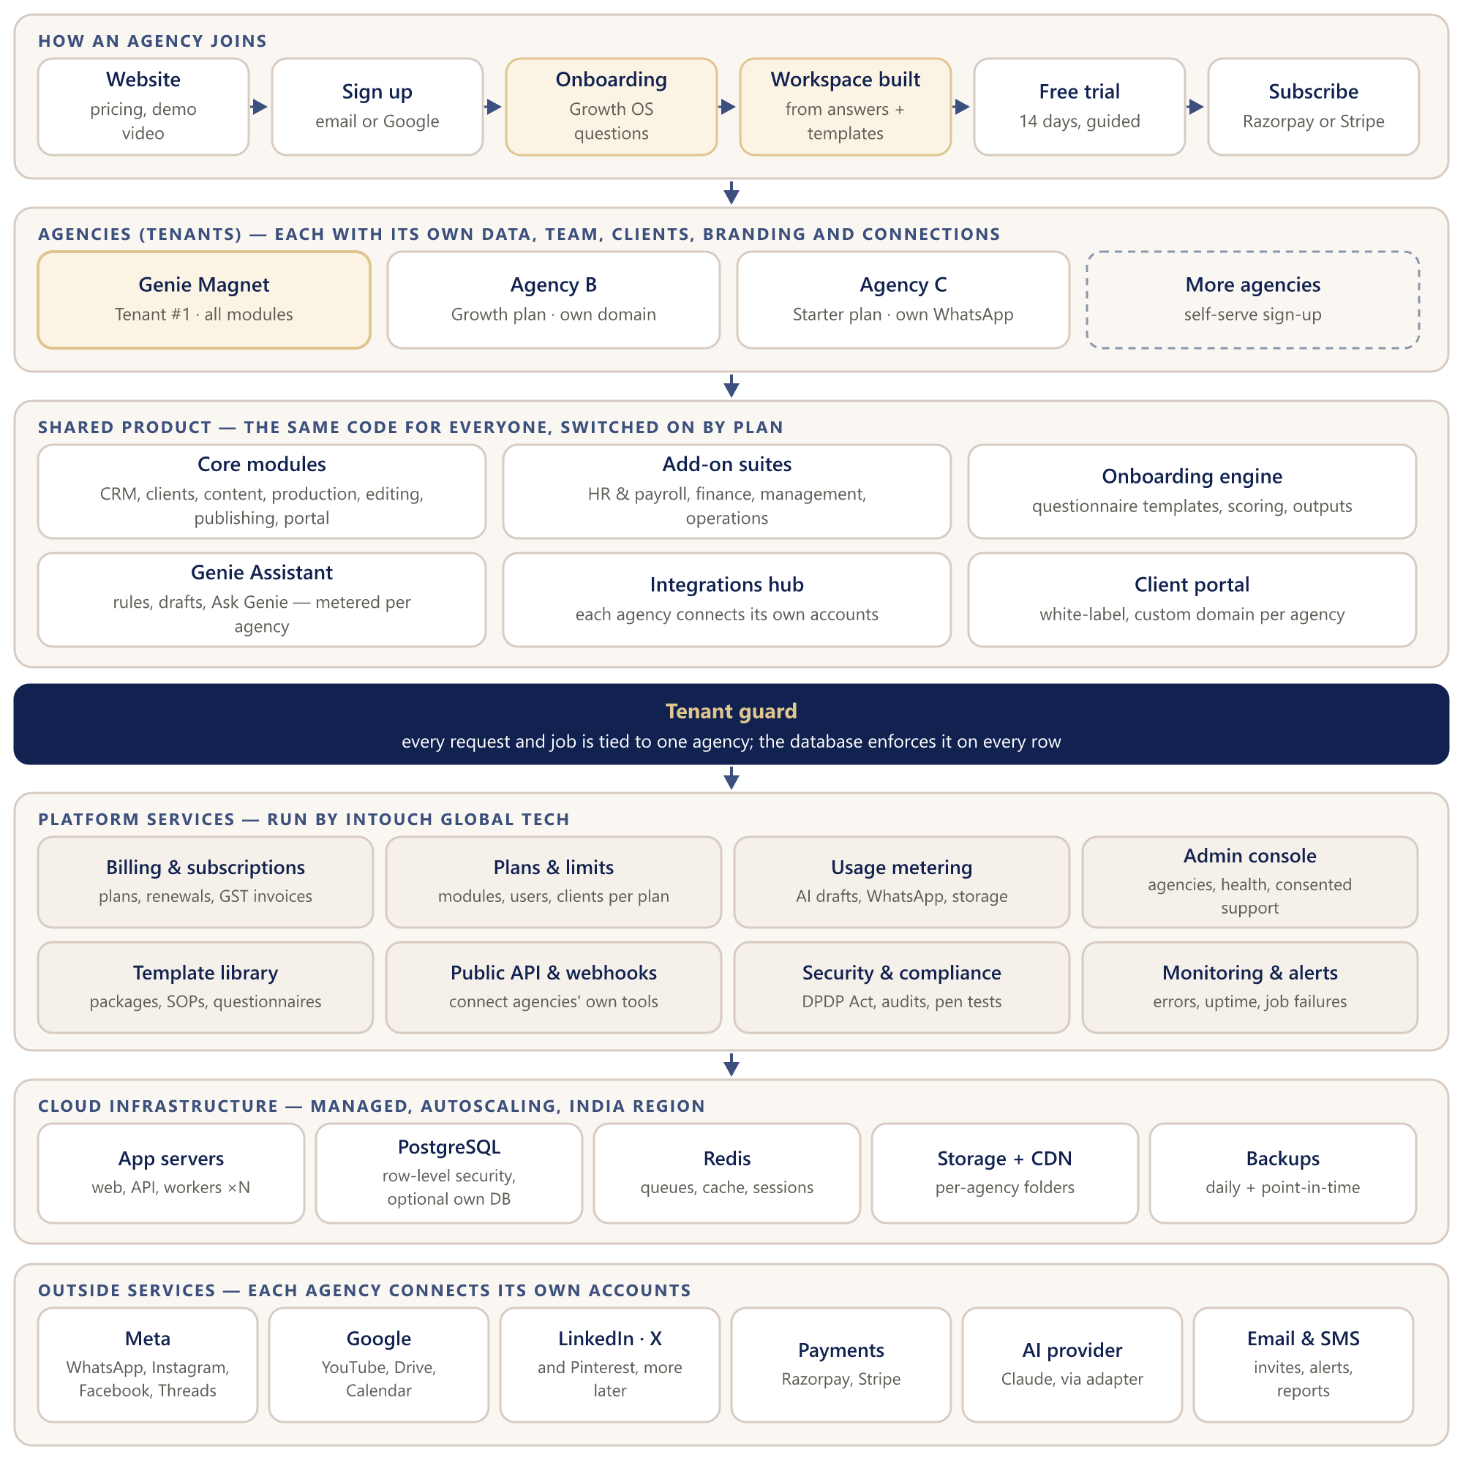
Figure 11 — SaaS platform architecture — stage 2, many agencies

Technical view: keeping each agency separate
Every request and background job passes the tenant guard before it reaches shared data, so agencies share infrastructure but never see each other's records.
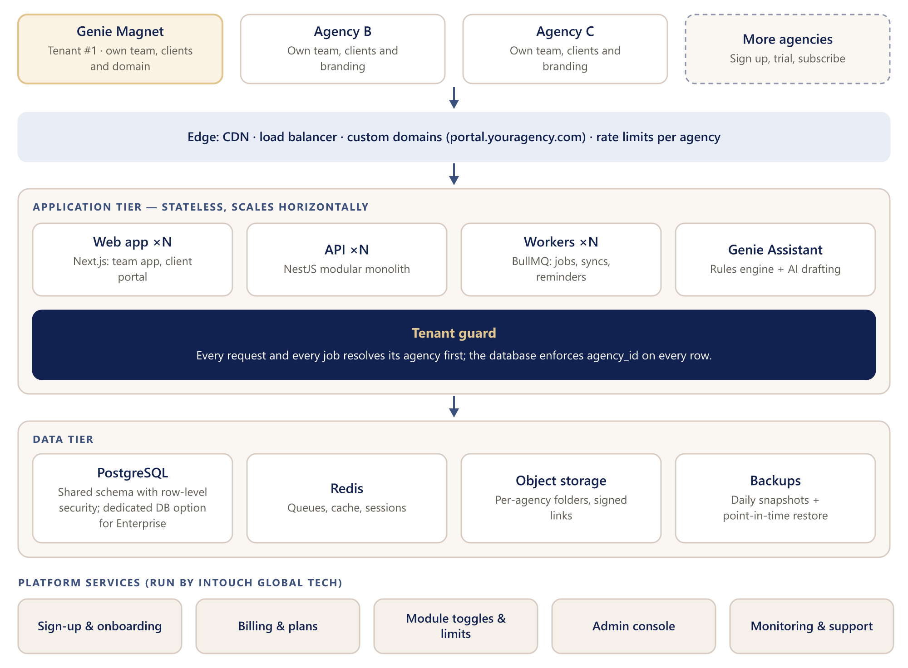
Figure 12 — SaaS technical view: stateless application tier, tenant guard and shared data tier

13.3 Who it is for
Segment | Typical size | Why they buy
Freelancers and small studios | 1–5 people, up to 10 clients | Replace spreadsheets and WhatsApp chaos; look professional to clients
Growing agencies | 5–20 people, 10–40 clients | Production control, approvals, quotas, true cost per video
Established agencies | 20–60 people | HR, finance and reviews in one place; white-label portal
Brands' in-house content teams | Varies | Content pipeline, approvals and reporting

13.4 What each agency can configure
- Branding: logo, colours, and a custom domain for the client portal (for example portal.youragency.com).
- Packages: name, price, videos and posts per month, platforms, revision allowance, add-ons.
- Workflow: video stages, edit checklist steps, QC checklist, approval rules, SOPs.
- Labels: role names and the Growth OS terms, so each agency uses its own words.
- Onboarding questionnaires: edit, add or reorder questions for both the client and the agency questionnaire.
- Video code format, working days and holidays, currency and tax settings.
- Which modules are switched on, which platforms are connected, and which WhatsApp templates are used.

13.5 Plans and pricing (indicative)
The prices below are a starting point for discussion. They should be tested in 10–15 conversations with agencies before launch.
 | Starter | Growth | Scale | Enterprise
For | Freelancers, small studios | Growing agencies | Established agencies | Large or multi-branch
Team users | Up to 5 | Up to 15 | Up to 50 | Custom
Active clients | Up to 10 | Up to 40 | Unlimited | Unlimited
Modules | Core | Core + 1 add-on suite | Core + all suites | All + custom work
Genie Assistant | Rules + 100 drafts a month | 500 drafts a month | 2,000 drafts a month | Custom
Client portal | Standard | Your branding | White-label + custom domain | + single sign-on
Support | Email | Email and chat | Priority + onboarding | Dedicated manager, SLA
Indicative price | ₹2,999 / month | ₹7,999 / month | ₹19,999 / month | Custom

- 14-day free trial; annual billing with two months free.
- Usage add-ons: extra Genie Assistant drafts, extra storage, WhatsApp messages passed through at cost.
- Services: data migration, onboarding and training packages.
- Prices in rupees with GST invoices for India; US dollars through Stripe for other countries.

13.6 Billing, plans and limits
An entitlements service knows each agency's plan: which modules are switched on, how many users and clients are allowed, and how much Genie Assistant usage remains. Screens and the API both check it, so upgrading a plan switches features on immediately without a new release. Subscriptions, renewals, failed payments and GST invoices run through Razorpay (India) and Stripe (international).

13.7 A new agency's first day
- Sign up with email or Google; create the agency workspace.
- Answer the required onboarding questions (about 10 minutes); the workspace unlocks with packages and quotas, goals and the revenue cascade, and recommended modules. The deeper questions (customers, BFA, financials, challenges) are completed within 7 days, with Genie Assistant reminders, and fill in the Client Fitment Map, Strategic Road Map and STOP review calendar.
- Add branding and invite the team.
- Connect social platforms and the WhatsApp Business number (optional).
- Import clients from CSV or Google Sheets, or add them by hand.
- Guided first video: idea → script → video → client approval → published. This is the activation moment.

13.8 Platform admin console (InTouch Global Tech)
- Agencies, plans, subscriptions, invoices and usage.
- Health of integrations and background jobs; error and uptime monitoring.
- Support access only with the agency's consent, time-limited and logged.
- Announcements, feature flags and gradual roll-outs.

13.9 Going to market
Stage | When | How
Pilot | Weeks 26–30 | 3–5 agencies from Genie Magnet's network; free or discounted in exchange for weekly feedback
Launch in India | After the pilot | Founder-led sales, webinars, case study of Genie Magnet itself, content marketing (Genie Magnet's own strength), referral rewards
Scale | Following quarters | Partner and reseller programme, marketplace listings, international customers through Stripe

What sets it apart: unlike general tools (task boards, generic CRMs), it is built for content agencies: video codes, the edit checklist, revisions versus billable changes, posting quotas, WhatsApp approvals, true cost per video, and an assistant that understands that workflow.

13.10 How success is measured
Measure | Target (first year of SaaS)
Activation: new agency publishes its first video in the system | Within 7 days for 60% of sign-ups
Trial to paid conversion | 20% or higher
Monthly churn (paying agencies) | Below 3%
Genie Assistant drafts approved (with or without edits) | 70% or higher
Average client approval time | Down 30% compared with before the system

14. Risks and how we handle them
Risk | Impact | How we handle it
Scope is large (47 modules) | Delays to go-live | Core first, add-ons later; strict phase gates; changes go into a later phase, not the current one
WhatsApp limits (template approval, per-message cost, limited group automation) | Approvals feel slow or costly | Start Meta verification early; business-number messages with portal links; groups stay for conversation
Social platform approvals and costs (Meta and Google reviews, LinkedIn access, X paid tiers) | Some platforms late | Apply for API access in phase 1; manual post + proof fallback keeps quotas and reports working
AI quality and cost | Wrong or expensive drafts | Rules first; approve before acting; usage caps per plan; swappable provider; quality measured
Messy spreadsheet data | Bad data after migration | Import templates, validation reports, two-week parallel run
Team adoption | People keep using sheets | Champions, training, mobile-friendly screens, WhatsApp nudges, the daily sheet inside the system
Data leaking between agencies | Loss of trust | Row-level security, automated cross-agency tests, security review and penetration test before launch
Using Growth OS terminology in a commercial product | Legal or brand issue at launch | Confirm permission before the public SaaS launch; terms are configurable labels and can change without code
Long questionnaires put people off | Slow or incomplete onboarding | Only the essentials are required to start (5–10 minutes); the rest within 7 days with reminders; relevant questions only, save and resume, assisted mode on a call
Large video files | Storage cost | Raw footage stays in Drive or a NAS; the system stores links, exports and thumbnails with per-plan limits

15. Open questions and next steps

15.1 Questions for the meeting
- Hosting for Genie Magnet's live system: use the Genie Magnet VPS (please share its specifications) or a managed cloud?
- WhatsApp: which business number, is the Meta Business account verified, and is there a preferred WhatsApp provider?
- Social platforms: which platforms do Genie Magnet's clients use most, so those connectors come first?
- AI: approval to use Anthropic Claude, and a monthly budget for Genie Assistant.
- SaaS brand: the product name and domain for the market (Genie Magnet OS, or a separate brand).
- Pricing: agree to test the indicative plans with 10–15 agencies.
- Pilot agencies: who are the first 3–5 agencies for the beta?
- Data migration: which sheets, and how many months of history to bring in.
- Onboarding questions: confirm the client and agency question sets in Appendix C, including which are required to start and which are completed within 7 days, and whether clients fill theirs through the portal link or the account manager fills it with them on the call.
- STOP rhythm: confirm how the daily, 7-day, 14-day and 45-day reviews map to the Strategic, Tactical and Operational levels.
- Commercial model: ownership, revenue share and support responsibilities between Genie Magnet and InTouch Global Tech for the SaaS.

15.2 Next steps (next two weeks)
# | Step | Owner
1 | Review this document together and answer the questions above | Genie Magnet + InTouch
2 | Update the demo (phase 0) with Content, Genie Assistant, platforms, WhatsApp previews and Growth OS names | InTouch
3 | Host the demo with an access code; the team leaves feedback on every screen | InTouch, then Genie Magnet
4 | Share the package list, tracking sheet, SOPs and QC checklist; mark changes to the onboarding questions (Appendix C) | Genie Magnet
5 | Start Meta Business verification and social API applications | Genie Magnet with InTouch
6 | Sign off the phase 0 scope; start phase 1 | Both

Appendix A — Naming glossary
Term | Meaning in Genie Magnet OS
Genie Assistant (was “QI”) | The AI layer: rules find what slipped, AI drafts, a person approves. The question box is “Ask Genie”.
STOP reviews | The Strategic (every 45 days, full day), Tactical (weekly or fortnightly, 2 hours) and Operational (daily, 10–15 minutes) review rhythm.
ATM | Achievement Tracking Mechanism: the dashboard used in STOP reviews.
Customer Product Matrix | Which services and content types each client takes.
Client Fitment Map | The 2×2 view of customers by effort and return: Amazing (low effort, high return), Bread-winning (high effort, high return), Convenience (low effort, low return) and Dangerous (high effort, low return).
Business Canvas | The one-page view of a client's plan, goals and audience.
Health score | A client's account health, and the agency-wide view.
Business Aspiration (BA) | The aspiration goal, timeline, the reason behind it and SMART financial goals.
Business Functional Assessment (BFA) | A review of seven business functions for consistency, owner dependency and results.
Business stage | Struggle, Survival, Stability, Success or Scale.
Strategic Road Map (STR) | Month-by-month functional focus built from the diagnostic.
PSS | Process, System and Structure for each function: steps (SOPs), competencies, KRAs and measures.
KRA | Key result area for a role, with how it is measured.
Video code | The human-readable key for a video: client code, month and number (for example KVR-0926-05).
VP | Video protection: a flag on videos that need protected handling.
Tracking sheet | The list of coded videos with clips, priority and editor, now a table in Production.
Final Output Group | Approved, locked videos ready for publishing.
Agency correction / Included revision / CR | The three kinds of client change (section 5.3).
True cost | Cost per video: labour, equipment, overhead and rework.
Daily Data Sheet | Each employee's daily task log, signed off by the manager and HR.
Round Table | The 45-day team feedback circle: timed rounds, anonymous to the employee, released by the manager.
Tenant / agency | One subscribing agency in the SaaS; Genie Magnet is tenant number 1.

Appendix B — Modules in the current demo
Depth: Demo = fully clickable · Preview = sample screens · Planned = overview page.
Section | Module (depth)
Overview | Dashboard (Demo) · Module Map (Demo)
Client delivery | CRM & Sales (Demo) · Agreements (Demo) · Onboarding (Preview) · Recurring Cycles (Preview) · Projects & Tasks (Preview) · Planning & Capacity (Preview) · Video Production (Demo) · Shoots & Kit (Demo) · SOPs & Checklists (Preview) · Internal QC (Demo) · Revisions & CRs (Demo) · Publishing (Preview) · Outcomes & Reports (Preview) · Cycle Reconciliation (Preview) · Client Health (Preview)
People & resources | Daily Data Sheet (Demo) · Team & HR (Preview) · Recruitment (Preview) · Attendance & Leave (Preview) · Calendar (Preview) · Performance & KRA (Preview) · Learning (Preview) · Payroll (Preview) · Equipment & Assets (Preview) · Time Tracking (Preview)
Finance | Billing & Collections (Preview) · Expenses & Vendors (Preview) · True Costing (Demo) · Financial Reports (Preview) · Financial Planner (Demo)
Management | Goals (Demo) · Reviews & Meetings (Demo) · Decisions & Commitments (Preview) · Business Diagnostic (Planned) · Scenario Planner (Planned) · Round Table (Demo)
Platform | AI Assistant → Genie Assistant (Planned) · Automation (Planned) · Integrations (Planned) · Offline Field App (Planned) · Audit Log (Planned) · Data Migration (Planned) · Documents (Planned) · Settings (Preview)
Client | Client Hub — client portal (Demo)

Appendix C — Onboarding question bank (draft)
Drafted from Genie Magnet's Growth OS consulting workbook and the requirements questionnaire. Sections marked Required must be answered to start; the others are completed within 7 days. Genie Magnet should mark any question to add, remove or reword; the final sets become the default templates.

C.1 Client onboarding questionnaire
Section | Questions | When
A. Business basics | 1. Business or legal name, and brand name if different.  2. Owners, partners or directors, with phone numbers and email.  3. Years in business and business type (sole proprietorship, partnership, LLP, private limited, public limited).  4. Nature of the business, head-office location and branches.  5. Website and social-media handles.  6. Stage of the business: Struggle, Survival, Stability, Success or Scale. | Required
B. Business model and customers | 7. Who do you sell to: businesses (B2B), consumers (B2C), through channel partners (B2CH), or a mix?  8. B2B customers: industry, annual turnover, employees, location, branches, who makes the buying decision.  9. B2C customers: age group, income, gender, occupation, marital status, education, location.  10. Channel customers: industries, turnover, distribution network strength, decision makers.  11. For each customer type: how many you serve, the revenue they bring and your profitability.  12. Which customer segments could you serve but have not explored yet? | Within 7 days
C. Needs, problems and desires | 13. Which problems of your customers do your products or services solve?  14. Which needs do you fulfil?  15. What are their non-negotiable expectations from you?  16. What deep-rooted desires do they have?  17. Which needs or problems are you not addressing yet? | Within 7 days
D. Products and services | 18. For each product or service: price, profit margin, share of revenue and effort to deliver (high or low). | Within 7 days
E. Competition and positioning | 19. Your top 5 competitors, and how each one competes with you.  20. How are you different: cheaper, faster or better? | Within 7 days
F. Marketing and sales today | 21. Do you have a marketing team? How are leads generated today?  22. Which marketing strategies have you tried, and which worked?  23. Which channels are active, and where are your customers on social media?  24. Which content formats suit you: infographics, carousels, blogs, videos, case studies?  25. Do you have a sales team? Describe the process from lead to close, and your sales strengths. | Within 7 days
G. Goals for this engagement | 26. What should this engagement achieve in 3, 6 and 12 months?  27. Target reach, followers, leads or sales; monthly marketing budget.  28. Your top three priorities. | Required
H. Brand, access and approvals | 29. Brand files (logo, colours, fonts, guidelines), tone of voice, do's and don'ts, topics to avoid.  30. Languages, people who will appear on camera, shoot locations and timings.  31. Access to social accounts, ad accounts and shared drives.  32. Who approves topics, scripts and videos, and through which channel (for example the WhatsApp group)?  33. Billing contact, GST number and billing address. | Required

C.2 Agency onboarding questionnaire
Section | Questions | When
A. Discovery details | 1. Agency name, owners, contacts, years in business, business type and location.  2. Website and social handles; stage of the business (Struggle to Scale). | Required
B. Services and packages | 3. Services offered (video production, social media management, personal branding, ads, websites, others).  4. For each package: name, monthly price, videos and posts per month, platforms, shoot days and revision allowance. | Required
C. Customers: effort vs return | 5. Types of customers, how many of each, share of revenue and average billing per year.  6. For each type: effort to acquire and deliver (high or low) and return (high or low). | Within 7 days
D. Business Functional Assessment | For each of Marketing, Sales, Operations / delivery, R&D, Accounts & Finance, HR and Management:  7. Are the actions done consistently? (yes / no)  8. Does it depend on the owner? (yes / no)  9. Are the results efficient? (high / low)  10. What is working, and what is not?  11. Team size and roles; is there a manager or second-line leader?  12. For each gap: hire, develop, delegate, outsource or do it yourself, and by when? | Within 7 days
E. Business Aspiration — main goal | 13. Aspiration goal, timeline and the WHY behind it.  14. Revenue: current and aspirational. | Required
E. Business Aspiration — full goals | 15. Quarterly break-up of the revenue goal; profitability: current and aspirational.  16. Owner's income: current and aspirational.  17. Cash flow: collection cycle, payment cycle and working capital needed. | Within 7 days
F. Financials | 18. Turnover, gross profit and net profit for the last 3–4 years.  19. Monthly fixed expenses (with break-up), variable expenses, owner's salary and loans. | Within 7 days
G. Team and approval roles | 20. Team members (employees and freelancers), their roles, and who approves what. | Required
G. Review practice | 21. Do roles have clear daily tasks? How is performance reviewed and feedback given?  22. Which tools are used for appraisals, career growth and training? | Within 7 days
H. Challenges and priorities | 23. The main challenges in each function, rated 1–10.  24. What you expect from the system, in priority order.  25. Tools and spreadsheets used today (to plan the migration). | Within 7 days
I. Workspace setup (SaaS sign-up only) | 26. Logo, colours and the client-portal domain.  27. Modules to switch on, platforms to connect and the WhatsApp Business number.  28. Import clients now (CSV or Google Sheets) or later. | Required (SaaS)

