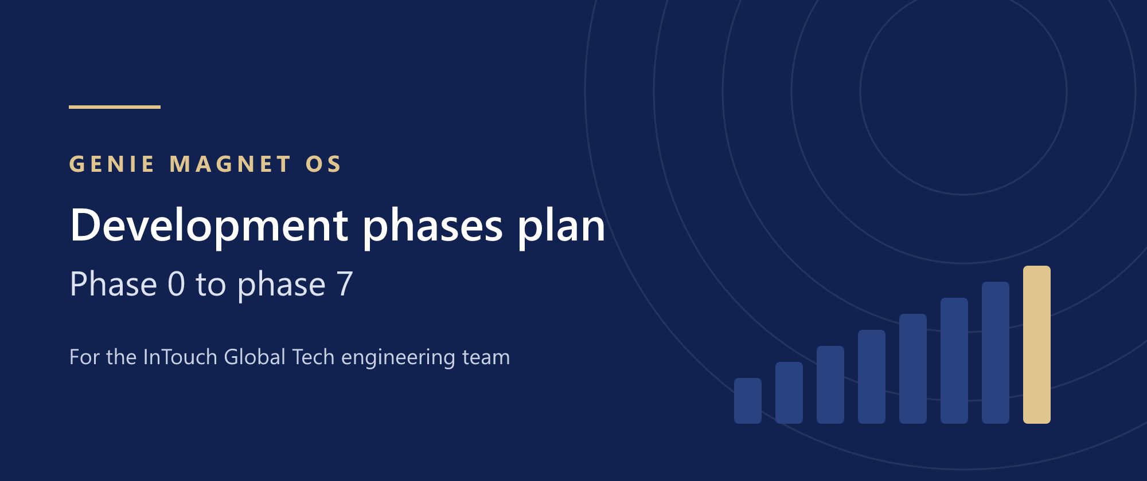
Development Phases Plan
Genie Magnet OS · phase 0 to phase 7
The working plan for the engineering team: what we build in each phase, who does it, what “done” means, and what we need from Genie Magnet.
Item | Detail
Prepared for | InTouch Global Tech engineering team: tech lead, developers, QA, design and project management
Project | Genie Magnet OS — Genie Magnet's own system (stage 1), then the SaaS platform for agencies (stage 2)
Companion document | Genie Magnet OS — Architecture, Build Plan & SaaS Roadmap, version 1.3 (product and architecture decisions)
Date | 30 September 2026
Version | 1.1 — everything configurable by each agency; changes are recorded in section 16
Planned start | Monday 5 October 2026 (week 0)

How to use this plan
The whole software is built in eight phases, numbered 0 to 7. Each phase has a goal, a scope split by work stream, the database tables it adds, its deliverables, an exit gate demonstrated to Genie Magnet, what we need from Genie Magnet, and its risks. The product and architecture decisions behind the plan are in the companion architecture document; this plan repeats them only where a developer needs the detail.
When a plan changes, it is updated here with a new version number and a line in the change log (section 16). Nobody works from an old copy.
If you are… | Start with
Tech lead | Sections 1, 3 and 16, then every phase gate
Backend developer | Section 3, then the phase you are working on
Frontend developer | Sections 3.1, 3.3 and 3.5, then your phase
Integrations developer | Sections 3.8 and 13, then phases 3, 5 and 6
QA engineer | Sections 3.11 and Appendix A, then each exit gate
Project manager | Sections 1, 2, 13, 14, 15 and 16

Contents
How to use this plan 2
1. Summary: eight phases 4
2. Team and ways of working 6
3. Technical foundation (every phase) 8
4. Phase 0 — Demo update and project setup 13
5. Phase 1 — Foundation 15
6. Phase 2 — Production pipeline 17
7. Phase 3 — Client portal, WhatsApp and go-live 19
8. Phase 4 — Genie Assistant 21
9. Phase 5 — Add-on suites 23
10. Phase 6 — SaaS launch 25
11. Phase 7 — Scale 27
12. Module-to-phase matrix 28
13. External approvals and accounts 30
14. Milestones and release calendar 30
15. Delivery risks 31
16. Changing the plan 32
Appendix A — Definition of Ready and Done 33
Appendix B — Conventions quick reference 33

1. Summary: eight phases
Counting from a start on Monday 5 October 2026, Genie Magnet goes live on the system in week 14 (11 January 2027) and the SaaS beta opens in week 26 (early April 2027). Phase 7 then continues as regular releases. Phases 0 to 4 build Genie Magnet's own system; phases 5 and 6 complete it and open it to other agencies.
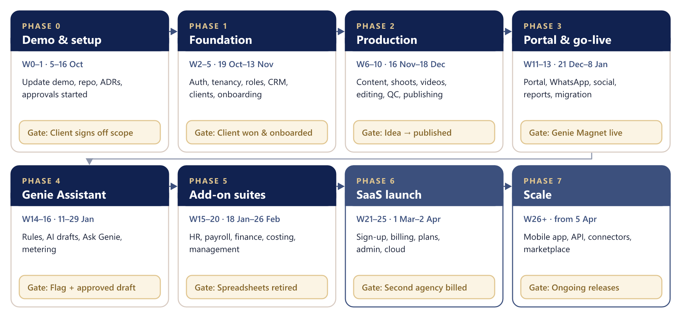
Figure 1 — The eight phases, each ending at a gate demonstrated to Genie Magnet
Phase | Weeks | Dates | Goal | Exit gate
0 · Demo & setup | 0–1 | 5–16 Oct 2026 | Client approves the merged scope on the updated demo; engineering set up | Genie Magnet signs off the scope
1 · Foundation | 2–5 | 19 Oct – 13 Nov | Sign-in, agencies, roles, audit; CRM, clients, agreements, onboarding on real data | A client can be won and onboarded
2 · Production pipeline | 6–10 | 16 Nov – 18 Dec | Content, cycles, shoots, videos, editing, QC, revisions, publishing | A video goes from idea to published
3 · Portal, WhatsApp, go-live | 11–13 | 21 Dec – 8 Jan 2027 | Client portal, WhatsApp, social, reports, payments, migration, production | Production ready; live from 11 Jan
4 · Genie Assistant | 14–16 | 11–29 Jan | Rules, AI drafts, Ask Genie, usage metering | A flag and an approved AI draft
5 · Add-on suites | 15–20 | 18 Jan – 26 Feb | HR, payroll, finance, true costing, management, assets | Genie Magnet fully on the system
6 · SaaS launch | 21–25 | 1 Mar – 2 Apr | Sign-up, billing, plans, white-label, admin console, cloud | A second agency is billed automatically
7 · Scale | 26+ | From 5 Apr | Mobile app, public API, more connectors, marketplace | Quarterly releases

1.1 Calendar and the 31 December date
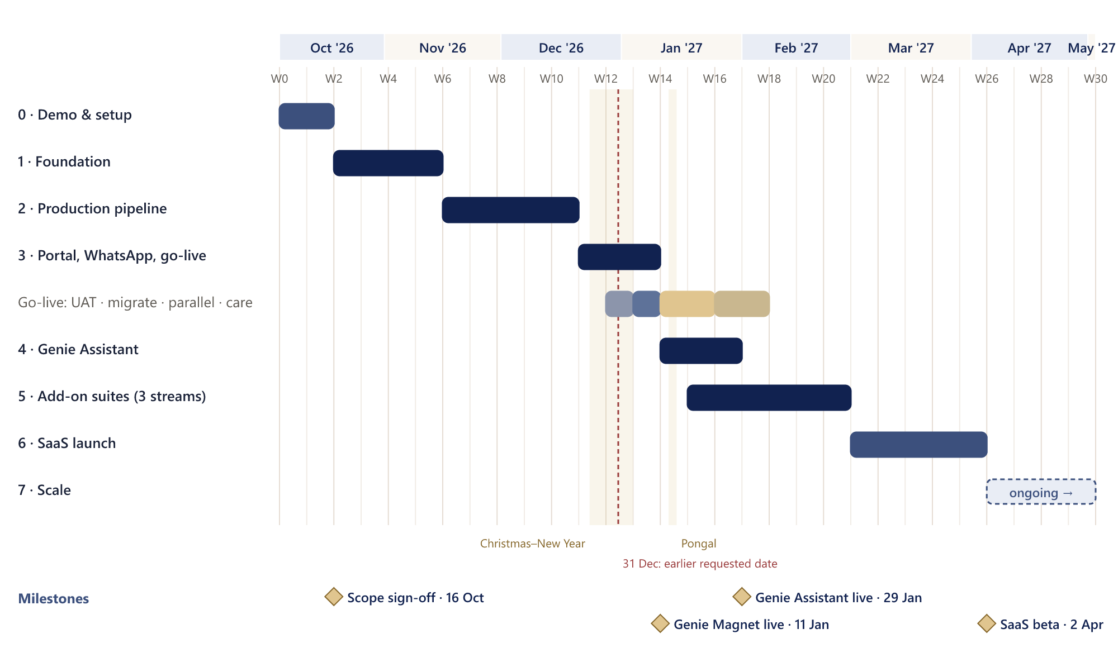
Figure 2 — Dated roadmap with holidays, go-live steps and milestones
Decision needed: the earlier requested launch date
Genie Magnet earlier asked for a launch on 31 December 2026. In this plan that date falls in week 12, during user acceptance testing and the holiday period.
Options: (a) keep the plan — live on 11 January 2027; (b) add one or two developers from phase 1, which could bring go-live forward by one to two weeks; (c) treat 31 December as the start of a pilot with one or two clients. InTouch and Genie Magnet should choose before phase 1 starts.

1.2 Decisions built into the plan
- Stack: Next.js + React (web), NestJS (API and workers), PostgreSQL + Prisma, Redis + BullMQ, Better Auth, CASL; React Native + Expo for mobile in phase 7.
- One modular-monolith API; modules talk through services and events, never each other's tables.
- Multi-agency from day one: agency_id on every agency-owned table, enforced by PostgreSQL row-level security.
- Onboarding questionnaires: only the essentials are required to start; the rest are completed within 7 days, with Genie Assistant reminders.
- Genie Assistant: rules first, AI drafts second, and a person approves before anything happens.
- Social media works as “add a platform” connectors; WhatsApp through the official WhatsApp Business Platform.
- Growth OS names are kept; the AI is called Genie Assistant.

1.3 How phases and gates work
- Every phase ends with a gate: a scripted demonstration on staging (or production) that Genie Magnet signs off.
- Work that misses a gate either holds the gate (if the gate depends on it) or moves to the next phase (if it does not). The PM records either choice.
- Phases run one after another, except phases 4 and 5, which overlap with separate people on each.
- New requests during a phase go into the change process (section 16) and are planned into a later phase unless they are critical.

2. Team and ways of working

2.1 Team
Role | Main responsibilities | Phases
Tech lead / architect | Architecture and ADRs, tenancy, auth and permissions core, code reviews, releases, AI integration lead | All
Backend developer | Domain modules, business rules, jobs, reports, payroll and costing engines | 1–6
Integrations / full-stack developer | WhatsApp, social connectors, payments, Google, imports, subscription billing | 1–6 (heaviest in 3 and 6)
Frontend developer | Demo updates, connecting screens to the API, client portal, new screens, design system | 0–6
QA engineer | Test plans, Playwright automation, regression, UAT support; part-time in 0–2, full-time from 3 | All
UI/UX designer (part-time) | Phase 0 screens, onboarding and portal UX, SaaS sign-up, admin console | 0, 3, 6
Project manager / scrum master | Plan and backlog, external approvals, client communication, change control, weekly status | All
Product owner (Genie Magnet) | Ashwin day to day; Janarthanan gives final approval at each gate | All

Names are to be assigned by InTouch. The timeline assumes these four developers from week 2; a smaller team stretches the dates in proportion.

2.2 Who works on what, by phase
Phase | Backend | Frontend | Integrations | DevOps / QA
0 | ADRs, database design (ERD v0) | Demo screens for the new scope | Start external approvals | Repo, CI skeleton, local stack; test strategy
1 | Auth, tenancy, CRM, clients, agreements, onboarding engine | API data layer, auth screens, connect modules | Email, file storage | Staging, error tracking; tenancy test suite
2 | Cycles, content, shoots, videos, editing, QC, revisions, publishing | Production screens on the API | Drive links, calendar data | Performance baseline; state-machine and e2e tests
3 | Portal API, monthly report, imports | Client portal, calendar, message log | WhatsApp, Meta, YouTube, Razorpay | Production server, backups; UAT and migration checks
4 | Rules engine, AI drafts, Ask Genie | Insight inbox, draft review, Ask Genie panel | Anthropic API | AI usage metrics; evaluation set
5 | HR, payroll, finance, costing, management | Add-on suite screens | Hikvision import, LinkedIn, X | Calculation tests; payroll parallel run
6 | Sign-up, entitlements, usage, admin | Sign-up, onboarding wizard, admin console | Subscriptions, Stripe, WhatsApp embedded sign-up | Managed cloud, Genie Magnet migration; pen and load tests
7 | Public API, webhooks | Mobile app (Expo) | More connectors | Mobile release pipeline

2.3 Weekly rhythm
- One-week sprints, Monday to Friday. Monday: planning (1 hour). Every day: 15-minute stand-up.
- Friday: 30-minute demo to Genie Magnet on staging, then the weekly release to staging is tagged.
- Retrospective every two weeks; phase gate review at the end of each phase.
- Backlog in GitHub Projects: Backlog → Ready → In progress → Review → QA → Done. Every story has acceptance criteria and links to its module.
- A weekly status note to Genie Magnet: done, next, risks, and what we need from them.

3. Technical foundation (every phase)
These rules apply from the first commit. They are set up in phase 0 and phase 1 and are not renegotiated per module.

3.1 Repository and modules
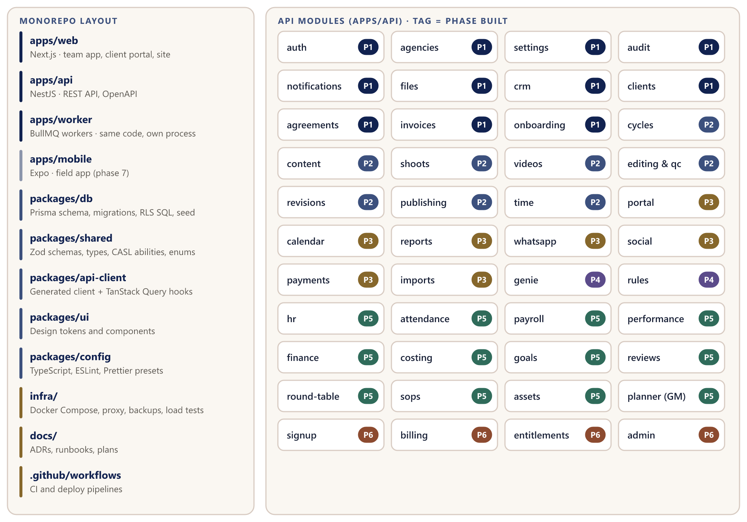
Figure 3 — Monorepo layout and API modules, tagged with the phase in which each is built

3.2 Backend conventions
- One NestJS module per domain: controller (HTTP only), service (business rules), Prisma for data access, DTOs from the shared Zod schemas.
- REST under /api/v1. OpenAPI is generated from the code, and the frontend client is generated from OpenAPI; no hand-written fetch calls.
- Errors use problem+json with a stable error code; validation errors list the fields.
- Cursor pagination, filtering and sorting on every list; no endpoint returns an unbounded list.
- Money is stored as integer paise with a currency code. Dates are stored in UTC and shown in IST (Asia/Kolkata). IDs are UUIDs.
- Every agency-owned table has agency_id, created_at/by, updated_at/by and deleted_at (soft delete); unique keys include agency_id.
- Business events (for example sale.confirmed, video.approved) are published on an internal event bus; notifications and jobs subscribe to them.
- Webhooks and payment endpoints use idempotency keys.

3.3 Frontend conventions
- Keep the demo's design system: the colour tokens, three text sizes and existing components. New screens use existing components first.
- Data comes through the generated API client and TanStack Query. Forms use React Hook Form with the shared Zod schemas.
- CASL abilities from packages/shared decide what is shown or disabled; the API still enforces every rule.
- Feature folders mirror the API modules. No business rules in components.
- Every list has loading, empty and error states. Every form has required marks, inline errors and full keyboard access.
- Mock data is removed module by module as each phase connects it. A demo-mode flag keeps not-yet-built modules browsable until their phase.

3.4 Keeping each agency's data separate
- The auth guard resolves the user and the active agency (from the session, or from the portal domain for client users).
- The agency is stored in a request context (AsyncLocalStorage) for the request or job.
- A Prisma client extension wraps the work in a transaction and runs SET LOCAL app.agency_id; each table's row-level security policy only allows rows with that agency_id.
- The application's database role cannot bypass row-level security; migrations run under a separate owner role.
- Background jobs carry the agency_id in their payload and set the same context before running.
- Files are stored under a per-agency folder and served with signed links that expire in minutes.
- CI runs a cross-agency test suite on every pull request: for every module, a user of agency A must get “not found” for agency B's records. A failure blocks the merge.
-- example policy (one per agency-owned table)
ALTER TABLE video ENABLE ROW LEVEL SECURITY;
CREATE POLICY agency_isolation ON video
USING (agency_id = current_setting('app.agency_id')::uuid)
WITH CHECK (agency_id = current_setting('app.agency_id')::uuid);

3.5 Sign-in and permissions
- Better Auth: email and password, Google sign-in, two-factor sign-in for owners and admins, password reset, session expiry; organisations map to agencies; invitations by email.
- CASL: each role has a set of abilities defined once in packages/shared and used by both the API and the UI.
- Record-level rules, for example: an editor may update a video only if assigned to it; a client user may read only their own client's videos, and only from “Client review” onwards; a freelancer sees only assigned work.
- Every permission change and every sign-in to another user's context is written to the audit log.

3.6 Background jobs
Queue | Used for | From phase
notifications | In-app, email and WhatsApp notifications | 1
reminders | Onboarding (day 2, 5, 7), approvals, shoots, invoices | 1
cycles | Monthly cycle generation from agreements | 2
integrations | Social metrics pull, token refresh, calendar sync | 3
whatsapp | Outbound messages and webhook processing | 3
reports | Monthly report PDFs and exports | 3
imports | Spreadsheet and Hikvision imports with validation | 3
genie-rules / ai-drafts | Rule evaluation and AI drafting | 4
billing | SaaS subscriptions, usage aggregation, dunning | 6

Rules: every handler is idempotent; retries use exponential backoff; failed jobs go to a dead-letter queue that alerts the team; each agency has a concurrency limit; scheduled jobs run on IST time.

3.7 Files and media
S3-compatible object storage (MinIO locally). Browsers upload directly with signed links; the API checks file type and size. Raw footage stays in Google Drive or a NAS; the system stores links, exports, thumbnails and documents.

3.8 Integration connectors
Every outside service sits behind an interface, so a new platform or provider is a new class and no module changes:
interface SocialConnector {
platform: 'instagram' | 'facebook' | 'youtube' | 'linkedin' | 'x' | string;
getConnectUrl(clientId: string): Promise<string>; // OAuth start
handleCallback(params: CallbackParams): Promise<ConnectedAccount>;
refreshAccess(account: ConnectedAccount): Promise<void>;
schedule(post: Post): Promise<ScheduleResult>; // or 'manual' fallback
fetchMetrics(account: ConnectedAccount, range: DateRange): Promise<PostMetric[]>;
health(account: ConnectedAccount): Promise<HealthStatus>;
}
interface WhatsAppProvider { sendTemplate(...); sendInteractive(...); handleWebhook(...); }
interface PaymentProvider { createPaymentLink(invoice); handleWebhook(...); }

3.9 Genie Assistant: AI implementation notes
- SDK: the official Anthropic TypeScript SDK (@anthropic-ai/sdk) inside apps/api, wrapped by an AiProvider adapter so the provider can change without touching modules.
- Model: claude-opus-5-5 (Claude Opus 5.5). Thinking is always on for this model; depth and cost are set per task with output_config.effort (for example low for short captions and follow-ups, medium for scripts and summaries, high for the monthly report). Set it explicitly on every call.
- Structured outputs (output_config.format with a JSON schema) for drafts, so the UI receives fields such as caption, hashtags and thumbnail text rather than free text.
- Prompt caching: the stable system prompt and the agency's brand context go first and are cached; dates and record IDs come after. Check usage.cache_read_input_tokens in logs.
- Streaming for long outputs (monthly report, scripts), using the SDK's stream helper and its final-message method.
- Ask Genie uses the SDK's Tool Runner with read-only tools that call existing services under the asking user's CASL abilities. tool_choice stays auto (forcing a specific tool is not supported on this model); answers link back to records.
- Refusals: always check stop_reason before reading the content, and enable server-side fallbacks (fallbacks: "default" with the server-side-fallback-2026-07-01 beta).
- Bulk, non-urgent work (for example month-end report drafts for every client) goes through the Message Batches API at lower cost.
- Metering: record response.usage per agency, feature and user; check plan limits before each call.
- Privacy: send only the fields a task needs; never salary, bank or identity data; keep AI logs for the period agreed with Genie Magnet.
- Quality: before launch, build a small evaluation set from Genie Magnet's approved captions and scripts; track approval rate and how much people edit drafts; change prompts only against that set.

3.10 Environments and release pipeline
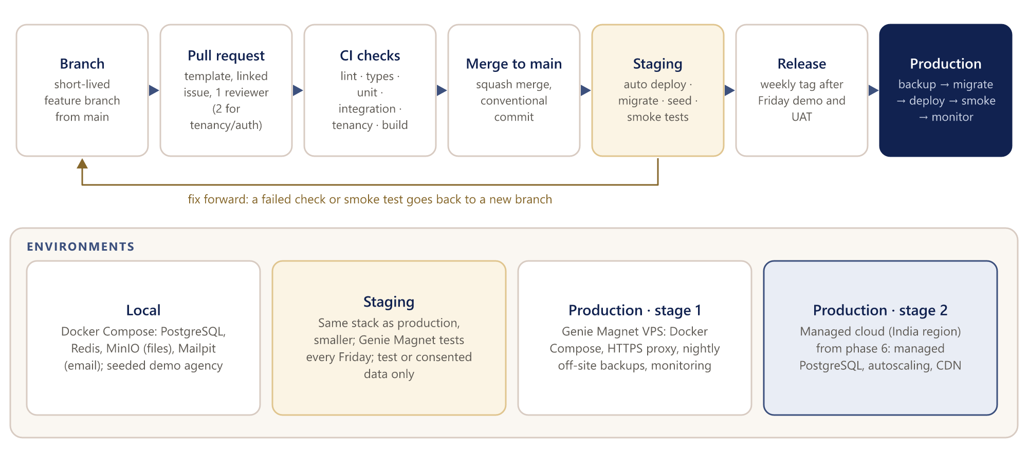
Figure 4 — From branch to production, and the four environments
- Trunk-based: short-lived branches from main, named feat/GM-123-short-name; conventional commits; squash merge; aim for pull requests under about 400 changed lines.
- Database migrations are expand-then-contract: never remove or rename a column in the same release that stops using it.
- Unfinished features ship behind feature flags, off by default.
- Every production release: backup first, migrate, deploy, smoke test, watch errors for 30 minutes. Rollback = previous image plus the restore point.

3.11 Testing
Level | Tool | What | When
Unit | Vitest | Services, rules and calculators (costing, payroll, revenue cascade, quotas) | Every pull request
Integration | Supertest + test PostgreSQL | Every endpoint, including permission checks | Every pull request
Tenancy | Cross-agency suite | Agency A cannot read or change agency B's records, for every module | Every pull request (blocking)
End-to-end | Playwright | Each phase's gate scenario and key flows | Each staging deploy and nightly
API contract | OpenAPI diff | Breaking API changes are flagged | Every pull request
Accessibility | axe with Playwright | WCAG 2.1 AA checks on main screens | Nightly
Load | k6 | Key endpoints and jobs under load | Phases 3 and 6
Acceptance | Genie Magnet | The gate scenario on staging | End of each phase

Coverage targets: at least 80% of lines in calculation modules (costing, payroll, revenue cascade, quotas) and at least 60% across services.

3.12 Security baseline
- HTTPS only with HSTS; secure, HTTP-only cookies; CSRF protection; a content security policy.
- Rate limits on every endpoint, stricter on sign-in and public links; per-agency limits from phase 6.
- Validation with Zod on every input; Prisma for all queries (no string-built SQL).
- Secrets in the environment or a secret manager, never in the repository; OAuth and WhatsApp tokens encrypted at rest.
- Dependabot and npm audit in CI; high-severity findings block releases.
- Salary, bank and identity documents visible only to HR and finance roles; the audit log is append-only.
- Encrypted backups; a breach runbook; data requests handled under India's Digital Personal Data Protection Act 2023.

3.13 Performance targets
Measure | Target
API response, list and detail endpoints | Under 500 ms for 95% of requests
Main screens on a 4G phone | Usable in under 2 seconds
Background job delay | Under 1 minute for reminders and notifications
Monthly report PDF | Under 30 seconds per client
Availability | 99.5% for Genie Magnet; 99.9% for the SaaS

4. Phase 0 — Demo update and project setup
Item | Detail
Weeks and dates | Weeks 0–1 · Monday 5 October to Friday 16 October 2026
Goal | Genie Magnet approves the merged scope on the updated demo, and the engineering foundation is ready so phase 1 starts on day one.
Team focus | Frontend developer and designer on the demo; tech lead on setup and design; PM on approvals and backlog
Exit gate | Genie Magnet signs off the scope; the phase 1 backlog is ready

4.1 Scope

Demo (apps/web, sample data)
- Onboarding: client questionnaire (public link view and assisted mode) and agency questionnaire, with required sections and “complete within 7 days” sections, a progress checklist and previews of the outputs (Business Canvas, Customer Product Matrix, Client Fitment Map).
- Content module: idea bank, client topic selection, research notes, script editor with versions, script approval.
- Genie Assistant: insight inbox on Home, draft approve / edit / reject, and an Ask Genie panel with scripted answers.
- Publishing: connected platforms with “Add platform”, schedule slots, monthly quota meter, proof link.
- WhatsApp message previews: approval request, reminder, confirmation.
- Client lifecycle tracker on the client page; revenue cascade in Goals; STOP review calendar in Reviews.
- Names: AI Assistant becomes Genie Assistant; Client Fitment Map quadrants become Amazing, Bread-winning, Convenience and Dangerous.
- Hosted with an access code and the feedback inbox.

Engineering setup
- Monorepo layout (section 3.1), TypeScript project references, ESLint, Prettier, commit hooks, pull request template, issue templates.
- Local stack with Docker Compose: PostgreSQL, Redis, MinIO, Mailpit.
- Architecture decision records (ADRs): modular monolith, tenancy with row-level security, Better Auth, CASL, API contract and generated client, shared Zod schemas, job queues, AI adapter.
- Database design v0 (Prisma schema draft) reviewed by the team.
- CI skeleton in GitHub Actions; accounts for staging hosting, error tracking, email sending and object storage; domain and DNS.
- Short technical spikes: Better Auth organisations with row-level security, and a Prisma transaction extension that sets the agency.

Project management
- Start external approvals (section 13): Meta Business verification, WhatsApp provider, Meta app review preparation, Google Cloud project, LinkedIn API access, Razorpay account.
- Write the phase 1 and phase 2 backlog as user stories with acceptance criteria.

4.2 Deliverables
- Updated demo link
- Scope sign-off from Genie Magnet
- ADRs and database design v0
- Repository, CI skeleton and local stack
- Ready backlog for phase 1

4.3 Exit gate
- Walk Genie Magnet through the updated demo: onboarding, Content, Genie Assistant, publishing and WhatsApp previews.
- Review the feedback inbox together and agree the changes.
- Janarthanan confirms the scope in writing.

4.4 Needs from Genie Magnet
- Feedback on the demo within the fortnight
- Feedback on the default packages, roles and question sets in the demo (each can be changed later in Settings)
- Confirmation of the lifecycle steps and checklists
- Decision on the 31 December date (section 1.1) and on hosting

4.5 Risks
- Late feedback delays the scope: agree a feedback deadline at kick-off.
- External approvals take weeks: start them in this phase, not later.

5. Phase 1 — Foundation
Item | Detail
Weeks and dates | Weeks 2–5 · Monday 19 October to Friday 13 November 2026
Goal | The real application skeleton — sign-in, agencies, roles, audit — with clients won and onboarded on real data.
Team focus | Tech lead: tenancy, auth, permissions. Backend: CRM, clients, agreements, onboarding engine. Integrations: email, files. Frontend: data layer and screens.
Exit gate | A client can be won and onboarded in the real app

5.1 Scope
- Platform: NestJS scaffold (config, structured logging, error filter, validation, OpenAPI, health checks, rate limiting); Prisma base fields, migrations and seed; tenancy with row-level security and the cross-agency test suite; audit log; notifications (in-app and email); file storage with signed links; BullMQ with retries and a dead-letter queue.
- Sign-in and permissions: Better Auth (email and password, Google, two-factor for owners and admins, invitations); default roles (Owner, Manager, Team leader, Editor, Shooter, Script writer, Social media manager, Finance, HR, Freelancer, Client approver, Client viewer) that each agency can rename, copy or add to; CASL abilities built from each agency's own permission settings, with record-level rules.
- Settings — set by each agency: Nothing an agency may want to change is hard-coded; every setting starts from a Growth OS default: agency profile and branding; custom roles with a permission matrix (see, edit, approve for each area); packages with price, videos and posts per month, platforms, shoot days and revision allowance; CRM pipeline stages; invoice settings (GSTIN, state, SAC codes, tax rates, number format, payment terms, bank details, logo); the onboarding question builder (below).
- CRM: Leads, pipeline stages, calls and activities, proposals, discount approval, won deal.
- Clients and agreements: Clients and contacts; agreements with package, terms, quotas, revision allowance and billing schedule; basic invoices (manual, using the agency's own invoice settings, PDF).
- Onboarding engine: A question builder for each agency (add, edit, reorder and remove questions; choose the type; mark required or within the window; map an answer to a field; translations such as Tamil), starting from the Growth OS question sets. Templates, sections, questions (types, required or within 7 days, branching, field mapping), responses and answers with versions, public token links, assisted mode, reminders on day 2 and day 5 (email and in-app for now), a flag after day 7, and outputs: client profile, draft Business Canvas, and for the agency questionnaire the packages, main goal and team roles.
- Sale confirmed: When a deal is won: create the client, agreement, onboarding questionnaire and checklist, and notify the account manager.
- Frontend: Generated API client with TanStack Query; session handling; role-aware navigation; real screens for sign-in, invitation, two-factor, Settings, CRM, Clients, Agreements, Invoices and Onboarding (internal, assisted and public link).
- DevOps: CI with lint, types, unit, integration, tenancy and build; staging deployed automatically from main with migrations; error tracking; uptime check; staging backups.

5.2 Tables added
Agency, User, Membership, Role, Invitation (plus Better Auth tables), AuditEntry, Notification, NotificationPreference, FileObject, Package, Lead, Deal, Activity, Proposal, DiscountApproval, Client, ClientContact, Agreement, Invoice, InvoiceLine, QuestionnaireTemplate, Question, QuestionMapping, QuestionTranslation, QuestionnaireResponse, Answer, OnboardingChecklistItem, RolePermission, PipelineStage, InvoiceSettings, NumberSequence.

5.3 Deliverables
- Staging environment with the foundation and the modules above on real data
- Tenancy test suite running in CI
- API documentation (OpenAPI)
- Genie Magnet's workspace set up by their own team on staging: agency questionnaire, packages, roles and permissions, questions and invoice settings

5.4 Exit gate
- The owner signs in with two-factor and invites a manager.
- The owner creates a custom role and changes one permission, edits an onboarding question and sets the invoice number format; each change takes effect at once and is in the audit log.
- The manager creates a lead, logs a call and sends a proposal with a discount that needs the owner's approval; the owner approves.
- The deal is marked won; the client, agreement and onboarding questionnaire are created automatically.
- The client opens the link and answers the required sections; the account manager sees the 7-day sections pending and the reminder goes out (clock moved forward on staging).
- The onboarding gate shows ready, and the audit log shows every step.
- A user of a second test agency cannot see any of it.

5.5 Needs from Genie Magnet
- A half-day set-up session in week 4: Genie Magnet's team enters their own packages, team, roles and permissions, questions and invoice settings (nothing needs to be sent in advance)
- Hosting decision (VPS details or cloud)
- Domain for email sending

5.6 Risks
- Row-level security with Prisma is new to the team: the phase 0 spike and tech-lead ownership reduce the risk.
- The onboarding engine grows too big: build only the question types the two questionnaires need; scoring rules come in phase 5.
- The settings builders make phase 1 larger: they cover add, edit, reorder and on/off; a visual rules editor and the template marketplace stay in phases 6 and 7. Every setting starts from a Growth OS default, so a new workspace is never blank.

6. Phase 2 — Production pipeline
Item | Detail
Weeks and dates | Weeks 6–10 · Monday 16 November to Friday 18 December 2026
Goal | A video goes from idea to published, with every step recorded.
Team focus | Backend and tech lead on the pipeline rules; frontend connecting the production screens; integrations on Drive links and calendar data; QA on the state machine.
Exit gate | Three to five real Genie Magnet videos flow from idea to published on staging

6.1 Scope
- Monthly cycles: Generated from agreements at the start of each cycle; planned versus delivered units; carry-forward rules.
- Content: Idea bank, topic shortlist and client selection, research notes, scripts with versions and comments, approval records (recorded by the team now; portal and WhatsApp approvals come in phase 3).
- Shoots: Scheduling, shoot sheet, kit checklist templates (dual and single camera, editable by each agency), crew, clip logging.
- Videos: Code generator with a configurable format (for example KVR-0926-05); a state machine for the ten stages with allowed moves and checks; urgency, VP flag, editor allocation, due dates; tracking-sheet view.
- Editing and QC: The edit-step and Internal QC checklists (Growth OS defaults, editable by each agency) with pass or fail and notes; editor self-review.
- Revisions: Client changes classified as agency correction, included revision or change request; revision allowance counters on the agreement; change-request quote and approval.
- Publishing: Platforms per client (manual for now), schedule slots, monthly quota tracking, captions and thumbnails, manual post with proof link or screenshot.
- Time and calendar data: Time entries against videos and shoots (for true costing later); calendar events for shoots and deadlines.
- Notifications: Assignment, due soon, QC failed, revision requested.
- Frontend: Content pages, Production board and list, video detail tabs, Shoots & Kit, Internal QC, Revisions & CRs, Publishing, Recurring Cycles — all on the API.

6.2 Tables added
Cycle, CycleUnit, ContentIdea, TopicSelection, ResearchNote, Script, ScriptVersion, Approval, Shoot, ShootCrew, KitTemplate, KitChecklist, Video, VideoStageEvent, Clip, EditStep, QcTemplate, QcResult, Revision, ChangeRequest, Post, ScheduleSlot, TimeEntry, CalendarEvent.

6.3 Exit gate
- The month's cycle is generated for a client.
- A writer adds ideas; topics are selected; a script is written and approved.
- A shoot is scheduled and its kit checklist completed; clips are logged and videos coded.
- The editor completes the 9 steps and self-review; the team leader fails one QC item; the editor fixes it and QC passes.
- One client change is recorded as an included revision and the allowance drops; a second becomes a change request with a quote.
- The video is approved, the post scheduled and proof added; the quota shows 1 of 12.
- The video's timeline shows every step, with who and when.

6.4 Needs from Genie Magnet
- The current tracking sheet, if it should be imported (optional)
- Three to five real videos and the team's time for the trial

6.5 Risks
- Stage rules differ from real practice: trial with real videos in weeks 9–10, not only at the gate.
- Scope creep into publishing automation: connectors are phase 3; phase 2 stays manual.

7. Phase 3 — Client portal, WhatsApp and go-live
Item | Detail
Weeks and dates | Weeks 11–13 · Monday 21 December 2026 to Friday 8 January 2027 (holiday period: plan for about 20% less capacity)
Goal | The system is ready for Genie Magnet's live clients: portal, WhatsApp, first social connectors, reports, payments, migrated data and production hosting.
Team focus | Integrations developer on WhatsApp, Meta, YouTube and Razorpay; backend on portal API, reports and imports; frontend on portal and calendar; tech lead on production; QA on UAT and migration.
Exit gate | Production ready with migrated data and a trained team; Genie Magnet starts running live clients on it on Monday 11 January 2027

7.1 Scope
- Client portal: Client users limited to their own client; topic selection, script approval, video review with time-coded comments, approve or request changes (the team then classifies the change), reports, invoices and requests; on Genie Magnet's own sub-domain.
- WhatsApp Business: Provider integration (Cloud API or a Meta business solution provider); template registry; outbound approval requests with buttons, reminders (including onboarding), published confirmations, invoice and report notices; inbound webhook linked to the approval record; opt-in tracking; message log; retries.
- Social connectors: Connector framework plus Instagram, Facebook Pages and YouTube: connect per client, token refresh, schedule or publish where the platform allows, metrics pull; manual fallback otherwise.
- Monthly report: Generated from posts, metrics and delivered units; PDF; released to the portal between the 25th and 30th with a WhatsApp notice.
- Payments: Razorpay payment links on invoices; webhook reconciliation with idempotency.
- Calendar: Calendar screens for shoots, follow-ups, deadlines and the posting schedule; optional one-way Google Calendar sync.
- Data migration: Importers for clients, agreements, the tracking sheet and open videos from Google Sheets or Excel, with a validation report.
- Production: Genie Magnet VPS with Docker Compose (web, API, workers, PostgreSQL, Redis, HTTPS proxy), nightly off-site backups and a tested restore, monitoring and alerts, and a runbook.

7.2 Go-live sequence
When | Step
Week 11 (21–24 Dec) | Finish the build; freeze scope for go-live
Week 12 (28 Dec – 1 Jan) | User acceptance testing on staging; migration rehearsal (reduced holiday capacity)
Week 13 (4–8 Jan) | Production deployed; data migrated and validated; role-based training; phase 3 gate on Friday 8 January
Weeks 14–15 (11–22 Jan) | Genie Magnet live; parallel run with the existing sheets; differences fixed daily
Friday 22 January | Cutover: production sheets become read-only
Weeks 16–17 (25 Jan – 5 Feb) | Hypercare: priority support and quick fixes

7.3 Tables added
VideoComment, WhatsAppTemplate, WhatsAppMessage, ConnectedAccount, AccessToken (encrypted), PostMetric, MonthlyReport, PaymentLink, Payment, ImportJob, ImportRow.

7.4 Exit gate
- A client signs in to the portal, picks topics and approves a script.
- The client receives a WhatsApp approval request for a video and taps “Request changes”; the request appears on the video.
- An approved video is published to Instagram through the connector; its metrics arrive the next day.
- The monthly report is generated and released, the client is notified on WhatsApp, and an invoice is paid through a Razorpay link and reconciled.
- The migration validation report is signed off by Genie Magnet.
- Production backups, restore and monitoring are shown working.

7.5 Needs from Genie Magnet
- WhatsApp Business number and Meta Business verification completed
- Admin access to clients' social accounts
- Google Workspace access; Razorpay account
- Two in-house champions for training; UAT testers in week 12
- Server access (or cloud account) by week 11

7.6 Risks
- Holidays reduce capacity: 20% buffer planned; UAT scripts prepared in week 11.
- Meta or Google approvals not ready: the manual post and proof fallback keeps publishing and reports working.
- Migration data quality: rehearse in week 12; the validation report must be clean before cutover.

8. Phase 4 — Genie Assistant
Item | Detail
Weeks and dates | Weeks 14–16 · Monday 11 January to Friday 29 January 2027
Goal | Genie Assistant watches the live data, drafts the next step, and a person approves it.
Team focus | Tech lead and backend developer (with the frontend developer for the inbox and review screens); the integrations developer supports go-live and starts phase 5.
Exit gate | Genie Assistant flags a stuck video and drafts a caption that a manager approves, on production

8.1 Scope
- 4a · Rules (weeks 14–15): Rule definitions with thresholds in Settings; scheduled evaluation per agency; insights with severity, owner, linked records, status and a duplicate check; insight inbox on Home and badges on modules; notifications.
- Rules delivered: Video stuck, revision loop, client waiting, behind quota, report due, invoice overdue, editor load, shoot readiness, margin, client health, onboarding incomplete.
- 4b · Drafts (weeks 15–16): AiProvider adapter on the Anthropic SDK (section 3.9); prompt templates for content ideas, scripts, captions and thumbnail text, client follow-ups, the monthly report, the onboarding summary and 90-day plan, and meeting summaries; context from the brand voice and past approved work; structured outputs; approve, edit or reject; edit tracking.
- 4c · Ask Genie (week 16): Tool Runner with read-only tools over existing services, each checked against the user's permissions; answers link to records; conversation retention per the agreed policy.
- Metering and limits: AI usage per agency, feature and user; limits before each call; a usage view for the owner.
- Evaluation: An evaluation set from Genie Magnet's approved captions and scripts; approval-rate target of 70% or higher.

8.2 Tables added
Rule, RuleSetting, Insight, Draft, DraftDecision, AiUsage, AskGenieConversation, AskGenieMessage.

8.3 Exit gate
- A video idle in editing for 3 days raises an insight for the team leader.
- The team leader asks for a WhatsApp nudge draft, edits it and sends it.
- The social media manager asks for a caption draft on an approved video and approves it with small edits.
- Ask Genie answers “Which Kaveri videos are waiting on the client?” with the right videos and links; an editor asking the same sees only their own work.
- The owner's usage view shows the agency's AI usage.

8.4 Needs from Genie Magnet
- Approval to use Anthropic's API and a monthly AI budget
- Examples of good captions, scripts and reports
- Agreed retention period for AI logs

8.5 Risks
- Drafts miss the brand voice: the evaluation set and edit tracking show it early; prompts are tuned only against the set.
- Cost grows with use: effort set per task, prompt caching, batches for bulk work and per-agency limits.
- Team split during hypercare: go-live support has priority; rules (4a) can finish before drafts (4b) if needed.

9. Phase 5 — Add-on suites
Item | Detail
Weeks and dates | Weeks 15–20 · Monday 18 January to Friday 26 February 2027 (overlaps phase 4)
Goal | Genie Magnet runs the whole business on the system: people, payroll, finance, costing and management.
Team focus | Three streams: HR and payroll (backend developer), finance and costing (integrations developer after go-live), management (tech lead and frontend developer from week 17).
Exit gate | Genie Magnet runs fully on the system; the remaining spreadsheets are retired

9.1 Scope

Stream A — HR and people
- Employees, departments and restricted documents.
- Recruitment: role task document, candidates, STAR interview scorecards, offer, joining (which creates onboarding tasks).
- Attendance from Hikvision or Excel exports, with rules and corrections; leave policies, requests, approvals and capacity conflicts.
- Payroll: salary structures, monthly run, deductions as configured, payslip PDFs, locking.
- Performance and KRAs: scorecards, A/B player rating, leaderboard. Learning: paths, LMS links, skill matrix.
- Daily data sheet: role templates with manager and HR sign-off. Time tracking: full entries and approvals.

Stream B — Finance and costing
- Billing and collections: invoice schedules from agreements, GST invoices, reminders, Razorpay reconciliation, ageing.
- Expenses and vendors: requests, receipts, approvals, allocation to client or video.
- True costing: labour (time × cost rate), equipment (hours × rate), overhead allocation and rework cost, per video, client and package.
- Financial reports: contracted, invoiced, earned and collected, with margins; cycle reconciliation and period close.

Stream C — Management
- Goals (company → department → person) and the revenue cascade from historical ratios.
- STOP reviews: daily stand-up, 7-day and 14-day tactical, 45-day strategic, with agendas and snapshots of the figures reviewed.
- Round Table: real-time timed rounds (WebSockets), moderation and release, ported from the demo's logic.
- Decisions and commitments with owners, due dates and carry-forward to tasks.
- SOPs and checklists with PSS and KRAs, versions, and doer / checker / approver.
- Business diagnostic (BFA scores and founder-dependency index from the agency questionnaire), Strategic Road Map, scenario planner, Client Fitment Map and health score formula.
- Financial Planner (Way To Fortune), for Genie Magnet only.

Operations and connectors
- Equipment and assets: register, custody, check-out and return against shoots, maintenance, depreciation.
- Projects and tasks; an import screen for spreadsheets.
- LinkedIn and X connectors.

9.2 Tables added
Employee, Department, EmployeeDocument, JobOpening, Candidate, Interview, Scorecard, Offer, AttendanceImport, AttendanceRecord, LeavePolicy, LeaveRequest, SalaryStructure, PayrollRun, Payslip, KraScorecard, PerformanceReview, LearningPath, SkillMatrix, DailySheetTemplate, DailySheetEntry, Expense, Vendor, CostRate, CostEntry, OverheadAllocation, FinancialPeriod, Goal, GoalTarget, CascadeRatio, Review, ReviewAgenda, RoundTableSession, RoundTableAnswer, Decision, Commitment, Sop, SopVersion, PssItem, DiagnosticScore, RoadmapItem, Scenario, HealthScore, Asset, AssetCustody, MaintenanceLog, Project, Task, PlannerProfile.

9.3 Exit gate
- Attendance is imported from a Hikvision export, leave is approved, and February payroll runs with payslips issued (in parallel with the current method for this one cycle).
- Expenses are allocated and the true cost per video is shown for a client.
- A 45-day strategic review is held in the system with the Round Table, and the results are released.
- Goals and the revenue cascade come from the agency questionnaire; the BFA scorecard and Strategic Road Map are published.
- The remaining spreadsheets are marked retired.

9.4 Needs from Genie Magnet
- Payroll rules and salary structures
- Hikvision attendance export format
- Review agendas for the daily, 7-day, 14-day and 45-day reviews
- Health score and diagnostic formulas to confirm

9.5 Risks
- Payroll errors: one cycle in parallel with the current method, and calculation tests at 80% coverage.
- Review agendas still undefined: build with editable agendas; Genie Magnet confirms the content.
- Three streams at once: weekly cross-stream review by the tech lead.

10. Phase 6 — SaaS launch
Item | Detail
Weeks and dates | Weeks 21–25 · Monday 1 March to Friday 2 April 2027
Goal | Other agencies can sign up, set themselves up from the onboarding questionnaire, and pay; Genie Magnet becomes tenant number 1 on the cloud.
Team focus | Integrations developer on billing; backend on sign-up, entitlements and usage; frontend and designer on sign-up, onboarding wizard and admin console; tech lead on cloud migration and security.
Exit gate | A second agency runs on its own data and is billed automatically

10.1 Scope
- Sign-up and set-up: Marketing site and pricing page; sign-up with email or Google; workspace creation; the agency questionnaire's required sections build the workspace (packages, goals, recommended modules); templates from Genie Magnet's playbook (packages, stages, checklists, SOPs, question sets); optional sample data.
- Billing: Plans (Starter, Growth, Scale, Enterprise); Razorpay Subscriptions with GST invoices in India and Stripe Billing abroad; 14-day trial; upgrades, downgrades and failed-payment handling.
- Entitlements and usage: Plan → modules and limits (users, clients, Genie Assistant drafts, storage), enforced in API guards and the UI; usage metering for AI, WhatsApp and storage.
- White-label: Agency logo and colours mapped to the design tokens; custom portal domains with automatic certificates; sender domain for email.
- Platform admin console: Agencies, plans, usage and health; support access only with the agency's consent, time-limited and logged; feature flags; announcements.
- Per-agency connections: WhatsApp embedded sign-up and each agency's own social connections.
- Data portability: Full export (CSV and JSON archive); workspace deletion with a grace period.
- Cloud: Managed cloud in an India region: managed PostgreSQL with point-in-time restore, autoscaling containers, managed Redis, object storage with CDN; Genie Magnet migrated from the VPS in a planned, rehearsed window.
- Security and load: Penetration test, OWASP review, per-agency rate limits, load test at ten times Genie Magnet's load, restore drill.
- Support: Help centre, in-app guides, support inbox; 3–5 pilot agencies onboarded.

10.2 Tables added
Plan, Subscription, SubscriptionInvoice, Entitlement, UsageRecord, CustomDomain, BrandSettings, FeatureFlag, SupportAccessGrant, DataExport, WorkspaceDeletion, Announcement.

10.3 Exit gate
- A new agency signs up with Google, answers the required questions and has a working workspace within minutes.
- It invites a user, connects WhatsApp and Instagram, and adds a client.
- The trial ends, the subscription is charged and a GST invoice is issued.
- A downgrade hides an add-on suite without losing data.
- The platform admin sees the agency's usage and health but cannot open its data without consent.
- Genie Magnet runs as tenant number 1 on the cloud after migration.

10.4 Needs
- SaaS brand name and domain
- Pricing sign-off
- 3–5 pilot agencies
- Agreement between Genie Magnet and InTouch on the commercial model

10.5 Risks
- Tenant data leak: row-level security, the cross-agency suite and the penetration test before launch.
- Migrating Genie Magnet to the cloud: rehearse twice; plan a weekend window; keep the VPS as a fallback for two weeks.
- Billing edge cases (GST, proration, failed payments): use the providers' hosted flows and test with their sandboxes.

11. Phase 7 — Scale
Item | Detail
Weeks and dates | From week 26 · Monday 5 April 2027, in quarterly releases
Goal | Grow the product for many agencies and the field team.
Exit gate | Each quarterly release is reviewed with Genie Magnet and the pilot agencies

- Mobile app (Expo): shoots, offline kit checklist, clip logging, daily sheet, attendance, approvals, push notifications, offline sync.
- More connectors: Threads, Pinterest, Google Business Profile.
- Public API and webhooks so agencies can connect their own tools.
- Template marketplace: packages, SOPs, checklists and questionnaires shared between agencies.
- Genie Assistant advanced: performance insights and posting-time suggestions.
- More currencies and languages; enterprise options: single sign-on, dedicated database, stronger compliance controls.
Tables added over time: MobileDevice, PushToken, ApiKey, Webhook, WebhookDelivery, MarketplaceTemplate.

12. Module-to-phase matrix
Every module in the demo (and the new ones) with the phase in which it is built for real. “Demo” = fully clickable today, “Preview” = sample screens, “Planned” = overview page, “New” = not in the demo yet.
Module | Demo today | Built in phase | Notes
Dashboard / Home | Demo | 1, then 4 | Basic in 1; Genie Assistant insights in 4
CRM & Sales | Demo | 1
Agreements | Demo | 1 | Invoices v1 with it
Onboarding (questionnaires) | Demo | 1 | Engine and question builder in 1; scoring in 5
Settings | Preview | 1 | Roles, permissions, packages, stages and invoice settings in 1; plans in 6
Audit log | Planned | 1
Documents / files | Planned | 1, then 5 | Storage in 1; library in 5
Content | Demo | 2 | Topic and script approval in the portal in 3
Clients & lifecycle | Demo | 1, then 2 | Profile in 1; lifecycle tracker in 2
Recurring cycles | Preview | 2
Video production | Demo | 2
Shoots & kit | Demo | 2
Internal QC | Demo | 2
Revisions & CRs | Demo | 2
Publishing | Demo | 2, then 3 | Manual in 2; connectors in 3
Planning & capacity | Preview | 2, then 5 | Allocation in 2; capacity planning in 5
Time tracking | Preview | 2, then 5 | Entries in 2; approvals in 5
Client Hub (portal) | Demo | 3
Calendar | Preview | 3
Outcomes & reports | Preview | 3 | Monthly report
Integrations hub | Demo | 3, 5, 6 | Instagram, Facebook, YouTube (3); LinkedIn, X (5); per agency (6)
Data migration | Planned | 3, then 5 | Importers in 3; import screen in 5
Billing & collections | Preview | 1, 3, 5 | Invoices (1), payment links (3), full (5)
Genie Assistant (was AI Assistant) | Demo | 4
Automation | Planned | 4, then 6 | Rules engine in 4; agency-editable in 6
Team & HR | Preview | 5
Recruitment | Preview | 5
Attendance & leave | Preview | 5
Payroll | Preview | 5
Performance & KRA | Preview | 5
Learning | Preview | 5
Daily data sheet | Demo | 5
Expenses & vendors | Preview | 5
True costing | Demo | 5
Financial reports | Preview | 5
Cycle reconciliation | Preview | 5
Client health | Preview | 5 | Client Fitment Map and health score
Goals & revenue cascade | Demo | 5 | Seeded from onboarding in 1
Reviews & meetings (STOP) | Demo | 5
Round Table | Demo | 5
Decisions & commitments | Preview | 5
SOPs & checklists (PSS, KRA) | Preview | 5
Business diagnostic | Planned | 5 | From the agency questionnaire
Scenario planner | Planned | 5
Equipment & assets | Preview | 5
Projects & tasks | Preview | 5
Financial Planner (Way To Fortune) | Demo | 5 | Genie Magnet only
Sign-up, billing, admin console | New | 6 | SaaS
Offline field app | Planned | 7 | Mobile app
Module Map | Demo | — | Demo-only page; replaced by plan-based module switches

13. External approvals and accounts
These depend on other companies and can take weeks, so they start early. The allowances are planning estimates, not guarantees.
Item | Owner | Start | Allow | Needed by
Domain and email sending (SPF, DKIM, DMARC) | InTouch + Genie Magnet | Phase 0 | 1 week | Phase 1
Meta Business verification | Genie Magnet with InTouch | Phase 0 | 2–4 weeks | Phase 3
WhatsApp number, display name and provider onboarding | Genie Magnet with InTouch | Phase 0 | 1–3 weeks | Phase 3
WhatsApp message templates | InTouch | Phase 2 | Days per template | Phase 3
Meta app review (Instagram and Facebook publishing, insights) | InTouch | Phase 1 | 2–6 weeks | Phase 3
Google Cloud project and OAuth verification (YouTube, Drive, Calendar) | InTouch | Phase 1 | 2–6 weeks | Phase 3
YouTube API compliance audit (public uploads) | InTouch | Phase 2 | Several weeks | Phase 3 (manual fallback until approved)
LinkedIn API access | InTouch | Phase 1 | Several weeks | Phase 5
X API paid tier | Genie Magnet / InTouch | Phase 4 | Days | Phase 5
Razorpay account and KYC (payment links) | Genie Magnet | Phase 1 | 1–2 weeks | Phase 3
Anthropic API organisation, billing and limits | InTouch | Phase 3 | Days | Phase 4
Server access (Genie Magnet VPS) or cloud account | Genie Magnet | Phase 1 | — | Phase 3
Razorpay Subscriptions and Stripe (SaaS) | InTouch | Phase 5 | 2–4 weeks | Phase 6
Penetration test provider | InTouch | Phase 5 | 2 weeks to book | Phase 6

14. Milestones and release calendar
Date | Week | Milestone
Mon 5 Oct 2026 | 0 | Kick-off; phase 0 starts
Fri 16 Oct 2026 | 1 | Phase 0 gate: scope signed off
Fri 13 Nov 2026 | 5 | Phase 1 gate: client won and onboarded (staging)
Fri 18 Dec 2026 | 10 | Phase 2 gate: idea to published (staging)
28 Dec 2026 – 1 Jan 2027 | 12 | User acceptance testing and migration rehearsal (holiday week)
Fri 8 Jan 2027 | 13 | Phase 3 gate: production ready, data migrated, team trained
Mon 11 Jan 2027 | 14 | Genie Magnet live; parallel run starts
Fri 22 Jan 2027 | 15 | Cutover: production sheets read-only
Fri 29 Jan 2027 | 16 | Phase 4 gate: Genie Assistant live
Fri 5 Feb 2027 | 17 | Hypercare ends
Fri 26 Feb 2027 | 20 | Phase 5 gate: Genie Magnet fully on the system
Fri 2 Apr 2027 | 25 | Phase 6 gate: SaaS beta, second agency billed
From Mon 5 Apr 2027 | 26+ | Phase 7: quarterly releases

Weekly: a staging release every Friday after the demo. Production releases every two weeks after go-live, or sooner for fixes.

15. Delivery risks
Risk | Likelihood | Impact | Mitigation | Owner
Scope keeps growing (47 modules) | High | High | Strict phase gates; new requests go through change control into later phases | PM
External approvals late (Meta, Google, LinkedIn) | Medium | Medium | Start in phases 0–1; manual fallbacks keep features usable | PM
Holiday period in phase 3 | High | Medium | 20% buffer; UAT scripts ready early; go-live after the holidays | PM
Row-level security or auth mistakes | Low | High | Tech-lead ownership, two reviewers on tenancy code, blocking test suite | Tech lead
Spreadsheet data is messy | High | Medium | Rehearsed migration, validation report, parallel run | Backend
Team availability or a key person leaves | Medium | High | ADRs, code reviews, runbooks, pairing on core modules | Tech lead
Payroll or costing calculations wrong | Medium | High | High test coverage, one payroll cycle in parallel | Backend
AI quality or cost | Medium | Medium | Evaluation set, approval before action, effort per task, limits | Tech lead
Genie Magnet slow to give feedback or data | Medium | High | Weekly demos, a named product owner, dates for each input in section 13 | PM

16. Changing the plan
Plans will change. Every change follows the same path so the team always works from one agreed version:
- Raise: Genie Magnet or InTouch describes the change (what, why, who asked).
- Assess: the PM and tech lead estimate the effort and which phases and dates it affects.
- Decide: Genie Magnet's product owner and InTouch agree. Unless it is critical, the change goes into a later phase and the current gate stays as it is.
- Update: this document gets a new version and a line in the change log below; the backlog is updated the same day.

16.1 Change log
Version | Date | Change | Agreed by
1.0 | 30 Sep 2026 | First version of the development phases plan | InTouch Global Tech
1.1 | 30 Sep 2026 | Everything configurable by each agency: roles and permissions, packages, pipeline stages, onboarding questions (with translations) and invoice settings become self-service settings in phase 1; QC and kit checklists in phase 2. Genie Magnet no longer sends packages, team, roles, questions or invoice formats in advance — their team sets them up in a guided session in week 4. Module matrix updated for the phase 0 demo. | InTouch Global Tech

Appendix A — Definition of Ready and Done

A.1 A story is ready when
- It has a clear user and outcome, and acceptance criteria that QA can test.
- Screens exist in the demo or a design, or the story says none is needed.
- Data changes are known (tables and fields), including agency_id and permissions.
- Dependencies (other stories, approvals, data from Genie Magnet) are available.
- It fits in one sprint; otherwise it is split.

A.2 A story is done when
- Code is reviewed and merged; CI is green, including the tenancy suite.
- Unit and integration tests cover the new rules; the end-to-end test is updated if the flow changed.
- Permissions are enforced in the API and reflected in the UI.
- Every change is written to the audit log where it should be.
- Loading, empty and error states work; keyboard and screen-reader basics pass.
- OpenAPI and any affected docs or runbooks are updated.
- It is deployed to staging and accepted by QA (and by Genie Magnet at the Friday demo when it is visible to them).

Appendix B — Conventions quick reference
Topic | Convention
URLs | /api/v1/{module}/{resource}, plural nouns, kebab-case
Methods | GET read, POST create or action, PATCH partial update, DELETE soft delete
IDs | UUIDs; the video code is a separate, human-readable field unique per agency
Dates and money | UTC in storage, IST in the UI; money as integer paise with a currency code
Pagination | Cursor based: ?cursor=…&limit=…, maximum 100
Errors | problem+json with type, title, status, detail and a stable code
Database names | Prisma models PascalCase singular; tables and columns snake_case
Branches | feat/GM-123-short-name, fix/GM-456-short-name
Commits | Conventional commits: feat:, fix:, chore:, docs:, test:, refactor:
Logging | Structured JSON with request id and agency id; never personal data or secrets
Feature flags | Per agency; new flags off by default; removed once a feature is stable

