LITHOLOGICALLY CONSTRAINED INVERSION OF MAGNETIC AND GRAVITY DATA SETS
By D. FitzGerald, A. Guillen, R. Lane, R. Seikel & P. McInerney

We describe a gravity and magnetic potential field litho-inversion scheme that greatly assists 3-D geological mapping. We use GeoModeller to rapidly build a 3-D ‘starting’ model that contains all the known geological knowledge. To be able to complete the inversion task in a reasonable period of time, it is important that we be able to rapidly built this ‘starting’ model and that forward calculations based on the geometry in this geological model produce a response for each of the different geophysical responses that is close to what has been observed.

We utilize a Bayesian approach to inversion, generating a large number of viable models, each with known likelihood with respect to the observed potential field data.

We run the inversion using shape and commonality constraints so that we deal with plausible geology at all times. Secondary density, susceptibility and remanence models are produced by noting the category value of the selected geological model element and randomly re-sampling the physical properties from the statistical distribution supplied for this litho-category.

A case study for the method is presented for the Bet Bet region in central Victoria, Australia.

Planned future developments include implementation of a cluster computer approach to significantly increase the computational capacity of the method. This will be required for computing solutions within a practical user time-frame for more complex geologic models requiring a finer discretisation of the geology.

Introduction
With increasing demand for the generation of 3D geologic models, there is a need to produce more models more quickly, and, coupled with this, a need to quantify the reliability of those models.

To build 3D geologic models rapidly, we use potential-field interpolators to model the geologic surfaces (Lajaunie et al., 1997; Calcagno et al., 2006). The methodology allows the model to be constructed directly from geology observations, which means that the model can be revised from time to time as new data become available.

We then statistically estimate the validity of the 3D model by inverting complementary geophysical datasets. Gravity and magnetic potential field data generally satisfy the criteria that (a) the data are a function of the 3D distribution of a source, (b) the response of the 3D source distribution can be calculated, and (c) the source distribution shows a degree of correlation with the geologic litho-regions. Unfortunately, inversion of these data does not allow source geometry to be uniquely resolved, nor is the source geometry likely to be perfectly correlated with the litho-regions.

Despite these limitations, we can investigate uncertainty by using a Bayesian approach to inversion involving the generation of a large number of viable litho-models. The posterior probability density function for a Bayesian inversion procedure shows that the uncertainty in prior geologic knowledge is modified by investigating the fit to observed potential field data for various models. Litho-models which have reasonable probability based on prior geologic knowledge are downgraded if the likelihood deduced from the associated potential field response is very low.

To reduce the non-uniqueness and to improve the accuracy and spatial resolution of gravity and magnetic surveys, we can include the tensor components of the potential field in the inversion procedure. Instead of one scalar measurement to reflect a potential field, three or more extra constraints having both amplitude and phase become available. The vertical gravity and magnetic gradients computed from the vertical component of the gravity acceleration or the total magnetic field are classically used in geophysical interpretation, and the full gravimetric and magnetic tensor are now measured more routinely in both petroleum and mining applications for imaging subsurface structures. For those reasons, we have developed a 3D forward modelling and inversion method that caters for tensor potential field data.

Geologic Model
A 3D geologic model describing the 3D geometry of geological units is built from a combination of geological observations and inferences. The model is discretised into a 3D matrix of voxels to produce a reference lithology model. This reference model is a single instance of a suite of geologic configurations that would be equally likely on the basis of the available geologic information.

Litho-Inversion Methodology
Using the voxel-based litho-model, the inversion method is essentially one of generating alternate geological configurations, testing the geologic validity of each new instance by reference to geologic constraints – such as field observations or drilled geology - that are defined for the reference lithology model (above), and then examining the consistency of each of these models with the observed gravity and magnetic data. The inversion explores variations to the initial model which reproduce the supplied gravity or magnetic data to within a desired tolerance level. The adopted strategy is a guided random walk around the space of possible models for a given set of a priori information. This approach was proposed by Mosegaard and Tarantola (1995) and developed in 2D by Bosch et al. (2001).

An iterative procedure is used to generate many postulated models. At each iteration, we make one of two possible changes. The physical property (density and/or magnetic susceptibility and/or remnant magnetisation) for a randomly selected voxel anywhere in the model may be modified. The new physical property value for that voxel is derived from a random selection from the probability function of the relevant physical property distribution supplied by the user for the lithological unit assigned to this particular voxel.

Alternately, the lithology of a voxel that lies on the interface between two or more units may be modified. The postulated new lithology is derived from a random selection from the set of lithologies assigned to the voxels in the immediate neighbourhood of the target voxel. Since a change of lithology constitutes a small change to geologic boundaries of the litho-model, such a postulated revision of the geologic voxel model is first examined for consistency with a priori geologic constraints. One or more of a range of geologic tests may be applied, including:

- Shape Ratio: We specify the ‘shape’ of a unit, based on the ratio of that unit’s surface area to volume, to be maintained between limits. This effectively specifies the degree to which the ‘shape’ of a geologic body is maintained.

- Commonality with a Reference Model: We specify the degree of overlap in the distribution of each unit relative to configuration in the reference lithology model. This specification is guided by our level of confidence in the initial distribution of each unit in the reference model.

If the proposed new lithology model is rejected on the basis of any of the geologic tests, that model is discarded, and a new iteration is started. Alternatively, if the new lithologic model is accepted, new physical properties are assigned to the voxel using the probability-based functions supplied by the user for the new lithology.

The geophysical response is calculated for the modified model, and the change in the misfit between the observed gravity and/or magnetic field and/or tensor components data is determined. This change is examined in a probabilistic framework to determine whether the modification to the model is accepted.

Detailed Outline of the Inversion Algorithm
The inversion algorithm can be defined using 13 steps:

- Build the a priori geological model
- Define the a priori physical property laws
- Specify any a priori geologic constraint properties for each unit, such as those that are required for use with the Shape Ratio and Commonality tests
- Discretise the model to a voxel-based lithologic model
- Specify a priori ‘fixed’ voxels, the lithology of which may not be altered
- Make a list of the geologic-boundary or frontier cells
- Compute a unit-response kernel for the gravity and/or magnetic field and/or their tensor components for each voxel at each observation location
- Initialise the distribution of density, magnetisation, remanence and geologic constraints on the basis of voxel lithology
- Compute the geophysical effects of the model
- Select a voxel at random and postulate a change to the model
- Assess the geologic acceptability of the changed model
- If geologically accepted, compute the geophysics responses of the changed model
- Using the geophysics misfits, compute the likelihoods of the changed model

During the initial part of the inversion, the data misfit for each field of the current model follows a generally decreasing trend. As the data misfit reaches values more in keeping with the specified data uncertainty values, the rate of change in misfit decreases, and we begin to store the models. These stored models are an exploration of the probability space of acceptable models.

At Step 11, the changed geologic model may be rejected on the basis of any one of the geologic tests, in which case the proposed change is discarded and the inversion commences a new iteration at Step 10.

At Steps 12 and 13, each of the requested geophysics fields are computed in turn, and their likelihood evaluated. If the changed model is rejected on the basis of a computed likelihood, the proposed change is discarded and the inversion commences a new iteration at Step 10. Steps 12 and 13 are repeated sequentially for each of the requested geophysics fields (and any requested tensor components). If the changed model is accepted on the basis of the computed likelihood for all requested geophysics fields and tensor components, the proposed change is retained, and this new model is stored. The inversion returns to Step 10 and continues to iterate around this loop. An ensemble of models that satisfy geologic constraints, and can satisfactorily explain the geophysical signature might be explored by continuing for a further million iterations.

In a variation of the inversion sequence, we can also choose to use some iterations at Step 10 to homogenise the current model. This uses morphology-based operations applied to geologic boundaries to add or remove voxels from the boundaries of features in order to smooth them, to join separated portions of features or separate touching features, and to remove isolated voxels (noise) from the model.

Statistical Presentation of Inversion Outcomes
Using this procedure, it is possible to generate a large number of models that reproduce the gravity and magnetic observations to an acceptable degree. These can then be analysed statistically. For example, the ‘most probable lithology above a specified threshold’ can be computed from the many stored models, and presented as voxel-models, as cross-sections and as horizontal slices through the project area.

Application to the Bet Bet Region
A 3D geological model of the Bet Bet region, Victoria, Australia, was built from a combination of field mapping data, drillholes and interpretive inferences. The 33km x 57km project area was discretised to 33 x 57 x 77 voxels having dimensions of 1000m x 1000m x 100m. Eleven geological units were used in the model. For several of these, only limited physical property data were available in government geology databases. Based on the initial lithology model, and computed unit-response for the geophysical fields, a least-squares best-fit analysis of the summed formation signatures compared to the observed data was used to propose optimal physical property values for the geology formation. For some formations, given the paucity of field-measured data, these optimised values were used in the inversion work.

For the geologic constraints, the lithology was assumed to be known perfectly (‘fixed’) for those voxels coinciding with areas of mapped outcrop, and also for voxels pierced by drillholes. The inversion was required to maintain an approximate overlap of 80% in the distribution of each unit relative to the configuration in the reference geological model. This implies a level of confidence in the reference model, indicative that the reference model is considered to be ‘approximately 80% correct’. The Shape Ratio for each unit was also generally maintained to produce shapes that were within 5% of the shape expressed in the reference model.

Using these parameters, several inversion runs were performed, and many millions of stored models were generated. Through statistical analysis, we identified refinements to the geometry of several units that were common to many of these models, and thus produced a revised 3D geological model that was consistent not just with the geological observations but also with the observed gravity and magnetic data (Figure 1).

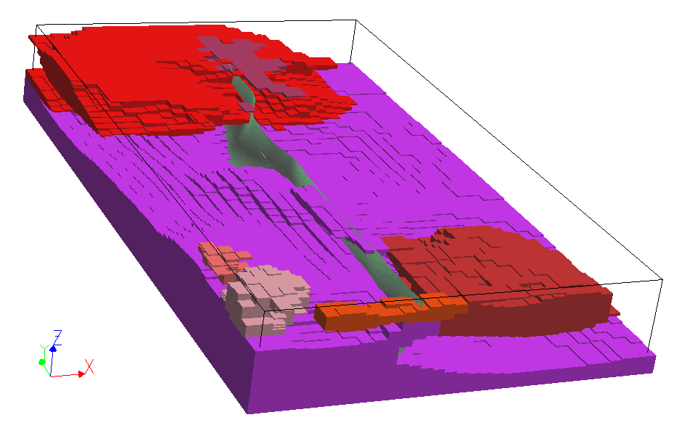
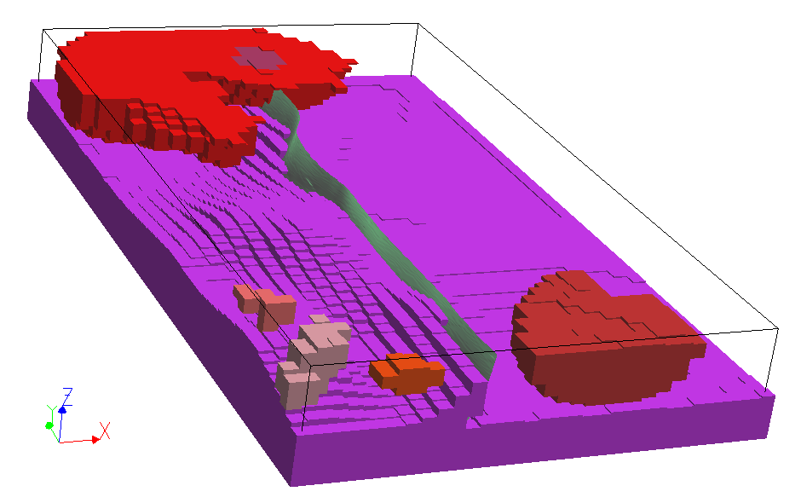
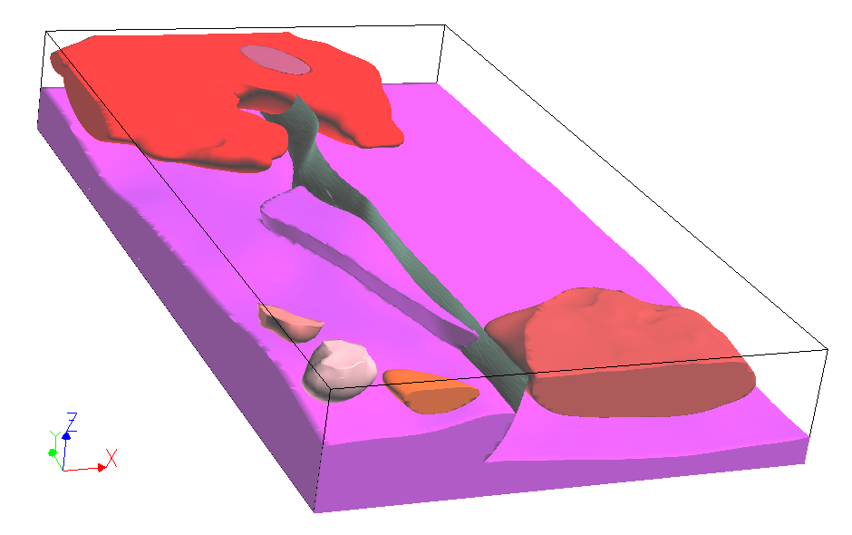
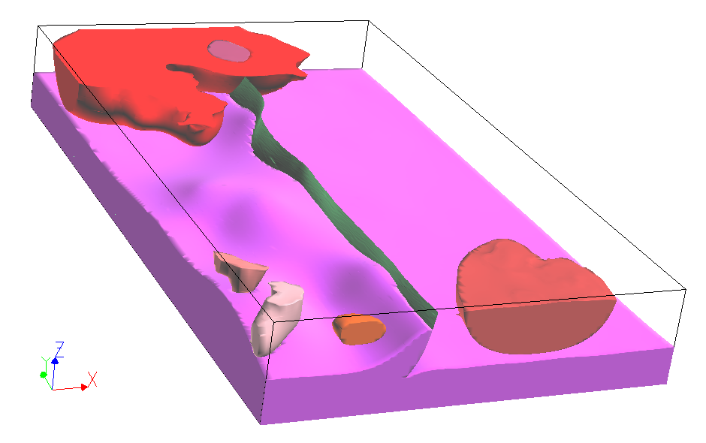
‘Most probable’ model from inversion study
Initial model as voxels … ready for inversion
Initial model, meta- sediments removed
Improved model after inversion study

- Inversion of the Bet Bet 3D geology model. The initial 3D GeoModeller model (top-left) is voxelised ready for inversion (top-right). The ‘most probable’ model (lower-right) is an outcome derived from a statistical analysis of large numbers of equally likely geologic models. Insights derived from this inversion solution led were incorporated into an improved geologic model (lower-left). Model dimensions are 33km x 57km x 8km.

Recent and Planned Developments
The computational advances that have been achieved in the last year include development of a process model with a formal schema for forward and inverse geophysical computation, implementation of support for full tensor gradiometry, and improved voxel-based statistical reporting/presentation of inversion results.

A cluster-computer approach is planned as the next phase to increase the computational capacity of the method. Finer discretisation of the geologic model will be required to represent more complex and realistic geology problems, which will result in an increase in the total number of voxels by an order of magnitude or more. The additional processing capacity of clustered computing systems will allow a user to generate a solution for such tasks within an acceptable timeframe.

References
Bosch M., Guillen A. and Ledru P., 2001, Lithologic tomography: an application to geophysical data from the Cadomian belt of Northern Brittany, France: Tectonophysics, 331, 197-228.

Calcagno Ph., Courrioux G., Guillen A., Fitzgerald D., McInerney P. 2006 How 3D implicit Geometric Modelling Helps To Understand Geology. The 3DGeoModeller Methodology. International Society for Mathematical Geology, XIth International Congress, Université de Liège – Belgium.

Lajaunie Ch., Courrioux G., Manuel L. 1997, Foliation fields and 3D cartography in geology: principles of a method based on potential interpolation. Mathematical Geology, 29, 571-584.

Mosegaard K., and Tarantola A., 1995, Monte Carlo sampling of solutions to inverse problems: J. Geophys. Res., 100, No. B7, 124321-12447.

Acknowledgements
The principal author of the Bet Bet inversion study was R. Lane (Geoscience Australia). Contributors to the development of the Bet Bet geology model included John Wilford (CRC LEME, Geoscience Australia), Fiona Watford (Geoscience Australia) and David Moore (GeoScience Victoria).

The development and commercialisation of the 3D GeoModeller Software and Inversion is a collaborative project between Intrepid Geophysics and BRGM, with support from the Commonwealth and State geological agencies of Australia, Geological Survey of Namibia, Geological Survey of Canada, Barrick Gold Corporation, and Shell Exploration and Production.

The commercialisation project was also proudly supported by International Science Linkages established under the Australian Government’s innovation statement, Backing Australia's Ability.

