1 No Tests 2
2 PriorOnly – Tune the Commonality Parameter 6
2.1 Nonsense Geology Models? 11
3 PriorOnly – Tune the ShapeRatio Parameter 13

GeoModeller Geophysics Workshops – February-March 2009
The exercises associated with this document are in Directory “L_TUNING_GeologyTests”

No Tests
PriorOnly cases are enabled by switching off any geophysics tests, leaving only geology tests.
But if we then individually turn off all geology tests (e.g. Preserve Vertical Relationships (PVR), Commonality, Shape Ratio and Volume Ratio), we have a situation where no tests are performed. The basic process of selecting a voxel on a boundary at random and proposing to change the geology (+ physical properties), or selecting a voxel at random and proposing to change the physical properties continues to operate. However since there are no tests; no asking “is this a valid geology model?”, then all proposed changes are accepted. The result is a rapid deterioration from the Reference (geology) Model to a state of random distribution of geology voxels with highly convoluted boundary arrangements.

Training Example Tutorial SLAB_Project
Create a new Case …, turn off all ‘geology tests’ and untoggle “geophysical misfit tests”
- A_20_CaseA_NoTests_CreateNewCase.bat
Three Runs … will generate different results …
- A_21_CaseA_NoTests_Run1_Inversion.bat
- A_21_CaseA_NoTests_Run2_Inversion.bat
- A_21_CaseA_NoTests_Run3_Inversion.bat

And then generate reports so that we can examine the outcomes …

- A_30_CaseA_NoTests_MakeEvolutionMovie.bat
Play the movies (EvolutionMovie_CaseA_NoTests_Run1…, etc.). Some snaps from the Run1 movie are shown in Figure 1. Note that the movies – and Figure 1 – show the geology on Section 500N for individual models. Of the 100,000 models generated, the movies show 1 in every 500.

- A_31_CaseA_NoTests_MakeSuperSummaryStats.bat
The above ‘statistics’ are used to make the following products …

- A_32_CaseA_NoTests_MakeSectionImage.bat
The section images – showing the ‘Probability of Slab (Formation)’ for Section 500N are shown in Figure 2. These images are a statistical report, derived from many models (5000 through to 100,000).
- A_33_CaseA_NoTests_MakeSectionMovie.bat
Play the movies (SectionSweepMovie_CaseA_NoTests_Run1…, etc.). These movies are very similar to the above section; they report the same statistical data, derived from many models. But, whereas the above is just one section (Section 500N), the movie is a series of sections that sweep across the model from south to north (there are 21 sections shown in the movie, sweeping from 0N to 1000N).

RESULT With no tests being performed at all – no asking “is this a valid geology model?” – the model rapidly deteriorates to random nonsense. After just 10,000 iterations (Figure 1) the geology model is quite meaningless.

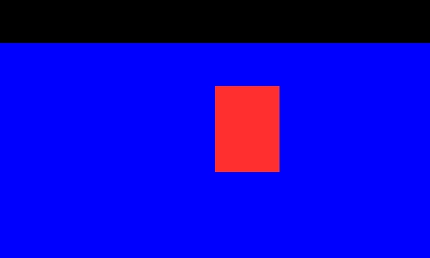
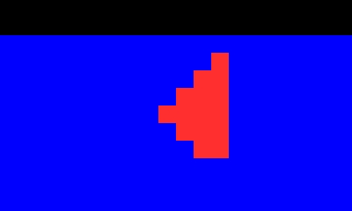

1000
1

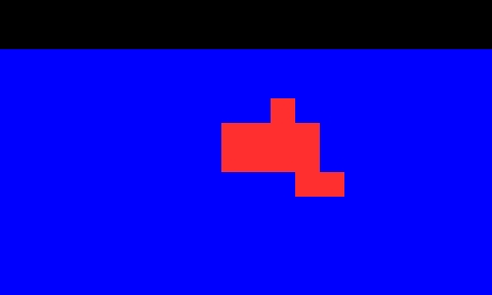
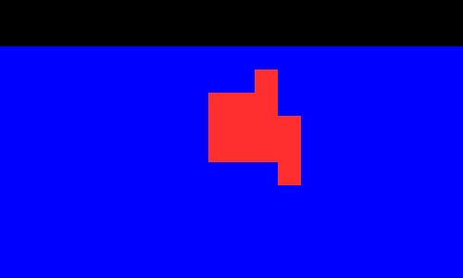

5000
2000
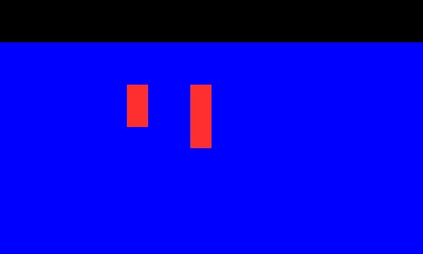
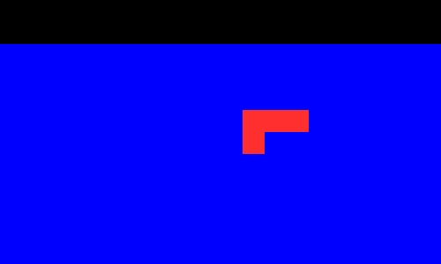

15000
10000

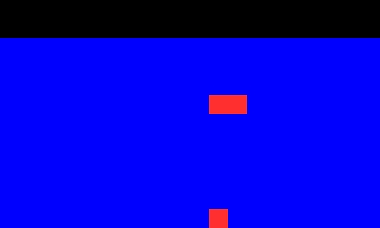
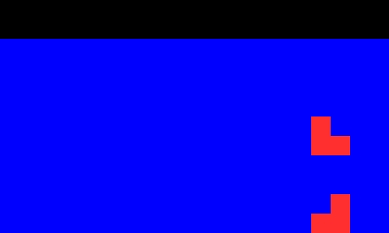

25000
20000

- Images of Lithology on Section 500N for selected models generated in Run 1 for the ‘No Tests’ case. Host is blue, Slab is red. The eight individual models were those that existed at the iteration-number shown. Observe that the geology model rapidly deteriorates to random nonsense after only a few iterations. The box shows the location of the Reference Model.

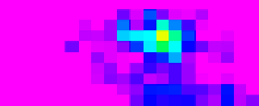

Run 1
Run 1


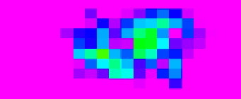

Run 2
Run 2

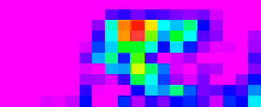

Run 3
Run 3

- Images of ‘Probability of Slab’ geology on Section 500N for three different Runs of the ‘No Tests’ case. On the left are three JPGs as created by the MakeSectionImage command. On the right the same data using the ERS files (also created by MakeSectionImage) and displayed in Intrepid Visual using the same linear rainbow colour stretch for the three images (Range: 0% to 50% ‘probability of Slab’). Statistics derived from models 5,000 to 100,000. The box shows the location of the Reference Model.

PriorOnly – Tune the Commonality Parameter
PriorOnly 1 and AllowCommonalityTest 1
In a nutshell: Do three or four Runs with different parameter values for the Commonality property. Start with higher values of the scale parameter (see below) and progress to lower values so that the appropriate value is bracketed (e.g., from lambda=1 to lambda=0.01). There will some extreme high or low values that are clearly undesirable, and an intermediate range within which any value would be acceptable.

For the Commonality property of geology formations we use a Weibull distribution. The Weibull distribution has two parameters ... Weibull(λ, κ)
- 1st - λ - a scale parameter - needs to be tuned for each inversion job
- 2nd - κ - a shape parameter - we always use 1.0
(For κ=1.0, Weibull reduces to an exponential probability distribution)

If, for some geology formation, we were reasonably confident in our initial model then we might wish to specify that the inversion retains, say, an 80% overlap – or commonality - with that formation's voxels in the initial model ...
- for this, use λ=0.25 (see graph in Reference Manual)

For more confidence in my initial model ... more Commonality with initial voxels
- use a smaller value of λ (e.g. 90% overlap or commonality ... use λ=0.1)

For less confidence in my initial model ... less Commonality with initial voxels
- use a larger value of λ (e.g. 70% overlap or commonality ... use λ=0.5)
In Run_1 use λ=0.02 - a tight constraint on geology
... allows little change away from the initial model
In Run_2 use λ=0.2 - a looser constraint on the geology
... allows more change away from the initial model
In Run_3 use λ=2.0 - very little constraint on the geology
... allows almost any change away from initial model
In tuning the λ parameter for your project, try test cases that are too high and too low. It is recommended that you produce additional Runs as required until you have solutions that ‘bracket’ your chosen solution – i.e. you have a result demonstrating your considered choice of λ, and two alternative results that demonstrate the ‘too constrained’ (λ too low) and the too un-constrained (λ too high) cases.
This tuning process need not be too pedantic. It is really a matter of making a choice of λ which is OK to within an order of magnitude … we do not need to do a ‘fine tuning’!
BATCH SCRIPTS
Create a new Case … and set PriorOnly 1 … and turn on the Commonality test (AllowCommonalityTest 1) …
- B_20_CaseB_PriorOnly_TuneComm_CreateNewCase.bat
Three Runs, with the scale parameter (λ) of the Commonality set to 0.02, 0.2 and 2.0 respectively.
- B_21_CaseB_PriorOnly_TuneComm_Run1_0p02_100K_Inversion.bat
- B_21_CaseB_PriorOnly_TuneComm_Run2_0p2_100K_Inversion.bat
- B_21_CaseB_PriorOnly_TuneComm_Run3_2p0_100K_Inversion.bat

And then generate reports so that we can examine the outcomes …

- B_30_CaseB_PriorOnly_TuneComm_MakeEvolutionMovie.bat
Play the movies (EvolutionMovie_CaseB_PriorOnly_TuneComm_Run1…, etc.). Some snaps from the Run1 movie are shown in Figure 3. Note that the movies – and Figure 3 – show the geology on Section 500N for individual models. Of the 100,000 models generated, the movies show 1 in every 250.
RESULT The results presented in Figure 3 are very demonstrative of this tuning process. The Commonality property for the Slab geology will only influence any changes to voxels that are ‘Slab’ geology in the Reference Model – so - for the moment – focus only the small rectangular box representing the Slab geology in the Reference Model (marked in Figure 3 … but try to imagine it in the movies). If we do that, we clearly see three different results for the three settings of the λ parameter.
- For λ=0.02 a consistently high degree of ‘overlap’ or commonality with the Reference Model is maintained … perhaps 95 - 98%, say
- At the other end of the scale is the Run 3 result for λ=2.0 … and the commonality with the Reference Model is very low – less than 10%, say.
- Run 2 (λ=0.2) maintains a modest degree of commonality … perhaps 30 – 50%

Now generate the statistics for models 5000 through to 100,000 …
- B_31_CaseB_PriorOnly_TuneComm_MakeSuperSummaryStats.bat

- B_32_CaseB_PriorOnly_TuneComm_MakeSectionImage.bat
The section images – showing the ‘Probability of Slab (Formation)’ for Section 500N are shown in Figure 4. These images are a statistical report, derived from many models. Note that Figure 4 also shows results from the ‘C’ series of operations (see below) which were identical except that 1 million iterations were generated.
The colour plots are presented with identical colour range; pink = 0% probability, through to red = 100% probability (of Slab). If the statistics of the ERMapper grids are examined, the peak probabilities for the three Runs are: 97% for the λ=0.02, 60-70% for λ=0.2, and 33% for λ=2.0. The greyscale plots are comparable – but the colour plots highlight the differences more clearly?
Essentially these plots also demonstrate the higher degree of commonality maintained for λ=0.02, and the considerably lesser commonality for the other two Runs.
- B_33_CaseB_PriorOnly_TuneComm_MakeSectionMovie.bat
Play the movies (SectionSweepMovie_CaseB_PriorOnly_TuneComm_Run1…, etc.). These movies – like the greyscale section-images above – show the same outcome, but with less clarity that the other plots.

ADDITIONAL BATCH SCRIPTS
The following batch scripts execute identical tasks, except that 1 million iterations are produced.
- C_21_CaseB_PriorOnly_TuneComm_Run4_0p02_1M_Inversion.bat
- C_21_CaseB_PriorOnly_TuneComm_Run5_0p2_1M_Inversion.bat
- C_21_CaseB_PriorOnly_TuneComm_Run6_2p0_1M_Inversion.bat

These batch scripts report the results. Since these deal with 1 million iterations, a couple of the reporting commands use slightly different parameters.
- C_30_CaseB_PriorOnly_TuneComm_MakeEvolutionMovie.bat
The movies show similar results to those plotted in Figure 3; … just more of the same!
- C_31_CaseB_PriorOnly_TuneComm_MakeSuperSummaryStats.bat
- C_32_CaseB_PriorOnly_TuneComm_MakeSectionImage.bat
The section images are shown in Figure 4; the results are statistically ‘cleaner’, and the boundaries between zones of higher probability and lower probability (for the λ=0.02 and λ=0.2 Runs) are sharper.
- C_33_CaseB_PriorOnly_TuneComm_MakeSectionMovie.bat

CONCLUDING REMARK re TUNING the COMMONALITY
The choice of this commonality scale parameter (λ) needs to be guided by the behaviours demonstrated in these movies and section-images … and by our confidence in the geology model that we have constructed. For this Slab geology model, a value for λ somewhere around 0.2 should be OK. If we have some nagging doubts about the reliability of the Reference Model – we may not want to be too tightly constrained to that model … and could increase λ a little. In the inversion processing examples for this Slab model a value λ=0.5 was used … allowing a little more scope for the inversion geology to more away from the Reference Model.

Do I really need to look at the movies? They’re a bit ‘gimmicky’ … don’t you think?
The images generated by MakeSectionImage present a result derived from all models … and are thus an average of many models. These single images (from different Runs) should present results from which I can make choices about the choice of parameters.
The importance of the movies is that they show (a selection of) actual, individual geology models that did exist during the Run … and the acceptable choice of settings should also be clear from individual frames captured in an EvolutionMovie. Remember that each and every model generated must be acceptable as a viable geological configuration. We cannot rely on statistics to mask this requirement. The average of junk is junk.

Run 1 λ=0.02
Run 2 λ=0.2
Run 3 λ=2.0

1
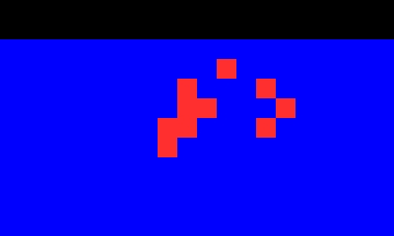
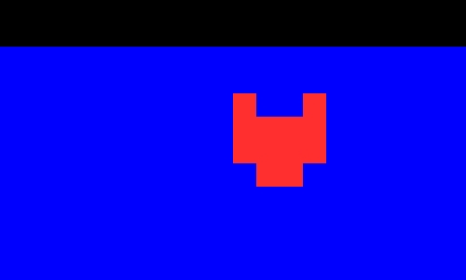
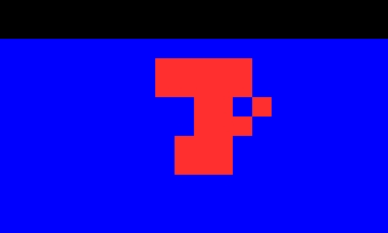

6250
6250
6250
50000
25000
75000
12500
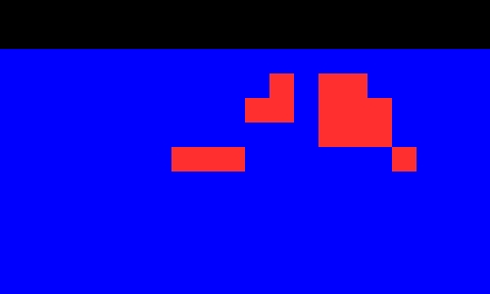
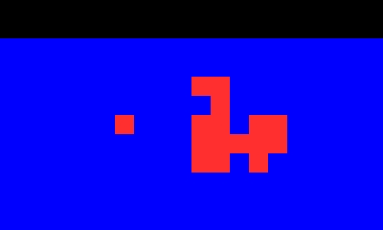
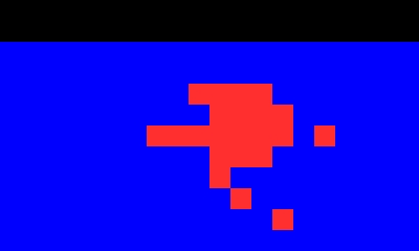

12500
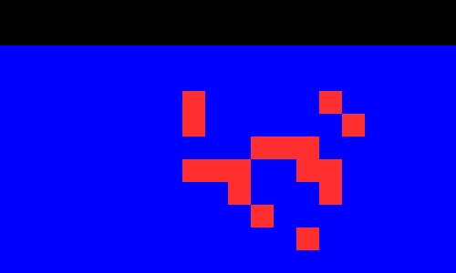
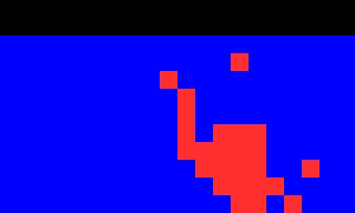
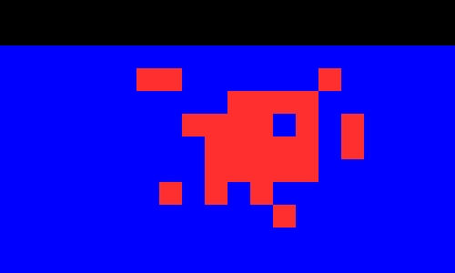

25000
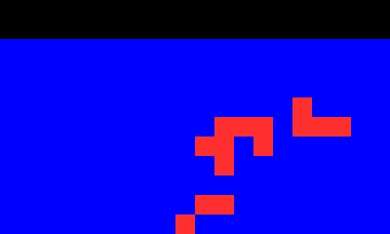
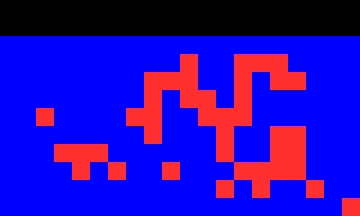
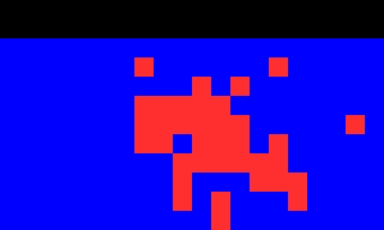

50000


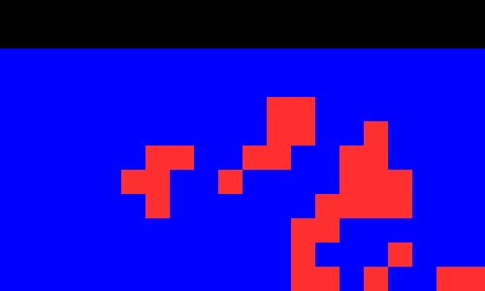
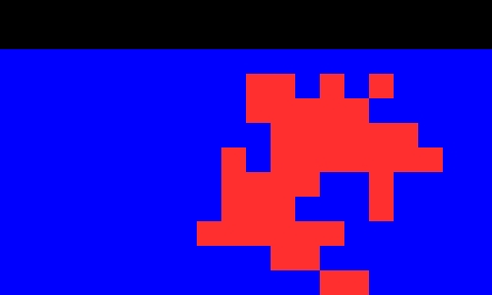

75000
50000
25000
75000
12500

- Images of Lithology on Section 500N for selected models generated in Run 1 (λ=0.02), Run 2 (λ=0.2) and Run 3 (λ=2.0) for the ‘Tune Commonality’ case. Host is blue, Slab is red. The fifteen individual models were those that existed at the iteration-number shown (for the respective Run). The box shows the location of the Reference Model. Observe the degree of overlap (or commonality with the Reference Model) that is maintained for the three values of λ - a high degree of commonality for the λ=0.02 Run, but very little commonality constraint for the λ=2.0 Run.


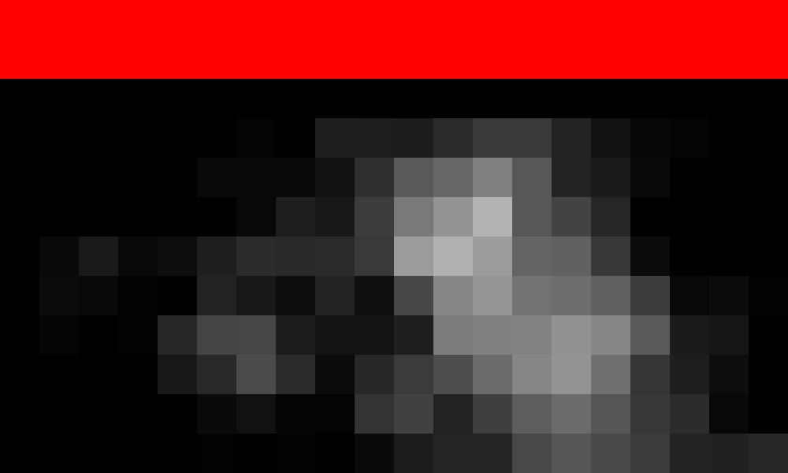

Runs 1 & 4 λ=0.02
Runs 2 & 5 λ=0.2
Runs 3 & 6 λ=2.0

Run 1




Run 4
Run 5
Run 6
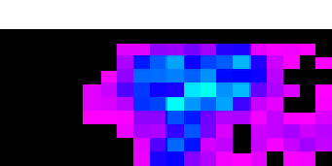
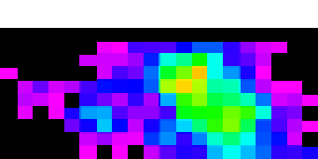
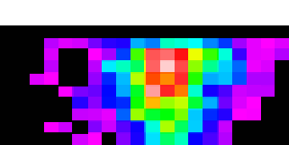

Run 1
Run 6
Run 3
Run 3
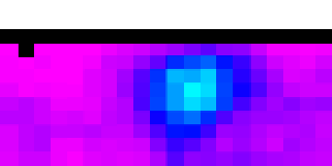
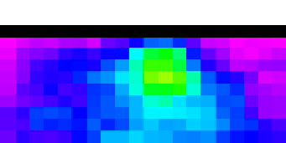
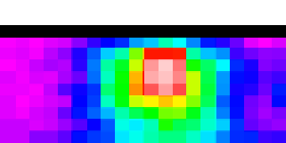

Run 4
Run 5
Run 2
Run 2

- Images of ‘Probability of Slab’ geology on Section 500N generated in Runs 1 & 4 (λ=0.02), Runs 2 & 5 (λ=0.2) and Run 3 & 6 (λ=2.0) for the ‘Tune Commonality’ case. At the top are JPG images as created by the MakeSectionImage command. At the bottom the same data using the ERS files (also created by MakeSectionImage) and displayed in Intrepid Visual using the same linear rainbow colour stretch for the six images (Range: 0% to 100% ‘Probability of Slab’). Statistics derived from models 5,000 to 100,000 for Runs 1, 2 & 3, and derived from models 5,000 to 1,000,000 for Runs 4, 5 & 6. The box shows the location of the Reference Model. Observe the degree of overlap (or commonality with the Reference Model) that is maintained for the three values of λ - a high degree of commonality for the λ=0.02 Runs, but very little commonality constraint for the λ=2.0 Runs. Note also the relatively noisier data from those Runs with 100,000 iterations compared to the statistically smoother results where 1,000,000 iterations were used.
PMM Note: Strictly the batch scripts need to be revised – to gather the statistics after a longer ‘burn-in’ phase – because the starting configuration is not representative of what eventuates. Eventually, λ=1.0 or higher should produce low probability (of Slab) almost everywhere. The images above (for λ=2.0) show a higher probability at the original location of the Slab in the Reference Model because a large number of ‘early models’ have been included in the statistics.

Nonsense Geology Models?
We noted above that a high degree of commonality was maintained with the Reference Model (for λ=0.02, and acceptable commonality for λ=0.2). How can that be? … surely these models shown in Figure 5 are nonsense geology models? … these look nothing like our Reference Model!

50000
75000
50000
75000
Run 1 λ=0.02
Run 2 λ=0.2

- Images of Lithology on Section 500N for selected models generated in Run 1 (λ=0.02) and Run 2 (λ=0.2). (Extracted from Figure 3). Surely these models of the Slab geology are garbage?
Three comments …
- Yes … these models (shown in Figure 5) are nonsense! But we will shortly be turning on the ShapeRatio geology test. These models have many voxels of Slab geology randomly spreading out into areas that were Host geology in the Reference Model. The impact of this is that the shape ratio for the Slab geology would be significantly higher in these geology models – compared to what it was in the Reference Model. (Shape ratio is the ratio of square root of Formation surface to the cube root of Formation volume).
With the ShapeRatio test we will specify a constraint on the allowed variation of the Slab’s shape ratio – and this will limit the tendency towards randomly distributed voxels of Slab geology. It will tend to maintain the Slab geology as a more coherent geology body.

- The considerable discussion with reference to Figure 3 above was entirely about the Commonality property for the Slab geology formation. The setting of that property – for the Slab geology – only has an influence on those (relatively few) voxels that were Slab geology in the Reference Model. The Commonality property for Slab exerts no control over those many voxels of the Reference Model that were Host geology!

- OK … but we also set the same Commonality property for the Host geology. Check the batch scripts …
B_21_CaseB_PriorOnly_TuneComm_Run1_0p02_100K_Inversion.bat has the following:
call %DoTask% %CaseXML% CaseControl SetLaw ^
Slab Commonality Weibull(0.02,1.0) ^
Host Commonality Weibull(0.02,1.0)
Why has this setting for the Host allowed so many voxels of Slab geology to now replace voxels that were Host in the Reference Model?
The reason is that Host has something like 30x as many voxels as Slab … and it is quite easy - with this many voxels to work with – for the Host geology to maintain a very high degree of Commonality with the Reference Model – but at the same time allow what appears to be a large number of voxels of other geology formations to occur at voxels that were Host in the Reference Model.
We do not recommend the following … but you could demonstrate this point with the following experiment. Try the same batch scripts … but set the Host’s λ parameter to a much more tightly constraining value … try λ=0.0002
See D_21_CaseB_PriorOnly_TuneComm_Run7_EXPERIMENT_100K_Inversion.bat …
call %DoTask% %CaseXML% CaseControl SetLaw ^
Slab Commonality Weibull(0.2,1.0) ^
Host Commonality Weibull(0.0002,1.0)

EXPERIMENTAL BATCH SCRIPTS
Compare the EvolutionMovies and the Section-Images for these ‘D’ series of scripts with the corresponding ones from the ‘C’ series.

- D_21_CaseB_PriorOnly_TuneComm_Run7_EXPERIMENT_100K_Inversion.bat
- D_21_CaseB_PriorOnly_TuneComm_Run8_EXPERIMENT_100K_Inversion.bat
- D_30_CaseB_PriorOnly_TuneComm_MakeEvolutionMovie.bat
- D_31_CaseB_PriorOnly_TuneComm_MakeSuperSummaryStats.bat
- D_32_CaseB_PriorOnly_TuneComm_MakeSectionImage.bat

PriorOnly – Tune the ShapeRatio Parameter
PriorOnly 1 and AllowCommonalityTest 1 and AllowShapeRatioTest 1
In a nutshell: Do three or four Runs with different parameter values for the ShapeRatio property. Start with higher values of the spread measure (= std. dev.) parameter (see below) and progress to lower values. Typically start with spread measure = 0.20 (i.e. maintain ShapeRatio within 20%). For the Slab Project a value of 0.05 yielded acceptable results.

For the ShapeRatio property of geology formations always use a Log-normal distribution. The Log-normal distribution has two parameters ... Log-normal(mean, std. dev.)
Note: Strictly speaking the terms ‘mean’ and ‘standard deviation’ apply to normal distributions and are not correct for a log-normal distribution. A more generalised terminology would be …
Log-normal(central measure, spread measure)
- 1st parameter - central measure (= mean) - typically close to 0.0
- 2nd parameter – spread measure (=std. dev.) - needs to be tuned for each inversion job

Following notes ‘pasted in’ here; these are somewhat ‘colloquial’ notes that should be reviewed.

Shape is defined as the dimensionless number square_root (boundary_counts) / cube_root (volume_counts) where "boundary_counts" is the number of faces of voxels occupied by a particular formation that are in contact with voxels of another formation. Note that the RunControl parameter settings IncludeAboveTopoFacesInShapeRatio and IncludeOutsideFacesInShapeRatio control whether voxels in contact through a face to a voxel of the AboveTopo lithology or voxel faces forming part of the outside of the mesh contribute to the boundary_count. "volume_counts" is the number of voxels occupied by the particular formation.
ShapeRatio is the ratio of the Shape of the present model divided by the Shape of the same formation in the reference model.

For ShapeRatio always use Log-normal distribution.
If we want a ‘shape’ to be the same as the ‘shape’ in a Reference Model … the ratio for this case is 1. Although we use a log-normal distribution, we enter the ‘arithmetic ratio value 1’ for the central measure and an arithmetic standard deviation for the spread measure.
ShapeRatio Log-normal(central measure, spread measure)
Central Measure (Mean) … the first parameter
The first parameter in setting the shape-ratio is the ‘mean’ … a mean of ‘1’ is basically saying - maintain the initial (reference) shape ratio.
One is tempted to write "always use mean = 1" … but this is not strictly correct.
A very likely case is that my Reference Model is a slightly simplified, smoother model (‘smoother’ and thus pushing the ‘shape-ratio’ down to a relatively lower value). In practice, the evolving voxel-model of the inversion really must have some nooks and crannies and edges and protuberances and holes (i.e. tendency towards a higher shape-ratio) – and in the real geology world also the likelihood is that geology reality will also have these same ‘rough’ characteristics compared to an idealised, smooth Reference Model.

Thus … the ShapeRatio ‘mean’ could usefully be set to, say, 1.20 - meaning "I expect that the geology is actually rougher than my idealised starting model" … rougher to the tune of 20% higher shape-ratio. Specifying this mean will actually push the evolving (inversion) model away from the reference shape-ratio, and towards a rougher model.
But note also … you could set the ‘mean’ to be 0.80 … meaning I want to force the model in the direction of becoming smoother than my starting model. It is not easy to visualise a case where you might choose to do this, but one possible example: Imagine you choose a voxel model from some point along the progress of a previous inversion Run, and chose to use that (probably ‘rough’) model as the Reference (starting) Model for a new inversion Run. You might say “this is a suitable Reference Model … but it’s a bit rough … I want a result that is smoother than this!” If you specify, say, ‘mean’ is 0.8 you are saying “I want the result to have a ShapeRatio that is about 20% smoother than in my Reference Model”

Spread Measure (Standard Deviation) … the second parameter
This is the parameter that should be tuned by doing a small series of PriorOnly Runs.
Start with a value which is too large: say, 0.2 (=allow 20% variation of ShapeRatio away from the Reference). This will allow the changing geology model to change significantly away from the ‘shape’ defined in the Reference Model.
Do a series of Runs using progressively lower values for the spread measure. For the Slab Project a value of 0.05 is good - representing "allow 5% variation of ShapeRatio"
If I chose 0.01 – I’d probably have too many rejections; many of the proposed changes that are put up for consideration would be knocked out by this tight criterion to maintain a ShapeRatio closely aligned with the reference model.
On the other hand, 0.2 (= allow 20% variation) is pretty much saying ‘allow anything’. In fact, a very large spread measure for the ShapeRatio starts to emulate the PriorOnly No-Tests case (which is essentially to allow ‘infinite’ variation of shape-ratio).


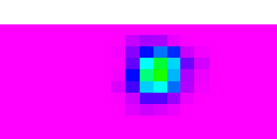
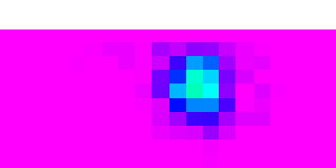
Runs 2 & 5 λ=0.2
Run 5
Run 2
With λ=0.5
ShapeRatio SD 0.20
With λ=0.5
ShapeRatio SD 0.10

With λ=0.5
ShapeRatio SD 0.05

0.20
0.10
0.05

- Images of ‘Probability of Slab’ geology on Section 500N. Upper two images from the ‘Tuning Commonality’ Runs 2 & 5 (λ=0.2) and ShapeRatio testing ‘turned off’. Lower three images from ‘Tuning ShapeRatio’, using three different values for the ‘spread measure’ of the ShapeRatio log-normal distribution. Turning ‘on’ the ShapeRatio test produces a much more constrained set of ‘new’ geology models. All images from the ERS files (created by MakeSectionImage) and displayed in Intrepid Visual using the same linear rainbow colour stretch for the five images (Range: 0% to 100% ‘Probability of Slab’). The box shows the location of the Reference Model.

