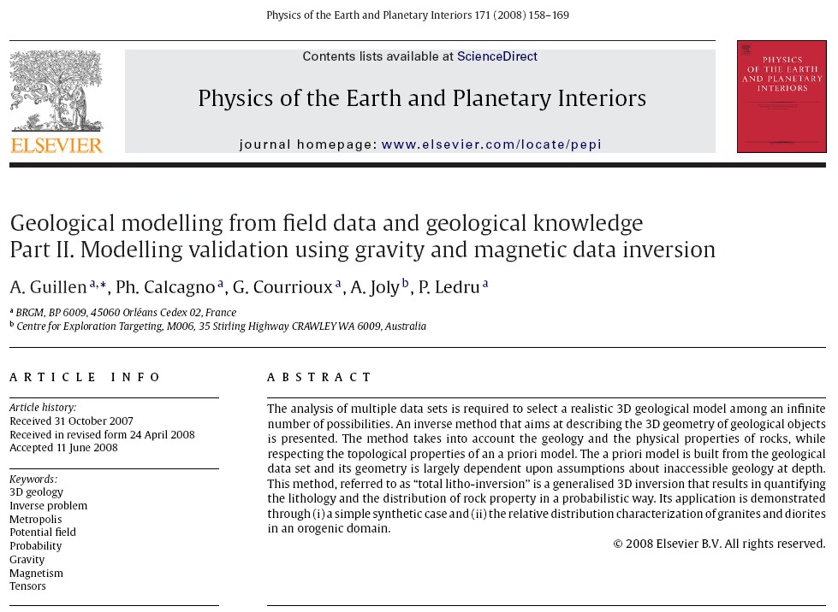
Notes on Topology Operators from …

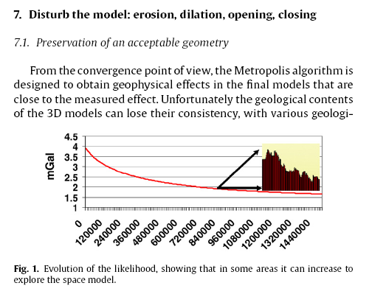

… then add Pages 162-164 from the original paper …

