**GRP04 Low-Fi User Test & Iteration**

**Team Name:** Just in Time Development (JITD)

**Team Members:** Ianto Xi, Tatiana Ferreyra, David Ju, Josef Nunez

**Roles:** Ianto drafted the script that was used to interview the participants.Ianto, Tatiana, and Josef each met with a participant and conducted one of three interviews individually, and completed a preliminary report of the interview. David summarized the information from all three reports to produce the final assignment write-up that is to be turned in, making sure the write-up complied with the length limitations as noted in the assignment specs.

**Project Summary**

The goal of our app is to help travelers who are traveling to different time zones combat the effects of jet lag by generating a personalized sleep schedule integrated with optional sleep strategies for them to follow, which will help them adjust to their destination’s local time upon arrival.

**Method**

The first participant is a 24 year old male graduate of engineering who often travels between New York and San Francisco, as well as occasionally to Melbourne. He expressed difficulty dealing with jet lag when traveling to Melbourne, although he has no trouble with jet lag when traveling between New York and San Francisco. The second participant is a 23 year old female graduate of molecular and cellular biology who is a seasoned traveler and plans to travel all over Europe in the future. She noted that she already has experience in using sleep applications in trying to adjust her natural sleep schedule. The third participant is a 58 year old female who often travels to Europe for vacation and travels to the Philippines to visit family. She has no experience in using sleep applications to help combat the effects of jet lag.

The participants in this experiment were selected by choosing friends or family members of group members who were frequent travelers and were available to be interviewed. Ianto, Tatiana, and Josef were able to find participants that fit the criteria, and given the time constraints of this assignment, only the team member associated with each interviewee was able to conduct the interview with their participant, having to simultaneously take on the roles of the greeter, computer, facilitator, and observer. All three interviews were conducted in each participant’s homes so that they would be in an environment they are familiar and comfortable in. To set up our application prototype, the Balsamiq sketches of our app interfaces were loaded onto a smartphone, and the smartphone was held against the participant’s wrist to simulate a smartwatch. The interviewer would then manually load the appropriate image on the phone in response to the actions of the participant. All interviews closely followed a script that was drafted by Ianto, and the script had the participants perform an easy, moderate, and difficult task to expose potential flaws in our design and areas that could use improvement. Participants were given the prototype without any explanation so that interviewers could observe how intuitive the app seemed to be for the participants, and the interview script was only interrupted when the participants had questions to ask or needed clarification to accomplish a task.

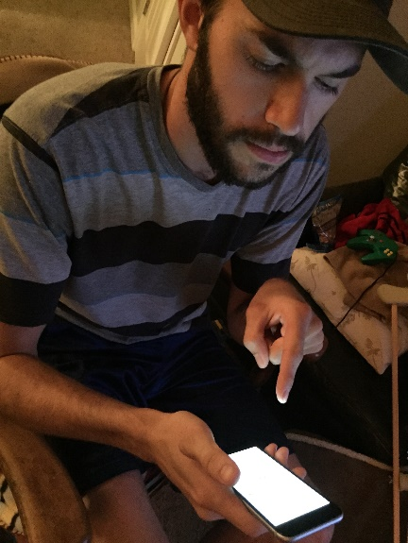

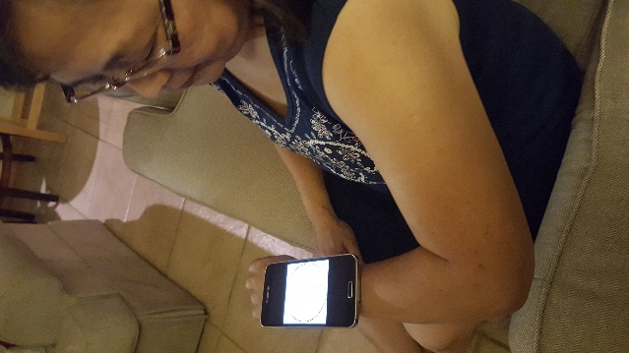

Participant 2

Participant 1

Participant 3

**Results**

The incident that was most problematic for all three of our participants was how they all found our graphical interface for the suggested sleep plan to be too confusing and struggled interpreting what different elements of the graph meant. Both participants 1 and 3 mentioned that they could successfully interpret the graph for the suggested sleep plan if there were more labels to explain the interface, but the graph alone was not intuitive enough the way it is currently. In addition, participant 3 felt that the graph could use some simplification, as she felt it was too unnecessarily detailed, and suggested an option for users to view their sleep schedule without a graphical interface.

Another common incident that all three participants ran into was in regards to our app screen where users could select optional sleep strategies to integrate into their sleep plan, such as taking melatonin or controlling their exposure to light. Participant 1 was skeptical about the sleep strategies, and wanted more information about the strategies to understand how they worked before deciding to dedicate himself to one. Participant 2 felt that it would be useful to provide the option for users to select alternatives to melatonin, such as sleep aids like ZzzQuil or SleepyTime tea, since some people may be especially tolerant to melatonin and will not benefit from consuming it. Participant 3, who did not want to try any additional sleep strategies, identified a flaw in our app design that currently forces the user to select at least one of the two sleep strategies before being able to proceed to the next screen.

Finally, two of our participants had suggestions for the sleep strategy evaluation section of our app. Although participant 1 found the evaluations easy to use, he personally would not make use of them if he were to use our application. Participant 3 pointed out that the app’s log of past evaluation reviews may be confusing to less experienced travelers since it currently uses airport codes (such as SFO and JFK) to represent locations, and it would be more clear if we explicitly wrote out the current and destination cities on the reviews instead.

**Discussion**

It is obvious from our interviews that the graphical interface for the suggested sleep plan needs to be revamped to make it more intuitive to users, or provide users with a very thorough overview of the graph upon first use so that they can learn to interpret it. Because the interface for the suggested sleep plan is the heart of our app and all three of our participants found it confusing, we assign this problem a severity rating of 5, since it has proven to be a major usability issue that must be resolved. As participant 3 suggested, we may implement a non-graphical interface of the suggested sleep plan for users to prefer a purely textual interface.

For the interface which allows users to select sleep strategies, a fix needs to be made to make clear that the sleep strategies are completely optional, and that users can proceed with the app without having to select any sleep strategy at all. As we learned from participant 1, providing users with access to more information about the sleep strategies is beneficial if they want to educate themselves and learn how the strategies work. We may or may not allow users the option to substitute sleep aids as an alternate to melatonin, as participant 2 suggested, pending research into how similar the effects of sleep aid and melatonin are to each other. For all the problems related to the sleep strategies, we assign a severity rating of 3, since they are all minor usability problems that can easily be taken care of.

We will also make our notification system more flexible by allowing users to specify the frequency of notifications and adjust how early they want notifications for different events to start appearing, especially since participant 1 and 3 both liked the idea of having discreet, persistent notifications throughout the day to remind them of their sleep schedule. We assign the problems related to notifications a severity rating of 4, since the notifications are a key feature to our app, and improving the flexibility of our notification system is key to produce a great user experience.

The main thing our experiments could not reveal was the effectiveness of our suggested sleep schedule, since participants did not have the opportunity to actually make use of the application. Because we only have one chance left to test our application with a high fidelity prototype, careful research needs to be put into our app to ensure that the sleep schedules we are suggesting to our users are the most optimal.

**Interview Script**

1. Hello! We are group of UC Berkeley students developing an application aimed to help travelers avoid jet lag. Today, we're going to ask you to help us evaluate a rough prototype of our application.

2. Your life will not be affected in anyway outside of this evaluation and you are free to leave any time you would like.

3. Right now, we only have rough images of what the basic functionality of the application will be like. The final product will include elements of this prototype but will visually be very different.

4. First, we'll demo a really simple task on the application so that you understand how the prototype works. We will simply select that we are going to be using flight data to calculate our time zone differences. [Do so]

5. Now pretend like you are flying on flight HK203 on August 30, and try to set up a sleep schedule that will help you not be jet lagged when you arrive in Hong Kong.

6. Examine the different strategies available and tell me what you think it is saying. Which strategies appeal to you and why? Which would you select?

7. Next, examine the sleep plan provided, and tell me what you think it is saying.

8. Next, let us pretend that you are trying to implement this strategy, with this watch here. What do you think of these reminders? Do you think that you are likely to forget any of these tasks without reminders? How else would you try to remember? What other strategies have you tried?

9. Next, try evaluating your sleep plan.