Ch 2 : Credit ggplot

Kiran Khanderao

April 25, 2019

# knitr::opts_chunk$set(echo = TRUE)  
  
## R Markdown  
#This is an R Markdown document.  
library(ggplot2)

## Warning: package 'ggplot2' was built under R version 3.5.3

library(readxl)

## Warning: package 'readxl' was built under R version 3.5.3

#install.packages("xlsx")  
#getwd()  
##.......Chapter 2.....Credit Data ggplot........##  
rm(credit_ds)

## Warning in rm(credit_ds): object 'credit_ds' not found

credit_ds <- read_excel("credit.xlsx")  
summary(credit_ds)

## Creditability Account_Balance Duration_Credit_Months Payment_Status   
## Min. :0.000 Min. :1.000 Min. : 6.00 Min. :0.000   
## 1st Qu.:1.000 1st Qu.:1.000 1st Qu.:12.00 1st Qu.:2.000   
## Median :1.000 Median :2.000 Median :18.00 Median :4.000   
## Mean :0.955 Mean :2.649 Mean :19.61 Mean :3.117   
## 3rd Qu.:1.000 3rd Qu.:4.000 3rd Qu.:24.00 3rd Qu.:4.000   
## Max. :1.000 Max. :4.000 Max. :48.00 Max. :4.000   
## Purpose Credit_Amount Value_Savings_Stocks  
## Min. : 0.000 Min. : 385 Min. :1.000   
## 1st Qu.: 0.000 1st Qu.: 1448 1st Qu.:1.000   
## Median : 2.000 Median : 2241 Median :1.000   
## Mean : 2.486 Mean : 2763 Mean :2.198   
## 3rd Qu.: 3.000 3rd Qu.: 3576 3rd Qu.:4.000   
## Max. :10.000 Max. :10875 Max. :5.000   
## Length_of_Current_Employment Instalment_pct Gender_Marital_Status  
## Min. :1.000 Min. :1.000 Min. :1.000   
## 1st Qu.:3.000 1st Qu.:2.000 1st Qu.:2.000   
## Median :3.000 Median :4.000 Median :3.000   
## Mean :3.541 Mean :2.937 Mean :2.748   
## 3rd Qu.:5.000 3rd Qu.:4.000 3rd Qu.:3.000   
## Max. :5.000 Max. :4.000 Max. :4.000   
## Guarantors Duration_at_Current_Address Most_Valuable_Asset  
## Min. :1.000 Min. :1.000 Min. :1.000   
## 1st Qu.:1.000 1st Qu.:2.000 1st Qu.:1.000   
## Median :1.000 Median :3.000 Median :2.000   
## Mean :1.081 Mean :2.829 Mean :2.099   
## 3rd Qu.:1.000 3rd Qu.:4.000 3rd Qu.:3.000   
## Max. :3.000 Max. :4.000 Max. :4.000   
## Age Concurrent_Credits Type_of_Apartment  
## Min. :21.00 Min. :1.000 Min. :1.000   
## 1st Qu.:29.00 1st Qu.:3.000 1st Qu.:2.000   
## Median :36.00 Median :3.000 Median :2.000   
## Mean :37.19 Mean :2.892 Mean :1.865   
## 3rd Qu.:41.50 3rd Qu.:3.000 3rd Qu.:2.000   
## Max. :65.00 Max. :3.000 Max. :3.000   
## No_of_Credits_To_Bank Occupation Dependents Telephone   
## Min. :1.000 Min. :1.000 Min. :1.000 Min. :1.000   
## 1st Qu.:1.000 1st Qu.:3.000 1st Qu.:1.000 1st Qu.:1.000   
## Median :1.000 Median :3.000 Median :1.000 Median :1.000   
## Mean :1.459 Mean :2.838 Mean :1.153 Mean :1.459   
## 3rd Qu.:2.000 3rd Qu.:3.000 3rd Qu.:1.000 3rd Qu.:2.000   
## Max. :4.000 Max. :4.000 Max. :2.000 Max. :2.000   
## Foreign_Worker   
## Min. :1.000   
## 1st Qu.:1.000   
## Median :1.000   
## Mean :1.054   
## 3rd Qu.:1.000   
## Max. :2.000

str(credit_ds)

## Classes 'tbl_df', 'tbl' and 'data.frame': 111 obs. of 21 variables:  
## $ Creditability : num 1 1 1 1 1 1 1 1 1 1 ...  
## $ Account_Balance : num 1 1 2 1 1 1 1 1 4 2 ...  
## $ Duration_Credit_Months : num 18 9 12 12 12 10 8 6 18 24 ...  
## $ Payment_Status : num 4 4 2 4 4 4 4 4 4 2 ...  
## $ Purpose : num 2 0 9 0 0 0 0 0 3 3 ...  
## $ Credit_Amount : num 1049 2799 841 2122 2171 ...  
## $ Value_Savings_Stocks : num 1 1 2 1 1 1 1 1 1 3 ...  
## $ Length_of_Current_Employment: num 2 3 4 3 3 2 4 2 1 1 ...  
## $ Instalment_pct : num 4 2 2 3 4 1 1 2 4 1 ...  
## $ Gender_Marital_Status : num 2 3 2 3 3 3 3 3 2 2 ...  
## $ Guarantors : num 1 1 1 1 1 1 1 1 1 1 ...  
## $ Duration_at_Current_Address : num 4 2 4 2 4 3 4 4 4 4 ...  
## $ Most_Valuable_Asset : num 2 1 1 1 2 1 1 1 3 4 ...  
## $ Age : num 21 36 23 39 38 48 39 40 65 23 ...  
## $ Concurrent_Credits : num 3 3 3 3 1 3 3 3 3 3 ...  
## $ Type_of_Apartment : num 1 1 1 1 2 1 2 2 2 1 ...  
## $ No_of_Credits_To_Bank : num 1 2 1 2 2 2 2 1 2 1 ...  
## $ Occupation : num 3 3 2 2 2 2 2 2 1 1 ...  
## $ Dependents : num 1 2 1 2 1 2 1 2 1 1 ...  
## $ Telephone : num 1 1 1 1 1 1 1 1 1 1 ...  
## $ Foreign_Worker : num 1 1 1 2 2 2 2 2 1 1 ...

## GGplot  
ggplot(credit_ds, aes(x = Age, y = Credit_Amount)) +geom_point()

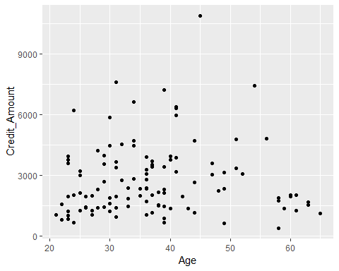

ggplot(credit_ds, aes(x = Age, y = Credit_Amount)) +geom_point(color="blue")

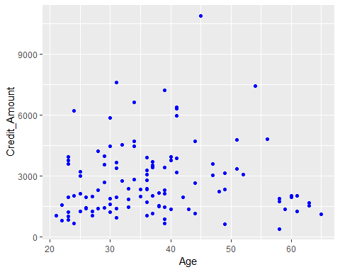

ggplot(credit_ds, aes(Age,Credit_Amount))+geom_point(color="purple")

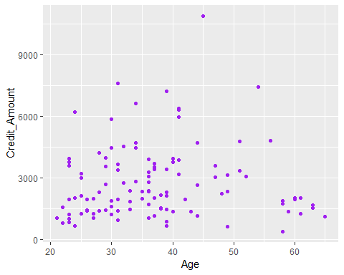

# something wrong in the plot ....  
  
ggplot(credit_ds, aes(Age)) +geom_histogram()

## `stat_bin()` using `bins = 30`. Pick better value with `binwidth`.

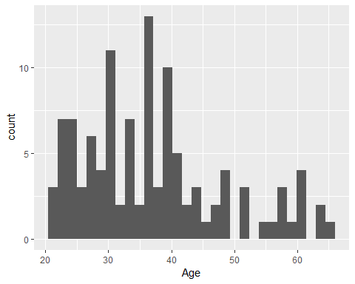

ggplot(credit_ds, aes(Age,Credit_Amount)) + geom_boxplot()

## Warning: Continuous x aesthetic -- did you forget aes(group=...)?

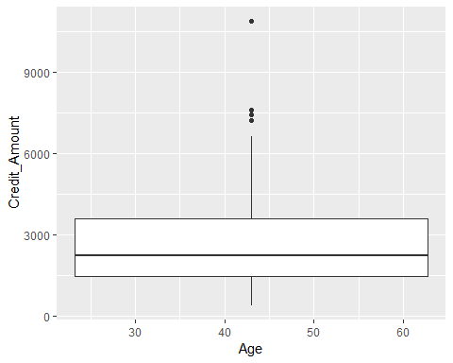

# Heart_Attack_Diagnosis = Age  
# Serum_Credit_Amountesterol = Credit_Amount   
  
## `stat_bin()` using `bins = 30`. Pick better value with `binwidth`.  
ggplot(credit_ds,aes(Age))+geom_bar(colour="Green ")

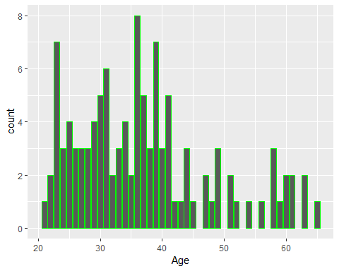

# Additional aesthetical componenets like color,shape can be added.   
# Color added to depict 1: Absence 2: Presence of heart risk   
ggplot(credit_ds, aes(Age,Credit_Amount,colour=Age))+geom_point()

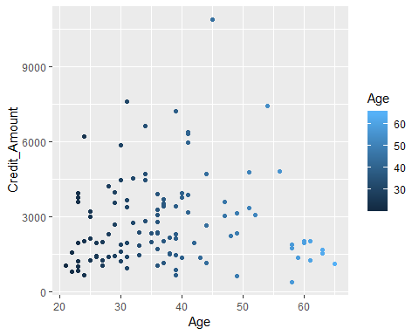

#Facetting used to replicate the display for the two groups:  
# 1 Absence of Risk 2 Presence of Risk   
ggplot(credit_ds,aes(Account_Balance,Credit_Amount))+geom_point(color="green")+facet_wrap(~Creditability)

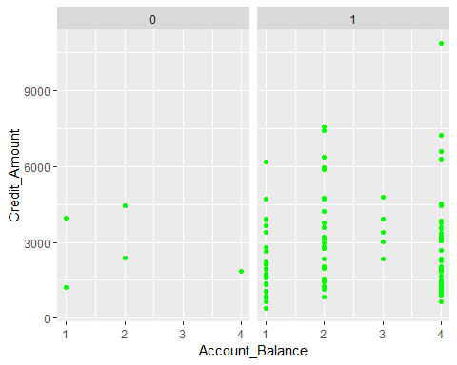

# Adding another layer,a smoother over the Age-Credit_Amountesterol plot   
ggplot(credit_ds,aes(Age, Credit_Amount))+geom_point(colour="brown")+geom_smooth()

## `geom_smooth()` using method = 'loess' and formula 'y ~ x'

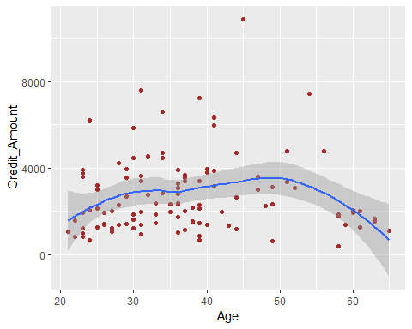

#`geom_smooth()` using method = 'loess' and formula 'y ~ x'  
  
  
# Span parameter helps overlay a fitted curve on the scatterplot using the de fualt loess method and then linear model.  
# Possibly overfitted.   
ggplot(credit_ds,aes(Age,Credit_Amount))+geom_point(colour="red")+geom_smooth(span=0.15)

## `geom_smooth()` using method = 'loess' and formula 'y ~ x'

## Warning in simpleLoess(y, x, w, span, degree = degree, parametric =  
## parametric, : pseudoinverse used at 37

## Warning in simpleLoess(y, x, w, span, degree = degree, parametric =  
## parametric, : neighborhood radius 1

## Warning in simpleLoess(y, x, w, span, degree = degree, parametric =  
## parametric, : reciprocal condition number 0

## Warning in predLoess(object$y, object$x, newx = if  
## (is.null(newdata)) object$x else if (is.data.frame(newdata))  
## as.matrix(model.frame(delete.response(terms(object)), : pseudoinverse used  
## at 37

## Warning in predLoess(object$y, object$x, newx = if  
## (is.null(newdata)) object$x else if (is.data.frame(newdata))  
## as.matrix(model.frame(delete.response(terms(object)), : neighborhood radius  
## 1

## Warning in predLoess(object$y, object$x, newx = if  
## (is.null(newdata)) object$x else if (is.data.frame(newdata))  
## as.matrix(model.frame(delete.response(terms(object)), : reciprocal  
## condition number 0

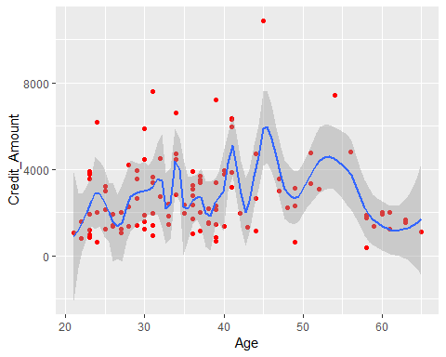

## `geomsmooth()` using method = 'loess' and formula 'y ~ x'  
  
ggplot(credit_ds,aes(Age,Credit_Amount))+geom_point(colour="red")+geom_smooth(span=1.25)

## `geom_smooth()` using method = 'loess' and formula 'y ~ x'

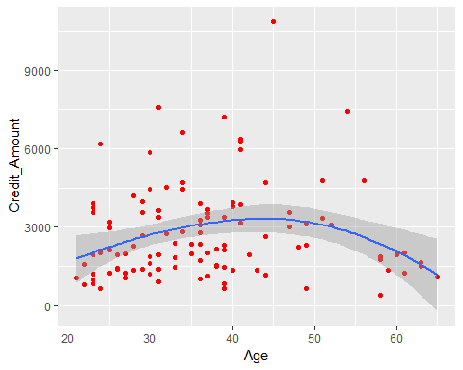

## `geom_smooth()` using method = 'loess' and formula 'y ~ x'  
  
ggplot(credit_ds,aes(Age,Credit_Amount))+geom_point(colour="purple")+geom_smooth(method="lm")

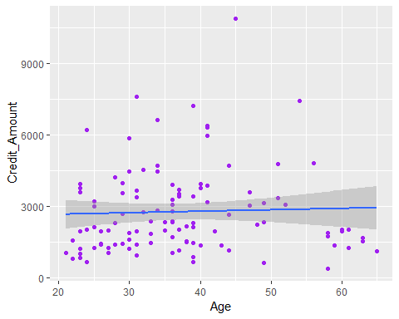

#Facetting used to replicate the display for the two groups:  
# 1 Absence of Risk 2 Presence of Risk   
ggplot(credit_ds,aes(Credit_Amount,colour=Age))+geom_freqpoly(binwidth=1)

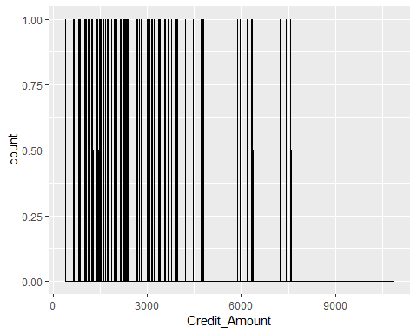

ggplot(credit_ds,aes(Credit_Amount,colour=Age))+geom_histogram(binwidth=.9)+facet_wrap(~Age,ncol=1)

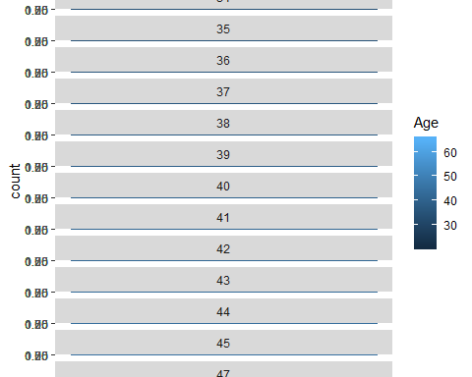

# Error: StatBin requires a continuous x variable: the x variable is discrete. Perhaps you want stat="count"?  
# Sum up the answer from the comments above:  
# 1 - Replace geom_histogram(binwidth=0.5) with geom_bar(). However this way will not allow binwidth customization.  
# 2 - Using stat_count(width = 0.5) instead of geom_bar() or geom_histogram(binwidth = 0.5) would solve it.  
  
  
# ---------------------  
# ggplot(credit_ds,aes(Credit_Amount,colour="Yellow"))+geom_bar()  
# ggplot(credit_ds,aes(Credit_Amount,colour=Age))+stat_count(width = # 0.5)+facet_wrap(~Creditability,ncol=2)