**Advanced Software Project Management**

**Research Methodology**

**Final Assessment**

**Name:** Nawal Butt

**SAP:** 12984

**Submitted to**: Ali irfan

**Department:**  FC

**Riphah International University Islamabad**

**Describe pros and cons of dedicated, virtual, part-time or partnership teams and complement which team composition you have used in your project?**

**Dedicated Teams:-**

Dedicated teams are put together to work on projects in a project organizational structure. Dedicated Team is a business model where a client and outsource provider mutually agree on the workload and project requirements for the specified amount of time.

**Pros:-**

* The dedicated team is 100% focused on one project.
* Cost Efficiency
* Transparent Management
* Absolute authority towards selecting, motivation, and management of dedicated team members.

**Cons:-**

* Time-Consuming
* Not suitable for short-term projects.
* **Time zones and culture gaps.**

**Virtual Teams:-**

A Virtual Team – also known as a Geographically Dispersed Team (GDT) – is a group of individuals who work across time, space, and organizational boundaries with links strengthened by webs of communication technology.

**Pros:-**

* Cost effective.
* **You have access to a larger pool of talent.**
* **It leads to higher productivity**
* **Higher scalability**

**Cons:-**

* lack of team collaboration.
* **Time zones and culture gaps.**
* **Managing a remote team can be a challenge**

**Part-time Teams:-**

Some projects are assigned to a team as an additional temporary work, with the rest of the organization's members carrying out their regular functions.

**Pros:-**

* Flexible Workforce

**Cons:-**

* Employees Viewed as Less Committed
* Part-time workers, especially those that work more seasonally, may have less knowledge.
* Lack of Familiarity with the Workplace

**Partnership Teams:-**

**Partnership teams** are cooperative relationship between people or groups who agree to share responsibility for achieving some specific goal.

**Pros:-**

* [Access to a wider range of expertise](https://www.americanexpress.com/us/small-business/openforum/articles/should-i-build-or-acquire-expertise/)
* Allow you to share the financial burden
* Increased Employee Morale

**Cons:-**

* Loss of Autonomy
* Lack of Stability
* Less independence
* Inflexible

My team was “Partnership Team” as me along with my partner had made our FYP which was a requirement for passing out as a Graduate Student. We partnered and make “Online Notice Board Project” and we distributed all expenses among us.

**Q2) Extract/define activities from the WBS along dependency determination, duration and lead/lag (if any).**

|  |  |  |  |  |
| --- | --- | --- | --- | --- |
| **Activity No.** | **Activity** | **Dependency** | **Duration** | **Lead/ Lag** |
| **A** | Create Add Course interface | - | 3 Days | 0 |
| **B** | Create Update Course Interface | - | 3 Days | 0 |
| **C** | Create View Course Interface | - | 3 Days | 0 |
| **D** | Create Reset Password Form | - | 3 Days | 0 |
| **E** | Create View Notice Button | C | 2 Days | 0 |
| **F** | Create Delete Course Button | A | 2 Days | 0 |
| **G** | Create Update Course Button | B | 2 Days | 0 |
| **H** | Add Course information TextBox | A | 2 Days | 0 |
| **I** | Enable Add Course Content TextBox | H | 2 Days | -1 |
| **J** | Create a Database Connection | - | 3 Days | 0 |
| **K** | Create a Temporary Token Table | J | 2 Days | 0 |
| **L** | The system requests the user to provide email for reset password. | D | 4 Days | 0 |
| **M** | Get the user details from the database to reset password. | L | 2 Days | +1 |
| **N** | If the user information is found in the database, then the user will be allowed to enter new password. | M | 1 Day | 0 |
| **O** | Reset password script will be executed. | N | 1 Day | 0 |
| **P** | Password will be reset | O | 1 Day | 0 |
| **Q** | System checks for new notices from the database. | E | 2 Days | 0 |
| **R** | All previous notices are fetched from database | Q | 2 Days | 0 |
| **S** | If there are new notices on the server, system will also fetch all those notices. | R | 2 Day | 0 |
| **T** | Course will be deleted from database when delete course button is clicked | F | 2 Days | -1 |
| **U** | System will allow the user to make changes in Course | B | 2 Days | 0 |
| **V** | Course will be Updated in database | U | 1 Day | 0 |
| **W** | System saves the updated course information | V | 1 Day | 0 |
| **X** | A confirmation message will be sent | W | 2 Days | 0 |
| **Y** | SYSTEM DISPLAYS CONFIRMATION MESSAGE | X | 2 Days | 0 |

**Draw project network schedule diagram and determine the critical path.**

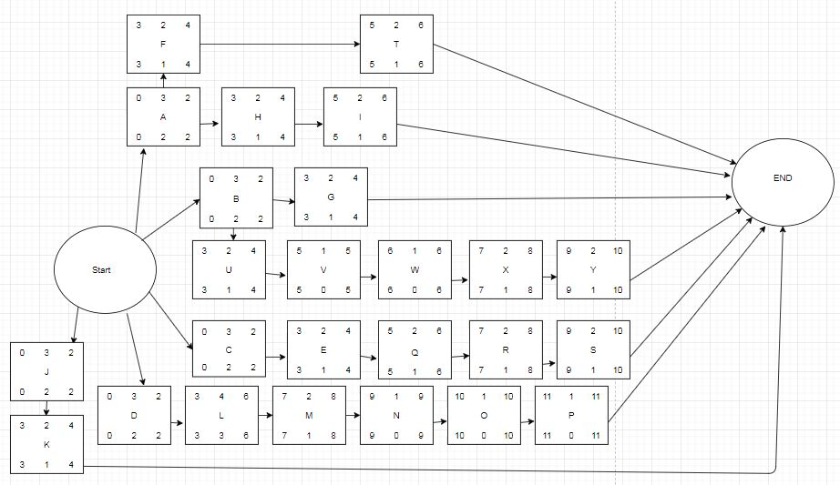

**Critical Path is:- D – L – M – N – O – P= 12.**

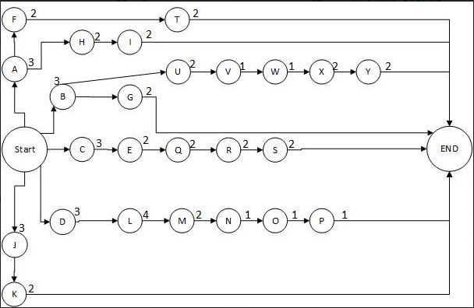

**Calculate and mention the possible float/slack against all activities in project network schedule diagram.**

|  |  |  |  |  |  |  |
| --- | --- | --- | --- | --- | --- | --- |
| **Activity** | **Duration** | **ES** | **EF** | **LS** | **LF** | **Float/ Slack** |
| **A** | 3 Days | 0 | 2 | 0 | 2 | 2 |
| **B** | 3 Days | 0 | 2 | 0 | 2 | 2 |
| **C** | 3 Days | 0 | 2 | 0 | 2 | 2 |
| **D** | 3 Days | 0 | 2 | 3 | 4 | 2 |
| **E** | 2 Days | 3 | 4 | 3 | 4 | 1 |
| **F** | 2 Days | 3 | 4 | 3 | 4 | 1 |
| **G** | 2 Days | 3 | 4 | 3 | 4 | 1 |
| **H** | 2 Days | 3 | 4 | 3 | 4 | 1 |
| **I** | 2 Days | 5 | 6 | 5 | 6 | 1 |
| **J** | 3 Days | 0 | 2 | 0 | 2 | 1 |
| **K** | 2 Days | 3 | 4 | 3 | 4 | 1 |
| **L** | 4 Days | 3 | 6 | 3 | 6 | 3 |
| **M** | 2 Days | 7 | 7 | 7 | 8 | 1 |
| **N** | 1 Day | 0 | 9 | 9 | 9 | 0 |
| **O** | 1 Day | 10 | 10 | 10 | 10 | 0 |
| **P** | 1 Day | 11 | 11 | 11 | 11 | 0 |
| **R** | 2 Days | 7 | 8 | 7 | 8 | 1 |
| **S** | 2 Days | 9 | 10 | 9 | 10 | 1 |
| **T** | 2 Day | 5 | 6 | 5 | 6 | 1 |
| **U** | 2 Days | 3 | 4 | 3 | 4 | 1 |
| **V** | 2 Days | 5 | 6 | 5 | 5 | 0 |
| **W** | 1 Day | 6 | 6 | 6 | 6 | 0 |
| **X** | 1 Day | 7 | 8 | 7 | 8 | 1 |
| **Y** | 2 Days | 9 | 10 | 9 | 10 | 1 |

**Create RACI matrix against the activities you have defined in Q#2.**

|  |  |  |  |  |  |  |
| --- | --- | --- | --- | --- | --- | --- |
| **Activities** | **Project Owner** | **Developer** | **Database Administer** | **Sponsor** | **Stakeholder** | **Supervisor** |
| **Create Add Course interface** | **A** | **R** | **-** | **I** | **I** | **C** |
| **Create Update Course Interface** | **A** | **R** | **-** | **I** | **I** | **C** |
| **Create View Course Interface** | **A** | **R** | **-** | **I** | **I** | **C** |
| **Create Reset Password Form** | **A** | **R** | **-** | **I** | **I** | **C** |
| **Create View Notice Button** | **A** | **R** | **-** | **I** | **I** | **C** |
| **Create Delete Course Button** | **A** | **R** | **-** | **I** | **I** | **C** |
| **Create Update Course Button** | **A** | **R** | **-** | **I** | **I** | **C** |
| **Add Course information TextBox** | **A** | **R** | **-** | **I** | **I** | **C** |
| **Enable Add Course Content TextBox** | **A** | **-** | **R** | **I** | **I** | **C** |
| **Create a Database Connection** | **A** | **-** | **R** | **I** | **I** | **C** |
| **Create a Temporary Token Table** | **A** | **-** | **R** | **I** | **I** | **C** |
| **The system requests the user to provide email for reset password.** | **A** | **-** | **R** | **I** | **I** | **C** |
| **Get the user details from the database to reset password.** | **A** | **-** | **R** | **I** | **I** | **C** |
| **If the user information is found in the database, then the user will be allowed to enter new password.** | **A** | **-** | **R** | **I** | **I** | **C** |
| **Reset password script will be executed.** | **A** | **-** | **R** | **I** | **I** | **C** |
| **Password will be reset** | **A** | **-** | **R** | **I** | **I** | **C** |
| **System checks for new notices from the database.** | **A** | **-** | **R** | **I** | **I** | **C** |
| **All previous notices are fetched from database** | **A** | **-** | **R** | **I** | **I** | **C** |
| **If there are new notices on the server, system will also fetch all those notices.** | **A** | **-** | **R** | **I** | **I** | **C** |
| **Course will be deleted from database when delete course button is clicked** | **A** | **-** | **R** | **I** | **I** | **C** |
| **System will allow the user to make changes in Course** | **A** | **R** | **-** | **I** | **I** | **C** |
| **Course will be Updated in database** | **A** | **-** | **R** | **I** | **I** | **C** |
| **System saves the updated course information** | **A** | **-** | **R** | **I** | **I** | **C** |
| **A confirmation message will be sent** | **A** | **R** | **-** | **I** | **I** | **C** |
| **SYSTEM DISPLAYS CONFIRMATION MESSAGE** | **A** | **R** | **-** | **I** | **I** | **C** |

**Create a comprehensive communication plan against your project.**

|  |  |  |  |  |  |  |  |
| --- | --- | --- | --- | --- | --- | --- | --- |
| **Communication Type** | **Objective of communication** | **Medium** | **Frequency** | **Audience** | **Owner** | **Deliverable** | **Format** |
| **Meeting with Supervisor** | To check work progress and to get insight that what is being done, by whom and when. | Face-to-Face and conference calls, Meeting | Weekly | Project Team | Project Manager | Agenda | Soft copy |
| **Project Team Meeting** | to gain a deeper understanding of project tasks, timing, and resource requirements | Meeting | Daily | Project Team | Project Manager | 1. Agenda  2.Meeting Minute | Soft copy |
| **Stakeholder Update** | To achieve a transparent decision-making process with greater input from stakeholders | Email Newsletter | Monthly | Stakeholders | Project Manager | Processes and schedules | Soft copy and hard copy |
| **Board Meeting** | to make decisions, set policy, solve problems and to plan and evaluate. | Meeting | Every two weeks | Project Board | Project Manager | Policies | Soft copy |
| **Kickoff Meeting** | to formally notify all team members, clients, and stakeholders that the project has begun and make sure everyone has a common understanding of the project and their roles | Face-to-Face and conference calls | Once | Project Team, Stakeholders | Project Manager | 1. Agenda  2.Meeting Minute | Soft copy |
| **Weekly status update** | Updates on critical project issues | E-Mail | Once a week | Project Team | Project Manager | Solutions | Soft copy |
| **Schedule updates** | to provide **updates**, deliver announcements, solicit feedback, share information |  | Weekly | Project Team | Project Manager | planning the steps necessary to meet objectives | Soft copy |
| **Project Review** | Present project deliverables | Meeting | At Milestones | Project team and sponsor | Project Manager | Bug fixes | Soft copy |