**기존 학습 그래프**

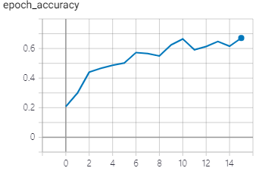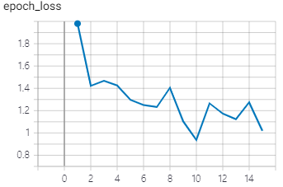

validation accuracy 0.6711 을 기록하고 epoch_loss가 불안정하게 하강하는 모습을 볼 수 있다.

**Hyperparameter Tuning 이후 그래프**

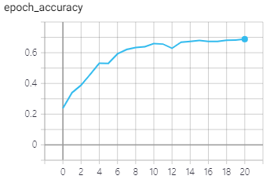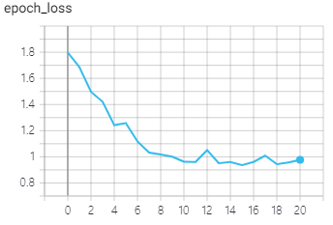

+validation accuracy 0.6883+ 을 기록하고 epoch_loss가 비교적 안정적으로 하강하는 모습이다.

깊이 2048의 합성곱 신경망 레이어를 추가하고 오버피팅을 방지하기 위해 이미지 배치 사이즈를 4로 조정, earlystopping을 민감하게 반응하도록 조정하여 학습 시간이 증가하였지만 오버피팅이 발생하지 않고 loss 그래프가 안정적으로 하강하였다.

**기존 모델의 예측 결과**

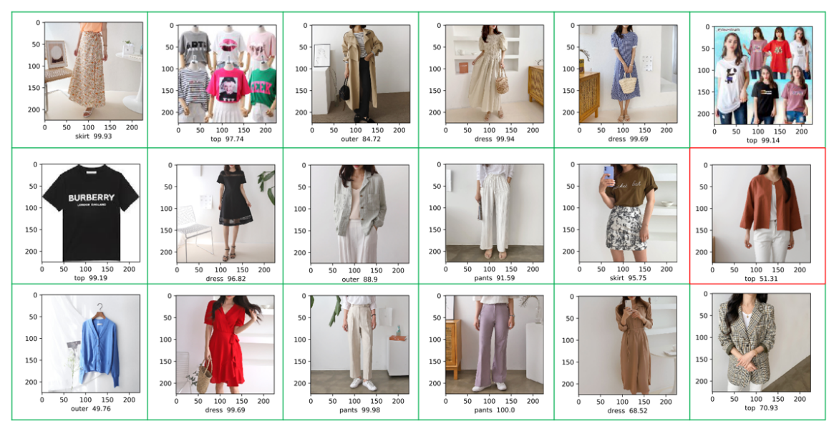

아우터를 top으로 인식하는 문제 발생

**Hyperparameter tuning 업데이트 된 모델의 예측 결과**

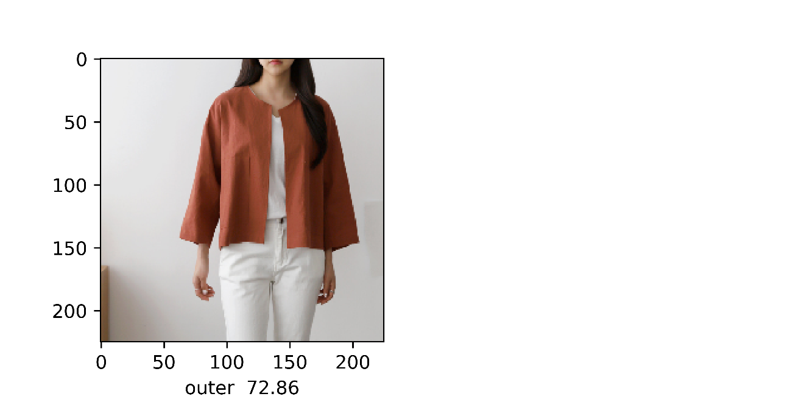

아우터 이미지를 정상적으로 인식

**해당 모델의 데모 API**

<http://121.140.112.233/>

**Model Layer 구성**

Model: "model"

__________________________________________________________________________________________________

Layer (type) Output Shape Param # Connected to

==================================================================================================

input_1 (InputLayer) [(None, 225, 225, 3) 0

__________________________________________________________________________________________________

sequential (Sequential) (None, 225, 225, 3) 0 input_1[0][0]

__________________________________________________________________________________________________

rescaling (Rescaling) (None, 225, 225, 3) 0 sequential[0][0]

__________________________________________________________________________________________________

conv2d (Conv2D) (None, 113, 113, 32) 896 rescaling[0][0]

__________________________________________________________________________________________________

batch_normalization (BatchNorma (None, 113, 113, 32) 128 conv2d[0][0]

__________________________________________________________________________________________________

activation (Activation) (None, 113, 113, 32) 0 batch_normalization[0][0]

__________________________________________________________________________________________________

conv2d_1 (Conv2D) (None, 113, 113, 64) 18496 activation[0][0]

__________________________________________________________________________________________________

batch_normalization_1 (BatchNor (None, 113, 113, 64) 256 conv2d_1[0][0]

__________________________________________________________________________________________________

activation_1 (Activation) (None, 113, 113, 64) 0 batch_normalization_1[0][0]

__________________________________________________________________________________________________

activation_2 (Activation) (None, 113, 113, 64) 0 activation_1[0][0]

__________________________________________________________________________________________________

separable_conv2d (SeparableConv (None, 113, 113, 128 8896 activation_2[0][0]

__________________________________________________________________________________________________

batch_normalization_2 (BatchNor (None, 113, 113, 128 512 separable_conv2d[0][0]

__________________________________________________________________________________________________

activation_3 (Activation) (None, 113, 113, 128 0 batch_normalization_2[0][0]

__________________________________________________________________________________________________

separable_conv2d_1 (SeparableCo (None, 113, 113, 128 17664 activation_3[0][0]

__________________________________________________________________________________________________

batch_normalization_3 (BatchNor (None, 113, 113, 128 512 separable_conv2d_1[0][0]

__________________________________________________________________________________________________

max_pooling2d (MaxPooling2D) (None, 57, 57, 128) 0 batch_normalization_3[0][0]

__________________________________________________________________________________________________

conv2d_2 (Conv2D) (None, 57, 57, 128) 8320 activation_1[0][0]

__________________________________________________________________________________________________

add (Add) (None, 57, 57, 128) 0 max_pooling2d[0][0]

conv2d_2[0][0]

__________________________________________________________________________________________________

activation_4 (Activation) (None, 57, 57, 128) 0 add[0][0]

__________________________________________________________________________________________________

separable_conv2d_2 (SeparableCo (None, 57, 57, 256) 34176 activation_4[0][0]

__________________________________________________________________________________________________

batch_normalization_4 (BatchNor (None, 57, 57, 256) 1024 separable_conv2d_2[0][0]

__________________________________________________________________________________________________

activation_5 (Activation) (None, 57, 57, 256) 0 batch_normalization_4[0][0]

__________________________________________________________________________________________________

separable_conv2d_3 (SeparableCo (None, 57, 57, 256) 68096 activation_5[0][0]

__________________________________________________________________________________________________

batch_normalization_5 (BatchNor (None, 57, 57, 256) 1024 separable_conv2d_3[0][0]

__________________________________________________________________________________________________

max_pooling2d_1 (MaxPooling2D) (None, 29, 29, 256) 0 batch_normalization_5[0][0]

__________________________________________________________________________________________________

conv2d_3 (Conv2D) (None, 29, 29, 256) 33024 add[0][0]

__________________________________________________________________________________________________

add_1 (Add) (None, 29, 29, 256) 0 max_pooling2d_1[0][0]

conv2d_3[0][0]

__________________________________________________________________________________________________

activation_6 (Activation) (None, 29, 29, 256) 0 add_1[0][0]

__________________________________________________________________________________________________

separable_conv2d_4 (SeparableCo (None, 29, 29, 512) 133888 activation_6[0][0]

__________________________________________________________________________________________________

batch_normalization_6 (BatchNor (None, 29, 29, 512) 2048 separable_conv2d_4[0][0]

__________________________________________________________________________________________________

activation_7 (Activation) (None, 29, 29, 512) 0 batch_normalization_6[0][0]

__________________________________________________________________________________________________

separable_conv2d_5 (SeparableCo (None, 29, 29, 512) 267264 activation_7[0][0]

__________________________________________________________________________________________________

batch_normalization_7 (BatchNor (None, 29, 29, 512) 2048 separable_conv2d_5[0][0]

__________________________________________________________________________________________________

max_pooling2d_2 (MaxPooling2D) (None, 15, 15, 512) 0 batch_normalization_7[0][0]

__________________________________________________________________________________________________

conv2d_4 (Conv2D) (None, 15, 15, 512) 131584 add_1[0][0]

__________________________________________________________________________________________________

add_2 (Add) (None, 15, 15, 512) 0 max_pooling2d_2[0][0]

conv2d_4[0][0]

__________________________________________________________________________________________________

activation_8 (Activation) (None, 15, 15, 512) 0 add_2[0][0]

__________________________________________________________________________________________________

separable_conv2d_6 (SeparableCo (None, 15, 15, 728) 378072 activation_8[0][0]

__________________________________________________________________________________________________

batch_normalization_8 (BatchNor (None, 15, 15, 728) 2912 separable_conv2d_6[0][0]

__________________________________________________________________________________________________

activation_9 (Activation) (None, 15, 15, 728) 0 batch_normalization_8[0][0]

__________________________________________________________________________________________________

separable_conv2d_7 (SeparableCo (None, 15, 15, 728) 537264 activation_9[0][0]

__________________________________________________________________________________________________

batch_normalization_9 (BatchNor (None, 15, 15, 728) 2912 separable_conv2d_7[0][0]

__________________________________________________________________________________________________

max_pooling2d_3 (MaxPooling2D) (None, 8, 8, 728) 0 batch_normalization_9[0][0]

__________________________________________________________________________________________________

conv2d_5 (Conv2D) (None, 8, 8, 728) 373464 add_2[0][0]

__________________________________________________________________________________________________

add_3 (Add) (None, 8, 8, 728) 0 max_pooling2d_3[0][0]

conv2d_5[0][0]

__________________________________________________________________________________________________

separable_conv2d_8 (SeparableCo (None, 8, 8, 1024) 753048 add_3[0][0]

__________________________________________________________________________________________________

batch_normalization_10 (BatchNo (None, 8, 8, 1024) 4096 separable_conv2d_8[0][0]

__________________________________________________________________________________________________

activation_10 (Activation) (None, 8, 8, 1024) 0 batch_normalization_10[0][0]

__________________________________________________________________________________________________

separable_conv2d_9 (SeparableCo (None, 8, 8, 2048) 2108416 activation_10[0][0]

__________________________________________________________________________________________________

batch_normalization_11 (BatchNo (None, 8, 8, 2048) 8192 separable_conv2d_9[0][0]

__________________________________________________________________________________________________

activation_11 (Activation) (None, 8, 8, 2048) 0 batch_normalization_11[0][0]

__________________________________________________________________________________________________

global_average_pooling2d (Globa (None, 2048) 0 activation_11[0][0]

__________________________________________________________________________________________________

dropout (Dropout) (None, 2048) 0 global_average_pooling2d[0][0]

__________________________________________________________________________________________________

dense (Dense) (None, 6) 12294 dropout[0][0]

==================================================================================================

Total params: 4,910,526

Trainable params: 4,897,694

Non-trainable params: 12,832

__________________________________________________________________________________________________