**PROFESSIONAL STADIUM ARE HELPFUL FOR THE COMMUNITY OR ARE THEY?**

Thursday, December 20th, 2018

Dionte Austin

Seyoum Settpani

University of Richmond

Richmond, Virginia 23173

**Table of Contents**

1. List of Participates who Helped
2. Abstraction
   1. What location?
   2. What help?
3. Level
   1. History background
4. Work plan
5. Final production
6. Work cited

**List of Participant**

* Project director
  + Dionte Austin
* Co- director
  + Seyoum Settpani
* Letter of support
  + Roger Goodell
    - Head of the National Football League
  + Jeff Spear
    - Built the Ravens Stadium
* Institutional affiliation
  + Washington University in St. Louis
  + Rice University
  + Cornell

**Abstract**

My partner Seyoum Settpani and I, Dionte Austin, will be looking into the effects of major league sports teams building stadiums into already established communities. We will prove that before the stadiums were built while the poverty line was at average, and the minorities were collaborated as collective group. Also, we will look at the population number in the part of city in which the stadium plans or currently resides. With many major league teams, they like to build the stadiums into the heart of the city, where there's a greater amount of people living at. That leaves many questionings what happens to those people. The results and choices of those currently residing citizens will also be displayed in our presentation. The main component we will use to present our information, is a website called social explorer. Social explorer allows you to view things before and after certain events have occurred.

**What location?**

We will look into cities that have been affected over time by a high rate of poverty, overpopulation, education system problems, and some form of family structure problem. By looking at those cities we will include the major league stadiums being built and prove that they are cause of the incline in social poverty of big-time cities. The locations of the big-time stadiums being studied include:

Green bay, WI - Lambeau Field

Jacksonville, FL - TIAA Bank Field

Charlotte, NC - Bank of America Stadium

Tampa Bay FL - Raymond Field

Phoenix, AZ - State Farm

Baltimore, MD - M&T Bank Stadium

Atlanta, GA - Mercedes Benz Stadium

Miami, FL - Hard Rock Stadium

**What help?**

After establishing the locations, we also want to find out reasons why these stadiums where built and why they were built in the location there currently are in. Was it because the new stadium runs on a new type of generator, so it saves power over the city? Does the new stadium make a city that is considered “dry” transform to become a tourist location? With the help of top architecture schools such as Washington University in St. Louis, Rice University, and Cornell University, these universities make an effort to help discover why CEO’s built the stadiums the way they did and what were they trying to accomplish. Lastly, one last important help we will get is the help from the National Football League owner, Roger Goodell, and specifically help from one famous team the Baltimore Ravens, developer Jeff Spear. We will talk about why they built it in that location and what where their thoughts behind building it. However, this is just one example of a source.

**Level**

The level of grant we want to use is level II which we will ask for anything between $50,000- $100,000 to help preform this project.

**History of gentrification in the United States**

When doing research for this project finding the definition of gentrification was one of harder aspect of the research portion of this project. The team Gentrification was made popular by Ruth Glass an english sociologist. She noticed members of the middle class were moving out of their districts and buying property in the older working class districts. This trend started to accord more frequently in the United States in 1970s. Gentrification is a tough subject because of the fact that there are major successful cities that have been transformed to what they are today, like Tokyo and Amsterdam. However  when gentrification is used in the united states it is often another term for “reverse white fight” and “African American displacers”. In many cities outside the United States Gentrification came to rundown factories and poor industrial eras where their was not much in it. Gentrification has Almost taken place in every major city in the United States. In the 1880s Boston families started to move out of Beacon Hill to renovate and sell deteriorated colonial townhouse. In the 1950s Philadelphia started to renovate a smaller section of Panama Street. The renovations that we're being occurred were not just “makeovers”. The landlords and would turn them into large scale luxury apartments that we're meant for  successful writers, artists, and musicians.

**Work plan**

We want to be completely finishes with the whole project within six months the first three months will be traveling and obtaining  data from every major sports city. We will spend one week at every location. The next three months will be focusing on composing final reports and summarizing all the data we found, ass well as making a report.  We have requested that our salary be paid because when conducting this research we will not be able to do any type of work. The directors are planning on giving all of our time to the project that we have a lot of passion for.  Any major risks that we have in sight is if our data do not align with our hypothesis. We already have a lot of information that gives us a lot of confidence that we are right. Travel issues is a risk also if we go off schedule there's a chance that we are going to have to use our receiver fund. The reserve fund is about of grant money that we are going to put aside for extra travel expense.A large portion of the grant money will be on using students to travel to each of the major cities also the evaluators that are in use to get research that we could use for this project. Our plans our to have a lot of the research to be done by students and hired researchers. Our plans are to travel as a team to each of the major cities and all do our role in obtain reachers and composing reports. We will have weekly meeting do discus everything that needs to be covered. We want to go to every major City that has NBA, area ,NFL ,MLB stadium. The members of the research team will have weekly meeting where they can get all the information that is available, from personal accounts to reports form the construction companies and the reports from each sports facility.  The weekly press conference will go over all the major headlines of each report.

**Final production**

As our team receives our results throughout the process, we will be posting on social media about what is going on and where we currently stand with the project. However, we will not share all of our information with the public. The specific audience we are targeting is young adults and adults between the ages of 18-35.

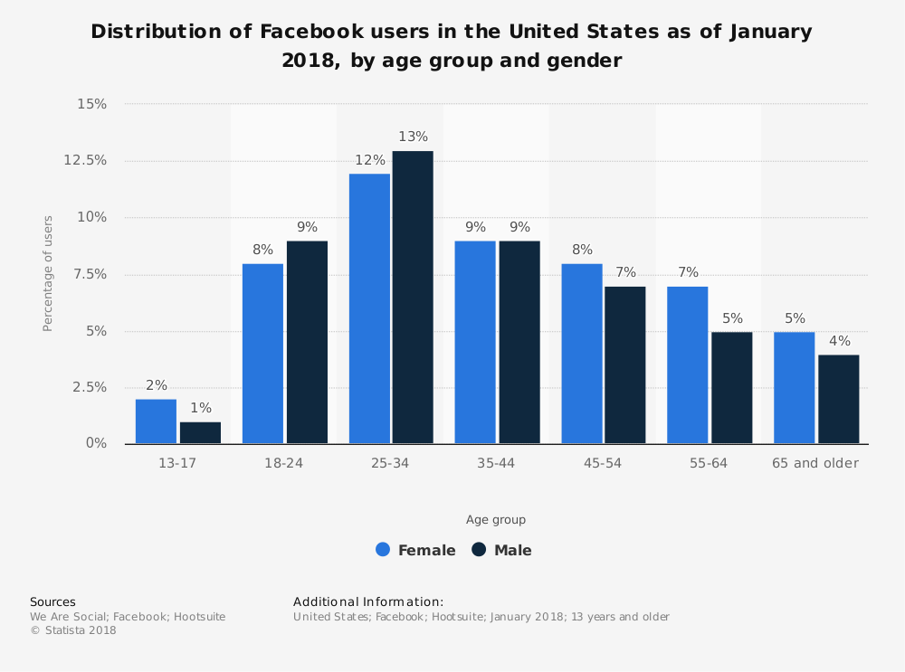

It is clear that the data found, established that Facebook has a large target market for middle aged individuals, in considering how much they use that social media. Compared to the young adults population, where young adults were found to veer towards the use of Instagram or similar social media sites which we plan to also use to promote our project.

Once we have established how we plan to promote our project, we will continue and stop up to about three weeks before all of our results come in. After all of the results come in, we will be presenting it at a venue of our choice. We will set up our project, and stand for everyone to view our results, which will be similar to how we presented it on our social media page, but instead you can actually view up in person. Some of the top locations we are looking to present at are Green bay,  Jacksonville, Charlotte, Tampa Bay, Phoenix, Baltimore, Atlanta, 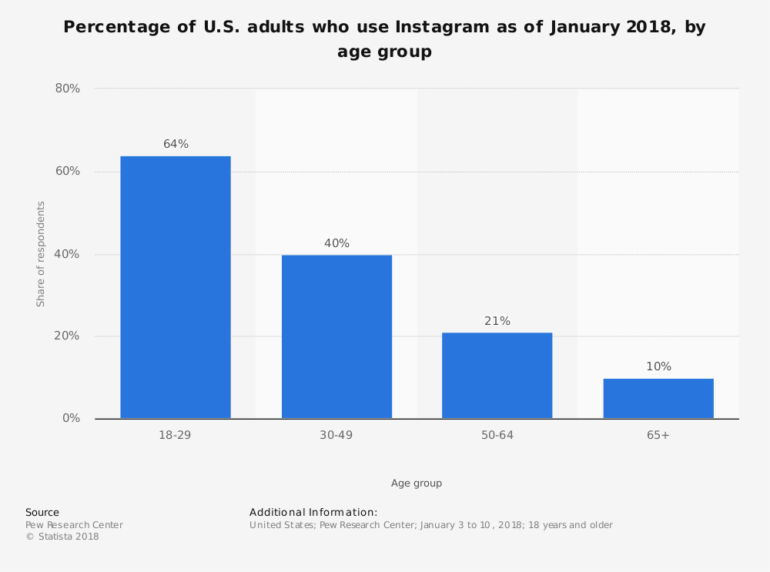and Miami. We will present at these places because we talk about these cities, and many like them, in our presentation which will help people further understand the conclusions of stadiums being built in their hometowns. With our presentation stand, we would like to include 3D props and models for our viewers to see. We would also like to incorporate a 3D picture of how the view of the city currently looks like with the stadium(s) in it, as well as a viewing of the city without those stadiums. Within the 3D picture you will see colors in which it will show where the minorities live today and before, the income of the area today and before in effort to show how the effect of the building of the stadium. Also, we will have out iPad’s for people to take and comment on how it looks and any question they would like for us to answer before we go up and exchange words with the public. Those question and comments will be talked about in our presentation at the end.  As we advance through our project, we plan to help everyone to see and hear our vision for this project. We will have individuals whom specialize in sign language people all around the venue and at the presentation. As for individuals whom have any type of physical disability, before our official venue on our social media we will include a link so they can comment or request what they need, so that we can accommodate to them. For example if an individual needs to sit closer to the stage because of eyesight, that option will be made available to them. The reason behind getting those who have disabilities opinions or questions, is to help us take our project to the next level. We plan to take it to the internet with an article that we will also be promoted via link on our social media pages. With the help of our diverse audience, the ceiling to expand is limitless. Once we complete our article we would like to take it to a national level by getting our project onto TV for the late night news so people are no longer in the dark on what is happening to their community.

**Work Cited**

* Soebbing, Brian P, Daniel S Mason, and Brad R Humphreys. “Novelty Effects and Sports Facilities in Smaller Cities: Evidence from Canadian Hockey Arenas.” Urban Studies 53, no. 8 (June 2016): 1674–90. doi:10.1177/0042098015576862.
* "The Effect of Professional Sports on Earnings and Employment in the Services and Retail Sectors in US Cities." NeuroImage. March 15, 2002. <https://www.sciencedirect.com/science/article/pii/S0166046202000108>.
* Dehring, C. A., Depken, C. A., & Ward, M. R. (2007). THE IMPACT OF STADIUM ANNOUNCEMENTS ON RESIDENTIAL PROPERTY VALUES: EVIDENCE FROM A NATURAL EXPERIMENT IN DALLAS-FORT WORTH. *Contemporary Economic Policy, 25*(4), 627-638. doi:<http://dx.doi.org/10.1111/j.1465-7287.2007.00077.x>
* Coates, Dennis, and Brad R. Humphreys. "The Growth Effects of Sport Franchises, Stadia, and Arenas." *Journal of Policy Analysis and Management* 18, no. 4 (1999): 601-24. <http://www.jstor.org/stable/3325757>.
* Maennig, Wolfgang, and Florian Schwarthoff. "STADIUMS AND REGIONAL ECONOMIC DEVELOPMENT: INTERNATIONAL EXPERIENCE AND THE PLANS OF DURBAN, SOUTH AFRICA." *Journal of Architectural and Planning Research* 28, no. 1 (2011): 1-16. <http://www.jstor.org/stable/43030923>.
* DeSchriver, T. D., Rascher, D. A., & Shapiro, S. L. (2016). If we build it, will they come? examining the effect of expansion teams and soccer-specific stadiums on major league soccer attendance. *Sport, Business and Management, 6*(2), 205-227. Retrieved from <http://newman.richmond.edu:2048/login?url=https://search.proquest.com/docview/1784068837?accountid=14731>
* Baker, N. (2018). PLAYING A MAN DOWN: PROFESSIONAL SPORTS AND STADIUM FINANCE-HOW LEAGUES AND FRANCHISES EXTRACT FAVORABLE TERMS FROM AMERICAN CITIES. *Boston College.Law School.Boston College Law Review, 59*(1), 281-317. Retrieved from <http://newman.richmond.edu:2048/login?url=https://search.proquest.com/docview/2014384488?accountid=14731>
* Davies, Larissa E. “Sport and the Local Economy: The Effects of Stadia Development on the Commercial Property Market.” Local Economy 23, no. 1 (February 2008): 31–46. doi:10.1080/02690940801906718.
* Alakshendra, Abhinav. 2016. How are we funding professional sports stadiums? an overview. *Managerial Finance* 42, (9): 885-890, http://newman.richmond.edu:2048/login?url=https://search.proquest.com/docview/1823116581?accountid=14731 (accessed December 20, 2018).
* Ahlfeldt, Gabriel M., and Georgios Kavetsos. "Form or Function?: The Effect of New Sports Stadia on Property Prices in London." Significance. February 07, 2013. <https://rss.onlinelibrary.wiley.com/doi/full/10.1111/rssa.12006>.

Torres, Jorge Enrique Agudelo, Gabriel Alberto Agudelo Torres, Luis Ceferino Franco Arbeláez, and Luis Eduardo Franco Ceballos. "The Effect of a Sports Stadium on Housing Rents: An Application of Geographically Weighted Regression." Co-herencia. <http://publicaciones.eafit.edu.co/index.php/ecos-economia/article/view/3045>.