TIMING ANALYSIS CONCEPTS

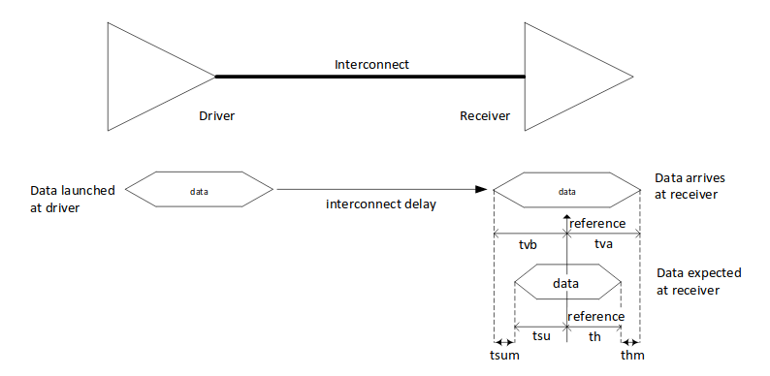

Invariants for correct operations:

tvb >= tsu
tva >= th

Timing margins:

tsum = tvb – tsu
thum = tva – th

Common Clock Interface
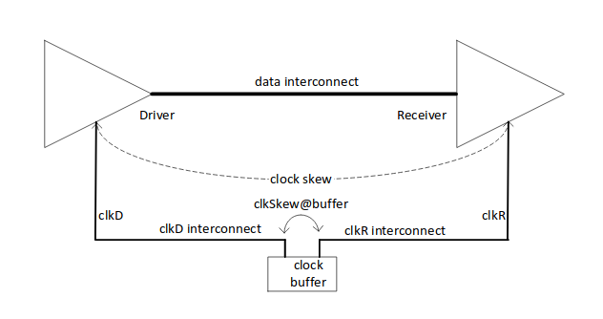
Timing margins of the data signal are affected by the clock
skew which is defined as the difference between the arrival times of the clock signal at the driver and receiver inputs.
The clock skew is calculated from the clkD and clkR propagation delays plus the skew between the outputs of the clock source andthe jitter that the clock source may have.

Common Clock Interface Setup Margin Timing Diagram

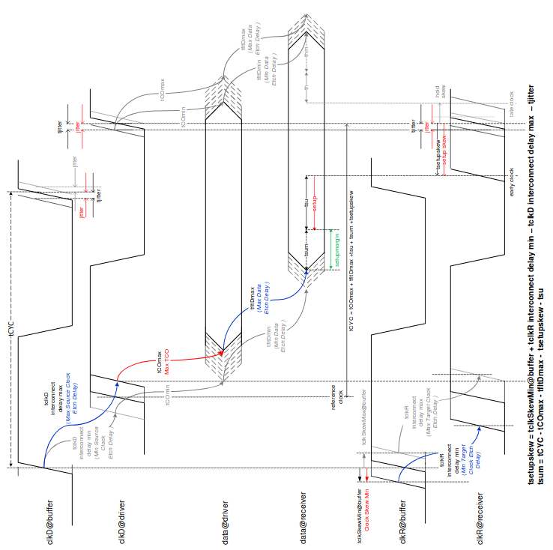

tsetupskew =
tclkSkewMin@buffer + tclkR_interconnect_delay_min -
tclkD_interconnect_delay_max – tjitter

tsum = tCYC – tCOmax – tfltDmax – tsetupskew – tsu

Common Clock Interface Hold Margin Timing Diagram

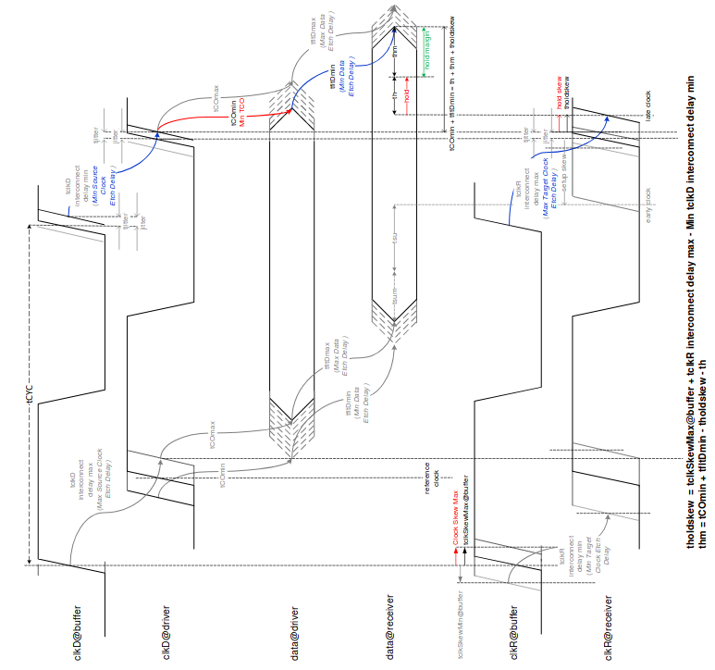

tholdskew =
tclkSkewMax@buffer + tclkR_interconnect_delay_max -
tclkD_interconnect_delay_min

thm = tCOmin + tfltDmix – tholdskew – th

