D.A.V CENTENARY COLLEGE
FARIDABAD

Practical file on
JAVA PROGRAMMING
(24BCA404DS03)

Submitted by: Submitted to:
Shivam Ms. Uttama Pandey
BCA 4rd semester Assistant Professor
1241182149 BCA Department

List of Programs
Sr. No | Name of Program | Date | Signature
1 | Write a java program to define a class ‘Student’ with data member for name and age, Include member functions to input and display the details of a student. | 10/02/2026
2 | Create a Java program to demonstrate method overloading by creating multiple methods with the same name but different parameters in a class. | 12/02/2026
3 | Create a Java program to demonstrate method overriding by creating a base class ‘Animal’ and a derived class ‘Dog’ that overrides a method form base class. | 18/02/2026
4 | Implement a java program to define an abstract class 'Shape' with an abstract method 'draw()'. Create derived classes 'Circle' and 'Square' that implement the draw method . | 27/02/2026
5 | Implement a java program to demonstrate the use of the 'Vector' class by performing operations like adding, removing and displaying elements of a vector. | 07/03/2026
6 | Write a java program to create a user-defined package and use it another class. | 10/03/2026
7 | Create a java program to handle multiple exceptions using try-catch blocks . | 15/03/2026
8 | Implement a java program to demonstrate the use of 'finally' statement in exception handling. | 20/03/2026
9 | Write a java program to create and throw a custom exception. | 22/03/2026
10 | Create a Java program to implement a multithreaded application by extending the ‘Thread’ class. | 24/03/2026
11 | Implement a Java program to demonstrate thread synchronization. | 27/03/2026
12 | Create a Java program to read and write data to a file using ‘FileInputStream’ and ‘FileOutputStream’. | 30/03/2026
13 | Write a Java applet to display “Hello World!”. | 01/04/2026
14 | Create a Java applet to demonstrate the use of the ‘APPLET’ tag and pass parameters to the applet. | 04/04/2026
15 | Create a Java program to demonstrate the use of AWT controls like buttons , labels, and text fields. | 07/04/2026

1. Write a java program to define a class ‘Student’ with data member for name and age, Include member functions to input and display the details of a student. import java.util.Scanner;

class Details_Student
{
String name; int age;
void getdata()
{
System.out.print("Enter the student name : "); Scanner s = new Scanner(System.in); name=s.nextLine();
System.out.print("Enter the student age : "); age=s.nextInt();
} void display()
{
System.out.println("Student name : "+name);
System.out.println("Student age : "+age);
}
public static void main(String args[])
{
Details_Student obj=new Details_Student(); obj.getdata(); obj.display();
}
}
Output:-

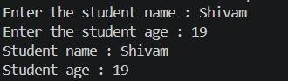

2. Create a Java program to demonstrate method overloading by creating multiple methods with the same name but different parameters in a class.
class Method_Overloding {
int sum(int a) {
return a;
} int sum(int a, int b) { return a + b;
} int sum(int a, int b, int c) { return a + b + c;
}
double sum(double a, double b) { return a + b;
}
public static void main(String args[]) {
Method_Overloding obj = new Method_Overloding(); obj.sum(5); obj.sum(5, 7); obj.sum(5, 7, 5); obj.sum(3.4, 7.1);
System.out.println("Sum = " + obj.sum(5));
System.out.println("Sum = " + obj.sum(5, 7));
System.out.println("Sum = " + obj.sum(5, 7, 5));
System.out.println("Sum = " + obj.sum(3.4, 7.1));
}
}
Output:-
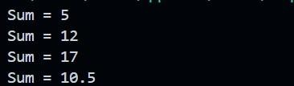

3. Create a Java program to demonstrate method overriding by creating a base class ‘Animal’ and a derived class ‘Dog’ that overrides a method form base class.

class Animal {
void sound() {
System.out.println("Animal makes a sound");
}
}
class Dog extends Animal { void sound() {
System.out.println("Dog Barks");
}
} class Method_Overriding { public static void main(String[] args) { Dog d = new Dog(); d.sound();
}
}
Output:-


4. Implement a java program to define an abstract class 'Shape' with an abstract method 'draw()'. Create derived classes 'Circle' and 'Square' that implement the draw method .

abstract class Shape { abstract void draw();
} class Circle extends Shape { void draw() {
System.out.println("Drawing a Circle");
}
} class Square extends Shape { void draw() {
System.out.println("Drawing a Square");
}
} class Main {
public static void main(String[] args) {
Shape s1 = new Circle(); Shape s2 = new Square(); s1.draw(); s2.draw();
}
}
Output:-
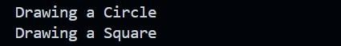

5. Implement a java program to demonstrate the use of the 'Vector' class by performing operations like adding, removing and displaying elements of a vector.

import java.util.Vector; class VectorDemo { public static void main(String[] args) {
Vector<String> v = new Vector<>(); v.add("Apple");
v.add("Banana");
v.add("Mango");
v.add("Orange");
System.out.println("Vector after adding elements:"); System.out.println(v); v.remove("Banana"); v.remove(1);
System.out.println("\nVector after removing elements:");
System.out.println(v);
System.out.println("\nDisplaying elements using loop:"); for (String fruit : v) {
System.out.println(fruit);
}
}
}
Output:-
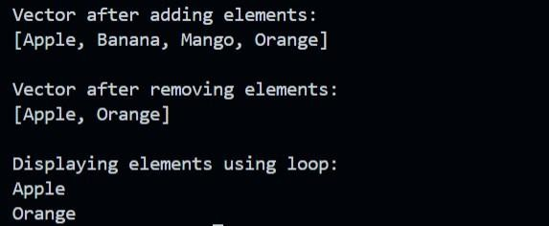

6. Write a java program to create a user-defined package and use it another class.

//package create package pkg1; public class A { int a, b; public A(int x, int y) { a = x; b = y;
}
public void Sum() {
System.out.println("Sum = " + (a + b));
}
}
//package ko dusare class me use kiya gaya hai import pkg1.A; class PackageDemo {
public static void main(String args[]) { A obj = new A(25, 5); obj.Sum();
}
}

Output:-


7. Create a java program to handle multiple exceptions using trycatch blocks .

class MultipleExceptionDemo {
public static void main(String[] args) { try { int a = 10, b = 0; int result = a / b;
} catch (ArithmeticException e) {
System.out.println("Arithmetic Exception: " + e);
} try { int arr[] = { 1, 2, 3 };
System.out.println(arr[5]);
} catch (ArrayIndexOutOfBoundsException e) {
System.out.println("Array Index Exception: " + e);
}
System.out.println("Program excuted ");
}
}

Output:-

.
8. Implement a java program to demonstrate the use of 'finally' statement in exception handling.

class FinallyDemo { public static void main(String[] args) { try { int a = 10, b = 0; int result = a / b;
System.out.println("Result: " + result);
}
catch (ArithmeticException e) {
System.out.println("Exception caught: " + e);
} finally {
System.out.println("Finally block always executes.");
}
}
}

Output:-

.

9. Write a java program to create and throw a custom exception.

class InvalidAgeException extends Exception {
public InvalidAgeException(String message) { super(message);
}
}
class CustomExceptionDemo { static void checkAge(int age) throws InvalidAgeException { if (age < 18) {
// Throw custom exception throw new InvalidAgeException("Age must be 18 or above!");
} else {
System.out.println("You are eligible to vote.");
}
} public static void main(String args[]) {
try {
checkAge(16); // Change value to test
} catch (InvalidAgeException e) {
System.out.println("Exception caught: " + e.getMessage());
}
}
}

Output:-

.

10. Create a Java program to implement a multithreaded application by extending the ‘Thread’ class.

class MyThread1 extends Thread {
public void run() {
for (int i = 1; i <= 5; i++) {
System.out.println("Thread 1: " + i); try {
Thread.sleep(500); // pause for 500ms
} catch (InterruptedException e) {
System.out.println(e);
}
}
}
}
class MyThread2 extends Thread {
public void run() {
for (int i = 10; i <= 15; i++) {
System.out.println("Thread 2: " + i); try {
Thread.sleep(500);
} catch (InterruptedException e) {
System.out.println(e);
}
}
}
}
class ThreadDemo {
public static void main(String args[]) { MyThread1 t1 = new MyThread1();
MyThread2 t2 = new MyThread2();
.
t1.start();
t2.start();
}
}

Output:-

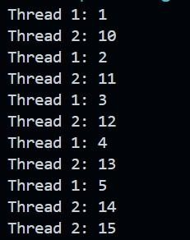

11. Implement a Java program to demonstrate thread synchronization.

class Table { synchronized void printTable(int n)
{
for (int i = 1; i <= 5; i++) {
System.out.println(n + " x " + i + " = " + (n * i)); try {
Thread.sleep(400);
} catch (Exception e) {
System.out.println(e);
}
}
}
}
class MyThread1 extends Thread {
Table t;
MyThread1(Table t) {
this.t = t;
} public void run() { t.printTable(5);
}
}
class MyThread2 extends Thread {
Table t;
MyThread2(Table t) { this.t = t;
}
public void run() {
t.printTable(10);
}
} class SyncDemo {
public static void main(String args[]) {
Table obj = new Table();
MyThread1 t1 = new MyThread1(obj);
MyThread2 t2 = new MyThread2(obj);
t1.start(); t2.start();
}
}

Output:-

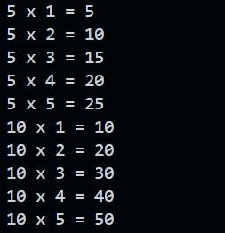

12. Create a Java program to read and write data to a file using ‘FileInputStream’ and ‘FileOutputStream’.

import java.io.*; class FileDemo { public static void main(String args[]) { try {
FileOutputStream fout = new FileOutputStream("test.txt"); String data = "Hello, this is file handling in Java!"; byte b[] = data.getBytes(); fout.write(b); fout.close();
System.out.println("Data written successfully.");
FileInputStream fin = new FileInputStream("test.txt"); int i;
System.out.println("Reading data from file:"); while ((i = fin.read()) != -1) {
System.out.print((char) i);
} fin.close();
} catch (Exception e) {
System.out.println(e);
}
}
}

Output:-

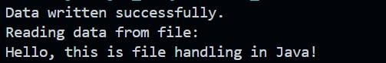

13. Write a Java applet to display “Hello World!”.

import java.applet.Applet; import java.awt.Graphics;
/*
Html code run applet ko browser par run karne ke liye

<html>
<body>
<applet code="HelloApplet.class" width="300" height="300">
</applet>
</body>
</html>
*/
// Applet class public class HelloApplet extends Applet {
// Method to display output public void paint(Graphics g) {
g.drawString("Hello World!", 100, 100);
}
}

Output:-
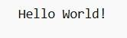

14. Create a Java applet to demonstrate the use of the ‘APPLET’ tag and pass parameters to the applet .

import java.applet.Applet; import java.awt.*;
/* //html code
<html>
<body>
<applet code="ParamDemo.class" width="400" height="300">
<param name="username" value="Vishal">
<param name="course" value="BCA">
</applet>
</body>
</html>
*/
// Applet class
public class ParamDemo extends Applet { String name, course; public void init() { name = getParameter("username"); course = getParameter("course");
}
g.drawString("Name: " + name, 80, 100);
g.drawString("Course: " + course, 80, 130);
}
}

Output:-
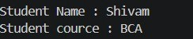

15. Create a Java program to demonstrate the use of AWT controls like buttons , labels, and text fields.

import java.awt.*; import java.awt.event.*;
// Main class
class AWTDemo extends Frame implements ActionListener {
Label l1, l2, l3;
TextField t1, t2, t3;
Button b;
// Constructor
AWTDemo() {
// Create components l1 = new Label("Enter First Number:"); l2 = new Label("Enter Second Number:"); l3 = new Label("Result:"); t1 = new TextField(10); t2 = new TextField(10); t3 = new TextField(10); t3.setEditable(false); b = new Button("Add");
// Set layout setLayout(new FlowLayout());
// Add components to frame add(l1); add(t1); add(l2); add(t2); add(b); add(l3); add(t3);
// Add action to button
b.addActionListener(this); // Frame settings setSize(300, 200);
setTitle("AWT Example"); setVisible(true);
// Close window addWindowListener(new WindowAdapter() { public void windowClosing(WindowEvent we) { dispose();
}
});
}
// Button click event public void actionPerformed(ActionEvent e) { int a = Integer.parseInt(t1.getText()); int b = Integer.parseInt(t2.getText()); int sum = a + b;
t3.setText(String.valueOf(sum));
}
public static void main(String args[]) { new AWTDemo();
}
}

Output:-

