**SIGN LANGUAGE DETECTION**

USING

**MACHINE LEARNING**

**BY**

GROUP ID - G13

**KUMAR SHANU ( 1773513025 )**

**MUSKAN MAHESWARI ( 1773513032 )**

**RAHUL ( 1773513037 )**

**VISHAL ( 1773513061 )**

DEPARTMENT OF

**INFORMATION TECHNOLOGY**

**RAJKIYA ENGINEERING COLLEGE, CHANDPUR**

**BIJNOR ( 246725 )**

**RAJKIYA ENGINEERING COLLEGE, CHANDPUR**

**BIJNOR ( 246725 )**

**(Affiliated to Dr. A.P.J Abdul Kalam Technical University, Lucknow)**



**PROJECT REPORT**

**ON**

**SIGN LANGUAGE DETECTION**

**Under the guidance of the Department of Information Technology**

in partial fulfilment of the requirements

for the degree of

**Bachelor of Technology**

**IN**

**INFORMATION TECHNOLOGY**

**S**ESSION 2020-21

**DECLARATION**

We hereby declare that this submission is our own work and that, to the best of our knowledge and blief, it contains no material previously publish or written by another person nor material which to a substantial extent has been accepted for the award of any other degree or diploma of the university or other institute of higher learning except where do acknowledgement has been made in the text.

Signature:

Name: Kumar Shanu

Roll No: ( 1773513025 )

Date:

Signature:

Name: Muskan Maheswari

Roll No: ( 1773513032 )

Date:

Signature:

Name: Rahul

Roll No: ( 1773513037 )

Date:

Signature:

Name: Vishal

Roll No: ( 1773513061 )

Date:



DEPARTMENT OF INFORMATION TECHNOLOGY (REC, BIJNOR)

**CERTIFICATE**

This is to certify that Project Report entitled **“SIGN LANGUAGE DETECTION USING MACHINE LEARNING”** which is submitted by **Kumar Shanu, Muskan Maheshwari, Rahul and Vishal** in partial fulfilment of the requirement for the award of degree B .Tech. in Department of Information Technology of Dr . A.P.J Abdul Kalam Technical University, U.P., Lucknow is a record of the candidate own work carried out by him under my/our supervision. The matter embodies in this thesis is original and has not been submitted for the award of any other degree.

............................. .......................... ..................................

**External Examiner Dr.Ishan Bhardwaj Mr.Vivek Kumar Jaiswal**

*(Head of Department)* *(Assistant professor/Supervisor)*

**ABSTRACT**

This project aspire at building machine learning model that will be able to classify the various hand gestures used for fingurespelling in sign language. In this autonomous model, classification machine learning algorithms are trained using a pixel dataset of images and testing is done on a completely diffrent set of data.

For the image dataset, depth images (i.e. image data used in pixel) are used, which gave better results than some of the previous literatures, owing to the reduced pre-processing time. Various machine learning algorithms are applied on the datasets, including **Convolutional Neural Network (CNN).** An attempt is made to increase the accuracy of the **CNN** model by pre-training it on the dataset.

**KERAS,** **TENSORFLOW** and **OPEN CV** libraries are used to develop the model on pixel image dataset.

**ACKNOWLEDGEMENT**

On the very outset of this report, we would like to extent our sincere and heartfelt obligation towards all the personages who have helped us in this endeavor. Without their active guidance, help, cooperation and encouragement, we could not have made headway in the project.

First and foremost, we would like to express our sincere gratitude to our guide, **Dr Ishan Bhardwaj** we were privileged to experience a substained enthusiastic and involved interest from her side. This fuelled our enthusiasm even further and encouraged us to boldly step into what was a totally dark and unexplored expanse before us. She always fuelled our thoughts to think broad and out of the box. We would also like to thank Director, **Dr. B.K. Triphati** and **HOD (IT), Dr. Ishan Bhardwaj** who, instead of his busy schedule, always guided us in right direction. I would like to thank the entire staff member for motivation guidance and support.

We are indebted to a number of friends and well – wishers who have extended their co-operation and help in the preparation of the project. Last but not the least, it goes without saying that we are deeply indebted to our parents for their support and their patient guidance.

*Thanking You*

**TABLE OF CONTENTS**

**CHAPTER 1 PROJECT OBJECTIVE**....................................................................1 - 1

1.1 SUB OBJECTIVE...............................................................................................1

**CHAPTER 2 INTRODUCTION**...............................................................................2- 6

2.1 INTRODUCTION TO SIGN LANGUAGE.......................................................2

2.2 HISTORY OF SIGN LANGUAGE.....................................................................4

2.3 TYPES OF SIGN LANGUAGE.........................................................................6

**CHAPTER 3 PRE-REQUIESITES**..........................................................................7 - 9

3.1 PYTHON (3.X) ..................................................................................................7

3.2 IDE (JUPYTER LAB) .......................................................................................7

3.3 NUMPY .............................................................................................................8

3.4 PANDAS............................................................................................................8

3.5 CV2 (OPEN CV) (Version ) ..............................................................................8

3.6 KERAS...............................................................................................................9

3.7 TENSORFLOW (keras uses tensorflow in backend and for image preprocessing) 9

**CHAPTER 4 STEPS TO DEVELOPE SIGN LANGUAGE DETECTION......10**

4.1 CREATING THE DATASET ..........................................................................10

4.2 TRAINING THE MODEL...............................................................................10

4.3 PREDICTING THE RESULT..........................................................................10

**CHAPTER 5 MOTIVATION..................................................................................11**

**CHAPTER 6 RESEARCH METHODOLOGY..............................................................**

**Results.**...................................................................................................

**BIBLIOGRAPHY.**....................................................................................................12

**LIST OF ABBREVIATIONS**

CNN - Convulution Nueral Network

ANN - Artificial Nueral Network

ML - Machine Learning

AI - Artificial Intelligenece

IDE - Integrated Development Environment

PY - Python

CSV - Comma Seprated Values

JSON - JavaScript Object Notation

SQL - Structured Query Langueage

Numpy - Numerical Python

Open CV - Open Source Computer Vision

BSD - Berkeley Source Distribution

ie - Id Est (That is)

**LIST OF FIGURES**

**Fig 2.1** Sign Language

**Fig 2.2** Alphabates in Sign Language

**Fig 2.3** Numbers in Sign Language

**Fig 2.4** Some basic words in Sign Language

**Fig 2.5** Some basic words in Sign Language

**Fig 2.6** Irish Sign Language

**Fig 2.7** American Sign Language

**Fig 3.1** Jupyter Lab IDE

**Fig 4.1** Directory Structure

**CHAPTER 1 PROJECT OBJECTIVE**

**OBJECTIVE:** Objective of the project is to provide plateform or service to deaf and dumb peoples, their relatives and sociaty.

There are some objectives are mentioned below:

1. Encourage the establishment of National association of Sign Language interpreters in countries that do not have them.
2. Host conference and seminars.
3. Encourage research.
4. To orient and different groups i.e. Government, teachers, professional and public at large for understanding and using Indian Sign Language.
5. To develope manpower for using Indian Sign Language(ISL) and teaching conducting research in ISL, including bilingualism..
6. To collect information relating to Sign Language used in other parts of the world input can be used to upgrade the Indian Sign Language.
7. Be a support network for existing National associations of sign language interpreters.
8. To Promote the use of Indian Sign Language as educational mode for deaf students at primary, secondary and higher education level.

**CHAPTER 2 INTRODUCTION**

**2.1 About Sign Language**

Sign language is a language which is used by, who can speek but can’t hearing people (i.e Deaf & Dumb ), most often families and relatives of such peoples, and interpreters who enable the deaf and wider communities to communicate to each other.

Sign language uses body languages, hand movements and facial exprerssion to communicate to society.

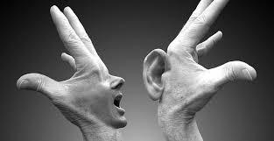

**Fig 2.1** Sign Language

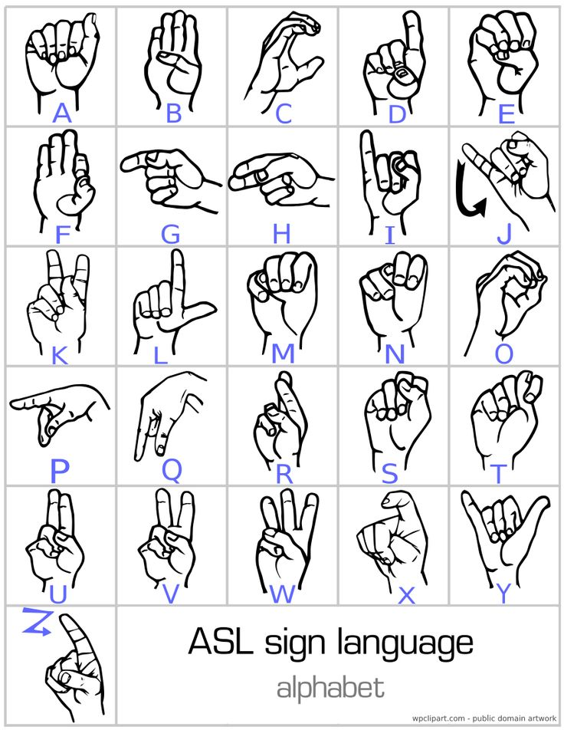

**Fig 2.2 Alphabates in Sign Language**

### 

Fig 2.3 Numbers in Sign Language

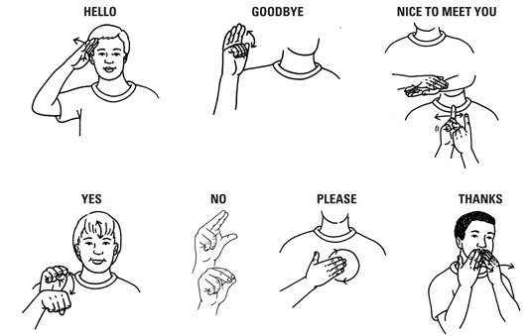

Fig 2.4 Some basic words in Sign Language

### 

Fig 2.5 Some basic words in Sign Language

### 2.2 History of Sign Language

**Indian Sign Language(ISL):** In the 2000s, the Indian deaf community advocated for an institute focused on ISL teaching and research.

In an order dated 20th April, 2015, the Ministry decided to integrate ISLRTC with the regional center of the Ali Yavar Jung National Institute of Hearing Handicapped (AYJNIHH) at Delhi. However, the Deaf community protested this decision due to the different perspectives and goals of Indian Sign Language Research and Training Centre (ISLRTC).

After a long struggle by the deaf community, the Ministry approved the establishment of ISLRTC at New Delhi on 28th September, 2015.

Official language of the deaf for different - different country are differ like ( BSL is for British Sign Language etc).

**Myth and Misconceptions:**g is merely a manual representation of the spoken language which is not true. In fact, the spoken language and language of the deaf have very little in common.

**2.3 Types of Sign Language:**

There are somewhere 138 to 300 different types of Sign Language used throughout the world today.

Let’s take at some Sign Language from arround the world are as below:

* British Sign Language (BSL), New Zealand Sign Language
* French Sign Language (LSF)
* American Sign Language (ASL)
* Irish Sign Language ( Sign Language arround the world)(ISL)
* Chinese Sign Language (CSL & ZGS)
* Indo-Pakistani Sign Language
* Brazilian Sign Language (Libras)

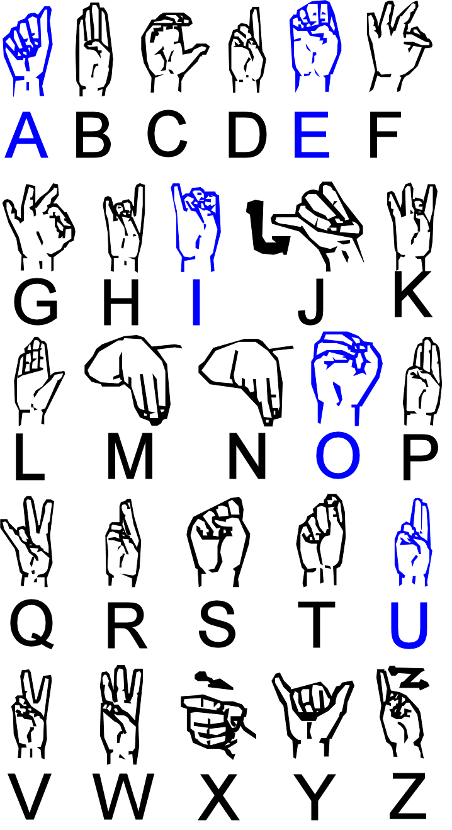

Fig 2.6 (Irish Sign Language) Fig 2.7 (American Sign Language)

**CHAPTER 3 PRE-REQUISITES**

The prerequisites softwares & libraries for the sing language detection project are following:

**3.1 Python ( version 3.x)**

Python is the best programming language for Machine Learning and Artificaial Intellegence based projects because python offers concise and readable code which makes easy developer to write realible code. Benefits that make the python best language for Machine Learning includes its simplicity, access to great libraries and frameworks for Machine Learning(ML), flexibility and platform independance.

**3.2 IDE (JUPYTER LAB)**

The IDE used for this project is Jupyter Lab which is a next-generation user interface for python. **JupyterLab** enables you to work with documents and activities such as **Jupyter** notebooks, text editors, terminals, and custom components in a flexible, integrated, and extensible manner.

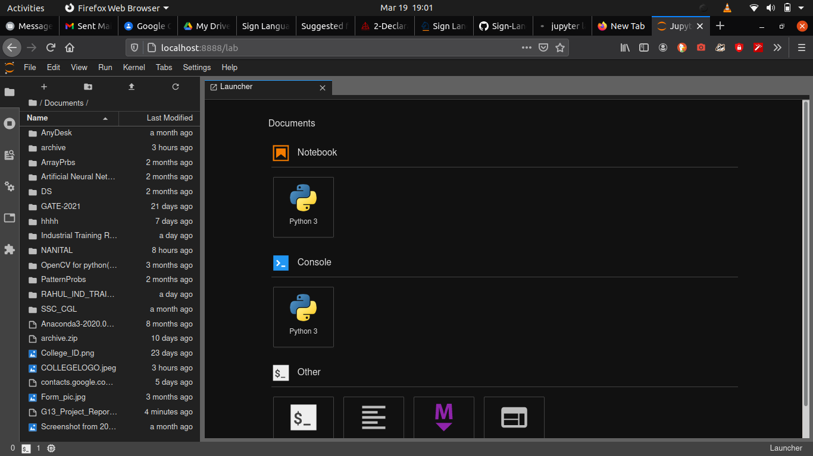

Fig 3.1 Jupyter Lab IDE

**3.3 NUMPY**

Numpy is a python library used to work with arrays. It also has functions for working in domain of linear algebra, fourier transformation, and matrics. Numpy stands for numerical python. NumPy arrays are stored at one continuous place in memory unlike lists, so processes can access and manipulate them very efficiently.

**3.4 PANDAS**

Pandas is a python library which is a fast, powerful, flexible and easy to use open source data analysis and manipulation tool, built on top of the Python programming language. Pandas allow importing data from various types of files such as CSV, JSON, SQL and Microsoft Excel. Pandas also allows various data manipulation operations.

**3.5 CV2 (OPEN CV)**

OpenCV (Open Source Computer Vision Library) is an open source computer vision and machine learning software library. OpenCV was built to provide a common infrastructure for computer vision applications and to accelerate the use of machine perception in the commercial products. Being a BSD-licensed product, OpenCV makes it easy for businesses to utilize and modify the code.

**3.6 KERAS**

Keras is an open-source software library that provides a Python interface for artificial neural networks. Keras acts as an interface for the TensorFlow library. The keras python library make it pretty simple to build a CNN. CNN is a deep learning algorithm which can take a input image and be able to differentiate one from other.

**3.7 TENSORFLOW**

The keras python library uses Tensoflow at backend. Tensorflow is an end-to-end open source platfrom for Machine Learning. It has a comprehensive, flexible ecosystem of tools, libraries and community resources that lets researchers push the state-of-the-art in ML and developers easily build and deploy ML powered applications.

**CHAPTER 4**

**STEPS TO DEVELOPE SIGN LANGUAGE DETECTION**

The steps to develope sign language detection are devided into the following parts:

* Creating the dataset
* Training the Model
* Predicting the Data

**4.1 Creating the Dataset**

we can create the dataset with the help of camera using open cv library. To create dataset we will be having a live feed from the video camera and every frame detects a hand in the ROI (Region of Interest) created will be saved in a directory that contains two folders **train** and **test,** each containing sub folders containing images captured.

The dataset for the project also available on internet sites such as kaggle.com. We can also download dataset from there.

**Directory Structure**

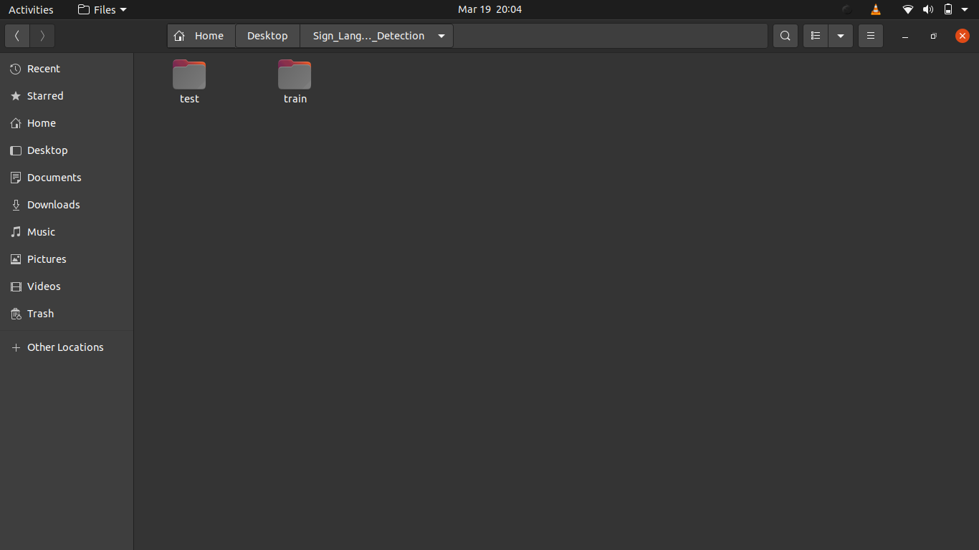

Fig 4.1 Directory Structure

**MOTIVATION**

* While automatic speech recognition has now advanced to the point of being com-mercially available, automation is still in its infancy.
* Currently all commercial translation services are human based, and therefore expensive, due to the experi-enced personnel required

**BIBLIOGRAPHY**

[**http://www.islrtc.nic.in/**](http://www.islrtc.nic.in/) **History of Sign Language**

[**https://opencv.org/**](https://opencv.org/) **CV2 (Open CV)**

[**https://www.tensorflow.org/**](https://www.tensorflow.org/) **Tensorflow**