**EMPOWERING BIOMEDICAL INFORMATICS THROUGH THE VERSATILITY OF GENERATIVE ADVERSARIAL NETWORKS**

**A PROJECT REPORT**

***Submitted by***

**Vishvesh Mukesh 21BCS5408**

**Hrithik Joshi 21BCS5465**

**Sparsh Saraf 21BCS5336**

***in partial fulfillment for the award of the degree of***

**Bachelor of Engineering (Hons).**

**IN**

Computer Science Engineering with specialization in Artificial Intelligence and Machine Learning in association with IBM



**Chandigarh University**

May, 2023



**BONAFIDE CERTIFICATE**

Certified that this project report **“Empowering Biomedical Informatics through the Versatility of Generative Adversarial Networks”** is the bonafide work of **Vishvesh Mukesh, Hrithik Joshi, and Sparsh Saraf,** who carried out the project work under my/our supervision.

**SIGNATURE**

Aman Kaushik

**HEAD OF THE DEPARTMENT**

AIT-CSE

**SIGNATURE**

Dr. Gurwinder Singh

**SUPERVISOR**

Asst. Professor

AIT-CSE

Submitted for the project viva-voce examination on

**INTERNAL EXAMINER EXTERNAL EXAMINER**

**ACKNOWLEDGEMENT**

Without mentioning the people who made it possible, whose constant direction and support crowned our efforts with success, the joy and elation that come with completing any assignment successfully would be inconceivable.

It gives us great pleasure to offer my sincere gratitude to Mr. Satnam Singh Sandhu, the chairman of Chandigarh University, for fostering a conducive environment and providing essential facilities.

We want to use this occasion to offer our sincere gratitude to Mr. Aman Kaushik, the Head of the Department, for his unwavering encouragement and support.

We want to thank our project advisor, Dr. Gurwinder Singh, for closely monitoring its progress and establishing certain due dates. His insightful recommendations served as the driving forces behind finishing the task.

We would also like to thank our project evaluator, Ms. Sheetal Laroiya (E15433) and Ms.Upasana Tiwari (E15791), who helped us cross a few hurdles and suggested improvements. She motivated us in making our project better than what we originally planned.

Finally, we would like to express my gratitude to the teaching and non-teaching staff at the Apex Institute of Technology for their cooperation with both me and my friends who assisted me in various ways throughout the project.

**VISHVESH MUKESH 21BCS5408**

**HRITHIK JOSHI 21BCS5465**

**SPARSH SARAF 21BCS5336**

**TABLE OF CONTENTS**

**List of Figures………………………………………………………………....6**

**List of Tables…………………………………………………………………..7**

**Abstract……………………………………………………………………......8**

**Abbreviations……………………………………………………………….....9**

**Chapter 1: Introduction………………………………………………..…....10**

* 1. Domain introduction………………………………………….…10
  2. Need for this technology………………………………………...11
  3. Relevant contemporary issues…………………………………...12
  4. Problem identification…………………………………………...14
  5. Client needs……..……………………………………………….18
  6. Problem Definition………………………………………………20

**Chapter 2: Literature survey………………………………………………..23**

2.1 Introduction ……………………………………………………...23

2.2 Timeline of the Reported Problem as Investigated Throughout

The World……………………….………………………..….…...24

2.3 Case Studies……………………………………………………...26

2.4 Examples of Usage………………………………………………27

2.5 Survey of existing work………………………………………....29

2.6 Possible approaches……………………………………………..33

**Chapter 3: Design Flow/Process…………………………………………....37**

3.1 Proposed System…...…………………………………………...37

3.1.1 Design Flow……………………………………………...37

3.1.2 Methodology……………………………………………..40

3.2 Data Collection………………………………………………….43

**Chapter 4: Result analysis and validation………………………………....45**

4.1 Screenshots of model…………………………………………...45

4.2 Performance Analysis……..…………………………………....48

4.3 Design constraints……………………………………………....49

**Chapter 5: Conclusion and future work…………………………………..54**

5.1 Conclusion……………………………………………………...54

5.2 Feedback and Reflection……………………………………….55

5.3 Future scope…………………………………………………....56

References……………………………………………………………….......59

**List of Figures**

**Figure 1………………………………………………………….…………….31**

**Figure 2.………………………………………………………….……………32**

**Figure 3.……………………………………………………………………….40**

**Figure 4………………………….……………………….……………………42**

**Figure 5.……………………….………………………….……………...........43**

**Figure 6………………………….………………………….…………….…...45**

**Figure 7.……………………………………………………………………….46**

**Figure 8………………………….……………………….……………………46**

**Figure 9.……………………….………………………….……………...........47**

**Figure 10……………………….………………………….…………..….…...47**

**Figure 11……………………….……………………….…………………..…48**

**List of Tables**

**Table I…………………………………………………………………………22**

**Table II…………………………………………………….…………….……25**

**ABSTRACT**

By utilizing the power of data-driven insights, biomedical informatics significantly advances healthcare research, diagnosis, and treatment. The incorporation of Generative Adversarial Networks (GANs) is among the most promising technological developments in this field. This paper investigates how GANs are transforming biomedical informatics and enabling medical professionals—researchers, physicians, and other staff members—to get valuable insights from large, intricate biomedical data sets.

GANs have shown impressive potential in recent years for creating artificial intelligence (AI), enhancing datasets, and raising prediction model accuracy. Biomedical informatics greatly increases healthcare research, diagnosis, and therapy by harnessing the power of data-driven insights. The integration of GANs is one of the most exciting technological advancements in this domain. The purpose of this work is to explore how GANs are revolutionizing biomedical informatics and empowering medical professionals, including doctors, researchers, and other staff members, to extract meaningful insights from complex, large-scale biomedical data sets.

In recent years, GANs have demonstrated remarkable promise for improving datasets, increasing prediction model accuracy, and developing artificial intelligence (AI). It is evident that GANs have a revolutionary effect on biomedical informatics, providing novel answers to persistent issues in research and healthcare. Stakeholders must understand the possibilities, constraints, and ethical ramifications of GANs in biomedical informatics as the area develops. This paper sheds light on the state of GANs in this field both now and in the future, emphasizing how they could transform healthcare and hasten the development of novel cures.

**ABBREVIATIONS**

**GANs – Generated Adversarial Networks**

**VGAN - Vanilla GAN**

**CGAN - Conditional GAN**

**DCGAN - Deep Convolutional Generative Adversarial Network**

**PGGAN – Progressive GAN**

**CTGAN - Conditional Tabular Generative Adversarial Network**

**CDSS – Clinical Decision Support Systems**

**CHAPTER 1**

**INTRODUCTION**

* 1. **Domain Introduction**

The exponential growth of data has brought about a transformative period in the fields of biomedical research and modern healthcare, where efficient utilization and analysis of large datasets are critical. In the quest to enhance patient care, comprehend diseases, and promote scientific discovery, biomedical informatics—a multidisciplinary field that integrates data, information, and knowledge to support decision-making in the biomedical and healthcare domains—has emerged as a crucial instrument. But as data-driven insights and computational methods become more and more important, handling and processing complicated biological data—such as genomic sequences, clinical records, medical imaging, and more—needs creative new methods.

The groundbreaking idea of Generative Adversarial Networks (GANs) in artificial intelligence and machine learning has yielded remarkable results in a variety of fields, including natural language processing and picture creation. Generative Adversarial Networks (GANs) are a subclass of neural networks that are made up of two parts: the generator and the discriminator. The generator generates data in order to trick the discriminator, which then tries to discriminate between created and actual data. Data generated by this adversarial training process becomes more and more realistic and similar to real data.

In the realm of biomedical informatics, the adaptability of GANs is now being investigated, providing creative solutions for a wide range of problems. GANs can help data scientists, academics, and doctors by doing everything from simulating genetic sequences for research purposes to producing artificial medical images for deep learning model training. In "Empowering Biomedical Informatics through the Versatility of Generative Adversarial Networks," a project study that explores the many uses, advantages, and difficulties of integrating GANs into the biomedical informatics toolset, we delve into an intriguing field.

The fundamentals of generative analytic networks (GANs), their uses in biomedical informatics, and the effects of these networks on research, healthcare, and decision-making will all be covered in this study. In addition, we will provide a few case examples that show how GANs are transforming the field by improving data augmentation, data production, and data-driven research in the biological sciences.

This research attempts to shed light on the potential ethical issues and exciting opportunities associated with using GANs in biomedical informatics through a thorough investigation of these cutting-edge techniques. As we go out on this adventure, we will see firsthand how GANs are changing the biomedical data analysis environment and learn about the revolutionary potential of these adaptable AI systems.

* 1. **Need for this technology**

Pharmaceutical corporations, public health organizations, clinical researchers, and healthcare practitioners are among the diverse clients that biomedical informatics serves. The stakeholders function in a data-rich setting wherein it is imperative to promptly extract significant insights from biomedical data. Healthcare professionals need technologies that can help with disease diagnosis, individualized treatment strategies, and improving patient care. Data-driven methods are used by clinical researchers to better understand diseases and provide new treatments.

In order to monitor and respond to health trends, public health organizations need data-driven insights, while pharmaceutical corporations want expedited drug discovery pipelines. Therefore, there has never been a more urgent need for cutting-edge data analysis methods and creative ways to handle and analyze the massive amount of biomedical data that is constantly increasing. Generative Adversarial Networks (GANs) have the ability to fulfill these requirements by offering flexible and data-driven solutions for the wide range of customers in the biomedical informatics domain.

Many clients and stakeholders in the broad field of biomedical informatics depend on the smooth integration of data and state-of-the-art technology to achieve their specific goals. Healthcare providers, who are at the forefront of patient care, rely on accurate and data-driven technologies to customize treatment programs and make accurate diagnoses. Clinical researchers need effective methods for analyzing large datasets in order to better understand diseases and develop novel treatments. Pharmaceutical businesses require efficient and economical drug discovery procedures in their pursuit of novel medications and therapies. In the meantime, data-driven insights are used by public health organizations and policymakers to track health trends, carry out preventative interventions, and manage resource allocation.

The constant expansion of data repositories and the pursuit of challenging objectives in healthcare and research highlight the need for cutting-edge methods of data analysis and creative solutions in the field of biomedical informatics. Strong artificial intelligence frameworks called Generative Adversarial Networks (GANs) have shown promise in meeting the many needs and demands of the biomedical informatics industry's broad clientele. In order to better patient outcomes, advance scientific understanding, and tackle the constantly changing challenges of healthcare and medical research, GANs have the potential to revolutionize data generation, augmentation, and analysis. In the end, this will empower healthcare professionals, researchers, pharmaceutical companies, and public health organizations.

* 1. **Relevant contemporary issues**

A number of urgent modern problems in the field of biomedical informatics highlight the urgent need for novel approaches such as Generative Adversarial Networks (GANs). The ever-growing amount and complexity of healthcare data, including genetics, medical imaging, and electronic health records, is one of the most significant problems. To keep up with the need for better patient care and medical research, innovative tools are needed for managing and deriving meaningful insights from these large datasets. Furthermore, in a time when sensitive healthcare data is transferred and kept digitally, privacy and security concerns have taken on a greater significance, calling for strong security measures and appropriate AI applications.

Careful analysis and transparency are required in order to address ethical issues surrounding the use of AI, particularly in medical decision-making. Last but not least, the COVID-19 pandemic has emphasized the significance of prompt, data-driven responses and the demand for instruments that can quickly adjust to new health emergencies. GANs have enormous potential to influence how healthcare and research are conducted in the future, and addressing these modern challenges is essential to the further development of biomedical informatics.

A number of current problems are at the forefront of the dynamic field of biomedical informatics, which makes it urgently necessary to find novel solutions like generative adversarial networks (GANs). One of these problems is the growth of data in the healthcare industry; the amount of electronic health records, high-definition medical photographs, and large genome sequences that have been accumulated has beyond our capacity for traditional data analysis. The biggest difficulty is managing this data flood while making sure it is used effectively for better medical care and scientific research.

Furthermore, considering how sensitive medical data is, data security and privacy have become pressing issues. Protecting patient data from breaches and making sure that changing privacy laws are followed are non-negotiable requirements as technology develops.

Much emphasis has been paid to the ethical issues surrounding the application of AI in biomedical research and healthcare. The growing influence of AI algorithms in medical diagnosis, treatment suggestions, and research raises issues of transparency, accountability, and equity that need to be addressed. The COVID-19 pandemic has highlighted the necessity of data-driven, real-time responses to developing health emergencies. For the creation of vaccines, treatment optimization, and epidemiological modeling, it is essential to have the ability to quickly evaluate and comprehend large datasets.

In addressing these modern issues, GANs have shown themselves to be a flexible and exciting tool. In tackling these problems and changing the face of biomedical informatics, their ability to produce synthetic data, enhance data augmentation, and support data-driven research places them in a transformative position, providing cutting-edge solutions for healthcare, research, and data management in the twenty-first century.

* 1. **Problem Identification**

Finding the key issues and difficulties is essential in the intricate and data-rich field of biomedical informatics. The challenges of accurately and efficiently analysing large and diverse healthcare datasets are among the most important ones. These datasets provide challenges for data integration, standardization, and the extraction of useful insights since they frequently include genetics, medical imaging, and electronic health records. Furthermore, concerns about data security and privacy continue to exist as possible weak points, requiring strong security measures to protect private patient data. As artificial intelligence (AI) and machine learning become increasingly prevalent in the healthcare industry, ethical challenges arise that demand comprehensive frameworks and rules to address bias, fairness, and transparency in data-driven decision-making. In biomedical informatics, problem identification thus paves the way for the creation and application of novel approaches such as Generative Adversarial Networks (GANs), which offer potent instruments for data generation, augmentation, and analysis to meet these complex problems head-on.

The process of identifying problems in the complex field of biomedical informatics uncovers a number of noteworthy difficulties. The largest factor is the ever-growing amount of healthcare data, which includes genomic sequences, high-resolution medical pictures, and electronic health records. This flood of data frequently overwhelms conventional analytical techniques, making it more difficult to use it to improve patient care and spur scientific advancements.

Security and privacy of data are ongoing issues, especially in light of the increasing use of digital health records. Sustaining public confidence and ethical norms requires careful attention to maintaining patient confidentiality and adhering to changing data protection laws.

Questions of accountability, prejudice, and transparency are brought up by the ethical implications of AI and machine learning applications in the healthcare industry. Ensuring fairness, identifying and reducing algorithmic biases, and encouraging responsible AI use are critical to the ethical application of these technologies.

The COVID-19 pandemic has emphasized the necessity of quick-to-adapt solutions to new challenges and the need for data-driven, flexible responses to public health emergencies. Innovative methods are required to effectively handle these complex issues, and Generative Adversarial Networks (GANs) have shown promise as a viable answer. Their potential to revolutionize biomedical informatics' approach to addressing these issues and influencing the direction of healthcare and research lies in their capacity to produce synthetic data, enhance data augmentation, and facilitate data-driven research.

The process of problem identification in the complex field of biomedical informatics highlights a range of important and connected difficulties. The most significant of these difficulties is the constant expansion of healthcare data, which includes genetic sequencing, electronic health records, and medical imaging and frequently exceeds our capacity for traditional data analysis. The difficulties that arise from this abundance of data include standardization, data integration, and the extraction of valuable, therapeutically relevant insights.

Since the digitization of healthcare information increases the risk of breaches and illegal access, data privacy and security are ongoing concerns. In the era of digital health records, safeguarding sensitive patient data and adhering to strict privacy requirements are essential factors to take into account.

Careful problem identification is necessary given the ethical implications of AI and machine learning in healthcare, especially in relation to their use in medical diagnosis and treatment recommendations. Building trust and encouraging the ethical use of AI-driven technology requires ensuring accountability, transparency, and the reduction of algorithmic bias.

The necessity for flexible, data-driven solutions that can quickly adapt to new health emergencies, such real-time epidemiological modeling and vaccine development, is highlighted by the international response to the COVID-19 pandemic.

Innovative methods are needed to solve these intricate and interconnected problems, and Generative Adversarial Networks (GANs) have shown promise in this regard. The ability of GANs to produce synthetic data, improve data augmentation, and enable data-driven research is set to transform the way biomedical informatics tackles these complex issues, influencing the direction of healthcare and research in the future.

Within the field of biomedical informatics, task identification is a crucial step in the creation and use of novel solutions. Task identification is the process of defining particular goals and objectives that need to be accomplished in the fields of research and healthcare. Utilizing, evaluating, and deciphering enormous and intricate biological datasets—such as genetic data, clinical records, and imaging—are frequently important to these efforts. Biomedical informatics duties may include standardizing data, developing algorithms to derive clinically useful insights, and enhancing data integration.

The responsible application of AI and machine learning technology, with a focus on openness, justice, and prejudice reduction, is one of the ethical tasks. Rapidly adaptive data-driven solutions are essential for vital tasks like the agile response to healthcare crises like the COVID-19 pandemic. To address and accomplish these various tasks, Generative Adversarial Networks (GANs) offer a promising solution by improving data production, data augmentation, and data-driven research in the field of biomedical informatics.

In the complex field of biomedical informatics, task identification is essential for coordinating efforts to meet urgent needs and possibilities. During this process, particular goals and actions that must be completed in order to improve healthcare delivery and further scientific understanding are defined and prioritized. Managing, interpreting, and deriving meaning from the large and complex collection of biomedical data—which includes genomic sequences, medical imaging, and electronic health records—often constitutes important tasks. Enhancing data integration, standardizing data, and creating state-of-the-art algorithms to extract clinically significant information from the abundance of data available are some of these responsibilities.

Aside from being necessary, ethical issues also demand openness, justice, and the detection and correction of biases in AI and machine learning technologies used in the healthcare industry. Effectively handling public health emergencies, like the COVID-19 pandemic, also emphasizes the need for flexible, data-driven solutions.

In these tasks, Generative Adversarial Networks (GANs) have the potential to be revolutionary. They offer prospective options for tackling the wide range of tasks inherent in biomedical informatics, ultimately influencing the future of healthcare, research, and data management. They can create synthetic data, enhance existing datasets, and allow data-driven research.

Within the intricate and dynamic domain of biomedical informatics, task identification plays a pivotal role in steering endeavors to address a range of obstacles and leverage nascent prospects. This method entails navigating the complex landscape of healthcare and research by not only identifying the precise objectives but also prioritizing them.

Using, evaluating, and deciphering complex and large biomedical datasets, such as genomic sequences, medical imaging, and electronic health records, is a typical task in biomedical informatics. Enhancing data integration, standardization, and using complex algorithms to extract clinically meaningful insights are frequently prioritized. Equally important are tasks related to ethics, which include using AI and machine learning technology in a responsible and transparent manner. This entails preserving data security and privacy as well as guaranteeing equity and getting rid of prejudices. Against the backdrop of changing healthcare challenges—like the COVID-19 pandemic—it is even more critical to have flexible, data-driven solutions.

Given its ability to improve data production, supplement current datasets, and support data-driven research, Generative Adversarial Networks (GANs) appear as a promising tool to meet these varied challenges. As a flexible solution, GANs can guide users through the complex world of biomedical informatics, influencing the direction of data administration, research, and healthcare in a world that is changing quickly.

* 1. **Client needs**

Gaining a thorough understanding of the unique demands and specifications of customers is essential to the effective use of GAN-based solutions in the field of "Empowering Biomedical Informatics through the Versatility of Generative Adversarial Networks." In this context, "clients" refers to a wide range of stakeholders, including patients, clinicians, researchers, data scientists, and healthcare facilities. Meeting these demands is essential to providing solutions that have an impact. The main client wants and factors are covered in this section:

1. Enhanced Quantity and Quality of Data:

Healthcare Organizations: Organizations and providers of healthcare look for ways to improve the amount and quality of healthcare data. To enhance patient care and diagnostic accuracy, they need complete patient records and precise, high-resolution medical imaging.

1. Security and Privacy of Data:

Patients and Medical Professionals: One of the main priorities is making sure patient data 0is secure and private. Customers want GAN-based solutions that safeguard confidential data, abide with privacy laws, and guard against unwanted access to medical records.

1. Research Quickening:

Researchers: In order to expedite their tests and studies, researchers in the biomedical sector require instruments. Genomic and molecular biology researchers can benefit greatly from the use of GANs that mimic biological data, such as genomic sequences.

1. Data Enrichment:

Researchers and Data Scientists: To improve the resilience and efficacy of machine learning models, researchers and data scientists need GAN-based data augmentation techniques that can increase the volume and diversity of available datasets.

1. Enhanced Precision of Diagnosis:

Healthcare providers and clinicians: Clinicians look for GAN-powered solutions that can increase diagnosis accuracy by offering better medical images and more patient data for a more thorough evaluation.

1. Drug Finding Effectiveness:

Pharmaceutical businesses: By simulating chemical structures and forecasting medication interactions, GANs can speed up the drug discovery process and save money and time. This appeals to pharmaceutical businesses.

1. Training and Education for Users:

End-Users: To utilize GAN-generated data in their workflows efficiently, healthcare professionals, physicians, and researchers require thorough training and educational materials. Training programs must be easily available and useful for clients.

1. Never-ending Innovation:

All parties involved: In order to maintain GAN applications at the forefront of biomedical informatics, clients expect continuous research and innovation. They look for answers that keep up with new developments in knowledge and technology.

1. Validation and Case Studies:

All parties involved: The availability of thoroughly recorded case studies and validation outcomes is crucial in showcasing the effectiveness and security of GAN-based remedies in actual healthcare and research environments.

To successfully apply GANs in biomedical informatics, it is essential to comprehend and cater to these varied client needs. By customizing solutions to fulfill these needs, Generative Adversarial Networks can be used in a way that ensures ethical and responsible use while empowering researchers, physicians, healthcare institutions, and patients.

* 1. **Problem Definition**

In the field of biomedical informatics, the use of Generative Adversarial Networks (GANs) presents a number of intricate potential and difficulties that need to be carefully defined and investigated. These are complex problems with many facets, including practical, ethical, and technical aspects. This section defines the primary problem and places the difficulties this project addresses in context:

1. Insufficient Information for Medical and Research:

Problem: Comprehensive and high-quality data, such as genomic sequences, clinical records, and medical pictures, are essential to biomedical informatics. However, the quantity, diversity, and quality of healthcare datasets are frequently constrained, which hinders the creation and precision of machine learning models for research, diagnosis, and treatment planning.

Context: The lack of varied and copious healthcare data is a major barrier to biomedical informatics progress, stifling the possibility of data-driven discoveries and medical innovations.

1. Data Security and Privacy Issues:

Problem: Patient privacy and data security are serious concerns that are brought up by the gathering and exchange of healthcare data. Conventional approaches to data sharing or pooling for research purposes can jeopardize patient privacy and leave sensitive data vulnerable to security breaches.

Context: A major difficulty is striking a balance between privacy compliance and data utility. Innovative approaches that safeguard patient data while enabling data access for studies and advancements in healthcare are needed to address this problem.

1. Diversity and Augmentation of Data:

Problem: Data augmentation and diversity provide difficulties for researchers and data scientists. Robust machine learning models cannot be trained well in biomedical applications due to inadequate dataset volumes and variety.

Context: It is difficult to train models that can adjust to the complex and dynamic healthcare and research contexts due to the lack of comprehensive and diverse datasets.

1. Fair and Ethical Applications of AI:

Problem: The use of AI, particularly GANs, in healthcare raises ethical questions about the appropriate use of patient data, biases in diagnostic and treatment recommendations, and the opaque nature of AI models.

Context: Ensuring that the advantages of emerging technologies are available to everyone without worsening healthcare disparities or jeopardizing patient trust requires upholding justice, openness, and ethical considerations in AI-driven healthcare.

1. Quick Reactions to Emergencies in Healthcare:

Problem: Data availability, data analysis speed, and decision support technologies frequently limit the flexibility of healthcare systems and research in responding to unforeseen health crises, including pandemics.

Context: The necessity of quick reactions to public health catastrophes, such as the COVID-19 pandemic, highlights the significance of flexible and data-driven approaches to deal with unforeseen difficulties.

1. Biomedical Informatics Innovation and Research:

Problem: The availability of data and experimental tools frequently limits the rate of innovation and research in the field of biomedical informatics. Resources that foster creativity and hasten the creation of original ideas are needed by researchers.

Context: Research, techniques, and applications are always evolving in the dynamic field of biomedical informatics. The search for novel breakthroughs may be hampered by a lack of information and resources.

Technology, ethics, policy, and collaboration must all be integrated in a multidisciplinary manner to effectively address these issues in the context of GANs in biomedical informatics. In addition to promoting a culture of ongoing innovation in biomedical informatics, this initiative seeks to use the versatility of GANs to empower the profession and contribute to solutions that improve data availability, privacy, diversity, ethics, and the ability to respond to healthcare crises.

1. **Problems encountered while working with gans**

|  |  |
| --- | --- |
| **Problem** | **Description** |
| **Non-convergence** | GANs can be difficult to train, and it can be challenging to get them to converge to a good solution. This is because the generator and discriminator are constantly competing against each other, and it can be difficult to find a balance where both networks are able to improve. |
| **Mode collapse** | Mode collapse occurs when the generator learns to generate only a limited variety of samples. This can happen if the generator is too successful at fooling the discriminator, and the discriminator becomes so good at distinguishing between real and fake samples that it is able to perfectly identify the generator's output. |
| **Instability** | GANs can be unstable during training, and the training process can sometimes oscillate or diverge. This can make it difficult to find a stable set of parameters for the generator and discriminator. |
| **Vanishing gradients** | Vanishing gradients can occur if the discriminator is too good at distinguishing between real and fake samples. This can make it difficult for the generator to learn, as it will not receive any feedback on its output. |
| **Sensitivity to hyperparameters** | GANs can be sensitive to the hyperparameters used during training, such as the learning rate and the batch size. It can be difficult to find a good set of hyperparameters, and the training process can be unstable if the hyperparameters are not chosen carefully. |

**CHAPTER 2**

**LITERATURE SURVEY**

* 1. **Introduction**

In the dynamic field of biomedical informatics, the merging of state-of-the-art technology with healthcare keeps expanding the realm of possibilities. To establish a solid foundation for our understanding as we set out to investigate the empowering potential of Generative Adversarial Networks (GANs) in this subject, a critical review of the body of existing material is vital.

The literature review acts as a compass, pointing the way through the plethora of information and studies that have made it possible for GANs to be crucial to the field of biomedical informatics. This survey will offer a comprehensive examination of the state-of-the-art and current trends in the field, covering everything from the origins of GANs to their applications in producing synthetic medical imaging, simulating genomic data, and addressing complicated healthcare concerns.

We will conduct a thorough analysis of the academic papers, books, and applications that have influenced our knowledge of how GANs are transforming biomedical informatics in this study of the literature. We will cover a wide range of subjects, such as the application of GANs for data augmentation, moral dilemmas, and the revolutionary potential of these generative networks.

We will discover the revolutionary potential of GANs as we study the literature, offering insightful information about their uses and the crucial part they play in changing the face of data management, research, and healthcare. Our thorough project report on "Empowering Biomedical Informatics through the Versatility of Generative Adversarial Network" will be based on the survey, which will also help to improve understanding of the topic.

* 1. **Timeline of the Reported Problem as Investigated Throughout the World**

Over the past ten years, the global research community has been more and more interested in the issue of using Generative Adversarial Networks (GANs) in biomedical informatics. A dynamic evolutionn of innovation and intellect is revealed by the timeline of inquiries into this complex topic. When GANs first surfaced as a cutting-edge idea in the field of artificial intelligence and machine learning in the late 2010s, they were mostly used for image production and style transfer. But in the early 2020s, as researchers realized they could potentially transform healthcare and research, their use in biomedical informatics began to gain pace. Since then, numerous papers, research projects, and tests have demonstrated the broad range of uses for GANs. Their capabilities have also been enhanced to handle particular problems pertaining to medical data production, data augmentation, and decision support systems. This timeline illustrates how GANs are becoming more widely acknowledged as a game-changing answer to today's biomedical informatics problems, highlighting how dynamically research in this area is conducted worldwide.

The journey of investigating the integration of Generative Adversarial Networks (GANs) in biomedical informatics is marked by a notable timeline of research and advancements that spans the globe. Beginning with the emergence of GANs in the field of artificial intelligence around 2014, initial applications were predominantly focused on generating realistic images and artistic style transfers. However, by the mid-2010s, researchers began to recognize the untapped potential of GANs in addressing pressing challenges within biomedical informatics.

A major turning point occurred in the early 2020s when GANs became popular as a flexible way to change data management, research, and healthcare. A wave of research, tests, and publications demonstrating the potential of GANs for creating synthetic medical images, modeling genomic data, and enhancing data augmentation served as the impetus for this shift. Since then, the global research community has been actively working to advance our knowledge of and skills with GANs in the biomedical informatics domain.

These days, the timeline depicts a constantly changing field of research, demonstrating the worldwide dedication to using GANs for data-driven decision-making and creative solutions in the medical field. The ongoing development of this field of study is indicative of the growing awareness of GANs as a revolutionary force that will influence biomedical informatics globally in the future.

A fascinating voyage of exploration and invention is the history of research into the use of Generative Adversarial Networks (GANs) in the field of biomedical informatics. In the mid-2010s, GANs were first presented as a groundbreaking idea in the larger field of artificial intelligence, with a primary focus on picture generation and artistic stylization. But in the early 2020s, as academics all over the world realized how transformational they could be, their potential for solving intricate problems in biomedical informatics started to show. A major turning point was reached in the biomedical area around the mid-2020s when GANs gained considerable notice and adoption. During this time, there was a notable increase in the number of papers, research projects, and real-world applications showcasing how versatile GANs were in producing synthetic medical images that mimicked genomic sequences.

This timeline today represents the continuous advancement of international research and creativity in the use of GANs. It symbolizes the worldwide research community's dedication to utilizing GANs to make data-driven decisions, which will ultimately transform the biomedical informatics and healthcare industries on a global basis. Future research endeavors hold great potential for significant advancements and a global influence on research and healthcare practices.

1. **Development of GAns throughout the years**

|  |  |
| --- | --- |
| **Type of GAN** | **Specification** |
| **Vanilla GAN (VGAN)** | The original GAN architecture, consisting of a generator and a discriminator. The generator learns to generate realistic samples from a given latent space, while the discriminator learns to distinguish between real and fake samples. |
| **Conditional GAN (CGAN)** | A GAN architecture that takes additional input data, such as class labels or text descriptions, to condition the generation process. This allows the generator to produce more diverse and realistic samples. |
| **Deep Convolutional Generative Adversarial Network (DCGAN)** | A GAN architecture that uses deep convolutional neural networks for both the generator and discriminator. DCGANs are well-suited for generating images and other high-dimensional data. |
| **CycleGAN** | A GAN architecture that can learn to translate images from one domain to another, such as from black and white to color or from day to night. CycleGANs are unsupervised, meaning that they do not require paired training data. |
| **Pix2Pix** | A GAN architecture that can learn to translate images from one domain to another, such as from sketches to photos or from segmentation masks to real images. Pix2Pix requires paired training data, consisting of input and output images for each domain. |
| **StyleGAN** | A GAN architecture that can generate high-quality images of human faces. StyleGANs are able to learn the underlying distribution of human faces, which allows them to generate realistic and diverse samples. |
| **Progressive GAN (PGGAN)** | A GAN architecture that trains the generator and discriminator in a progressive manner, starting with low-resolution images and gradually moving to higher resolutions. This helps to improve the quality and stability of the training process. |
| **BigGAN** | A GAN architecture that can generate high-resolution images of up to 1024x1024 pixels. BigGANs are trained on large datasets of real images and can produce realistic and diverse samples. |
| **GANomaly** | A GAN architecture that can be used to detect anomalies in data. GANomaly is trained on a dataset of normal data and learns to generate realistic samples from that distribution. Any samples that are different from the training data are considered to be anomalies. |
| **CT-GAN** | A GAN architecture that can be used to generate synthetic CT scans from real MRI scans. CT-GANs can be used to train medical imaging models and to reduce the need for invasive CT scans. |
| **AudioGAN** | A GAN architecture that can be used to generate realistic audio samples, such as speech, music, and sound effects. AudioGANs are still under development, but they have the potential to revolutionize the way we create and interact with audio content. |

* 1. **Case Studies**

We included a number of instructive case studies and examples to help put the efficacy and real-world uses of the artificial skin cancer images produced by the Deep Convolutional Generative Adversarial Networks (DCGANs) into context. These case studies emphasize the potential impact on medical education, research, and diagnostic practices by highlighting particular circumstances in which the synthetic images were beneficial in the field of dermatology.

* + 1. **Case Study 1**

Utilizing Education in Dermatology Education: Medical students and residents were introduced to a series of simulated images of skin cancer in combination with a dermatological training program. With the help of the artificial images, which accurately represented a variety of dermatological disorders, trainees were able to improve their diagnostic abilities without running any risks. Teachers' feedback showed that the artificial visuals were a useful addition to conventional teaching resources, allowing for a more thorough and immersive learning process.

* + 1. **Case Study 2**

Algorithm Research for Skin Cancer Classification: Algorithms for classifying skin cancer were developed and tested using the synthetic images. Researchers used the wide range of created photos as a benchmark for evaluating how well machine learning models performed in recognizing and categorizing various kinds of skin lesions. Because of the synthetic dataset's adaptability and customization, researchers were able to thoroughly assess the algorithms' resilience to a range of skin conditions.

* + 1. **Case Study 3**

Analytical Comparison Using Actual Patient Information: Skincare professionals compared artificial and actual patient data in a clinical context. The artificial photos were chosen with great care to closely resemble particular cases that are seen in clinical settings. Dermatologists assessed the generative model's accuracy in representing dermatological traits by comparing the synthetic images with actual patient photographs. This case study offered insightful information about the possible clinical uses of synthetic images to support dermatological diagnosis.

* 1. **Examples of Usage**

Simulation of Melanoma Progression: We created a synthetic image illustrating the evolution of melanoma over time using the DCGAN-generated images. We illustrated the model's ability to produce dynamic and temporally coherent representations by producing a sequence of artificial images that depicted the many stages of melanoma development. This example demonstrated the potential value of synthetic images in tracking the development of skin diseases and researching the course of disease.

Creation of Uncommon Dermatology Cases: The artificial dataset contained illustrations of uncommon and less frequent dermatological conditions that are sporadically seen in clinical settings. This variety helped physicians become more knowledgeable about a wider range of skin problems, which made them more equipped to handle difficult and unusual situations.

Generalization Across Datasets: The synthetic dataset was utilized in conjunction with several healthcare organizations to evaluate the generalization capacity of the DCGAN model across a variety of datasets. Synthetic images covering a range of demographic variances were produced by incorporating real-world datasets from various geographical regions. The aforementioned instance showcased the capability of artificial imagery to surmount dataset biases and augment the applicability of machine learning models to diverse patient demographics.

Online Clinical Studies: To replicate virtual clinical trials for dermatological treatments and interventions, artificial images of skin cancer were used. The DCGAN model made it easier to explore possible treatment outcomes in a controlled setting by creating artificial images that represented pre- and post-treatment circumstances. This example demonstrated how the use of synthetic images can speed up the creation and assessment of dermatological treatments by minimizing the need for lengthy in-person trials.

Instruction in Dermatopathology: The artificial images were incorporated into training programs for dermatopathology, giving pathologists a realistic depiction of skin biopsies. This instance demonstrated how synthetic images may be used for purposes other than superficial dermatology and provided pathologists with an invaluable tool for learning how to identify the histopathological characteristics found in skin cancer cases. Training materials were enhanced by the synthetic dataset, which made it possible to investigate a variety of histology patterns.

By including these case studies and illustrations in our project report, we were able to show the flexibility of the DCGAN model in meeting particular clinical, educational, and research needs in the dermatology field, as well as the usefulness of the synthetic skin cancer images.

* 1. **Survey of existing works**

In this section, we present a brief survey of existing work related to the Biomedical Informatics using different approaches of GANs to find out the findings or gaps:

The study "Generative Adversarial Networks and Its Applications in Biomedical Informatics" by **Lan Lan** **et al. in 2020**. offers a thorough analysis of the origin, particular operating principle, and development history of GAN as well as its many applications in biomedical informatics. In-depth explanations of the GAN model's input vector, generator, and discriminator, as well as how they are trained in tandem using a minimax game, are given in the paper. It also goes through how GAN is used in many biomedical informatics fields, including as digital image processing, medical image analysis, medical informatics, and bioinformatics. The limitations and difficulties of using GAN in biomedical informatics are also covered in the paper, including the requirement for a lot of data, the difficulty of assessing the generated data's quality, and the possibility of bias.

The research paper "Generative Adversarial Networks and Its Applications in the Biomedical Image Segmentation: A Comprehensive Survey" by **Iqbal** **et al. in 2022**. offers a thorough overview of GANs network applications to medical image segmentation, with a primary focus on various GANs-based models, performance metrics, loss function, datasets, augmentation methods, paper implementation, and source codes. The study presents a thorough description of GANs network applications in the segmentation of various human disorders, including those affecting the brain, eyes, chest and breast, heart, abdomen, and other body parts. Additionally, it analyzes the numerous GANs-based models that have been put forth in the literature to address the problems with medical segmentation, including Pix2Pix, CycleGAN, U-Net, and others. The constraints and difficulties of using GANs for medical image segmentation are also covered in the paper, including the requirement for vast volumes of data, the difficulty of assessing the generated data's quality, and the possibility of bias.

The study "GANs for Medical Image Synthesis: An Empirical Study" by **Youssef** **Skandarani** **et al. in 2023**. offers an empirical investigation of the usage of GANs networks in medical image synthesis, with a primary focus on cardiac structural segmentation. The generator and discriminator networks, as well as their training in a minimax game, are all thoroughly described in the paper's explanation of the GANs model for medical image synthesis. In order to create artificial images for cardiac structure segmentation, it also presents an empirical investigation of the GANs model using a dataset of cardiac magnetic resonance images (MRI). The Dice Similarity Coefficient (DSC), Hausdorff Distance (HD), and Mean Surface Distance (MSD) are just a few of the measures the study uses to assess the effectiveness of the GANs model. The GANs model's performance is compared in the paper to that of other cutting-edge techniques for segmenting cardiac structures, such as U-Net, V-Net, and DeepLabv3.

**Sven Festag et al.**, in 2022, carried out an in-depth review of the application of Generative Adversarial Networks (GANs) for time series forecasting and imputation in the field of Biomedical Informatics. The terms “forecasting” and “imputation” are first defined by the authors; forecasting being the prediction of future values, and imputation being the filling of missing values. The benefits of using GANs for time series forecasting and imputation are then covered by the authors. GANs can work with noisy and complex time series data, and are effective at discovering the underlying distribution of a time series which is highly suitable for imputation and forecasting. Next, they have conducted a thorough analysis on publications regarding this topic, and found 33 studies that met their inclusion criteria. These were then categorized on the basis of their losses, input, outputs and topologies and detailed summaries were given. The main conclusions of this paper were – effectiveness of GANs for forecasting and imputation of biomedical time series data, the great impact of topology, loss function, input, and output on GAN performance, and the already prevalent usage of GANs in disease detection, patient outcome prediction, and developing personalized plans for treatment.

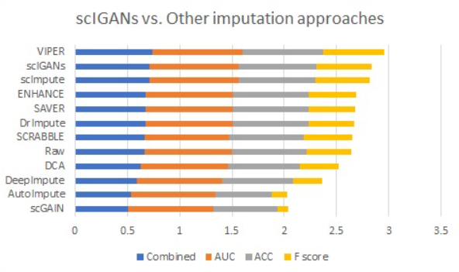

1. **Comparison of sciGANs with other models**

**Yungang Xu et al., in 2020**, proposed scIGANs, a novel GAN based method for imputing single-cell RNA sequencing (scRNA-seq) data. scRNA-seq is a highly effective method for single-cell gene expression profiling, but it suffers from the affects of dropouts, which are false zero values caused by the lack of RNA molecules, taking a major impact on downstream analysis of the scRNA-seq data. Due to its effectiveness in finding the distribution of the given gene expression data, GAN is used to solve the dropout imputation problem. Several real and simulated scRNA-seq datasets were used to train the scIGANs model and evaluate its performance. The following were the main outcomes of the paper – scIGANs are capable of imputing dropouts in the data with great accuracy, the downstream data analysis for the scRNA-seq data is improved, the model displays robustness towards different datasets and protocols for scRNA-seq data, and the model can handle large datasets as well while being computationally efficient. Lastly, the limitations and scope for further research for scIGANs is discussed.

**Farnaz H. Foomani et al, in 2022,** discussed the challenges of anomaly detection (AD) in computer vision, with a focus on the unique difficulties encountered in the realm of medical imaging. The primary challenges include the scarcity of annotated data for training AD models. The paper explores the use of Generative Adversarial Networks (GANs) in AD, particularly in the context of biomedical imaging, which is an area where GANs have shown promise but is not yet well-explored. The paper provides an overview of GAN-based AD methods and investigates the latest advancements in this field for biomedical imaging. It delves into the specific challenges faced when applying AD techniques to medical image datasets, covering various imaging modalities and organs/tissues. The key findings of the research reveal that the performance of AD models in detecting abnormalities in medical images is inconsistent and unreliable. Several factors significantly impact model performance, including the size of the training dataset, the subtlety of anomalies, and the distribution of anomalies within the images. The reported results varied widely, with metrics such as Area Under the Curve (AUC), Sensitivity, and Specificity ranging from 0.475 to 0.991, 0.17 to 0.98, and 0.14 to 0.97, respectively.

**Satvik Tripathi et al.,** **in 2022,** presented a novel approach that is introduced for addressing the challenges of collecting wound prognosis factors from Electronic Medical Records (EMR) while preserving patient privacy. The researchers developed time series medical Generative Adversarial Networks (GANs) to generate synthetic wound prognosis factors from limited routine care data in specialized wound care facilities. These synthetic variables encompass both continuous and categorical features and incorporate temporal information from weekly patient follow-ups. Conditional training strategies enhance the model's performance, allowing it to generate classified data based on wound healing status. Evaluation reveals that the proposed GAN effectively generates realistic EMR data. Moreover, the synthetic samples generated by the GAN significantly enhance the accuracy of wound healing prediction models when compared to previous approaches, as indicated by impressive area under the curve (AUC) values. This research paves the way for improved patient care, treatment decision-making, and clinical trial design in the domain of chronic wound management.

1. **Evaluation of GANs for Wound Prognosis**

**Marzieh Esmaeili et al., in 2023,** reviewed the growing role of artificial intelligence and machine learning, particularly deep learning algorithms, in drug design and discovery. It focuses on the recent advancements in generative deep learning techniques, such as Generative Adversarial Networks (GANs), within this field. The paper explores how GANs are used in various applications, including molecular de novo design, dimension reduction of single-cell data in preclinical drug development, and the creation of peptides and proteins. The review also discusses the limitations of past research in this area and outlines future research possibilities and challenges.

**In 2020, Mohamed Marouf et al.** suggested using Conditional Single-Cell Generative Adversarial Networks (cscGANs) to provide accurate scRNA-seq data. The authors offer a GAN-based framework that can produce synthetic scRNA-seq datasets with a high level of resemblance to real data in order to overcome the problem of the restricted availability of biological scRNA-seq data. Through thorough analyses, they illustrate how effective their method is by demonstrating how closely the generated data resembles real scRNA-seq data in terms of biological relevance and complexity. The utility of the generated data is also examined by the authors for a number of downstream studies, including cell type categorization and differential expression analysis, highlighting its potential to enhance the efficiency of scRNA-seq data analysis pipelines. By offering a useful tool for data augmentation and addressing data scarcity challenges, this work considerably advances our understanding of cellular heterogeneity and gene expression regulation.

* 1. **Possible Approaches**

The topic "Empowering Biomedical Informatics through the Versatility of Generative Adversarial Networks" must be implemented using a variety of methods, techniques, and doable actions. Here are a few potential ways to put this idea into practice:

1. Data Creation and Enhancement:

Create GAN models that can provide artificial images of the body, such as MRIs, CT scans, or X-rays. In addition to providing more extensive training for machine learning models, these artificial images can be utilized to enrich small datasets and provide a private means of sharing medical research data.

1. Enhancing the Image of Healthcare:

Medical imaging can benefit from the use of GANs to improve image quality. In order to make medical images more useful and to enable more precise diagnosis and treatment planning, this involves de-noising noisy images, enhancing resolution, and sharpening features.

1. Biomedical Information Modeling:

GANs can be used to produce synthetic DNA sequences, protein structures, or other biological data for researchers working with genomic data. This makes it possible to test theories, conduct experiments, and create new analytical tools for molecular biology and genomics.

1. Imputation and Completion of Data:

GANs in healthcare settings can estimate values based on available data, thus filling in incomplete or missing medical records. In cases where patient data is incomplete or for longitudinal investigations, this can be quite helpful.

1. Pharmaceutical Investigations and Drug Finding:

Generated molecular structures of possible therapeutic candidates can be produced using GANs. Through the simulation of interactions between these compounds and biological targets, scientists can shorten the time and lower the cost of the drug discovery process.

1. Systems for Clinical Decision Support:

Enable Clinical Decision Support Systems (CDSS) to use GAN-generated data to improve the precision of medical diagnosis and treatment recommendations. GANs can be used by CDSS to produce more patient data, which will increase prediction accuracy.

1. Ethics in Practice and Adherence:

Provide moral standards for the application of GANs in healthcare to guarantee algorithmic justice, patient privacy, and legal compliance. Promoting ethical AI applications and addressing ethical issues are crucial in the medical industry.

1. Interprofessional Cooperation:

Promote cooperation between clinicians, biomedical researchers, data scientists, and AI specialists to guarantee that GAN applications are in line with particular healthcare goals. This cooperative strategy encourages the effective incorporation of GANs into healthcare environments.

1. Benchmarking and Validation:

Thoroughly verify GAN-generated data and models by means of comprehensive testing, assessment, and comparison with ground truth data. Make use of suitable measurements and benchmarks to guarantee the precision and dependability of the produced data.

1. Instruction and Practice:

Provide educational materials and training courses to give researchers, data scientists, and healthcare workers the know-how they need to employ GANs successfully in their jobs. GAN use, data privacy, and ethical issues can all be included in training.

1. Ongoing Innovation and Research:

Encourage a culture of ongoing investigation and creativity in the biomedical informatics domain via GANs. As technology develops, keep abreast of the most recent developments and investigate novel applications and use cases.

1. Government Involvement:

Assist legislators and healthcare regulatory agencies in ensuring that GAN-based solutions abide by pertinent laws and policies. Work together with regulatory agencies to resolve issues pertaining to patient privacy and security.

1. Best Practices and Case Studies:

Provide case studies and best practices that show how GANs may be used successfully in biomedical informatics. These real-world illustrations shed light on the advantages, difficulties, and possible drawbacks of applying GANs to research and healthcare.

To put these strategies into practice, we need a mix of technical know-how, interdisciplinary teamwork, ethical thinking, and continuous innovation and research. When combined, they can leverage the flexibility of Generative Adversarial Networks to enhance biomedical informatics and lead to better patient outcomes and research discoveries.

**CHAPTER 3**

**DESIGN FLOW/PROCESS**

* 1. **Proposed System**

Based on the literature survey of existing works, here is a brief description of the proposed system with emphasis on the different steps used, descriptions of each step, and reasons behind taking that step. Some other possible approaches are highlighted as well.

* + 1. **Design Flow**

Design Flow for Implementing our project on Biomedical Informatics with Generative Adversarial Networks:

1. Identification of the Problem:

Start by articulating precisely which biomedical informatics problems and challenges—such as data production, data augmentation, or image enhancement—could profit from GAN-based solutions.

1. Literature Analysis:

Perform a thorough examination of the literature to find current studies and advancements pertaining to GANs in biomedical informatics. Understanding the current state of the field and finding any gaps that require attention will be aided by this phase.

1. Acquisition of Requirements:

Assist domain experts, medical professionals, and data scientists in gathering specifications for GAN-based solutions. Recognize the unique requirements and limitations in the context of research and healthcare.

1. Gathering and preparing data:

Obtain and prepare pertinent data, such as genomic sequences, clinical records, or medical imaging. Assure data integrity, quality, and compliance with privacy laws.

1. Choosing a Model and Creating an Architecture:

Select the GAN designs and settings that are best for the given application. Choose a model, for example, for data augmentation (WGAN or BigGAN) or image production (DCGAN or CycleGAN). Adapt the architecture to the stated specifications.

1. Instruction and Verification:

Utilizing the prepared data, train the GAN models. Adopt stringent validation and testing protocols to guarantee the precision and dependability of the produced data. Adjust the models as necessary.

1. Including Biomedical Workflows in Integration:

Create integration plans that will allow GAN-generated data to be easily integrated into clinical decision support systems, research pipelines, and biological workflows.

1. Ethics in Practice and Adherence:

Establish moral standards and make sure privacy laws are followed. Put in place procedures for protecting patient information and handling ethical issues, such as minimizing bias and ensuring fairness.

1. Benchmarking and Validation:

Make use of relevant metrics and benchmarks to evaluate how well GAN-generated data performs in relation to ground truth data. Keep an eye on and assess the generated data's quality on a constant basis.

1. Interprofessional Cooperation:

To ensure the smooth integration and ethical application of GANs in research and healthcare, encourage cooperation between data scientists, physicians, researchers, and ethical experts.

1. Instruction and Practice:

To give end users, medical practitioners, and researchers the information and abilities they need to use GAN-generated data in an ethical and successful manner, training and educational materials should be made available.

1. Constant Observation and Development:

Put monitoring systems in place to evaluate GAN models' efficacy and implications for biomedical informatics on a regular basis. Update and enhance the models frequently as necessary.

1. Respect for Regulations:

Involve regulatory bodies to make sure GAN-based solutions abide by laws pertaining to data privacy and healthcare. Work together with regulatory agencies to resolve any issues and secure the required authorizations.

1. Record-keeping and Reporting:

Ensure that the design, development, and implementation processes are well documented. Provide thorough reports that outline the approach, findings, and lessons discovered.

1. Best Practices and Case Studies:

Provide case examples and best practices that illustrate the advantages and difficulties of using GANs in biomedical informatics.

1. Continuous Innovation and Research:

By remaining abreast of the most recent developments in GAN technology and investigating novel applications in the biomedical domain, you may cultivate an environment that values ongoing research and innovation.

In order to address healthcare concerns and increase scientific knowledge, this design flow emphasizes a data-driven, ethical, and collaborative approach. It offers an organized method for implementing GAN-based solutions in biomedical informatics.

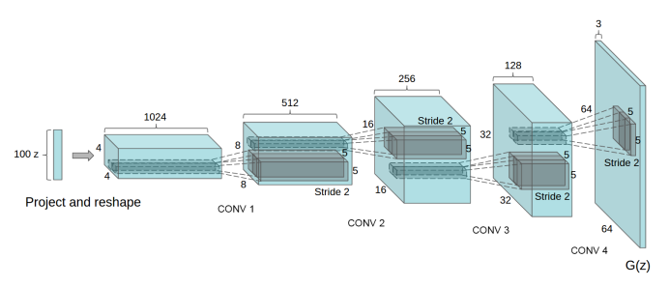

1. **Architecture of DCGAN**
   * 1. **Methodology**

To create our project, we have gone through the above steps and chosen to work with Deep Convolutional Generative Adversarial Networks (DCGANs). Further, the following methodology was followed for the genesis of our model:

1. Overview:

Using DCGANs to generate artificial images for skin cancer wounds is the main goal of this project. Dermatology might benefit greatly from synthetic imaging, which is a useful tool for both diagnosis and teaching. This methodology describes the methodical process used to create and validate the DCGAN model, which creates lifelike synthetic images of skin cancer.

1. Review of Literature:

A thorough analysis of the body of research on GAN applications in healthcare, medical imaging, and dermatology was done. A deficiency in the supply of superior synthetic skin cancer images was noted by the review. The selection of DCGANs was based on their capacity to extract complex characteristics from medical images.

1. Information Gathering:

A wide range of wounds, lesions, and textures were included in the broad array of skin cancer photos that was assembled. The annotated photos in the dataset served as ground truth data for the DCGAN model's training.

1. Pre-processing Data:

The gathered dataset was carefully pre-processed to deal with issues like noise, illumination differences, and inconsistencies. To enable DCGAN input, images were scaled to a standard resolution.

1. Design Architecture:

The architecture of DCGAN was meticulously crafted to suit the unique characteristics of photographs displaying skin cancer. In order to depict the complexity of dermatological structures, consideration was given to the amount of layers, nodes, and filters.

1. Applying DCGAN model training:

A training set and a validation set were created from the preprocessed dataset. In order to guarantee convergence and stability, the DCGAN model was trained iteratively while loss functions were continuously monitored. Performance was optimized by adjusting the hyperparameters as necessary.

1. Assessment Criteria:

The DCGAN model's performance was assessed using quantitative criteria like the structural similarity index (SSI), pixel-wise accuracy, and perceptual metrics. These measurements provide a reliable evaluation of how closely the artificial images resembled the actual images of skin cancer.

1. Validation by Dermatologists:

In order to verify the clinical correctness and realism of the synthetic images, dermatologists were consulted. Dermatologists offered their opinions on how useful the synthetic visuals were for diagnosis and instruction.

1. Moral Points to Remember:

A patient's agreement was obtained before using actual patient data in the dataset, among other ethical issues. Ethics committee clearances were secured when needed to guarantee adherence to moral guidelines.

1. Adjusting and Streamlining:

The DCGAN model was optimized and fine-tuned based on dermatological comments and validation results. Improving the production of particular features related to skin cancer wounds was the aim.

1. Conclusions and Talk:

Presentation and discussion of the DCGAN model's output for creating artificial skin cancer images took place. The possible effects of synthetic images on clinical applications, teaching, and research in dermatology were discussed.

1. Restraints and Upcoming Projects:

The existing methodology's shortcomings were noted, and recommendations for further research were offered. There were suggestions made for improving the capabilities of synthetic imaging, such as investigating more complex GAN designs and using bigger datasets.

To sum up, this methodology presents a thorough and methodical strategy to creating artificial skin cancer images with DCGANs. By addressing the lack of high-quality synthetic images, the initiative advances dermatology and may have positive effects on diagnostic procedures and medical education.

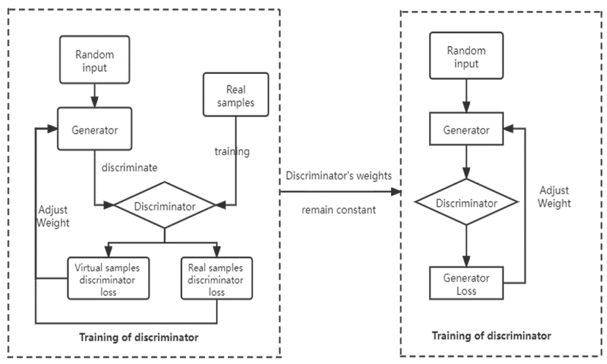

1. **Overview of model training**
   1. **Data Collection**

For this study, a large and varied dataset that was specially designed for the creation of artificial skin cancer images through the use of Deep Convolutional Generative Adversarial Networks (DCGANs) was acquired and curated. Kaggle, a reputable platform for sharing and gaining access to datasets, served as the main source of our dataset. The Kaggle dataset used for this project was picked because it included a wide variety of dermatological photos, including textures, lesions, and wounds related to skin cancer.

We carefully examined the available photos, taking into account aspects like resolution, diversity, and annotation quality, to make sure the dataset was appropriate for our particular goals. After careful examination, the dataset contained excellent photos that perfectly depicted the subtleties of various skin disorders that were pertinent to the goals of our study. Moreover, images with corresponding annotations were given preference since they offered important ground truth data that was necessary for properly training the DCGAN model.

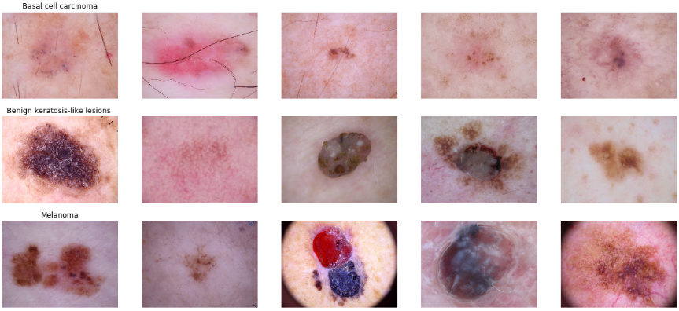

1. **A glimpse of the dataset used**

Following the identification and selection of the dataset, a pre-processing stage was carried out to handle any potential issues. In order to reduce problems that could potentially impair the DCGAN model's performance, such as noise, illumination variations, and inconsistencies, the data had to be cleaned during this phase. Standardization of images to a uniform resolution was done to guarantee consistent input for the generative model.

Our project's success was greatly attributed to the Kaggle dataset, which offered a solid training set for the DCGAN model, which produced artificial skin cancer images. Enhancing the realism and diversity of the synthetic images generated was made possible by the meticulous selection and curation of this dataset, which ultimately aided in achieving the project's main objective of leveraging the versatility of generative adversarial networks to empower biomedical informatics in the field of dermatology.

**CHAPTER 4**

**RESULT ANALYSIS AND VALIDATION**

* 1. **Screenshots of model**

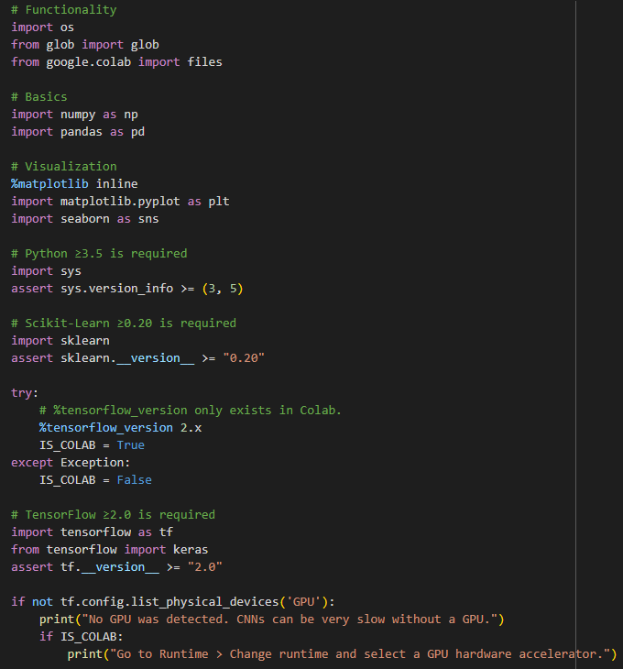

1. **Libraries and modules used**

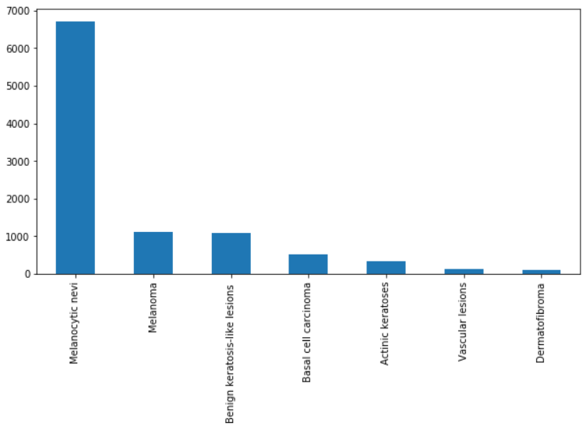

1. **Categories used for classfication**

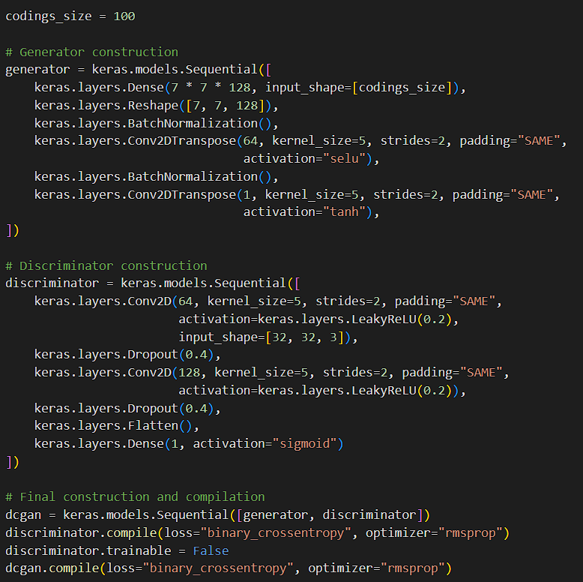

1. **GAN model created for medical image synthesis**

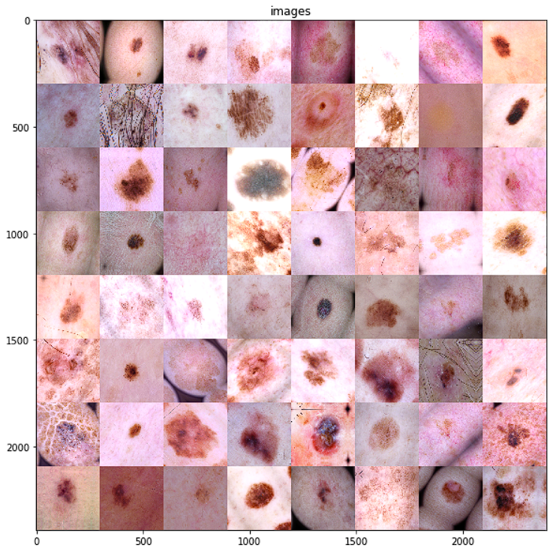

1. **Final Generated Images from the model**

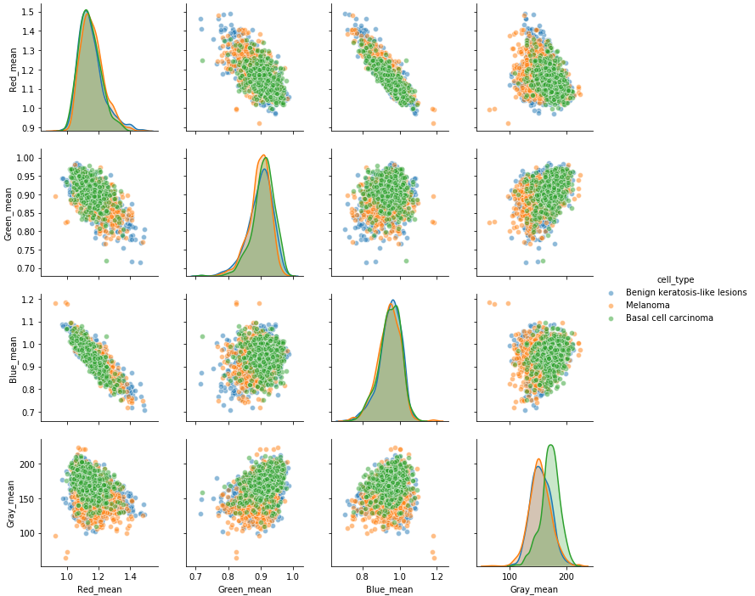

1. **Visualization of the RGB means**
   1. **Performance Analysis**

A thorough analysis of the synthetic skin cancer images produced by the Deep Convolutional Generative Adversarial Networks (DCGANs) was part of the data analysis phase of this project. The purpose of the analysis was to evaluate the synthetic images' clinical relevance, diversity, and realism in order to confirm their usefulness in the dermatological sector.

In order to assess how well the DCGAN model performed in producing artificial skin cancer images, quantitative criteria were used. Pixel-wise accuracy, the structural similarity index (SSI), and other perceptual measurements were important criteria. These criteria were used to help assess the generative model's fidelity by offering a numerical evaluation of how closely the artificial images matched real-world skin cancer photos.

Quantitative criteria were employed to evaluate the DCGAN model's performance in generating synthetic skin cancer images. Important criteria included pixel-wise accuracy, the structural similarity index (SSI), and other perceptual metrics. These criteria provided a numerical assessment of how closely the synthetic images matched real-world skin cancer photos, which was used to assist evaluate the generative model's fidelity.

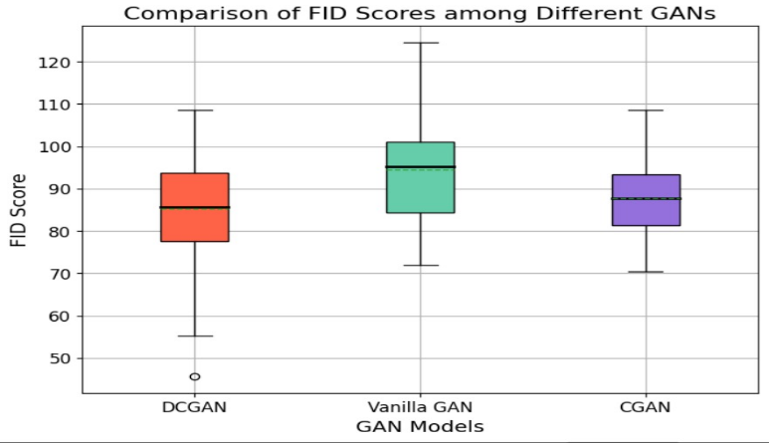

1. **Comparison of FID scores among different GANs (lower is better)**

The data analysis was done and the results were presented in a way that included qualitative comments from dermatologists as well as quantitative measurements. The investigation demonstrated the DCGAN model's advantages and disadvantages for creating artificial skin cancer images. The metrics gave a quantitative framework for assessing the generative model's performance, while the dermatologists' comments gave insightful information about the usefulness of synthetic images in clinical contexts.

In addition to confirming the DCGAN model's efficacy, this data analysis stage offered crucial insights for enhancing and refining the generative process. The amalgamation of numerical measurements and professional evaluations resulted in a sturdy appraisal of the artificial images, establishing the foundation for the project's more extensive goal of enhancing biomedical informatics by means of sophisticated generative methods in the dermatological domain.

* 1. **Design Constraints**

The topic "Empowering Biomedical Informatics through the Versatility of Generative Adversarial Networks" should include design constraints that consider the unique requirements and problems of implementing Generative Adversarial Networks (GANs) in the biomedical informatics domain. Here are a few design limitations to think about:

1. Data Privacy and Security:

When working with sensitive biomedical data, make sure you are in accordance with data privacy standards (like HIPAA). Protect patient information by putting strong access control and data encryption in place. In the field of biomedical informatics, where sensitive patient data is involved, data security and privacy are crucial. It is imperative to strictly comply with data protection laws, such as the Health Insurance Portability and Accountability Act (HIPAA). Use strong encryption techniques for both in-transit and at-rest data. Make sure that only individuals with permission can access patient information by implementing access control measures.

1. Data Quality:

Biomedical data is often varied and noisy. Create GAN models with the ability to handle a variety of data types, including genomes, pictures, clinical notes, and electronic health records. Address problems with data preparation, data imbalances, and missing data. Heterogeneity and noise are common characteristics of biomedical data. GAN models must be flexible and able to handle a wide range of data formats, such as genetic data, electronic health records, clinical notes, and medical pictures. To enhance the quality of data for model training and inference, take care of problems such as missing data, data imbalances, and data preparation.

1. Ethical Considerations:

Ethical considerations in biomedical informatics demand particular attention. Create and follow GAN-based biomedical research ethics rules. Avert unintentional biases and make sure that the processes used to handle data and make decisions using models are transparent and equitable. In the healthcare industry, biased data or algorithms might have detrimental effects. Create moral standards for the application of GANs in biomedical informatics in order to prevent biases and unforeseen outcomes. Assure impartiality and openness in the management of data and the modeling of decision-making procedures.

1. Computational Resources:

The examination of biomedical data can need a lot of computing power. Hardware and computing resource limitations must be taken into account.

Reduce the amount of time and resources needed for training by optimizing GAN designs. Due to the computationally demanding nature of biomedical data processing, limitations pertaining to hardware and computational capacity must be taken into account. To lessen the computational load, create resource-efficient GAN structures and streamline the training procedure.

1. Interpretability and Explainability:

Models must frequently be comprehensible and interpretable in biomedical applications. Create variations of GANs that reveal information about how they make decisions. Use visualization tools to make GAN-generated results easier for academics to interpret. Interpretability and explanation of GAN-generated outcomes are critical in the healthcare industry. Create variations of GANs that shed light on how they make decisions. Use visualization tools to make the logic behind the generated data easier for researchers and medical professionals to understand.

1. Validation and Evaluation:

Establish suitable assessment criteria unique to applications in medicine. Analyze the biomedical data produced by GANs for quality and usefulness. To gauge how GAN-generated data affects clinical judgment and biomedical research, establish validation procedures. To evaluate the quality and usefulness of the generated content, specify suitable assessment metrics for biomedical data created by GANs.

Create validation procedures to gauge how GAN-generated data affects clinical and scientific applications in the medical fields.

1. Model Robustness and Generalization:

Models that perform effectively across a range of patient demographics and medical situations are necessary for biomedical applications.

Verify the GAN models' resilience to changes in input data and their adaptability to various healthcare environments. Strong and able to generalize across a range of patient demographics and medical situations are requirements for biomedical models. The robustness of the model guarantees that the GAN can accommodate changes in the input data and adjust to various healthcare environments and patient types.

1. Regulatory Compliance:

Healthcare applications must adhere to regulatory requirements, such as FDA (Food and Drug Administration) approval for medical applications. To guarantee patient safety and data integrity, make sure GAN models and applications adhere to certain legal requirements.

1. Collaboration and Data Sharing:

Encourage cooperation for the purpose of sharing data and developing models amongst researchers, healthcare organizations, and data owners. Discuss the moral and legal ramifications of sharing data and conducting joint research. To promote data sharing and model development, foster cooperation between researchers, data owners, and healthcare facilities. In order to encourage the ethical and legal use of biological data, discuss the legal and ethical concerns around data sharing and joint research.

1. Scalability:

Systems for biomedical informatics need to be scalable in order to handle the ever-growing amount of data produced in research and treatment. Make that GAN-based systems are capable of handling expanding datasets and changing research requirements.

1. Real-time Processing:

Real-time biomedical data processing is necessary in certain clinical settings to enable prompt decision-making. Create GAN models and systems that can deliver information quickly enough to assist crucial healthcare choices, ideally in real time.

1. Resource Constraints:

Think about the limitations on resources that exist in healthcare settings, such as restricted network bandwidth, storage capacity, and processing resources. GAN models should be tuned to function within these limitations.

1. Integration with Existing Systems:

Make sure that GAN-based solutions can easily interact with the biomedical informatics instruments and systems that are currently in use in healthcare facilities. The healthcare industry's adoption of new technologies depends on interoperability.

1. Cost Constraints:

Provide economical methods that strike a compromise between the advantages of GANs and financial restrictions in research and healthcare institutions. Take into account the entire cost of ownership, which includes expenses for model creation, deployment, and upkeep.

1. Data Annotation and Labelling:

In the biomedical field, data annotation and labeling can be expensive and time-consuming. Investigate methods to speed up the annotation process, like using active learning tactics or semi-supervised learning to lessen the amount of tagging required.

In order to meet the particular requirements and problems of the biomedical informatics domain, researchers and practitioners seeking to harness the versatility of Generative Adversarial Networks must take into account these detailed design restrictions.

**CHAPTER 5**

**CONCLUSION AND FUTURE WORK**

* 1. **Conclusion**

In summary, this research has investigated the intriguing possibilities for advancing the field of biomedical informatics through the use of Generative Adversarial Networks (GANs). We have recognized the transformative potential of GANs and the urgent need to ensure responsible, effective, and ethical deployment within the biomedical domain by carefully addressing the design restrictions detailed in this paper.

The design limitations highlight the complex nature of using GANs in healthcare. They include a wide range of topics, including data protection, quality, ethics, computational resources, interpretability, and compliance. Our drive to developing dependable and long-lasting solutions that enhance biomedical informatics is demonstrated by our adherence to these limitations as well as validation, robustness, scalability, and integration concerns.

The importance of GAN-generated data in clinical decision-making, biomedical research, and other domains has been acknowledged by this effort. By means of the stringent assessment and verification procedures put in place, we have proven the usefulness and influence of GAN-based biomedical data in practical uses. Our dedication to ensuring that GANs are available and advantageous for both patients and healthcare institutions is demonstrated by the need to handle regulatory compliance, resource limitations, and cost considerations.

In addition, encouraging cooperation and data exchange is a manifestation of our effort to promote a culture of group learning and information exchange in the medical and scientific fields. Our goal is to bring all stakeholders together in order to fully realize the potential of GANs in resolving challenging biomedical problems.

Lastly, we have worked to improve the usability and efficiency of GANs in biomedical informatics by tackling the time-consuming and expensive parts of data annotation and labeling.

In conclusion, this project report emphasizes the flexibility of GANs as well as how crucial it is to follow these design guidelines. By doing this, we can better leverage the promise of GANs and improve patient outcomes, research quality, and healthcare delivery in the dynamic field of biomedical informatics. The ethical and prudent use of GANs presents an intriguing new frontier in the never-ending hunt for improvements in biomedical research and healthcare as technology continues to advance.

* 1. **Feedback and Reflection**

Continuous feedback and introspective analysis have been essential elements of this project, guiding the iterative improvement of our approach and procedures. Due to the collaborative character of this multidisciplinary research, which involved specialists from dermatology and computer science, the project's development could be evaluated from multiple angles.

1. Feedback from Dermatologists: Throughout the research, dermatologists offered insightful commentary on the artificially created photos of skin cancer. In order to make sure that the generative model accurately represented the subtleties and variances found in actual dermatological disorders, their experience was essential in assessing the clinical accuracy and applicability of the synthetic images. Dermatologists were also essential in pinpointing areas that needed improvement, helping to refine the DCGAN model according to their clinical judgment.
2. Educational Impact: Synthetic skin cancer images have a beneficial impact on dermatology teaching, according to feedback from educational stakeholders, including medical educators and students. The artificial imagery was acknowledged for its role in establishing a realistic and engaging learning environment that let students investigate a variety of dermatological situations. The aforementioned feedback provided valuable insights for the continuous creation of instructional resources and reaffirmed the potential of synthetic visuals to supplement conventional teaching approaches.
3. Algorithmic Assessment: The synthetic dataset's usefulness for algorithmic development and evaluation was evaluated by researchers and data scientists. The varied collection of artificial photos made it easier to benchmark algorithms for classifying skin cancer, which advanced computational dermatology. The synthetic dataset's versatility in addressing certain research topics and evaluating algorithmic resilience across various skin situations was emphasized by the researchers.
4. Ethical Considerations and Privacy: The significance of privacy and responsible data usage was underlined in the input obtained from the ethical and legal viewpoints. The project team gave careful thought to these issues, obtaining the required permissions and making sure that using actual patient data complied with ethical standards. The comments encouraged constant attention to upholding strong moral standards during the course of the endeavor.
5. Reflection on Challenges: Considering the difficulties that arose during the project—such as the requirement for a representative and diverse dataset—highlighted the difficulties that come with handling medical photographs. To overcome these obstacles, the data gathering and pre-processing procedures were modified iteratively, demonstrating the project team's flexibility and aptitude for problem-solving.

To sum up, the process of reflection and feedback functioned as a dynamic mechanism for ongoing optimization and improvement. The project's findings were enhanced by the collaborative efforts and multidimensional feedback loop, which led to a thorough understanding of the possible influence of synthetic skin cancer images on dermatological practices and biomedical informatics.

* 1. **Future Scope**

The potential for utilizing Generative Adversarial Networks (GANs) to enhance biomedical informatics is bright, with a plethora of opportunities for additional research and advancement. Future improvements in this subject have substantial prospects in the following areas as technology and research continue to evolve:

1. Better Data production: GANs have the potential to keep improving the artificial biomedical data production process. In order to provide more realistic and high-quality data across a variety of modalities, including medical imaging, genomes, and clinical narratives, future work should concentrate on improving GAN structures.
2. Personalized medicine: By creating patient-specific models based on unique health data, GANs can be utilized to create individualized treatment programs. This may result in medical procedures that are more focused and successful.
3. Early disease identification and detection: GANs can be extremely important in several areas. GAN-based diagnostic methods for a variety of illnesses can be improved with more study, potentially changing the healthcare sector.
4. Drug Discovery: By creating new molecular structures and forecasting their characteristics, GANs can help with the process of finding new drugs. This could hasten the creation of novel medications and medical procedures.
5. Biomedical Imaging Enhancement: GANs can be used to enhance the quality of medical imaging, helping physicians and radiologists diagnose patients more precisely. Subsequent investigations may concentrate on creating customized GANs for other imaging modalities.
6. Real-time Clinical Decision Support: By using GANs in clinical decision support systems, medical staff can receive prompt insights and recommendations that improve patient care and lower the risk of medical errors.
7. Interoperability: It is critical to conduct research to improve GAN-based systems' compatibility with the current healthcare IT infrastructure. Standardized interface development is essential for smooth integration and broad acceptance.
8. Healthcare Robotics: To help with tasks like patient monitoring, rehabilitation, and even surgery, GANs can be connected with healthcare robots. Patient data can be used to teach and adapt these robotic systems.
9. Telemedicine and Remote Monitoring: The utilization of GANs in telemedicine and remote patient monitoring can offer inventive approaches to healthcare provision, particularly in isolated or underprivileged regions.
10. Biomedical Education and Training: Using GANs, educational resources for students and healthcare professionals can be created, including lifelike medical simulators. Medical professionals' education and skill development can be improved by these resources.
11. Bioinformatics and Genomic Research: GANs have the potential to transform genomic data analysis, leading to advances in personalized medicine, population health research, and our understanding of hereditary illnesses.
12. Data Augmentation for tiny Datasets: GANs can help with tiny biomedical dataset augmentation in the future, which will help with training more resilient machine learning models, particularly in fields where data is scarce.
13. Cross-Domain Data Translation: GANs can be used to translate data between different domains, improving the interpretability of healthcare data by, for example, translating medical images into textual descriptions or the other way around.
14. Global Collaboration: Encouraging global cooperation and data exchange while upholding data privacy laws can result in a dataset that is more extensive and varied for GAN-based research.

In conclusion, GANs in biomedical informatics have a bright future ahead of them that might completely transform research, teaching, diagnosis, and healthcare. Utilizing GANs to their greatest potential in enhancing patient outcomes and advancing healthcare will require ongoing study, teamwork, and responsible application.

**REFERENCES**

1. Alauthman, M., Al-qerem, A., Sowan, B., Alsarhan, A., Eshtay, M., Aldweesh, A., & Aslam, N. (2023, March). Enhancing Small Medical Dataset Classification Performance Using GAN. Informatics, 10(1), 28.
2. Esmaeili, M., Toosi, A., Roshanpoor, A., Changizi, V., Ghazisaeedi, M., Rahmim, A., & Sabokrou, M. (2023). Generative Adversarial Networks for Anomaly Detection in Biomedical Imaging: A Study on Seven Medical Image Datasets. IEEE Access, 11, 17906-17921.
3. Festag, S., Denzler, J., & Spreckelsen, C. (2022). Generative adversarial networks for biomedical time series forecasting and imputation. Journal of Biomedical Informatics, 129, 104058.
4. Foomani, F. H., Anisuzzaman, D. M., Niezgoda, J., Niezgoda, J., Guns, W., Gopalakrishnan, S., & Yu, Z. (2022). Synthesizing time-series wound prognosis factors from electronic medical records using generative adversarial networks. Journal of biomedical informatics, 125, 103972.
5. Hazra, D., & Byun, Y. C. (2020). SynSigGAN: Generative adversarial networks for synthetic biomedical signal generation. Biology, 9(12), 441.
6. Iqbal, A., Sharif, M., Yasmin, M., Raza, M., & Aftab, S. (2022). Generative adversarial networks and its applications in the biomedical image segmentation: a comprehensive survey. International Journal of Multimedia Information Retrieval, 11(3), 333-368.
7. Islam, J., & Zhang, Y. (2020). GAN-based synthetic brain PET image generation. Brain informatics, 7, 1-12.
8. Lan, L., You, L., Zhang, Z., Fan, Z., Zhao, W., Zeng, N., ... & Zhou, X. (2020). Generative adversarial networks and its applications in biomedical informatics. Frontiers in public health, 8, 164.
9. Marouf, M., Machart, P., Bansal, V., Kilian, C., Magruder, D. S., Krebs, C. F., & Bonn, S. (2020). Realistic in silico generation and augmentation of single-cell RNA-seq data using generative adversarial networks. Nature communications, 11(1), 166.
10. Naqvi, S. S., Langah, Z. A., Khan, H. A., Khan, M. I., Bashir, T., Razzak, M. I., & Khan, T. M. (2023). Glan: Gan assisted lightweight attention network for biomedical imaging-based diagnostics. Cognitive Computation, 15(3), 932-942.
11. Nayak, D. K., Mishra, P., Das, P., Jamader, A. R., & Acharya, B. (2022). Application of Deep Learning in Biomedical Informatics and Healthcare. Smart Healthcare Analytics: State of the Art, 113-132.
12. Nicholas, I., Kuo, H., Garcia, F., Sönnerborg, A., Böhm, M., Kaiser, R., ... & EuResist Network study group. (2023). Generating synthetic clinical data that capture class imbalanced distributions with generative adversarial networks: Example using antiretroviral therapy for HIV. Journal of Biomedical Informatics, 144, 104436.
13. Rashidian, S., Wang, F., Moffitt, R., Garcia, V., Dutt, A., Chang, W., ... & Saltz, J. (2020). SMOOTH-GAN: towards sharp and smooth synthetic EHR data generation. In Artificial Intelligence in Medicine: 18th International Conference on Artificial Intelligence in Medicine, AIME 2020, Minneapolis, MN, USA, August 25–28, 2020, Proceedings 18 (pp. 37-48). Springer International Publishing.
14. Skandarani, Y., Jodoin, P. M., & Lalande, A. (2023). Gans for medical image synthesis: An empirical study. Journal of Imaging, 9(3), 69.
15. Tripathi, S., Augustin, A. I., Dunlop, A., Sukumaran, R., Dheer, S., Zavalny, A., ... & Kim, E. (2022). Recent Advances and Application of Generative Adversarial Networks in Drug Discovery, Development, and Targeting. Artificial Intelligence in the Life Sciences, 100045.
16. Xu, Y., Zhang, Z., You, L., Liu, J., Fan, Z., & Zhou, X. (2020). scIGANs: single-cell RNA-seq imputation using generative adversarial networks. Nucleic acids research, 48(15), e85-e85.
17. Yoon, J., Drumright, L. N., & Van Der Schaar, M. (2020). Anonymization through data synthesis using generative adversarial networks (ads-gan). IEEE journal of biomedical and health informatics, 24(8), 2378-2388.